|  |
| --- |
| SHREC – University of Florida |
| CMS L-1 Trigger in HLS |
| Team: Rafael Hernandez-Lopez, Andrew Sain, Dr Jia Fu Low, Alexander Madorsky, Dr Herman Lam, Dr Darin Acosta |

|  |
| --- |
| Written by: Hernandez-Lopez,Rafael  1-11-2022 |

**Table of Contents**

Notes v

Links & details v

Team vi

Purpose 1

Training/Tutorials 2

Lab Part 1 2

Lab Part 2 4

Lab PFinal 6

Final 9

Structure 10

Structure introduction 10

File structure 10

Function structure 11

Makefile 12

Rules 12

Example: 14

Setup 14

C/C++ simulation 15

C/C++ synthesis into Verilog 15

C/C++ cosimulation, RTL vs C/C++ 15

git clone 15

emtf-hlslib/ 16

emtf-data/ 16

include/ 16

interface/ 16

src/ 18

tb/ 20

tcl/ 22

tools/ 24

tops_Rafael/ 24

Functionality 26

Introduction 26

Code dissections 31

src/coord_delay.cc 31

src/prim_conv11.cc 45

src/prim_conv_EMTFe.cc 53

src/prim_conv_sector_EMTFe.cc 63

src/sp_EMTFe.cc 72

tb/ap_to_hex.h 88

tb/fill_params.h 89

tb/hex_to_ap.h 98

tb/sp_tb_EMTFe.cc 100

tcl/csim_r_ev.tcl 132

tops_Rafael/pcs_EMTFe.cc 133

firmware/emtf_hlslib/model_config.h 135

firmware/myproject.cpp 138

ZAPPV4.1 138

zone_host_converter 139

zapp 143

Appendix 145

EMTFe 145

Big Picture slides 145

Introduction 146

ZAPP 147

EMTF/EMTFpp distribution for EMTFe 148

Primitive Converters (EMTFe) 150

Pattern Recognition (EMTFe) 150

Pragma experimentation 154

myproject() on Vitis HLS 158

r_in notes 161

RPC <> CSC notes 163

Work Tree 165

EMTF SV function calls 172

Alex’s CPPF-to-RPC-link-mapping.docx 174

Alex’s cscid-to-ring-conversion.pdf 176

Terminology/Acronyms 179

# Notes

As requested by Alex, I made the documentation as a Word document. Example on how to run in Makefile/Example: along with some tutorials in Training/Tutorials

In around August, there was a hard shift from the original goal of making everything as optimized as possible to simply working as best as it can for the workshop (SAW) where we will hand everything over to Dr Acosta and Alex. Because of this, some features may appear half-baked in favor of something we could prepare, implement, and test before handing off.

## Links & details

* EMTF was provided by Alex, and he was our main source of information
  + I cannot find a link, so perhaps ask Alex for the code.
* EMTF++ was provided by Jia Fu, and he was our secondary source of information, and main source of information on EMTF++.
  + Jia Fu’s link: <https://github.com/jiafulow/emtf-hlslib>
  + Jia Fu’s code we started with: https://github.com/jiafulow/L1TriggerSep2016/blob/phase2-develop/L1TMuonEndCap/src/experimental
* The HLS code I started with was provided by Nikhil, YiHeng and AJ (Abhinandan, perhaps?).
  + Nikhil’s link: <https://github.com/nikhilghanathe/HLS-for-EMTF/tree/cleaned-HLS-code>
  + The original link I was working with, which I assume YiHeng and AJ were working on: <https://github.com/nikhilghanathe/HLS-for-EMTF>
* Vivado HLS manual is ug902, and it has been deprecated since 2020.2.
  + Vitis HLS is the name of Xilinx’s emerging HLS software
    - We attempted to shift over, but for some reason Vitis HLS stalls and does not complete synthesis. We expect that they may fix this issue in a later update, since the code works in Vivado HLS.

## Team

The team’s shifts as I recall them:

* Original team as I recall: Nikhil, Jia Fu, Dr Lam, Alex, Dr Acosta
* Next team: YiHeng, AJ, Jia Fu, Dr Lam, Alex, Dr Acosta
* Original team when I started: Rafael, Dr Lam, Shreyas Sreedhara, Nirali Patel, Alex, Dr Acosta
* Next team: Rafael, Dr Lam, Alex, Dr Acosta
* Next team: Rafael, Beichen “Oliver” Su, Dr Lam, Alex, Jia Fu, Dr Acosta
* Next team: Rafael, Siddhanta “Sid” Shroff, Dr Lam, Alex, Jia Fu, Dr Acosta
* Current team: Rafael, Andrew, Dr Lam, Alex, Jia Fu, Dr Acosta

And most importantly! Thank you, guys/gals, for providing me with the opportunity to work with you (directly or indirectly)! I hope this document is helpful to you.

# Purpose

The ultimate purpose of this document is to provide sufficient information on the current HLS code so future developers may have an easier time adjusting and learning about relevant parts of its history. Feel free to contact me at: rhernandezlopez1 at ufl dot edu and I will respond as soon as possible.

I go through all files and folders. For each file, I put detailed information about the file. For each folder, I put an overview of each file in the folder. On each folder, I do the same for all its contents.

While it may seem like a lot of pages, most of it is figures.

If the reader wants to get started as soon as possible, see Structure > Makefile > Example: > git clone.

# Training/Tutorials

It is strongly recommended to understand and do the first ~50 pages of the ug902 manual, which includes lots of tables and pictures as well as a tutorial. Also, read about HLS pragmas and ap_[u]int objects. Sid made a presentation on some pragmas.

Here is a slide from 3-1-2021 on our tutorials. The tutorials are called HLS_Labs.zip, and the code attached to it is EMTFe. EMTFe is not the latest version of the code as it does not have myproject(). The instructions are inside of Lab_x.info, which is a text file.

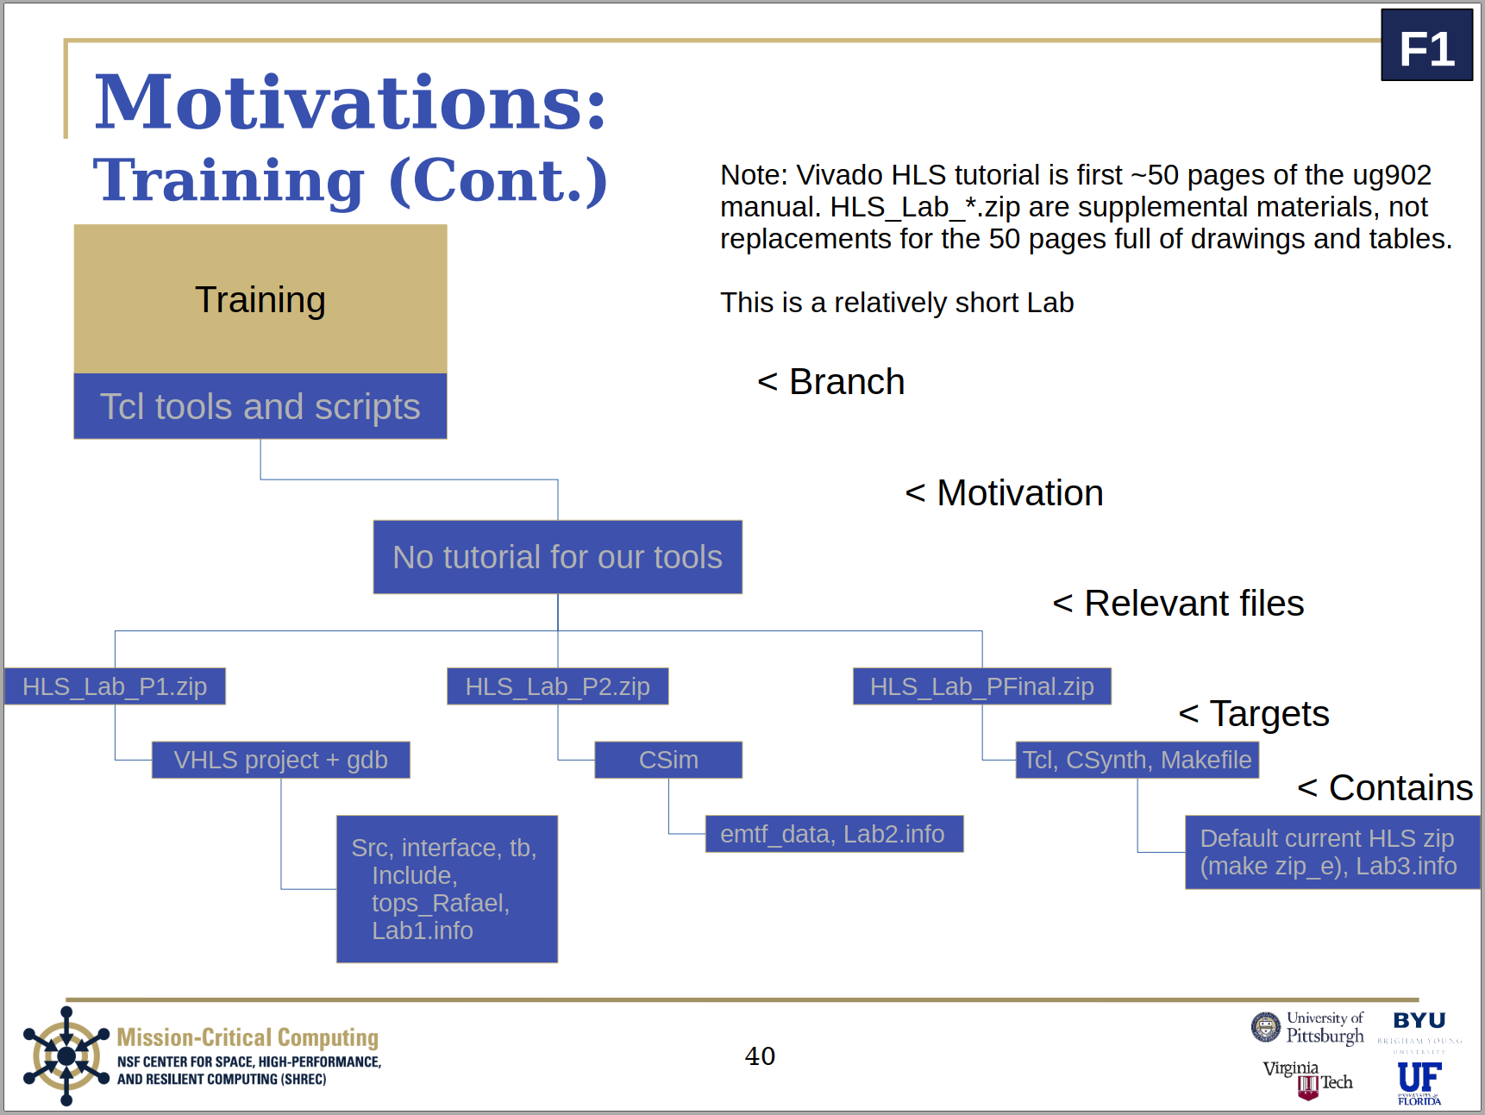

### Lab Part 1

Lab_1.info:

# Part 1: Setup Project

- Make a Vivado HLS project with the src/* and interface/* files, and give them

all the CFLAGS: "-std=c++0x" which will tell Vivado HLS to use modern C++. Put

the tb/sp_tb_EMTFe.cc as the Test Bench, not as a source file.

- Set the device as xcku025-ffva1156-1-c for now (until you get on SHREC server

and can use the actual FPGA).

- Set period to 20 ns

# Part 2: Run CSIM

- Run the C-simulation

Note: if the code fails, use gdb in Vivado HLS or gdb in the command line to

pinpoint the problem.

# Part 3: Reflection

- Reflect on what pops up in the terminal window after you run CSIM for a few

seconds. Tell Rafael what you see and what you think is needed now. [no longer any need for this]

# Part 4: Rafael

- Send me an email for the next part of this "lab" (rhernandezlopez1 at ufl dot edu) [no longer any need for this]

### Lab Part 2

Lab_2.info:

# Part 1: Setup Project

- Make a Vivado HLS project with the src/* and interface/* files, and give them

all the CFLAGS: "-std=c++0x" which will tell Vivado HLS to use modern C++. Put

the tb/sp_tb_EMTFe.cc as the Test Bench, not as a source file.

- Set the device as xcku025-ffva1156-1-c for now (until you get on SHREC server

and can use the actual FPGA).

- Set period to 20 ns

# Part 2: Run CSIM

- Run the C-simulation

Note: if the code fails, use gdb in Vivado HLS or gdb in the command line to

pinpoint the problem.

# Part 3: Reflection

- Reflect on what pops up in the terminal window after you run CSIM for a few

seconds. Tell Rafael what you see and what you think is needed now. [no need for this now]

# Part 4: Rafael

- Send me an email for the next part of this "lab" (rhernandezlopez1 at ufl dot edu) [no need for this now]

# Part 5: Missing files

- Make a symbolic link (ln -s) to emtf_data inside the folder <ProjectName>/<SolutionName>/csim/build

Note: You should now have a link/folder named emtf_data under /csim/build.

- Run CSIM with the missing files included.

# Part 6: CSIM results

- Identify the input and output files from the test bench and locate them on

your hard drive. They should look like:

Event: xx

xx xx xx xxx xxx xx

xx

xx xx xx xxx xxx xx

But instead of xx, there should be actual numbers.

# Part 7: Rafael

- Send me an email with your thoughts and questions about the files. [no longer any need for this]

# Part 8: Rafael's bags of goodies

- At this point, I will most likely give you the final part of the lab

### Lab PFinal

Lab_3.info:

# Part 1: Setup Project

- Make a Vivado HLS project with the src/* and interface/* files, and give them

all the CFLAGS: "-std=c++0x" which will tell Vivado HLS to use modern C++. Put

the tb/sp_tb_EMTFe.cc as the Test Bench, not as a source file.

- Set the device as xcku025-ffva1156-1-c for now (until you get on SHREC server

and can use the actual FPGA).

- Set period to 20 ns

# Part 2: Run CSIM

- Run the C-simulation

Note: if the code fails, use gdb in Vivado HLS or gdb in the command line to

pinpoint the problem.

# Part 3: Reflection

- Reflect on what pops up in the terminal window after you run CSIM for a few

seconds. Tell Rafael what you see and what you think is needed now. [no longer any need for this]

# Part 4: Rafael

- Send me an email for the next part of this "lab" [no longer any need for this]

# Part 5: Missing files

- Make a symbolic link (ln -s) to emtf_data inside the folder <ProjectName>/<SolutionName>/csim/build

Note: You should now have a link/folder named emtf_data under /csim/build.

- Run CSIM with the missing files included.

# Part 6: CSIM results

- Identify the input and output files from the test bench and locate them on

your hard drive. They should look like:

Event: xx

xx xx xx xxx xxx xx

xx

xx xx xx xxx xxx xx

But instead of xx, there should be actual numbers.

# Part 7: Rafael

- Send me an email with your thoughts and questions about the files. [no longer any need for this]

# Part 8: Rafael's bags of goodies

- At this point, I will most likely give you the final part of the lab

# Part 9: Tools

- Unzip all these folders in a different directory than before.

- Install the goodies, run "make install_e"

- Run the CSIM, run "make csim_e"

# Part 10: Reflect

- Make sure everything is as expected based on parts 6/7.

# Part 11: Csynth

- Comment out src/ph_pattern_sector_EMTFe.cc:101

- Uncomment src/ph_pattern_sector_EMTFe.cc:100

- Comment out tcl_r/csynth_r_e.tcl:9

- Uncomment tcl_r/csynth_r_e.tcl:7

- Comment out tcl_r/csynth_r_e.tcl:29

- Uncomment tcl_r/csynth_r_e.tcl:31

- Consider why I may have asked you to make these changes, and let me know in an

email once you are finished.

- Run Csynth, run "make csynth_e"

# Part 12: Questions

- Shoot me an email if you have any questions.

### Final

This is the final portion. Since the Extender was removed because the current myproject supports one bunch crossing (bx), you may skip this. I sent this final part of the lab with Alex’s emtf_core_verilog.zip, so ask him for that if you need the EMTF SV files. As Lab PFinal comes with EMTFe, you may still do this if you would like to. Here are the instructions for Lab PFinal:

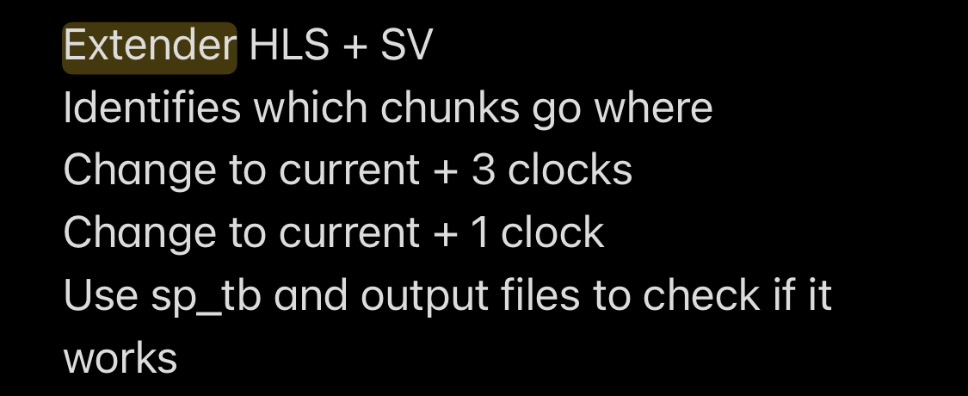

# Structure

## Structure introduction

### File structure

The overall file structure and an explanation of their purpose:

* Makefile
  + Includes rules for building and testing the code
* emtf-hlslib/
  + The Jia Fu code we used in the main function, sp. This has some important differences from the latest version at the time of writing.
* emtf_data/
  + The data we got from back when Nikhil Pratap Ghanathe was developing his own version of the HLS code, likely gotten from Alex. There are also some extra input files and sp output files from our test bench.
* include/
  + I went through all the Vivado HLS includes and took a subset of the includes we needed to compile the project using g++. This has not been updated since I stopped updating the Makefile’s extra rules under the “# Outdated”, but is possible to still be the minimum files needed by Vivado HLS.
* interface/
  + CMS coding guidelines, this folder contains the header files used by the HLS code.
* src/
  + Named based on the CMS coding guidelines. This folder contains the source files used by the HLS code.
* tb/
  + This includes some functions I made to go to/from string to ap_[u]int and the test bench files.
* tcl_r/
  + This includes the Tcl files I edited to make Vivado HLS easy to use via the command line. They originally come from “<project_name>/<solution_name>/<solution_name>.tcl”, I believe.
* tops_Rafael/
  + This includes some top levels I made to synthesize parts of the HLS code. Some may refer to things we have since removed, like the extenders and others may be outdated.

### Function structure

The function flow using MindNode on iPadOS (note that myproject is Jia Fu’s name for his HLS function):

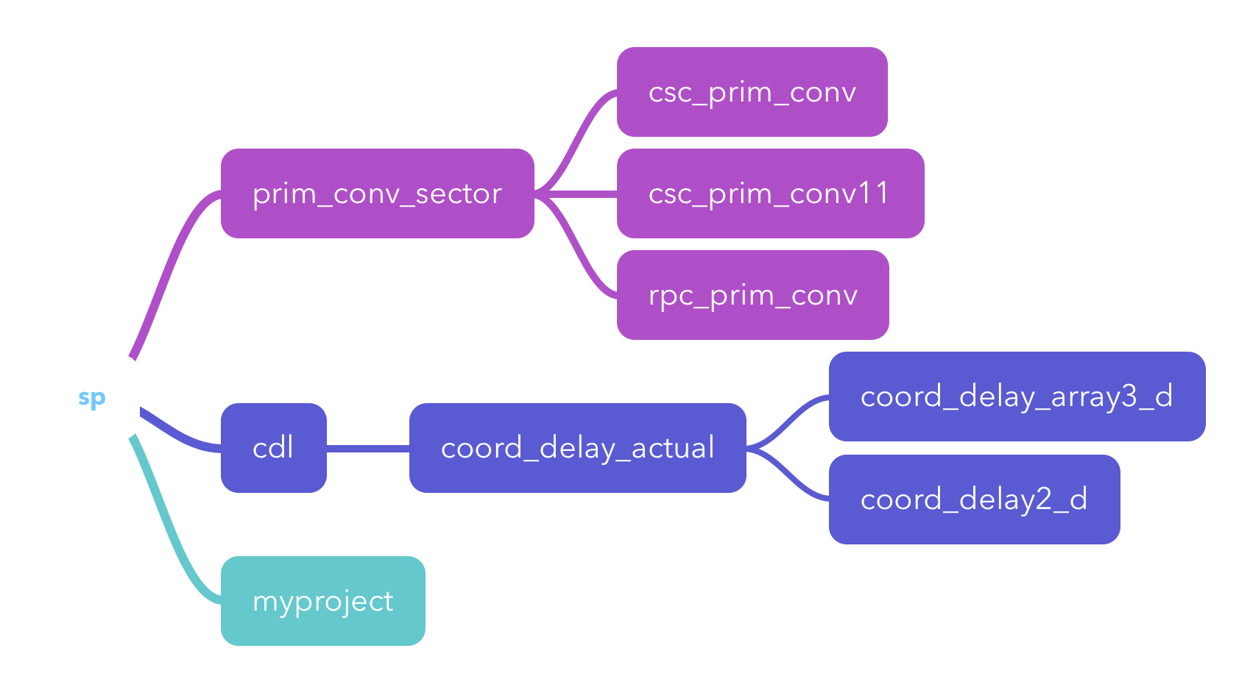

## Makefile

For ease of use, I provided a Makefile. Makefiles contain rules that you can use to run the bash script lines under the rule name. To make (execute bash code under a rulename) a rule, use “make <rulename>”. “make csim” will compile the HLS code and run the compiled HLS code via Vivado HLS. In case you need to run the Vivado HLS executable via a debugger outside of the built-in debugger, the executable is “<project_name>/<solution_name>/csim/build/csim.exe” provided the code has been compiled already.

### Rules

The Makefile has the following rules:

* full
  + Runs csim, csynth, wrapper, and wrp_synth rules
* cosim
  + Runs cosim using the Tcl file I edited from Vivado HLS’s generated Tcl file
    - cosim is Vivado HLS’s built-in RTL <> HLS checker
* csim
  + Runs csim using the Tcl file I edited
    - csim is Vivado HLS’s C simulation which runs the function using the user’s test bench file.
* csynth
  + Runs csynth using the Tcl file I edited
    - csynth is Vivado HLS’s C synthesis, which runs the HLS > RTL synthesizer. This generates the required Verilog code, as well as generates the code in other languages.
* wrapper
  + Runs the parser and wrapper generator. It expects csynth to have been completed, as well as expects the project name “eHLS_Vivado_project” and solution name “solution1”
* zip
  + Zips up the minimum required source files, and all of Jia Fu’s files and the data files, for the system. I frequently used this to move my code around to/from the SHREC server, as well as to send the code via email. It may be outdated now since I moved files around and made adjustments for ease-of-use by future developers when I moved everything onto github.
* wrp_synth
  + Runs Vivado synthesis
    - May need some work as our license expired before I could test Andrew’s synthesis script. I did modify the script to support the case where HLS function names changed or Vivado generates different names from the ones we used in early 2022.

There are a few other outdated rules that may become useful to the future developers of this project. They were meant to provide a way for me to run the code locally outside of Vivado HLS via g++. Since I transitioned to using Tcl files, these have not been updated.

### Example:

#### Setup

Assume zip file name: hls.zip

Assume wanted directory name: HLS

Before running any of the “make” commands, be sure a Vivado environment is loaded. Our servers have a “module load vivado” for some versions of Vivado HLS, while other versions require “source <path_to_Vivado_installation>/settings64.sh”. For example, I “source /tools/Xilinx/HLS/Vivado/2020.1/settings64.sh”

First, make a directory for the HLS code:

mkdir <preferred_path_to_hls>/HLS

unzip hls.zip -d <preferred_path_to_hls>/HLS

cd <preferred_path_to_hls>/HLS

#### C/C++ simulation

cd <preferred_path_to_hls>/HLS

make csim

#### C/C++ synthesis into Verilog

May need to verify the right part is selected in tcl_r/csynth_r_ev.tcl

cd <preferred_path_to_hls>/HLS

make csynth

#### C/C++ cosimulation, RTL vs C/C++

This one may need some more work, since at the time of writing we were rushing to get synthesis finished on our latest model before handing off the HLS code.

cd <preferred_path_to_hls>/HLS

make cosim

#### git clone

To get the git install and run CSimimulation, CSynthesis, generate the wrapper, and Synthesis, do:

git clone <https://github.com/RafHL/EMTF_HLS_2022/>

cd EMTF_HLS_2022

make

## emtf-hlslib/

I had to remove the ap_vld pragma from myproject(), as it was causing the II to increase to 35 as it was not the top-most function anymore. Removing ap_vld decreased the II to 4, which can be further reduced by editing Jia Fu’s configuration file to set IIs at 1. The config file can be found at: emtf-hlslib/firmware/emtf_hlslib/model_configs.h.

## emtf-data/

As can be seen in the test bench, sp_tb_EMTFe.cc, the two most used data files are “emtf_data/NikhilInputs.txt” and “emtf_data/raw_input_100_2GeV_12to24eta_4T_allE1S1_edit.txt”.

vl_lut has all the LUT data for the params that get sent into the primitive converters (PC) via the sector processor (SP) and the primitive converter sector (PCS).

## include/

The main goal of having these Vivado HLS files with the code is to be able to use the code without requiring a full Vivado HLS install. To use these, compile using “-D _LOCAL_AP_INT_H_”. It may be that external code requires more than just these, like for Jia Fu’s myproject code. In that case, these files may need to be extended to include those if not needing a full Vivado HLS install is still a concern.

## interface/

This folder has the headers. As mentioned in the “include” portion of this document, local headers can be used by providing this flag during compilation “-D _LOCAL_AP_INT_H_”.

The EMTFe suffix was a result of transitioning between a HLS version based fully on Alex’s EMTF code and an HLS version based fully on Jia Fu’s EMTF++. The resulting code used the ph_pattern method from Alex’s code and boundaries and patterns from Jia Fu’s pattern recognition module. As it was a merger, I felt EMTF enhanced was a good name for it. As now the focus shifted towards making a functional version of the code before the end of 2021, and we were provided with a HLS version of Jia Fu’s code, most of EMTFe’s code has been scrapped.

The files:

* coord_delay.h
* coord_delay_const.h
  + This file can be edited to configure the required delay for the coord_delay variables.
  + Alternatively, the _ENABLE_DLY_BYPASS can be defined and the !defined(__SYNTHESIS__) removed, adding a #pragma HLS pipeline II=<same as PCS> (pipeline pragma may not be needed if PCS’s II is the same as SP as the pragma may trickle down and affect the functions called but I am not sure). Currently, it allows easy customizability of array dimensions and a configurable delay.
  + The _ENABLE_DLY_BYPASS_ was made because Jia Fu originally requested II=4 to Vivado HLS, and we needed the extra delay to match that II. In csim, the II is ignored and so the delays were all wrong and had to be bypassed. Since I changed Jia Fu’s configuration header file to give everything an II of 1 (fully pipelined), all the modules are expected to have an II of 1 as requested in sp() and so the delay can be bypassed using the define provided and the !define(synthesis) be removed as mentioned above. #pragma HLS pipeline II=same_as_PCS #pragma HLS latency min=same_as_PCS_latency max=same_as_PCS_latency array_out[][][][] = array_in[][][][]
* ph_init_hard.h
  + May need to be edited for Jia Fu’s expected ph_init
* prim_conv11_EMTFe.h
  + Has CSC primitive converters for station 1, ring 1
* prim_conv_EMTFe.h
  + Has both CSC and RPC primitive converters
* prim_conv_sector_EMTFe.h
* spbits.h
  + Modified version of the spbits.sv provided to us by Alex.
* sp_EMTFe.h
* zns_bnd.h
  + Generated using ZAPP (tool)
  + Part 1 of the goal of making the PCs as generic as possible TODO. Left half-way due to having too little time.

## src/

These are the source files for the project. See interface for an explanation for the EMTFe suffix.

Previously, there was a heavier emphasis on object-oriented programming by Nikhil’s recommendation. I chose to make classes follow a “has-a” model of inheritance, where PCS class ended up having about 50 PC objects. This caused synthesis to take 3+ days, and after I shifted the PCS over to a purely functional-oriented (FOP) approach the synthesis time dropped to a few hours. This brought the disadvantage that we needed to set the PC params/th_*mem variables via the test bench, but that was a small price to pay. As you can see in the SV code provided by Alex, his test bench used uut.pcs.pc.params sort of addressing to set the params variables.

The files:

* coord_delay.cc
  + The driving force for wanting this module was that some inputs Jia Fu expects are not currently being used by the existing RPCs. To have the PCS focus only on converting, this module was made to focus only on delaying the inputs. As I mentioned above in the header portion, there is space for optimization here.
* prim_conv11_EMTFe.cc
  + This is heavily based on Alex’s PC11, and indeed used to share its name before the shift to merging our code with Jia Fu’s code. One difference is the phzvl portion. I had tried to make everything as generic as I could, hence why the zns_bnd array is there. Additionally, sometimes th was never assigned a value, so I check vl_tmp to set all the th values to 0 if for loops are never entered so that Valgrind will stop printing warning messages for when th is unitialized.
* prim_conv_EMTFe.cc
  + Also heavily based on Alex’s PCs, with the same phzvl_tmp genericness attempt as pc11s.
  + Has both RPC and CSC primitive converters.
* prim_conv_sector_EMTFe.cc
  + Contains all the primitive converter function calls for the sector.
* sp_EMTFe.cc
  + sp is the wrapper for the entire system, with the primitive converter sector, coordinate delay, and myproject (Jia Fu HLS function call). It is also in charge of packing up the data how Jia Fu expects it.

## tb/

The test bench folder, with all the test bench functions. The main function, sp_tb_EMTFe.cc, is heavily based on Alex’s test bench sp_tf.sv. As there wasn’t enough stack space sometimes, some arrays have been moved to the free-store/heap via vectors.

The files:

* ap_to_hex.h
  + Back when Beichen “Oliver” Su worked with us, he brought to my attention a bug in my code. I was using “>>” for reading from an fstream, which caused values larger than the regular size from being read properly and were being truncated when passed into an ap_[u]int variable. This code is the counterpart to the one in hex_to_ap which takes in the strings from a file and places them into the ap_[u]int variable byte-by-byte. Since this is ap_to_hex, it returns a string with the hex value in the ap_[u]int variable.
* fill_params.h
  + Heavily based, as most things are, on Alex’s fill_params.h. I made a file2array function that uses the hex_to_apu to load all the file data into the ap_uint variables provided.
* hex_to_ap.h
  + The counterpart to ap_to_hex.h, takes in an ap_[u]int variable and returns a hex string.
* sp_tb_EMTFe.cc
  + Heavily based on Alex’s sp_tf.sv. I converted everything into C++ from SV, so there may still be some comments using $fwrite and other SV functions.
  + I moved the necessary changes, like ifilename and dpath, closer to the top of the function for easier access. There may be variables that are no longer used due to the shift between EMTF and EMTF++.
  + The gold file is used for checking if a change made any difference on the current firmware and for cosim. You may want to run “rm emtf_data/sp_tf_gold.out” if you change the input files or make a change drastic enough to impact the code’s outputs (like attempting to pull the latest Jia Fu code, which will require additional merging to be merged properly [like adjusting the requested II]).

## tcl/

This folder has all my Tcl scripts, which I modified based on Vivado HLS’s generated Tcl scripts so that I could run all the jobs via the command line. The main advantages, in my opinion, to using the command line interface rather than the graphical interface is reduced overhead – both reduced human overhead and reduced overhead from having to run the GUI processes. These are used in the Makefile to provide an easy interface to csim/cosim/csynth in Vivado HLS. All the _e.tcl ones are outdated. If any issues occur using these, you may want to remake your entire project by running “rm -r eHLS_Vivado_project”. Note you need to csynth before you can cosim. xcvu13p-fsga2577-1-e

The files:

* cosim_r_e.tcl
  + Helps run cosim, but is outdated.
* cosim_r_ev.tcl
  + Helps run cosim.
  + For cosim, I would originally add a link to the emtf_data directory inside the folder with csim.exe. Vivado HLS would remove my link when it recompiles the code, so I had to make an optional input argument for the location of emtf_data. This is why there is a “-argv” supplied to cosim_design.
  + If there is no gold file, then the first cosim will make the gold reference file and the second one will provide an accurate result on whether the RTL code’s output matches the expected HLS code’s output.
  + May need to add the GOLD flag to sp_EMTFe.cc for cosim to work. TODO
* csim_r.tcl
  + Helps run csim, but is more outdated than csim_r_e.tcl
* csim_r_e.tcl
  + Helps run csim, but is also outdated.
* csim_r_ev.tcl
  + Helps run csim
* csynth_r.tcl
  + Used to help run csynth, but is even older and more outdated than csynth_r_e.tcl
* csynth_r_e.tcl
  + Helps run csynth, but is outdated.
* csynth_r_ev.tcl
  + Helps run csynth.
  + May need to add the GOLD flag to sp_EMTFe.cc for cosim to work. TODO
  + Having those extra outputs in sp() will make the synthesis take longer and will likely stop some Vivado HLS optimizations, so we may need a second version of csynth specifically for cosim which needs GOLD. The other version of csynth will be used to get Vivado’s expected RTL code and will be exactly like this one is now. TODO
  + GOLD moves the internal variables to the function interface so you can see their values from the test bench. It works something like this: sp(defined GOLD) {not defined GOLD}

## tools/

These are some tools we developed for use with the HLS code.

Tool list:

* HLS_Parser
  + Converts the generated Vivado HLS Verilog top level into an intermediate output usable by HLS_Wrapper
* HLS_Wrapper
  + Converts the intermediate output from HLS_Parser into a SV wrapper.
* lut2cpp
  + Developed in case we needed to turn Jia Fu’s LUT into cpp arrays with bitsizes or integer types.
* zap
  + Flattens ring dimension on Jia Fu’s zone boundaries, generating a C file included in the HLS code.

## tops_Rafael/

These are some top levels I used to synthesize the code. If they are not mentioned/used in csynth_r_ev.tcl, they are likely outdated. If they are commented out there, there is no guarantee that they are not outdated so check again to make sure all the inputs and outputs are as expected based on the called function’s header.

The files:

* pcs_EMTFe.cc
  + Has pcs_tl()
  + Originally used to synthesize the primitive converters
* php_EMTFe.cc
  + Has php_tl()
  + This is from when we were making EMTFe so it is outdated.
* pze_EMTFe.cc
  + Has pze_tl
  + This is from when we were making EMTFe so it is also outdated.
* sp_tl_EMTFe.cc
  + Has sp_tl
  + This is from before we transitioned to functional-oriented programming in the PCS and SP, with the Coordinate Delay (CDL) and Jia Fu’s code as-is. This is outdated, as sp can be used directly as the top_level now that it is a function call.
* sp_tl_EMTFe_mem_arrays.cc
  + Has sp_tl
  + This is also from before we transitioned to FOP and seems like it was before Andrew suggested to pass arrays by reference so it is also outdated.

# Functionality

## Introduction

As an introduction, I will show the workshop slides and include the script, with additional aside comments in brackets [] where applicable.

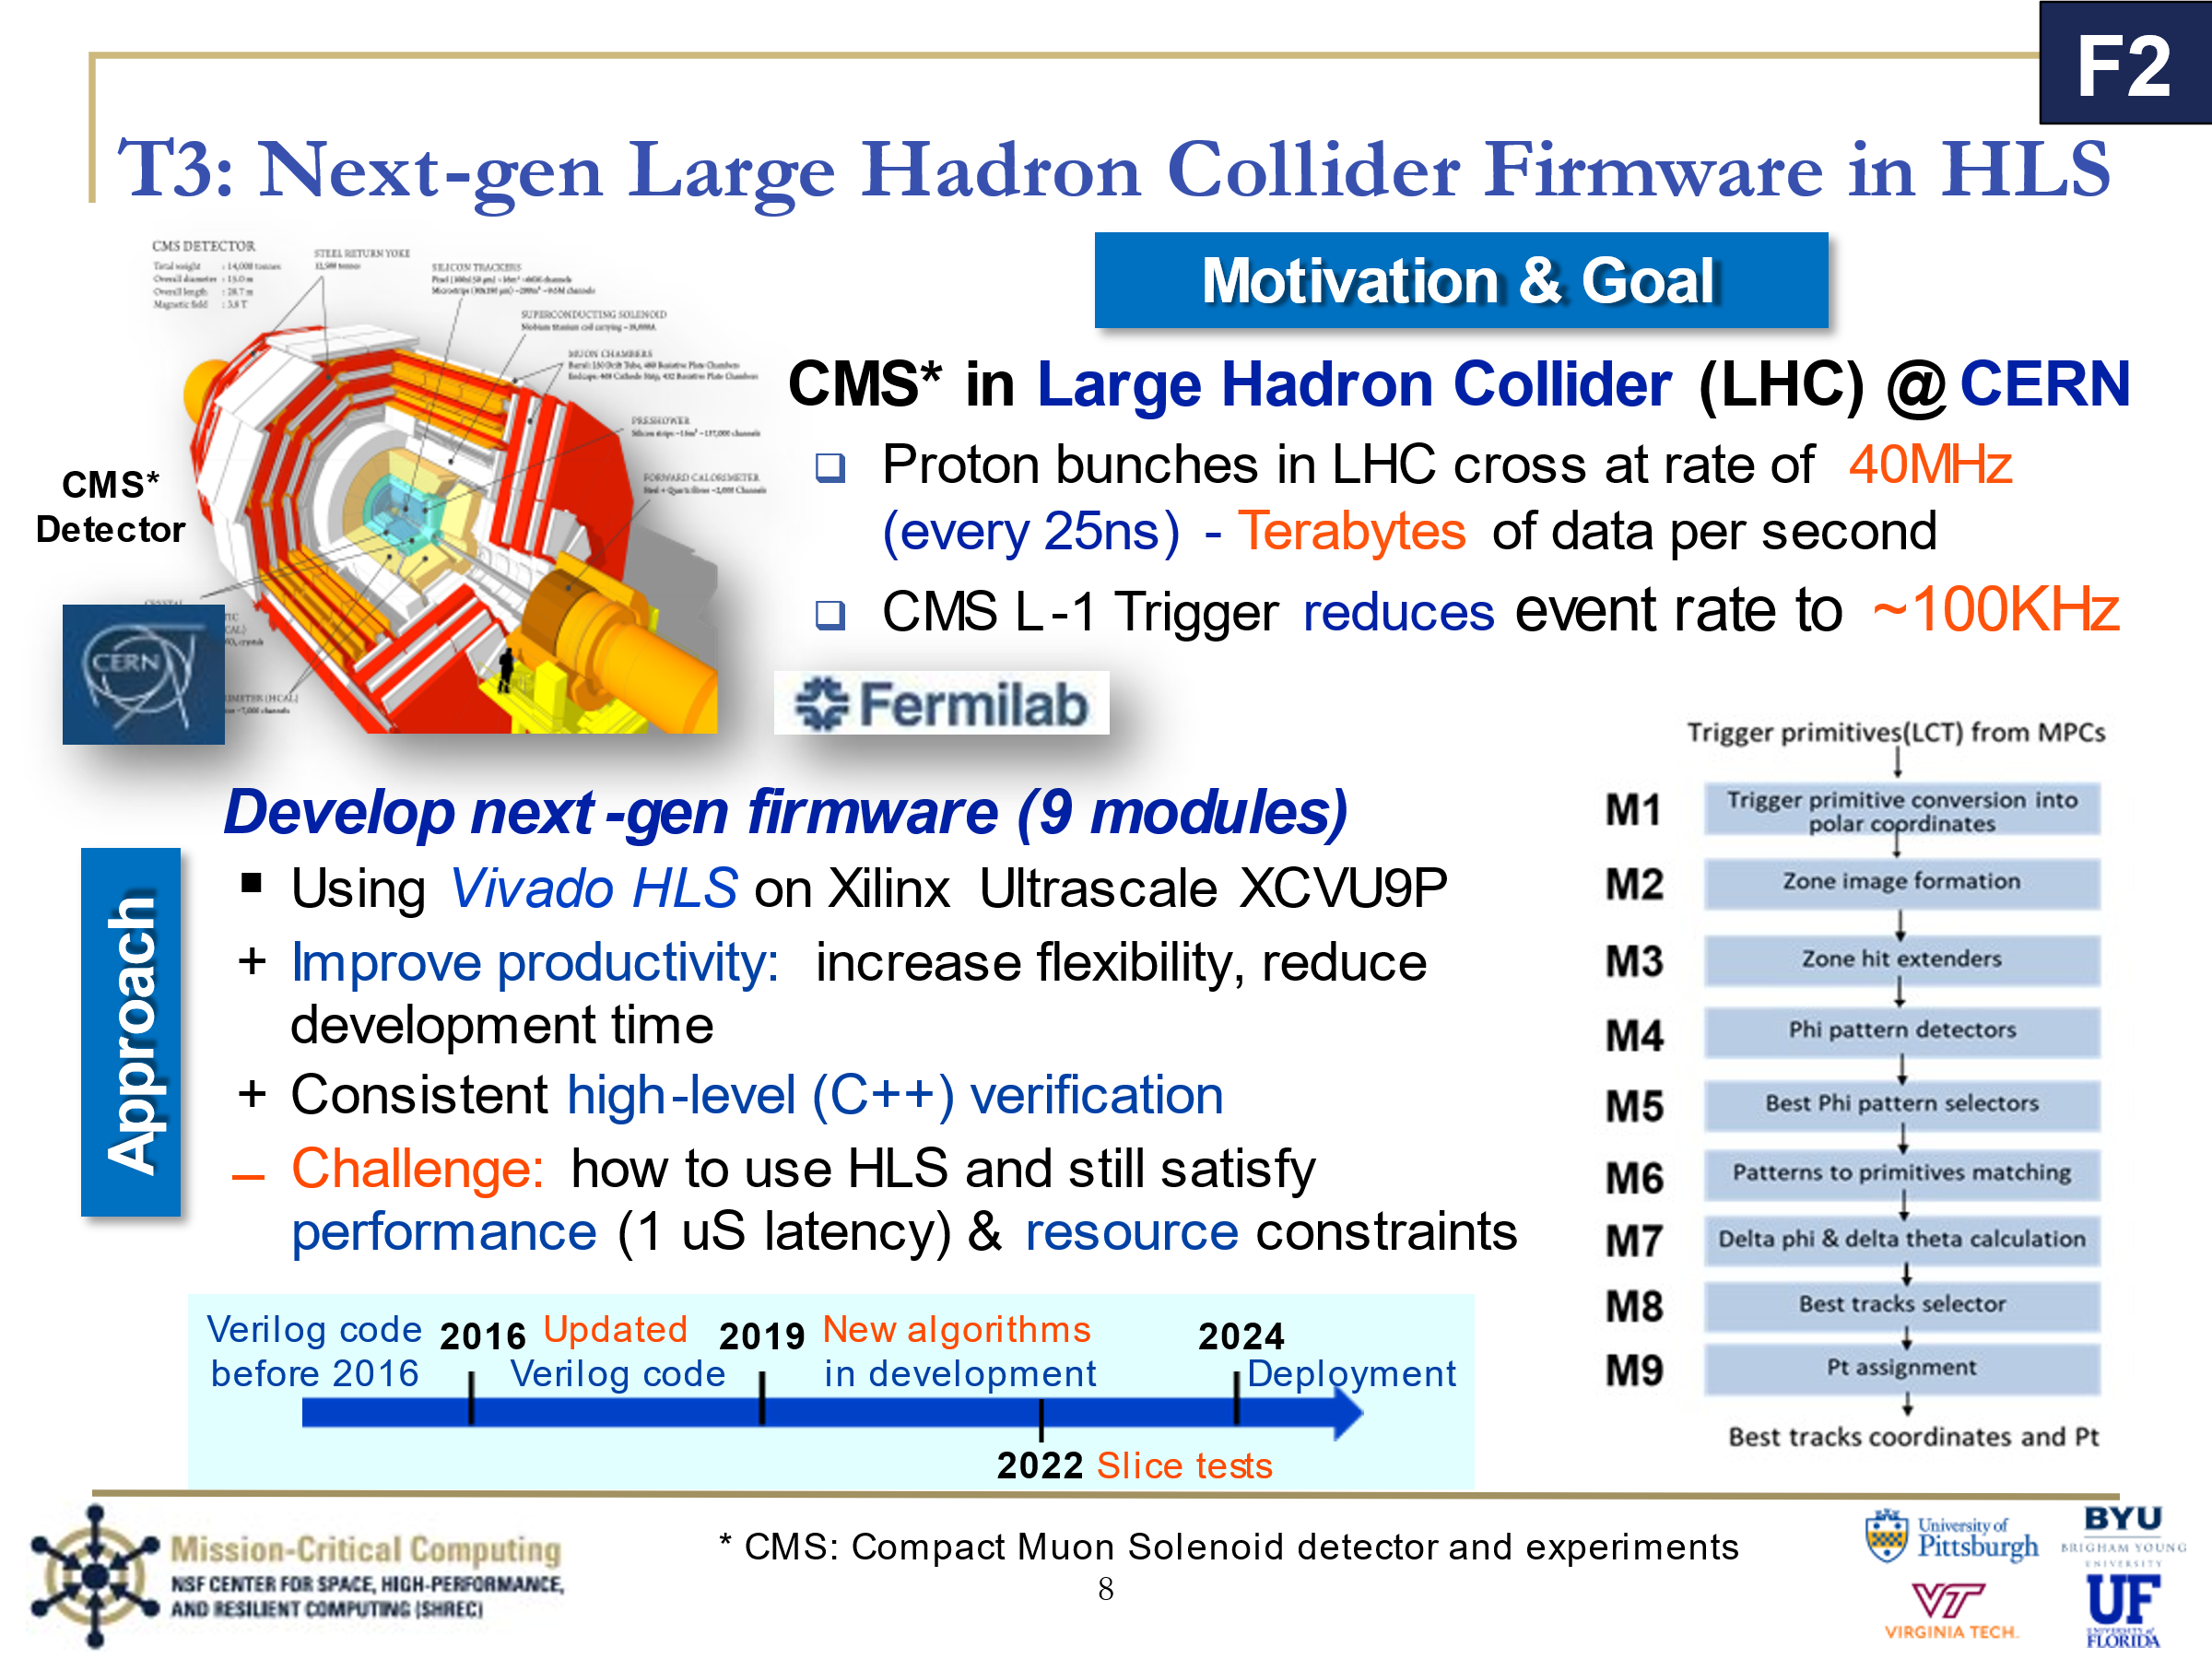

T3 is dedicated to developing the next-generation firmware to support experiments for the Large Hadron Collider at CERN. A lot of details here, but it boils down to a Big Data problem with strict real-time constraints.

Using Vivado HLS on the Xilinx Ultrascale platform, we can improve productivity, increase flexibility, and reduce development time as well as provide consistent high-level verification into CMS's simulation framework, CMSSW.

The current challenges include using HLS while satisfying performance and resource constraints.

In 2019, we were provided new algorithms in modern C++ that we are converting into Vivado HLS for deployment in 2024, with slice testing starting 2022.

The algorithm is shown on the right as these 9 modules.

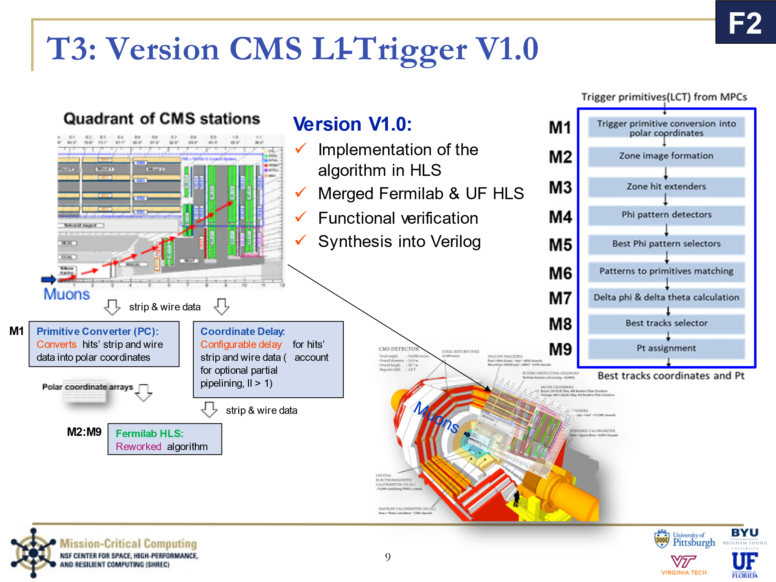

On the left, we see a quadrant cutout of the CMS stations. In the center we see where this quadrant is from.

The muons appear after the collisions in the collision beam shown in the bottom left of the quadrant. These muons traverse through the detector if they have enough momentum to pass through the dense magnetic field without spiraling out of control before they decay. Each hit against the detector stations (shown in colors) results in strip and wire data that gets forwarded into the primitive converters. The PCs convert the hits’ data into polar coordinates.

The configurable Coordinate Delay module accounts for optional partial pipelining (II > 1) by delaying inputs to the Sector Processor (sp) unused in the Primitive Converters so they arrive at the right time to Fermilab HLS. Fermilab HLS is the reworked algorithm we received in April 2021.

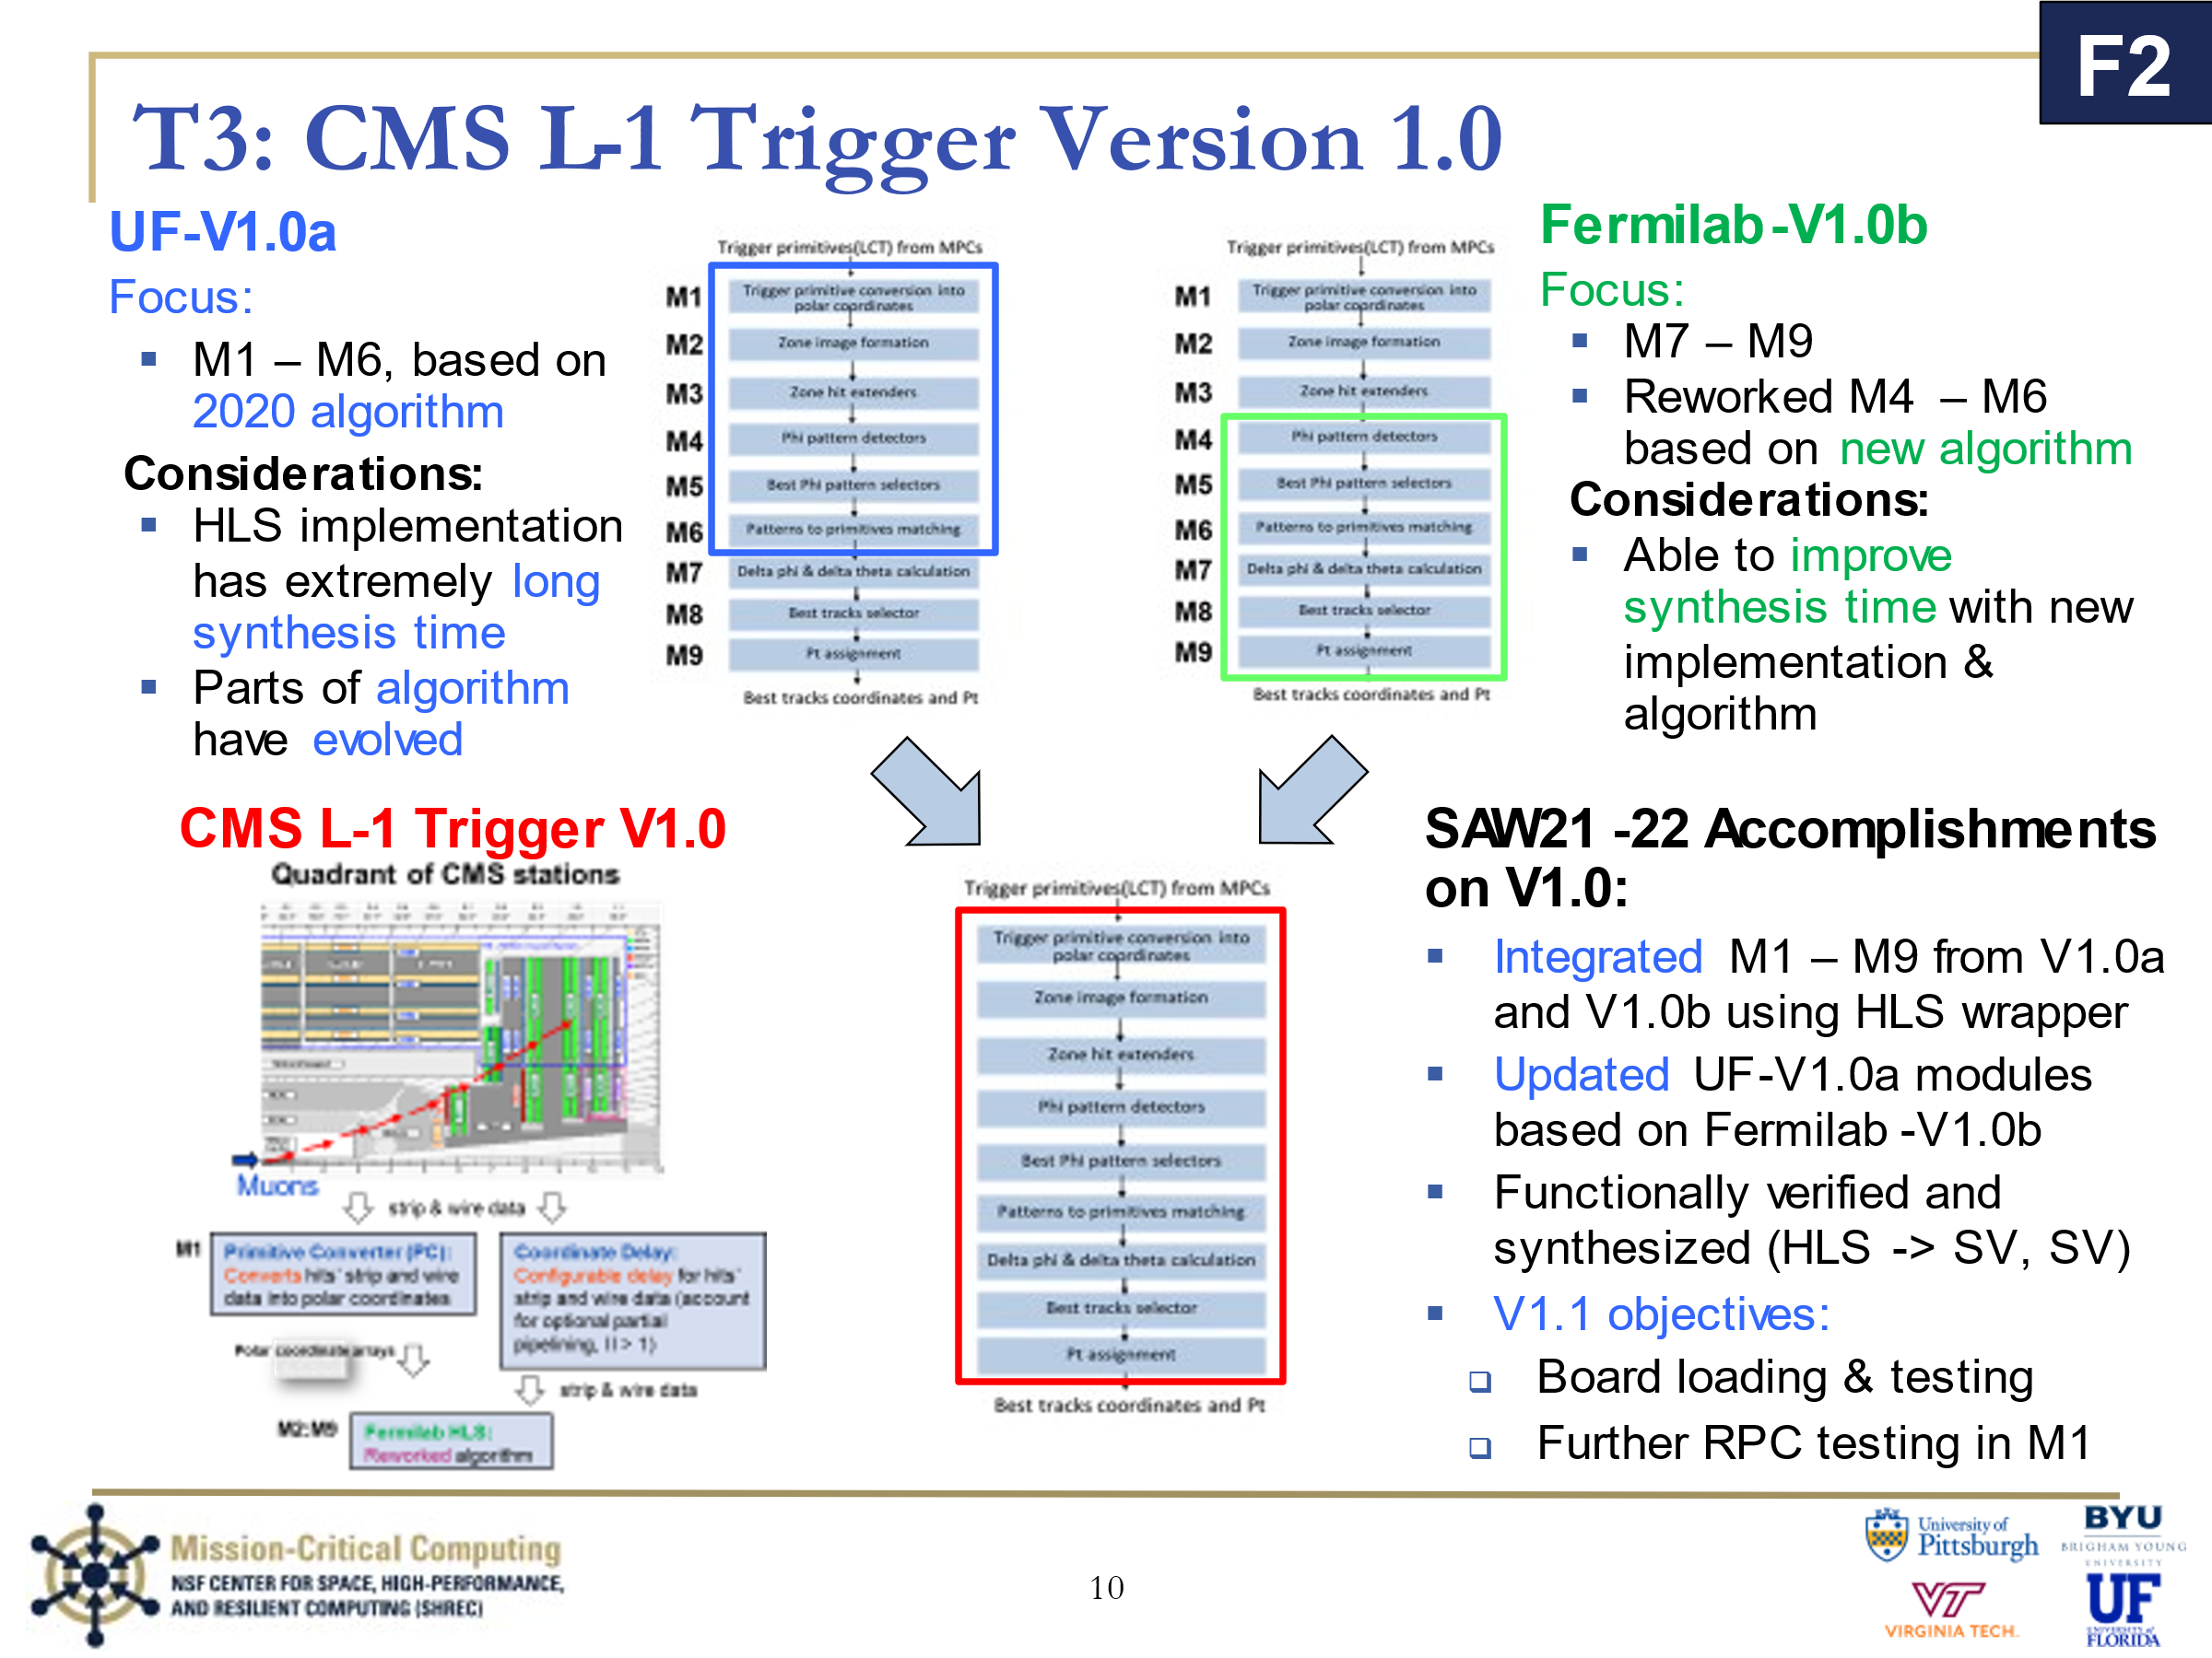

Along with UF-V1.0a, we also have a Fermilab-V1.0b made by our collaborators at Fermilab.

UF-V1.0a focused on modules 1 to 6, based on the 2020 algorithm. The HLS implementation of the 2020 algorithm has an extremely long synthesis time [which is a reason why we are now using Vivado HLS again along with FOP for SP and PCS], and parts of the algorithm have evolved since 2020.

Fermilab-V1.0b focuses on modules 7 to 9, with reworked modules 4 to 6. The new implementation and algorithm were able to improve the synthesis time.

For SAW21-22 we merged these two versions into one CMS L-1 Trigger V1.0. We merged and verified the new modules 1 to 9 based on the new algorithm, while maintaining an acceptable synthesis time.

We have integrated, updated UF-V1.0a modules based on Fermilab-V1.0b, and functionally verified and synthesized the HLS code. Going forward, developers reading this will work on board loading and testing as well as additional testing for the RPCs.

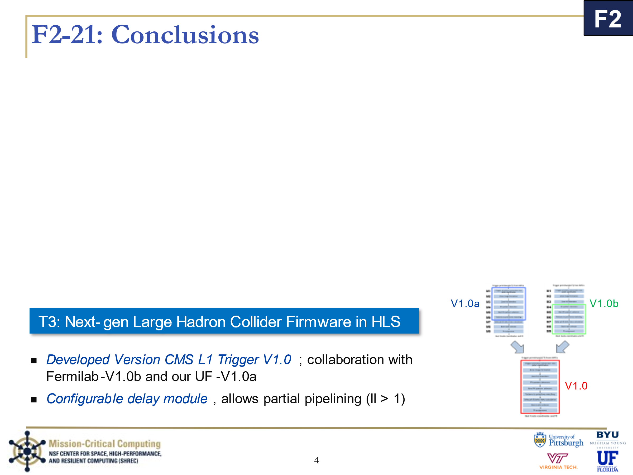

## Code dissections

I will embed my notes in light blue (I am not aware of a way to make this accessible to color-blind people, so I apologize in advance). The syntax highlighting and other goodies are brought to you by Vim’s “:runtime! syntax/2html.vim”. Another tip is to look for lines that do not have a line number, as those are either line-wrapping or my comments. In case anyone is curious, the color-scheme is badwolf by sjl (Steve Losh) on github.

### src/coord_delay.cc

Andrew told me that coord_delay is an extension of the version used by Sid, which was an updated version of the one made by Nikhil. For this reason and because we are running out of time, the version I talked about in the interface/ bullets with the pipelining and latency set to match PCS was not able to be implemented and tested in time.

Here is the README.txt Andrew provided me with his coord_delay:

Code base notes:

- All constants/defines should reside in co_ord_const.h

- Use DELAY_true_x defines to alter delay lengths

- Due to "DELAY_x" defines resulting in a actual delay 2 less than specified, DELAY_true_x was added

Testbench information:

- The testbench is in "tb" folder.

- Inputs for the simulation of the module are in the "tb/tb_in" folder.

- Outputs from the simulation of the modules are in the "tb/tb_out" folder.

- Tools for creating testbench inputs are also in "tb/tb_in" folder.

(array2ev_inputer_maker & array3ev_input_maker)

Note of concern:

- Currently displays the warnings

"make[1]: Warning: File `csim.mk' has modification time 0.31 s in the future" &

"make[1]: warning: Clock skew detected. Your build may be incomplete."

Quality of life TODOs:

- Implement BX history via preprocessor directives (dependent on "COORD_max_drift")

- Reduce repetition in co_ord.cc, in function co_ord_delay_actual, by creating various template functions

- Optimize register usage (specifically the difference between DELAY_true_x and DELAY_x)

Here is coord_delay_const.h:

1 #ifndef _COORD_DELAY_CONST_

2 #define _COORD_DELAY_CONST_

3

4 // Definitions

5 /// Delay

6 #define DELAY_true_0 4 // Delay on time_i to time_o & q_i to q_o

7 #define DELAY_true_1 0 // Delay on Everything Else

8 #define DELAY_0 (DELAY_true_0+2)

9 #define DELAY_1 (DELAY_true_1+2)

10

11 /// Delay Checking

12 #ifndef __SYNTHESIS__

13 static_assert(DELAY_0 >= 2, "coord_delay - DELAY_0 must be greater than or equal to 2");

14 static_assert(DELAY_1 >= 2, "coord_delay - DELAY_1 must be greater than or equal to 2");

15 #endif // Delay Checking

16

17 /// BX Config

18 #define COORD_max_drift 1 // TODO: only supports 1 right now

19

20 /// Structural Defines

21 #define __FULL_OUT__ // Change Between Output and Struct values

22 #define __ENABLE_DLY_BYPASS__ // Enable bypassing delays while simulating

23

24

25 // Constants

26 /// IO Dimensiosn

27 //// time Dimensions

28 constexpr int DIM_time_0 = 12;

29 constexpr int DIM_time_1 = 9;

30 constexpr int DIM_time_2 = seg_ch;

31 //// vl Dimensions

32 constexpr int DIM_vl_0 = 12;

33 constexpr int DIM_vl_1 = 9;

34 //// q Dimensions

35 constexpr int DIM_q_0 = 12;

36 constexpr int DIM_q_1 = 9;

37 constexpr int DIM_q_2 = seg_ch;

38 //// cpatr Dimensions

39 constexpr int DIM_cpatr_0 = 6;

40 constexpr int DIM_cpatr_1 = 9;

41 constexpr int DIM_cpatr_2 = seg_ch;

42 //// ph Dimensions

43 constexpr int DIM_ph_0 = 12;

44 constexpr int DIM_ph_1 = 9;

45 constexpr int DIM_ph_2 = seg_ch;

46 //// th11 Dimensions

47 constexpr int DIM_th11_0 = 3;

48 constexpr int DIM_th11_1 = 3;

49 constexpr int DIM_th11_2 = th_ch11;

50 //// th Dimensions

51 constexpr int DIM_th_0 = 12;

52 constexpr int DIM_th_1 = 9;

53 constexpr int DIM_th_2 = seg_ch;

54 //// phzvl Dimensions

55 constexpr int DIM_phzvl_0 = 12;

56 constexpr int DIM_phzvl_1 = 9;

57 //// ph_hito Dimensions

58 constexpr int DIM_ph_hito_0 = 13;

59 constexpr int DIM_ph_hito_1 = 9;

60

61 /// IO ap uint widths

62 constexpr int WDH_time = 6;

63 constexpr int WDH_vl = seg_ch;

64 constexpr int WDH_q = 4;

65 constexpr int WDH_cpatr = 4;

66 constexpr int WDH_ph = bw_fph;

67 constexpr int WDH_th11 = bw_th;

68 constexpr int WDH_th = bw_th;

69 constexpr int WDH_phzvl = 7;

70 constexpr int WDH_ph_hito = ph_hit_w;

71

72 /// IO Dimension Arrays (TODO: (low priority) remove need in coord_delay.cc)

73 constexpr int DIM_time[] = { DIM_time_0, DIM_time_1, DIM_time_2 };

74 constexpr int DIM_vl[] = { DIM_vl_0, DIM_vl_1 };

75 constexpr int DIM_q[] = { DIM_q_0, DIM_q_1, DIM_q_2 };

76 constexpr int DIM_cpatr[] = { DIM_cpatr_0, DIM_cpatr_1, DIM_cpatr_2 };

77 constexpr int DIM_ph[] = { DIM_ph_0, DIM_ph_1, DIM_ph_2 };

78 constexpr int DIM_th11[] = { DIM_th11_0, DIM_th11_1, DIM_th11_2 };

79 constexpr int DIM_th[] = { DIM_th_0, DIM_th_1, DIM_th_2 };

80 constexpr int DIM_phzvl[] = { DIM_phzvl_0, DIM_phzvl_1 };

81 constexpr int DIM_ph_hito[] = { DIM_ph_hito_0, DIM_ph_hito_1 };

82

83 #endif // _COORD_DELAY_CONST_

Here is coord_delay.h:

1 #ifndef _COORD_DELAY_

2 #define _COORD_DELAY_

3 #ifdef _LOCAL_AP_INT_H_

4 #include "../include/ap_int.h"

5 #else

6 #include <ap_int.h>

7 #endif

8 #include "../interface/spbits.h"

9 #include "../interface/coord_delay_const.h"

10

11 // Struct

12 struct coord_delay{

13 void operator() (

14 // For legacy tb support

15 #ifndef __FULL_OUT__

16 ap_uint<WDH_time> (&time_i) [DIM_time_0] [DIM_time_1] [DIM_time_2],

17 ap_uint<WDH_vl> (&vl_i) [DIM_vl_0] [DIM_vl_1],

18 ap_uint<WDH_q> (&q_i) [DIM_q_0] [DIM_q_1] [DIM_q_2],

19 ap_uint<WDH_cpatr> (&cpatr_i) [DIM_cpatr_0] [DIM_cpatr_1][DIM_cpatr_2],

20 ap_uint<WDH_ph> (&ph_i) [DIM_ph_0] [DIM_ph_1] [DIM_ph_2],

21 ap_uint<WDH_th11> (&th11_i) [DIM_th11_0] [DIM_th11_1] [DIM_th11_2],

22 ap_uint<WDH_th> (&th_i) [DIM_th_0] [DIM_th_1] [DIM_th_2],

23 ap_uint<WDH_phzvl> (&phzvl_i) [DIM_phzvl_0] [DIM_phzvl_1],

24 ap_uint<WDH_ph_hito> (&ph_hit_i) [DIM_ph_hito_0][DIM_ph_hito_1]

25 #endif // __FULL_OUT__

26

27 // For Synthesis

28 #ifdef __FULL_OUT__

29 // Inputs

30 const ap_uint<WDH_time> (&time_i)[DIM_time_0] [DIM_time_1] [DIM_time_2],

31 const ap_uint<WDH_vl> (&vl_i) [DIM_vl_0] [DIM_vl_1],

32 const ap_uint<WDH_q>(&q_i) [DIM_q_0] [DIM_q_1] [DIM_q_2],

33 const ap_uint<WDH_cpatr>(&cpatr_i)[DIM_cpatr_0] [DIM_cpatr_1][DIM_cpatr_2],

34 const ap_uint<WDH_ph>(&ph_i) [DIM_ph_0] [DIM_ph_1] [DIM_ph_2],

35 const ap_uint<WDH_th11>(&th11_i)[DIM_th11_0] [DIM_th11_1] [DIM_th11_2],

36 const ap_uint<WDH_th>(&th_i) [DIM_th_0] [DIM_th_1] [DIM_th_2],

37 const ap_uint<WDH_phzvl>(&phzvl_i)[DIM_phzvl_0] [DIM_phzvl_1],

38 const ap_uint<WDH_ph_hito>(&ph_hit_i)[DIM_ph_hito_0][DIM_ph_hito_1],

39

40 // Outputs

41 ap_uint<WDH_time> (&time_o) [COORD_max_drift][DIM_time_0] [DIM_time_1] [DIM_time_2],

42 ap_uint<WDH_vl> (&vl_o) [COORD_max_drift][DIM_vl_0] [DIM_vl_1],

43 ap_uint<WDH_q> (&q_o) [COORD_max_drift][DIM_q_0] [DIM_q_1] [DIM_q_2],

44 ap_uint<WDH_cpatr> (&cpatr_o) [COORD_max_drift][DIM_cpatr_0] [DIM_cpatr_1][DIM_cpatr_2],

45 ap_uint<WDH_ph> (&ph_o) [COORD_max_drift][DIM_ph_0] [DIM_ph_1] [DIM_ph_2],

46 ap_uint<WDH_th11> (&th11_o) [COORD_max_drift][DIM_th11_0] [DIM_th11_1] [DIM_th11_2],

47 ap_uint<WDH_th> (&th_o) [COORD_max_drift][DIM_th_0] [DIM_th_1] [DIM_th_2],

48 ap_uint<WDH_phzvl> (&phzvl_o) [COORD_max_drift][DIM_phzvl_0] [DIM_phzvl_1],

49 ap_uint<WDH_ph_hito> (&ph_hit_o) [COORD_max_drift][DIM_ph_hito_0][DIM_ph_hito_1]

50 #endif // __FULL_OUT__

51 );

52

53 // For legacy tb support

54 #ifndef __FULL_OUT__

55 ap_uint<WDH_time> time_o [COORD_max_drift][DIM_time_0] [DIM_time_1] [DIM_time_2];

56 ap_uint<WDH_vl> vl_o [COORD_max_drift][DIM_vl_0] [DIM_vl_1];

57 ap_uint<WDH_q> q_o [COORD_max_drift][DIM_q_0] [DIM_q_1] [DIM_q_2];

58 ap_uint<WDH_cpatr> cpatr_o [COORD_max_drift][DIM_cpatr_0] [DIM_cpatr_1][DIM_cpatr_2];

59 ap_uint<WDH_ph> ph_o [COORD_max_drift][DIM_ph_0] [DIM_ph_1] [DIM_ph_2];

60 ap_uint<WDH_th11> th11_o [COORD_max_drift][DIM_th11_0] [DIM_th11_1] [DIM_th11_2];

61 ap_uint<WDH_th> th_o [COORD_max_drift][DIM_th_0] [DIM_th_1] [DIM_th_2];

62 ap_uint<WDH_phzvl> phzvl_o [COORD_max_drift][DIM_phzvl_0] [DIM_phzvl_1];

63 ap_uint<WDH_ph_hito> ph_hit_o [COORD_max_drift][DIM_ph_hito_0][DIM_ph_hito_1];

64 #endif // __FULL_OUT__

65

66 };

67

68 template<typename GEN, int bx, int delay,

69 int dim_j, int dim_k>

70 void coord_delay_array2_d(

71 const GEN (&array_i)[dim_j][dim_k],

72 GEN (&t_array_i_1)[delay][dim_j][dim_k],

73 GEN (&array_o)[bx][dim_j][dim_k]

74 );

75

76

77 template<typename GEN, int bx, int delay,

78 int dim_j, int dim_k, int dim_l>

79 void coord_delay_array3_d(

80 GEN const (&array_i)[dim_j][dim_k][dim_l],

81 GEN (&t_array_i_1)[delay][dim_j][dim_k][dim_l],

82 GEN (&array_o)[bx][dim_j][dim_k][dim_l]

83 );

84

85

86 #endif // _COORD_DELAY_

Here is coord_delay.cc:

1 #include "../interface/coord_delay.h"

2 using namespace std;

3

4

5 struct coord_delay_struct{

6 //ap_uint<1> pr;

7

8 /*** FIRST BUNCH CROSSING *****/

9 ap_uint<WDH_time> t_time_i_1 [DELAY_0][DIM_time_0] [DIM_time_1] [DIM_time_2];

10 ap_uint<WDH_vl> t_vl_i_1 [DELAY_1][DIM_vl_0] [DIM_vl_1];

11 ap_uint<WDH_q> t_q_i_1 [DELAY_0][DIM_q_0] [DIM_q_1] [DIM_q_2];

12 ap_uint<WDH_cpatr> t_cpatr_i_1 [DELAY_1][DIM_cpatr_0] [DIM_cpatr_1][DIM_cpatr_2];

13 ap_uint<WDH_ph> t_ph_i_1 [DELAY_1][DIM_ph_0] [DIM_ph_1] [DIM_ph_2];

14 ap_uint<WDH_th11> t_th11_i_1 [DELAY_1][DIM_th11_0] [DIM_th11_1] [DIM_th11_2];

15 ap_uint<WDH_th> t_th_i_1 [DELAY_1][DIM_th_0] [DIM_th_1] [DIM_th_2];

16 ap_uint<WDH_phzvl> t_phzvl_i_1 [DELAY_1][DIM_phzvl_0] [DIM_phzvl_1];

17 ap_uint<WDH_ph_hito> t_ph_hit_i_1 [DELAY_1][DIM_ph_hito_0][DIM_ph_hito_1];

18

19

20 void coord_delay_actual(

21 // Inputs

22 const ap_uint<WDH_time> (&time_i)[DIM_time_0] [DIM_time_1] [DIM_time_2],

23 const ap_uint<WDH_vl> (&vl_i) [DIM_vl_0] [DIM_vl_1],

24 const ap_uint<WDH_q>(&q_i) [DIM_q_0] [DIM_q_1] [DIM_q_2],

25 const ap_uint<WDH_cpatr>(&cpatr_i)[DIM_cpatr_0] [DIM_cpatr_1][DIM_cpatr_2],

26 const ap_uint<WDH_ph>(&ph_i) [DIM_ph_0] [DIM_ph_1] [DIM_ph_2],

27 const ap_uint<WDH_th11>(&th11_i)[DIM_th11_0] [DIM_th11_1] [DIM_th11_2],

28 const ap_uint<WDH_th>(&th_i) [DIM_th_0] [DIM_th_1] [DIM_th_2],

29 const ap_uint<WDH_phzvl>(&phzvl_i)[DIM_phzvl_0] [DIM_phzvl_1],

30 const ap_uint<WDH_ph_hito>(&ph_hit_i)[DIM_ph_hito_0][DIM_ph_hito_1],

31

32 // Outputs

33 ap_uint<WDH_time> (&time_o) [COORD_max_drift][DIM_time_0] [DIM_time_1] [DIM_time_2],

34 ap_uint<WDH_vl> (&vl_o) [COORD_max_drift][DIM_vl_0] [DIM_vl_1],

35 ap_uint<WDH_q> (&q_o) [COORD_max_drift][DIM_q_0] [DIM_q_1] [DIM_q_2],

36 ap_uint<WDH_cpatr> (&cpatr_o) [COORD_max_drift][DIM_cpatr_0] [DIM_cpatr_1][DIM_cpatr_2],

37 ap_uint<WDH_ph> (&ph_o) [COORD_max_drift][DIM_ph_0] [DIM_ph_1] [DIM_ph_2],

38 ap_uint<WDH_th11> (&th11_o) [COORD_max_drift][DIM_th11_0] [DIM_th11_1] [DIM_th11_2],

39 ap_uint<WDH_th> (&th_o) [COORD_max_drift][DIM_th_0] [DIM_th_1] [DIM_th_2],

40 ap_uint<WDH_phzvl> (&phzvl_o) [COORD_max_drift][DIM_phzvl_0] [DIM_phzvl_1],

41 ap_uint<WDH_ph_hito> (&ph_hit_o) [COORD_max_drift][DIM_ph_hito_0][DIM_ph_hito_1]

42 );

43 };

44

45 void coord_delay::operator() (

46 // For legacy tb support

47 #ifndef __FULL_OUT__

48 ap_uint<WDH_time> (&time_i) [DIM_time_0] [DIM_time_1] [DIM_time_2],

49 ap_uint<WDH_vl> (&vl_i) [DIM_vl_0] [DIM_vl_1],

50 ap_uint<WDH_q> (&q_i) [DIM_q_0] [DIM_q_1] [DIM_q_2],

51 ap_uint<WDH_cpatr> (&cpatr_i) [DIM_cpatr_0] [DIM_cpatr_1][DIM_cpatr_2],

52 ap_uint<WDH_ph> (&ph_i) [DIM_ph_0] [DIM_ph_1] [DIM_ph_2],

53 ap_uint<WDH_th11> (&th11_i) [DIM_th11_0] [DIM_th11_1] [DIM_th11_2],

54 ap_uint<WDH_th> (&th_i) [DIM_th_0] [DIM_th_1] [DIM_th_2],

55 ap_uint<WDH_phzvl> (&phzvl_i) [DIM_phzvl_0] [DIM_phzvl_1],

56 ap_uint<WDH_ph_hito> (&ph_hit_i) [DIM_ph_hito_0][DIM_ph_hito_1]

57 #endif // __FULL_OUT__

58

59 // Normal IO

60 #ifdef __FULL_OUT__

61 // Inputs

62 const ap_uint<WDH_time> (&time_i)[DIM_time_0] [DIM_time_1] [DIM_time_2],

63 const ap_uint<WDH_vl> (&vl_i) [DIM_vl_0] [DIM_vl_1],

64 const ap_uint<WDH_q>(&q_i) [DIM_q_0] [DIM_q_1] [DIM_q_2],

65 const ap_uint<WDH_cpatr>(&cpatr_i)[DIM_cpatr_0] [DIM_cpatr_1][DIM_cpatr_2],

66 const ap_uint<WDH_ph>(&ph_i) [DIM_ph_0] [DIM_ph_1] [DIM_ph_2],

67 const ap_uint<WDH_th11>(&th11_i)[DIM_th11_0] [DIM_th11_1] [DIM_th11_2],

68 const ap_uint<WDH_th>(&th_i) [DIM_th_0] [DIM_th_1] [DIM_th_2],

69 const ap_uint<WDH_phzvl>(&phzvl_i)[DIM_phzvl_0] [DIM_phzvl_1],

70 const ap_uint<WDH_ph_hito>(&ph_hit_i)[DIM_ph_hito_0][DIM_ph_hito_1],

71

72 // Outputs

73 ap_uint<WDH_time> (&time_o) [COORD_max_drift][DIM_time_0] [DIM_time_1] [DIM_time_2],

74 ap_uint<WDH_vl> (&vl_o) [COORD_max_drift][DIM_vl_0] [DIM_vl_1],

75 ap_uint<WDH_q> (&q_o) [COORD_max_drift][DIM_q_0] [DIM_q_1] [DIM_q_2],

76 ap_uint<WDH_cpatr> (&cpatr_o) [COORD_max_drift][DIM_cpatr_0] [DIM_cpatr_1][DIM_cpatr_2],

77 ap_uint<WDH_ph> (&ph_o) [COORD_max_drift][DIM_ph_0] [DIM_ph_1] [DIM_ph_2],

78 ap_uint<WDH_th11> (&th11_o) [COORD_max_drift][DIM_th11_0] [DIM_th11_1] [DIM_th11_2],

79 ap_uint<WDH_th> (&th_o) [COORD_max_drift][DIM_th_0] [DIM_th_1] [DIM_th_2],

80 ap_uint<WDH_phzvl> (&phzvl_o) [COORD_max_drift][DIM_phzvl_0] [DIM_phzvl_1],

81 ap_uint<WDH_ph_hito> (&ph_hit_o) [COORD_max_drift][DIM_ph_hito_0][DIM_ph_hito_1]

82 #endif // __FULL_OUT__

83 ){

84 #pragma HLS INLINE off

85 #pragma HLS PIPELINE II=1

86 #pragma HLS INTERFACE ap_ctrl_none port=return

87

88 static coord_delay_struct inst;

89 //inst.pr=0;

90 inst.coord_delay_actual(

91 time_i, vl_i, q_i, cpatr_i, ph_i,

92 th11_i, th_i, phzvl_i, ph_hit_i,

93

94 time_o, vl_o, q_o, cpatr_o, ph_o,

95 th11_o, th_o, phzvl_o, ph_hit_o

96 );

97 }

98

99

100 void coord_delay_struct::coord_delay_actual(

101 // Inputs

102 const ap_uint<WDH_time> (&time_i)[DIM_time_0] [DIM_time_1] [DIM_time_2],

103 const ap_uint<WDH_vl> (&vl_i) [DIM_vl_0] [DIM_vl_1],

104 const ap_uint<WDH_q>(&q_i)[DIM_q_0] [DIM_q_1] [DIM_q_2],

105 const ap_uint<WDH_cpatr>(&cpatr_i)[DIM_cpatr_0] [DIM_cpatr_1][DIM_cpatr_2],

106 const ap_uint<WDH_ph>(&ph_i)[DIM_ph_0] [DIM_ph_1] [DIM_ph_2],

107 const ap_uint<WDH_th11> (&th11_i)[DIM_th11_0] [DIM_th11_1] [DIM_th11_2],

108 const ap_uint<WDH_th>(&th_i)[DIM_th_0] [DIM_th_1] [DIM_th_2],

109 const ap_uint<WDH_phzvl>(&phzvl_i)[DIM_phzvl_0] [DIM_phzvl_1],

110 const ap_uint<WDH_ph_hito>(&ph_hit_i)[DIM_ph_hito_0][DIM_ph_hito_1],

111

112 // Outputs

113 ap_uint<WDH_time> (&time_o) [COORD_max_drift][DIM_time_0] [DIM_time_1] [DIM_time_2],

114 ap_uint<WDH_vl> (&vl_o) [COORD_max_drift][DIM_vl_0] [DIM_vl_1],

115 ap_uint<WDH_q> (&q_o) [COORD_max_drift][DIM_q_0] [DIM_q_1] [DIM_q_2],

116 ap_uint<WDH_cpatr> (&cpatr_o) [COORD_max_drift][DIM_cpatr_0] [DIM_cpatr_1][DIM_cpatr_2],

117 ap_uint<WDH_ph> (&ph_o) [COORD_max_drift][DIM_ph_0] [DIM_ph_1] [DIM_ph_2],

118 ap_uint<WDH_th11> (&th11_o) [COORD_max_drift][DIM_th11_0] [DIM_th11_1] [DIM_th11_2],

119 ap_uint<WDH_th> (&th_o) [COORD_max_drift][DIM_th_0] [DIM_th_1] [DIM_th_2],

120 ap_uint<WDH_phzvl> (&phzvl_o) [COORD_max_drift][DIM_phzvl_0] [DIM_phzvl_1],

121 ap_uint<WDH_ph_hito> (&ph_hit_o) [COORD_max_drift][DIM_ph_hito_0][DIM_ph_hito_1]

122 ){

**In the idea I had, pragma HLS latency would also need to be added to match the PCS and this pragma HLS pipeline would need to match the PCS’s II (which it currently does).**

123 #pragma HLS PROTOCOL floating

124 #pragma HLS INTERFACE ap_ctrl_none port=return

125 #pragma HLS INLINE off

126 #pragma HLS PIPELINE II=1

127

128

129 /*** FIRST BUNCH CROSSING *****/

130 /* // Unecessary???

131 volatile ap_uint<WDH_time> a_time_i_1 [DELAY_0][DIM_time_0] [DIM_time_1] [DIM_time_2];

132 #pragma HLS ARRAY_PARTITION variable=a_time_i_1 complete dim=0

133 volatile ap_uint<WDH_vl> a_vl_i_1 [DELAY_1][DIM_vl_0] [DIM_vl_1];

134 #pragma HLS ARRAY_PARTITION variable=a_vl_i_1 complete dim=0

135 volatile ap_uint<WDH_q> a_q_i_1 [DELAY_0][DIM_q_0] [DIM_q_1] [DIM_q_2];

136 #pragma HLS ARRAY_PARTITION variable=a_q_i_1 complete dim=0

137 volatile ap_uint<WDH_cpatr> a_cpatr_i_1 [DELAY_1][DIM_cpatr_0] [DIM_cpatr_1][DIM_cpatr_2];

138 #pragma HLS ARRAY_PARTITION variable=a_cpatr_i_1 complete dim=0

139 volatile ap_uint<WDH_ph> a_ph_i_1 [DELAY_1][DIM_ph_0] [DIM_ph_1] [DIM_ph_2];

140 #pragma HLS ARRAY_PARTITION variable=a_ph_i_1 complete dim=0

141 volatile ap_uint<WDH_th11> a_th11_i_1 [DELAY_1][DIM_th11_0] [DIM_th11_1] [DIM_th11_2];

142 #pragma HLS ARRAY_PARTITION variable=a_th11_i_1 complete dim=0

143 volatile ap_uint<WDH_th> a_th_i_1 [DELAY_1][DIM_th_0] [DIM_th_1] [DIM_th_2];

144 #pragma HLS ARRAY_PARTITION variable=a_th_i_1 complete dim=0

145 volatile ap_uint<WDH_phzvl> a_phzvl_i_1 [DELAY_1][DIM_phzvl_0] [DIM_phzvl_1];

146 #pragma HLS ARRAY_PARTITION variable=a_phzvl_i_1 complete dim=0

147 volatile ap_uint<WDH_ph_hito> a_ph_hit_i_1 [DELAY_1][DIM_ph_hito_0][DIM_ph_hito_1];

148 #pragma HLS ARRAY_PARTITION variable=a_ph_hit_i_1 complete dim=0

149 */

150

151 ap_uint<WDH_time> t_time_i [DELAY_0][DIM_time_0] [DIM_time_1] [DIM_time_2];

152 ap_uint<WDH_vl> t_vl_i [DELAY_1][DIM_vl_0] [DIM_vl_1];

153 ap_uint<WDH_q> t_q_i [DELAY_0][DIM_q_0] [DIM_q_1] [DIM_q_2];

154 ap_uint<WDH_cpatr> t_cpatr_i [DELAY_1][DIM_cpatr_0] [DIM_cpatr_1][DIM_cpatr_2];

155 ap_uint<WDH_ph> t_ph_i [DELAY_1][DIM_ph_0] [DIM_ph_1] [DIM_ph_2];

156 ap_uint<WDH_th11> t_th11_i [DELAY_1][DIM_th11_0] [DIM_th11_1] [DIM_th11_2];

157 ap_uint<WDH_th> t_th_i [DELAY_1][DIM_th_0] [DIM_th_1] [DIM_th_2];

158 ap_uint<WDH_phzvl> t_phzvl_i [DELAY_1][DIM_phzvl_0] [DIM_phzvl_1];

159 ap_uint<WDH_ph_hito> t_ph_hit_i [DELAY_1][DIM_ph_hito_0][DIM_ph_hito_1];

160

161 // Delay Logic

**In the idea I had, this would stay the same but there would not be a need for the intermediate t_*_1 variables in the middle column.**

162 coord_delay_array3_d(time_i, t_time_i_1, time_o);

163 coord_delay_array2_d(vl_i, t_vl_i_1, vl_o);

164 coord_delay_array3_d(q_i, t_q_i_1, q_o);

165 coord_delay_array3_d(cpatr_i, t_cpatr_i_1, cpatr_o);

166 coord_delay_array3_d(ph_i, t_ph_i_1, ph_o);

167 coord_delay_array3_d(th11_i, t_th11_i_1, th11_o);

168 coord_delay_array3_d(th_i, t_th_i_1, th_o);

169 coord_delay_array2_d(phzvl_i, t_phzvl_i_1, phzvl_o);

170 coord_delay_array2_d(ph_hit_i, t_ph_hit_i_1, ph_hit_o);

171 }

172

173 template<typename GEN, int bx, int delay,

174 int dim_j, int dim_k>

175 void coord_delay_array2_d(

176 const GEN (&array_i)[dim_j][dim_k],

177 GEN (&t_array_i_1)[delay][dim_j][dim_k],

178 GEN (&array_o)[bx][dim_j][dim_k]

179 ){

**With the idea I had, you would only need this bypass loop and none of the intermediate arrays.**

180 #pragma HLS INLINE

181 #if defined(__ENABLE_DLY_BYPASS__) && !defined(__SYNTHESIS__)

182 for (int j = 0; j < dim_j; j++){

183 for (int k = 0; k < dim_k; k++){

184 array_o[0][j][k] = array_i[j][k];

185 }

186 }

187 #else

188 // reg wire

189 GEN t_array_i[delay][dim_j][dim_j];

190

191 // reg wire = reg contents

192 for (int dly = 0; dly < (delay - 2); dly++){

193 #pragma HLS unroll

194 for (int j = 0; j < dim_j; j++){

195 #pragma HLS unroll

196 for (int k = 0; k < dim_k; k++){

197 t_array_i[dly][j][k] = t_array_i_1[dly][j][k];

198 }

199 }

200 }

201

202 // Input

203 for (int j = 0; j < dim_j; j++){

204 #pragma HLS unroll

205 for (int k = 0; k < dim_k; k++){

206 t_array_i[delay-2][j][k] = array_i[j][k];

207 }

208 }

209

210 // Shift Reg

211 for (int dly = 0; dly < (delay - 2); dly++){

212 #pragma HLS unroll

213 for (int j = 0; j < dim_j; j++){

214 #pragma HLS unroll

215 for (int k = 0; k < dim_k; k++){

216 t_array_i_1[dly][j][k] = t_array_i[dly+1][j][k];

217 }

218 }

219 }

220

221 // Output

222 //#if COORD_max_drift == 1 // (for max_drift = 1)

223 for (int j = 0; j < dim_j; j++){

224 #pragma HLS unroll

225 for (int k = 0; k < dim_k; k++){

226 array_o[0][j][k] = t_array_i[0][j][k];

227 }

228 }

229 /*#elif COORD_max_drift == 3 // (for max_drift = 3)

230 for (int j = 0; j < dim_j; j++){

231 #pragma HLS unroll

232 for (int k = 0; k < dim_k; k++){

233 ph_hit_o[0][j][k] = t_array_i[2][j][k];

234 }

235 }

236 for (int j = 0; j < dim_j; j++){

237 #pragma HLS unroll

238 for (int k = 0; k < dim_k; k++){

239 ph_hit_o[1][j][k] = t_array_i[1][j][k];

240 }

241 }

242 for (int j = 0; j < dim_j; j++){

243 #pragma HLS unroll

244 for (int k = 0; k < dim_k; k++){

245 ph_hit_o[2][j][k] = t_array_i[0][j][k];

246 }

247 }

248 #endif*/

249 #endif

250 }

251

252

253 template<typename GEN, int bx, int delay,

254 int dim_j, int dim_k, int dim_l>

255 void coord_delay_array3_d(

256 GEN const (&array_i)[dim_j][dim_k][dim_l],

257 GEN (&t_array_i_1)[delay][dim_j][dim_k][dim_l],

258 GEN (&array_o)[bx][dim_j][dim_k][dim_l]

259 ){

**It would have been nice to try that idea, where it is just this loop and no other intermediate looping logic.**

260 #pragma HLS INLINE

261 #if defined(__ENABLE_DLY_BYPASS__) && !defined(__SYNTHESIS__)

262 for (int j = 0; j < dim_j; j++){

263 for (int k = 0; k < dim_k; k++){

264 for (int l = 0; l < dim_l; l++){

265 array_o[0][j][k][l] = array_i[j][k][l];

266 }

267 }

268 }

269 #else

270 GEN t_array_i[delay][dim_j][dim_k][dim_l];

271

272 for (int dly = 0; dly < (delay - 2); dly++){

273 #pragma HLS unroll

274 for (int j = 0; j < dim_j; j++){

275 #pragma HLS unroll

276 for (int k = 0; k < dim_k; k++){

277 for (int l = 0; l < dim_l; l++){

278 t_array_i[dly][j][k][l] = t_array_i_1[dly][j][k][l];

279 }

280 }

281 }

282 }

283

284 // Input

285 for (int j = 0; j < dim_j; j++){

286 #pragma HLS unroll

287 for (int k = 0; k < dim_k; k++) {

288 for (int l = 0; l < dim_l; l++) {

289 t_array_i[delay-2][j][k][l] = array_i[j][k][l];

290 }

291 }

292 }

293

294 // Shift Reg

295 for(int dly = 0; dly < (delay - 2); dly++){

296 #pragma HLS unroll

297 for(int j = 0; j < dim_j; j++){

298 #pragma HLS UNROLL

299 for(int k = 0; k < dim_k; k++){

300 for(int l = 0; l < dim_l; l++){

301 //a_th_i_1[dly][i][j][k]=t_th_i[dly][i][j][k];

302 t_array_i_1[dly][j][k][l]=t_array_i[dly+1][j][k][l];

303 }

304 }

305 }

306 }

307

308 // Output

309 //#if COORD_max_drift == 1 // (for max_drift = 1)

310 for(int j = 0; j < dim_j; j++){

311 #pragma HLS unroll

312 for (int k = 0; k < dim_k; k++){

313 for (int l = 0; l < dim_l; l++){

314 array_o[0][j][k][l] = t_array_i[0][j][k][l];

315 }

316 }

317 }

318 /*#elif COORD_max_drift == 3 // (for max_drift = 3)

319 for(int j = 0; j < dim_j; j++){

320 #pragma HLS unroll

321 for (int k = 0; k < dim_k; k++){

322 for (int l = 0; l < dim_l; l++){

323 array_o[2][j][k][l] = t_array_i[0][j][k][l];

324 }

325 }

326 }

327 for(int j = 0; j < dim_j; j++){

328 #pragma HLS unroll

329 for (int k = 0; k < dim_k; k++){

330 for (int l = 0; l < dim_l; l++){

331 array_o[1][j][k][l] = t_array_i[1][j][k][l];

332 }

333 }

334 }

335 for(int j = 0; j < dim_j; j++){

336 #pragma HLS unroll

337 for (int k = 0; k < dim_k; k++){

338 for (int l = 0; l < dim_l; l++){

339 array_o[0][j][k][l] = t_array_i[2][j][k][l];

340 }

341 }

342 }

343 #endif*/

344 #endif

345 }

### src/prim_conv11.cc

Here is the header file:

1

**This intro header may be outdated or stale, the header file itself is fine.**

//////////////////////////////////////////////////////////////////////////////////

2 // Company: UF

3 // Engineer: Madorsky

4 // Translator: Rafael Hernandez

5 //

6 // Create Date: 17:17:10 03/12/2010

7 // Design Name: tf_slhc

8 // Module Name: prim_conv

9 // Project Name: tf_slhc

10 // Target Devices: V6

11 // Tool versions: 11.4

12 // Description: primitive converter into angular values

13 //

14 // Dependencies:

15 //

16 // Revision:

17 // Revision 0.01 - File Created

18 // Additional Comments: Translated by Rafael into C++

19 //

20 //////////////////////////////////////////////////////////////////////////////////

**This is the regular header-shields**

21 #ifndef _PRIM_CONV11_CLASS_

22 #define _PRIM_CONV11_CLASS_

23

**This is for some prints inside the pc11 module, csc_prim_conv11**

24 //#define PC11_PRINT_MACRO

25

**This includes the printing header**

26 #ifndef __SYNTHESIS__

27 #ifdef PC11_PRINT_MACRO

28 #include <iostream>

29 #endif

30 #endif

This is for using the optional included Vivado HLS headers for compiling outside of Vivado HLS

31 #ifdef _LOCAL_AP_INT_H_

32 #include "../include/ap_int.h"

33 #else

34 #include <ap_int.h>

35 #endif

36 #include "../interface/spbits.h"

37

**This is the pc11 function call. The inputs have “const” and the outputs do not.**

38 void csc_prim_conv11(

39 // input parameters from MPC

40 const ap_uint<seg_ch> &vpf, // valid flags

41 const ap_uint<bw_wg> wiregroup[seg_ch], // wiregroup numbers

42 const ap_uint<bw_hs> hstrip [seg_ch], // halfstrip numbers

43 const ap_uint<4> clctpat [seg_ch], // clct pattern numbers

44 // theta correction lut, for me1/1 only

45 // takes index = {wiregroup(2 MS bits), dblstrip}, returns theta correction for tilted wires

**While these are also inputs, their values are written inside of the primitive converters using r_in.**

**Before using r_in, we had these directly set as inputs for sp(), but that caused synthesis times to run much longer which is why we added them back. Nikhil said that helped him with his synthesis times, so we followed his idea but did not have many layers for the memory block. Instead, we wrapped our PC’s logic in an if (!we) {do pc stuff} else {write th_*mem or params}**

46 ap_uint<4> th_corr_mem[th_corr_mem_sz],

47 ap_uint<6> th_mem [th_mem_sz], // makes memory size such that any address will be in range

48 ap_uint<13> params [6],

49 const ap_uint<4> st,

50 const ap_uint<4> ch,

51 const ap_uint<13> r_in,

52 const ap_uint<1> we,

53 const ap_uint<bw_addr> addr,

54 const ap_uint<2> sel,

55 // low-precision ph, only for detection

56 // high-precision ph with displacement correction will be calculated when

57 // 3 best tracks are found.

58 ap_uint<bw_fph> ph[seg_ch],

59 // full precision th, but without displacement correction, takes th

60 // duplication into account

61 ap_uint<bw_th> th[th_ch11], // Use worst case

62 ap_uint<seg_ch> &vl, // one-bit valid flags

63 ap_uint<7> &phzvl, // raw hit valid flags for up to 3 ph zones

64 ap_uint<seg_ch> &me11a,

65 ap_uint<4> clctpat_r[seg_ch], // clct pattern numbers

66 //ap_uint<ph_hit_w> &ph_hit, // ph and th raw hits

67 ap_uint<13> &r_out,

68 const ap_uint<1> &endcap

69 );

70

71 #endif

72

Here is the source file:

1 //////////////////////////////////////////////////////////////////////////////////

2 // Company: UF

3 // Author: Rafael Hernandez

4 //

5 // Create Date: 17:17:10 03/12/2010

6 // Design Name: tf_slhc

7 // Module Name: prim_conv

8 // Project Name: tf_slhc

9 // Target Devices: V6

10 // Tool versions: 11.4

11 // Description: primitive converter into angular values

12 //

13 // Dependencies:

14 //

15 // Revision:

16 // Revision 0.01 - File Created

17 // Additional Comments: Translated by Rafael into C++

18 //

19 //////////////////////////////////////////////////////////////////////////////////

**These are some notes I made for myself.**

20 // Try to localize temporary variables as much as possible

21 // Try to write and read same variable as little as possible

22

23 #include "../interface/prim_conv11_EMTFe.h"

24

25 void csc_prim_conv11(

26 // input parameters from MPC

27 const ap_uint<seg_ch> &vpf, // valid flags

28 const ap_uint<bw_wg> wiregroup[seg_ch], // wiregroup numbers

29 const ap_uint<bw_hs> hstrip [seg_ch], // halfstrip numbers

30 const ap_uint<4> clctpat [seg_ch], // clct pattern numbers

31 // theta correction lut, for me1/1 only

32 // takes index = {wiregroup(2 MS bits), dblstrip}, returns theta correction for tilted wires

33 ap_uint<4> th_corr_mem[th_corr_mem_sz],

34 ap_uint<6> th_mem [th_mem_sz], // makes memory size such that any address will be in range

35 ap_uint<13> params [6],

36 const ap_uint<4> station,

37 const ap_uint<4> cscid,

38 const ap_uint<13> r_in,

39 const ap_uint<1> we,

40 const ap_uint<bw_addr> addr,

41 const ap_uint<2> sel,

42 // low-precision ph, only for detection

43 // high-precision ph with displacement correction will be calculated when

44 // 3 best tracks are found.

45 ap_uint<bw_fph> ph[seg_ch],

46 // full precision th, but without displacement correction, takes th

47 // duplication into account

48 ap_uint<bw_th> th[th_ch11], // Use worst case

49 ap_uint<seg_ch> &vl, // one-bit valid flags

50 ap_uint<7> &phzvl, // raw hit valid flags for up to 3 ph zones

51 ap_uint<seg_ch> &me11a,

52 ap_uint<4> clctpat_r[seg_ch], // clct pattern numbers

53 //ap_uint<ph_hit_w> &ph_hit, // ph and th raw hits

54 ap_uint<13> &r_out,

55 const ap_uint<1> &endcap

56 ) {

57

**The interface ctrl none is so that Vivado HLS does not automatically attach ap control signals to our IO variables.**

58 #pragma HLS interface ap_ctrl_none port=return // Removes control signals

**This requests pipelining. Vivado HLS only takes suggestions, it will not guarantee a fully pipelined RTL.**

59 #pragma HLS pipeline // Fully pipelined, defaults to II=1

**Latency 1 is a requirement from the SV code, so I simply put it as 1 here too. Changing this may impact resources, so play with it if you would like. Any changes here must be reflected in the CoordDelay module or else the data will not arrive at Jia Fu’s myproject() at the right time.**

60 #pragma HLS latency max=1 // At most 1 clock cycle, and warn if more

61 //#pragma HLS inline off // inline off in case recursive inline in wrappers above

62

**These values are from an old experiment I made. It was all done using bash so it could be replicated, but is long outdated since it was from early 2019.**

63 // 9191 LUTs, 110 FF (params registers)

64 // 929 LUTs, 60 FF (params cyclic 4)

**These partitioning pragmas split your variables (which by default would be BRAM) into registers (perhaps referred to as DRAM).**

65 #pragma HLS array_partition variable=params

66 #pragma HLS array_partition variable=th_mem

67 #pragma HLS array_partition variable=th

68 #pragma HLS array_partition variable=th_corr_mem

69

**It is safe to assume that most of this is from Alex’s SV code.**

70 #define th_coverage 46 // Jia Fu request 2016-11-03

71 //#define th_negative = 50;

72

73 ap_uint<bw_fph> eight_str[seg_ch];

74 ap_uint<mult_bw> mult; // Always assigned before use

75 //ap_uint<bw_wg + 5> wg_mult;

76 ap_uint<bw_fph> ph_tmp;

77 ap_uint<bw_wg> wg;

78

79 // i, j for looping - placed within loop

80 ap_uint<bw_th> th_tmp, thf;

81 // theta lut, takes wiregroup, returns theta

82

83 // initial ph for this chamber scaled to 0.1333 deg/strip

84 ap_uint<bw_fph> fph[seg_ch];

85

86 // signals only for ME1/1

87 // have to declare them here since vppc does not support declarations in generate blocks yet

88 ap_uint<4> th_corr;

89 ap_uint<bw_ds+2> index;

90 ap_uint<6> th_orig;

91 ap_uint<seg_ch> vl_tmp = 0;

92 ap_uint<7> phzvl_tmp = 0;

93

94 ap_uint<11> factor[seg_ch]; // strip width factors for each segment

95

96 //const ap_uint<8> ph_zone_bnd1_c = ph_zone_bnd1; // From spbits

97 //const ap_uint<8> ph_zone_bnd2_c = ph_zone_bnd2; // From spbits

**The syntax for type casting into a ap_[u]int may be jarring at first. It is calling the constructor ap_uint<bit_size>(), different from the explicit type-casting usually seen in C: (ap_uint<>) var/num. Vivado HLS warns against the latter explicit type-casting and recommends type-casting using the constructor for ap_[u]int to prevent any issues.**

98 const ap_uint<4> st = (station == ap_uint<4>(0)) ? ap_uint<4>(1) : station; // ME11a and ME11b are station 1 in Jia Fu's array

99

100 ap_uint<3> clct_pat_corr; // phi correction derived from clct pattern

101 ap_uint<1> clct_pat_sign; // phi correction sign

102 ap_uint<3> ph_init_ix; // parameter index for ph_init

103

104 /* This is a debug variable from prim_conv11

105 ap_uint<7> th_tmp1[2];

106 */

107

**ph_init_hard comes from Alex, and I attempted to use LUT2cpp to convert Jia Fu’s init values but then we got the new code myproject().**

108 #include "../interface/ph_init_hard.h"

109 #pragma HLS array_partition variable=ph_init_hard dim=0

This comes from ZAPP, whose original purpose was to provide genericness and some optimizations for the patterns and zone boundaries. The current version of ZAPP prepares the boundaries from Jia Fu’s code for easy identification of zone validity below for all the converters.

110 #include "../interface/zns_bnd.h"

111 #pragma HLS array_partition variable=zns_bnd dim=0

112

113

114 // select chamber start for this unit from the table above

115 const ap_uint<bw_fph-5> ph_hard = ph_init_hard[station][cscid];

116 ap_uint<bw_fph-5> ph_reduced[2];

117 ap_uint<bw_fph> fph_to_reduce[2];

118

119 //ph_hit = 0;

120 //ap_uint<ph_hit_w> ph_hit_tmp = 0; // For initialization to 0 in case bit not written to below

121

122 // is this chamber mounted in reverse direction?

123 const ap_uint<1> ph_reverse = (endcap == 0u && station >= 3u) ? 1u :

124 (endcap == 1u && station < 3u) ? 1u : 0u;

125

126 if (we == 0) {

127 // calculate eight_str and me11a parameters upfront

128 // bug found by Jia Fu on 2016-09-16

129 for (unsigned int i = 0; i < seg_ch; i++) {

130 // May want to look into HLS resource for the DSPs generated by this

131 factor[i] = (station <= 1u && (cscid <= 2u || cscid == 12u) && hstrip[i] > 127u) ? 1707u : // ME1/1a

132 1301u; // ME1/1b

133

134 //{0.0, 0.0, -0.60, 0.60, -0.64, 0.64, -0.23, 0.23, -0.21, 0.21, 0.0}

135 // 0 0 -5 +5 -5 +5 -2 +2 -2 +2 0

136 switch (clctpat[i]) {

137 case 0 : clct_pat_corr = 0u; clct_pat_sign = 0u; break;

138 case 1 : clct_pat_corr = 0u; clct_pat_sign = 0u; break;

139 case 2 : clct_pat_corr = 5u; clct_pat_sign = 1u; break;

140 case 3 : clct_pat_corr = 5u; clct_pat_sign = 0u; break;

141 case 4 : clct_pat_corr = 5u; clct_pat_sign = 1u; break;

142 case 5 : clct_pat_corr = 5u; clct_pat_sign = 0u; break;

143 case 6 : clct_pat_corr = 2u; clct_pat_sign = 1u; break;

144 case 7 : clct_pat_corr = 2u; clct_pat_sign = 0u; break;

145 case 8 : clct_pat_corr = 2u; clct_pat_sign = 1u; break;

146 case 9 : clct_pat_corr = 2u; clct_pat_sign = 0u; break;

147 case 10: clct_pat_corr = 0u; clct_pat_sign = 0u; break;

148 default: clct_pat_corr = 0u; clct_pat_sign = 0u; break;

149 }

150

151 // reverse clct pattern correction if chamber is reversed

152 // if (ph_reverse) clct_pat_sign = ~clct_pat_sign;

153

154

155 // convert into 1/8 strips and remove ME1/1a offset (512=128*4)

156 me11a[i] = (station <= 1u && (cscid <= 2u || cscid == 12u) && hstrip[i] > 127u);

157 eight_str[i] = (ap_uint<2>(0), hstrip[i], ap_uint<2>(0)) - (me11a[i] ? 512u : 0u);

158

159 // clct pattern correction

160 if (clct_pat_sign == 0) eight_str[i] += clct_pat_corr(2,1);

161 else if (eight_str[i] != 0) eight_str[i] -= clct_pat_corr(2,1); // fix on Jia Fu request 2016-11-10

162 }

163

164 for (unsigned int i = 0; i < seg_ch; i++) {

165 if (vpf[i]) {

166 vl_tmp[i] = 1;

167 // ph conversion

168 // for factors 1024 and 2048 the multiplier should be replaced with shifts by synthesizer

169 mult = eight_str[i] * factor[i];

170 ph_tmp = mult(mult_bw-1,10);

171 ph_init_ix = me11a[i] ? 2u : 0u; // index of ph_init parameter to apply (different for ME11a and b)

172

173 if (ph_reverse) fph[i] = params[ph_init_ix] - ph_tmp;

174 else fph[i] = params[ph_init_ix] + ph_tmp;

175

176 fph_to_reduce[i] = fph[i] + 16u; // +16 to put the rounded value into the middle of error range

177 // divide full ph by 32, subtract chamber start

178 ph_reduced[i] = fph_to_reduce[i](bw_fph-1,5) - ph_hard;

179 //ph_hit_tmp[ph_reduced[i]] = 1; // set hit in zone

180 //ph_hit[ph_reduced[i]] = 1u; // set hit in zone

181

182 wg = wiregroup[i];

183 // th conversion

184 // call appropriate LUT, it returns th[i] relative to wg0 of that chamber

185 th_orig = th_mem[wg];

186

187

188 // need th duplication here

189 for (unsigned int j = 0; j < seg_ch; j++) {

190 if (vpf[j]) {

191 // calculate correction for each strip number

192 // index is: {wiregroup(2 MS bits), dblstrip(5-bit for these chambers)}

193 // rework on Jia Fu request, 2016-11-03

194 // wg_mult = wg * 5'd21;

195 if (me11a[j]) {

196 mult = eight_str[j] * ap_uint<11>(341u); // 341/256 =~ 1.333

197 // index = (wg_mult(9,8), mult(16,12));

**If you did not read the ap_[u]int section of the ug902 manual, this may look odd. operator() is overloaded by ap_[u]int to provide access to a concatenation function. The equivalent is {}, and & in VHDL.**

198 index = (wg(5,4), mult(16,12));

199 } else {

200 // index = (wg_mult(9,8), eight_str[j](8,4));

201 index = (wg(5,4), eight_str[j](8,4));

202 }

203

204 th_corr = th_corr_mem[index];

205

206 // apply correction to the corresponding output

207 th_tmp = (th_orig + th_corr);

208

209 /* This is a debug variable within prim_conv11

210 th_tmp1[j] = th_tmp;

211 */

212

213 // check that correction did not make invalid value outside chamber coverage

214 if (wg == 0) th_tmp = 0; // limit at the bottom

215 if (th_tmp > th_coverage) th_tmp = th_coverage; // limit at the top

216

217 // apply initial th value for that chamber

218 thf = th_tmp + params[4];

219 if (thf == 0u) thf = 1u; // protect against invalid value

220 th[j*seg_ch+i] = thf; // indexes switched i<-->j per Jia Fu request 2016-10-18

221

**Here is the ZAPP piece that remains in the current version. It checks all the zones and sets the zone as valid if the th is within range. I flattened down the ring index.**

222 // check which zones ph hits should be applied to

223 // TODO: Check vs zapp enum and zone_bnd

224 for (int zn = 0; zn < 3; zn++)

225 #pragma HLS unroll

226 if ( // TODO: Check with thf to see if size/any difference

227 th[j*seg_ch+i] >= zns_bnd[1][st][zn][0] &&

228 th[j*seg_ch+i] <= zns_bnd[1][st][zn][1]

229 ) phzvl_tmp[2-zn] = 1; // Bit reversed by Jia Fu request 8/13/21

230 } else {

231 th[j*seg_ch+i] = 0;

232 }

233 }

234 // Look over

235 clctpat_r[i] = clctpat[i]; // just propagate pattern downstream

236 } else {

237 fph[i] = 0;

238 clctpat_r[i] = 0;

239 vl_tmp[i] = 0;

240 }

241 ph[i] = fph[i];

242 }

243 } else {

**This piece is the extra part I needed to add to our old EMTFe code so that the params, th_mem,_th_corr_mem could be updated during runtime.**

244 if (sel == 0) params[addr] = r_in;

245 else if (sel == 1) th_mem[addr] = ap_uint<6>(r_in);

246 else if (sel == 2) th_corr_mem[addr] = ap_uint<4>(r_in);

247 }

248

249 r_out = (sel == 0) ? params[addr] :

250 (sel == 1) ? ap_uint<13>(th_mem[addr]) :

251 (sel == 2) ? ap_uint<13>(th_corr_mem[addr]) :

252 (ap_uint<5>(0), station, cscid);

253

254 if (vl_tmp == 0) { // when none are valid, th[j*seg_ch+i] never gets set to 0 in the else

255 th[0] = 0;

256 th[1] = 0;

257 th[2] = 0;

258 th[3] = 0;

259 }

260 vl = vl_tmp;

261 phzvl = phzvl_tmp;

262

**It is possible that these prints are outdated.**

263 #ifndef __SYNTHESIS__

264 for (unsigned int i = 0; i < seg_ch; i++)

265 if (!we && vl[i] != 0 && phzvl == 0)

266 std::cout << "Warning: PC11 hit not in any zone: st: " << station << " cscid: " << cscid << " th: " << th[i] << std::endl;

267 #ifdef PC11_PRINT_MACRO

268 for (unsigned int i = 0; i < seg_ch; i++)

269 if (!we && vl[i] != 0)

270 std::cout << " st:" << station

271 << " ch:" << cscid

272 << " ph:" << ph[i]

273 << " th:" << th[i]

274 << std::endl;

275 #endif // PC_PRINT

276 #endif // Synthesis

277 }

278

279 #undef th_coverage

280 //#undef th_negative

### src/prim_conv_EMTFe.cc

Here is the header file:

1 //////////////////////////////////////////////////////////////////////////////////

2 // Company: UF

3 // Author: Rafael Hernandez

4 //

5 // Create Date: 17:17:10 03/12/2010

6 // Design Name: tf_slhc

7 // Module Name: csc_prim_conv

8 // Project Name: tf_slhc

9 // Target Devices: V6

10 // Tool versions: 11.4

11 // Description: primitive converter into angular values

12 //

13 // Dependencies:

14 //

15 // Revision:

16 // Revision 0.01 - File Created

17 // Additional Comments: Translated by Rafael into C++

18 //

19 //////////////////////////////////////////////////////////////////////////////////

20

21 #ifndef _PRIM_CONV_CLASS_

22 #define _PRIM_CONV_CLASS_

23

24 //#define PC_PRINT_MACRO

25 #define RPC_PRINT_MACRO

26

27 #ifndef __SYNTHESIS__

28 #ifdef PC_PRINT_MACRO

29 #include <iostream>

30 #endif

31 #endif

32 #ifdef _LOCAL_AP_INT_H_

33 #include "../include/ap_int.h"

34 #else

35 #include <ap_int.h>

36 #endif

37 #include "../interface/spbits.h"

38

39 void csc_prim_conv(

40 // input parameters from MPC

41 const ap_uint<seg_ch> &vpf, // valid flags

42 const ap_uint<bw_wg> wiregroup[seg_ch], // wiregroup numbers

43 const ap_uint<bw_hs> hstrip [seg_ch], // halfstrip numbers

44 const ap_uint<4> clctpat [seg_ch], // clct pattern numbers

45 ap_uint<6> th_mem [th_mem_sz], // makes memory size such that any address will be in range

46 ap_uint<13> params [6], // programmable parameters [0] = ph_init, [1] = th_init, [2] = ph_displacement, [3] = th_displacement

47 const ap_uint<4> st,

48 const ap_uint<4> ch,

49 const ap_uint<13> r_in,

50 const ap_uint<1> we,

51 const ap_uint<bw_addr> addr,

52 const ap_uint<2> sel,

53 // outputs

54 ap_uint<bw_fph> ph[seg_ch], // phi

55 ap_uint<bw_th> th[seg_ch], // full precision th, but without displacement correction

56 ap_uint<seg_ch> &vl, // one-bit valid flags

57 ap_uint<7> &phzvl, // raw hit valid flags for up to 3 ph zones

58 ap_uint<seg_ch> &me11a,

59 ap_uint<4> clctpat_r[seg_ch], // clct pattern numbers

60 //ap_uint<ph_hit_w> &ph_hit, // ph and th raw hits

61 ap_uint<13> &r_out,

62 const ap_uint<1> &endcap,

63 const ap_uint<1> &lat_test // latency test mode

64 );

65

**One notable difference about this header file compared to prim_conv11’s header is the inclusion of the RPC converters. At the time of writing, the RPC converters only shifted over the pre-converted th and ph values by 2 (multiply by 4).**

66 void rpc_prim_conv(

67 // input parameters from MPC

68 const ap_uint<bw_fph-2> ph_rpc[seg_ch], /* input */

69 const ap_uint<bw_th-2> th_rpc[seg_ch], /* input */

70 const ap_uint<4> st,

71 const ap_uint<4> ch,

72 const ap_uint<seg_ch> &vpf, // valid flags

73 // outputs

74 ap_uint<bw_fph> ph[seg_ch], // phi

75 ap_uint<bw_th> th[seg_ch], // full precision th, but without displacement correction

76 ap_uint<seg_ch> &vl, // one-bit valid flags

77 ap_uint<7> &phzvl, // raw hit valid flags for up to 3 ph zones

78 //ap_uint<ph_hit_w> &ph_hit, // ph and th raw hits

79 const ap_uint<1> &lat_test // latency test mode

80 );

81

82 #endif

83

Here is the source file:

1 //////////////////////////////////////////////////////////////////////////////////

2 // Company: UF

3 // Author: Rafael Hernandez

4 //

5 // Create Date: 17:17:10 03/12/2010

6 // Design Name: tf_slhc

7 // Module Name: csc_prim_conv (rpc_prim_conv further down)

8 // Project Name: tf_slhc

9 // Target Devices: V6

10 // Tool versions: 11.4

11 // Description: primitive converter into angular values

12 //

13 // Dependencies:

14 //

15 // Revision:

16 // Revision 0.01 - File Created

17 // Additional Comments: Translated by Rafael into C++

18 //

19 //////////////////////////////////////////////////////////////////////////////////

**The RPC converters are further below, first the CSC’s converters:**

20

21 #include "../interface/prim_conv_EMTFe.h"

22

23 void csc_prim_conv(

24 // input parameters from MPC

25 const ap_uint<seg_ch> &vpf, // valid flags

26 const ap_uint<bw_wg> wiregroup[seg_ch], // wiregroup numbers

27 const ap_uint<bw_hs> hstrip [seg_ch], // halfstrip numbers

28 const ap_uint<4> clctpat [seg_ch], // clct pattern numbers

29 ap_uint<6> th_mem [th_mem_sz], // makes memory size such that any address will be in range

30 ap_uint<13> params [6], // programmable parameters [0] = ph_init, [1] = th_init, [2] = ph_displacement, [3] = th_displacement

31 const ap_uint<4> station,

32 const ap_uint<4> cscid,

33 const ap_uint<13> r_in,

34 const ap_uint<1> we,

35 const ap_uint<bw_addr> addr,

36 const ap_uint<2> sel,

37 // outputs

38 ap_uint<bw_fph> ph[seg_ch], // phi

39 ap_uint<bw_th> th[seg_ch], // full precision th, but without displacement correction

40 ap_uint<seg_ch> &vl, // one-bit valid flags

41 ap_uint<7> &phzvl, // raw hit valid flags for up to 3 ph zones

42 ap_uint<seg_ch> &me11a,

43 ap_uint<4> clctpat_r[seg_ch], // clct pattern numbers

44 //ap_uint<ph_hit_w> &ph_hit, // ph and th raw hits

45 ap_uint<13> &r_out,

46 const ap_uint<1> &endcap,

47 const ap_uint<1> &lat_test // latency test mode

48 ) {

49

50 #pragma HLS interface ap_ctrl_none port=return

51 #pragma HLS pipeline

52 #pragma HLS latency max=1 // For visible latency warnings

53 // Completely partition variable array into registers

54 #pragma HLS array_partition variable=params //cyclic factor=1

55 // \/ /\ cyclic 4 worked best

56 #pragma HLS array_partition variable=th_mem //cyclic factor=1

57 //#pragma HLS inline off

58

59 #include "../interface/ph_init_hard.h"

60 #pragma HLS array_partition variable=ph_init_hard dim=0

61 #include "../interface/zns_bnd.h"

62 #pragma HLS array_partition variable=zns_bnd dim=0

63

64 ap_uint<7> phzvl_tmp = 0;

65 ap_uint<bw_fph> fph[seg_ch]; // initial ph for this chamber scaled to 0.1333 deg/strip

66 ap_uint<bw_fph-5> ph_hard = ph_init_hard[station][cscid]; // select chamber start for this unit from the table above

67 ap_uint<bw_fph> fph_to_reduce[2];

68 ap_uint<bw_fph-5> ph_reduced[2];

69

70 ap_uint<3> clct_pat_corr; // phi correction derived from clct pattern

71 ap_uint<1> clct_pat_sign; // phi correction sign

72

73 // eighth-strip

74 ap_uint<bw_fph> eight_str[seg_ch];

75 ap_uint<mult_bw> mult;

76 ap_uint<bw_fph> ph_tmp;

77 ap_uint<bw_wg> wg;

78 ap_uint<bw_th> th_tmp;

79 ap_uint<seg_ch> vl_tmp = 0; // Tmp variable to reduce interval to 1

80 // theta lut, takes wiregroup, returns theta

81

82 //ph_hit = 0;

83

84 // from spbits.sv::113-123

85 // ph zone boundaries for chambers that cover more than one zone

86 // hardcoded boundaries must match boundaries in ph_th_match module

87 // calc parameters based on station and cscid

88 //const unsigned int ph_zone_bnd1_c = ph_zone_bnd1;

89 //const unsigned int ph_zone_bnd2_c = ph_zone_bnd2;

90 const ap_uint<4> st = (station == ap_uint<4>(0)) ? ap_uint<4>(1) : station; // ME11a and ME11b are station 1 in Jia Fu's array

91

92 // is this chamber mounted in reverse direction?

93 const ap_uint<1> ph_reverse = (endcap == 0 && station >= 3) ? 1 :

94 (endcap == 1 && station < 3) ? 1 : 0;

95

96 // strip width factor relative to ME234/2

97 // 1024 == 1

98 const ap_uint<11> factor = (station <= 1 && ((cscid >= 6 && cscid <= 8) || (cscid == 14))) ? 947 : // ME1/3

99 1024; // all other chambers

100

101 if (we == 0) {

102 for (unsigned int i = 0; i < seg_ch; i++) {

103 // clct pattern convertion array from CMSSW

104 //{0.0, 0.0, -0.60, 0.60, -0.64, 0.64, -0.23, 0.23, -0.21, 0.21, 0.0}

105 // 0 0 -5 +5 -5 +5 -2 +2 -2 +2 0

106 switch(clctpat[i]) {

107 case 0 : clct_pat_corr = 0; clct_pat_sign = 0; break;

108 case 1 : clct_pat_corr = 0; clct_pat_sign = 0; break;

109 case 2 : clct_pat_corr = 5; clct_pat_sign = 1; break;

110 case 3 : clct_pat_corr = 5; clct_pat_sign = 0; break;

111 case 4 : clct_pat_corr = 5; clct_pat_sign = 1; break;

112 case 5 : clct_pat_corr = 5; clct_pat_sign = 0; break;

113 case 6 : clct_pat_corr = 2; clct_pat_sign = 1; break;

114 case 7 : clct_pat_corr = 2; clct_pat_sign = 0; break;

115 case 8 : clct_pat_corr = 2; clct_pat_sign = 1; break;

116 case 9 : clct_pat_corr = 2; clct_pat_sign = 0; break;

117 case 10 : clct_pat_corr = 0; clct_pat_sign = 0; break;

118 default : clct_pat_corr = 0; clct_pat_sign = 0; break;

119 }

120

121 // Commented in original code

122 // reverse clct pattern correction if chamber is reversed

123 //if (ph_reverse) clct_pat_sign = ~clct_pat_sign;

124

125 // 10 deg chambers

126 if (

127 (station <= 1) || // ME1 all 10 deg

128 (station >= 2 && ((cscid >= 3 && cscid <= 8) || cscid == 10)) // ME2,3,4 outer ring

129 ) {

130 // full precision, uses only 2 bits of clct pattern correction

131 eight_str[i] = (ap_uint<2>(0), hstrip[i], ap_uint<2>(0));

132 if (clct_pat_sign == 0) eight_str[i] += clct_pat_corr(2,1);

133 else if (eight_str[i] != 0) eight_str[i] -= clct_pat_corr(2,1); // fix on Jia Fu request 2016-11-10

134 } else {

135 // 20 deg chambers

136 // multiply by 2, uses all 3 bits of pattern correction

137 eight_str[i] = (ap_uint<1>(0), hstrip[i], ap_uint<3>(0));

138 if (clct_pat_sign == 0) eight_str[i] += clct_pat_corr;

139 else if (eight_str[i] != 0) eight_str[i] -= clct_pat_corr; // fix on Jia Fu request 2016-11-10

140 }

141

142 if (vpf[i]) {

143 vl_tmp[i] = 1;

144 // ph conversion

145 // for factors 1024 and 2048 the multiplier should be replaced with shifts by synthesizer

146 mult = eight_str[i] * factor;

147 ph_tmp = mult(mult_bw-1, 10);

148 if (ph_reverse) fph[i] = params[0] - ph_tmp;

149 else fph[i] = params[0] + ph_tmp;

150

151 fph_to_reduce[i] = fph[i] + 16; // +16 to put the rounded value into the middle of error range

152 // divide full ph by 32, subtract chamber start

153 ph_reduced[i] = fph_to_reduce[i](bw_fph-1,5) - ph_hard;

154 //ph_hit[ph_reduced[i]] = 1; // set hit in zone

155

156 wg = wiregroup[i];

157 // th conversion

158 th_tmp = th_mem[wg];

159 th[i] = th_tmp + params[1];

160 if (th[i] == 0) th[i] = 1; // protect against invalid value

161

162

163 // check which zones ph hits should be applied to

164 // Wait to see what to do about the hit with no zone

165 for (int zn = 0; zn < 3; zn++)

166 #pragma HLS unroll

167 if (

168 th[i] >= zns_bnd[1][st][zn][0] &&

169 th[i] <= zns_bnd[1][st][zn][1]

170 ) phzvl_tmp[2-zn] = 1; // Bit reversed by Jia Fu request 8/13/21

171

172 clctpat_r[i] = clctpat[i]; // just propagate pattern downstream

173 } else if (lat_test == 1 && cscid == 0 && i == 0) { // 218-229

174 // in latency test mode, generate fake stub in chamber 0

175 vl_tmp[i] = 1;

176 fph[i] = 2048;

177 //ph_hit[22] = 1;

178 th[i] = 30; // ~17 deg

179 phzvl_tmp = 1;

180 clctpat_r[i] = 0;

181 } else {

182 vl_tmp[i] = 0;

183 fph[i] = 0;

184 clctpat_r[i] = 0;

185 th[i] = 0;

186 //phzvl_tmp = 0;

187 }

188 ph[i] = fph[i];

189 }

190

191 } else {

192 if (sel == 0) params[addr] = r_in;

193 else if (sel == 1) th_mem[addr] = ap_uint<6>(r_in);

194 }

195

196 r_out = (sel == 0) ? params[addr] :

197 (sel == 1) ? ap_uint<13>(th_mem[addr]) :

198 (ap_uint<5>(0), station, cscid);

199

200 //Assign outputs

201 me11a = 0;

202 vl = vl_tmp;

203 phzvl = phzvl_tmp;

204

205 #ifndef __SYNTHESIS__

206 for (unsigned int i = 0; i < seg_ch; i++)

207 if (vl[i] != 0 && phzvl == 0)

208 std::cout << "Warning: PC/PC11 hit not in any zone: st: " << station << " cscid: " << cscid << " th: " << th[i] << std::endl;

209 #define PC_PRINT_MACRO

210 #ifdef PC_PRINT_MACRO

211 for (unsigned int i = 0; i < seg_ch; i++) {

212 if (vl[i] != 0) {

213 std::cout << " st:" << station

214 << " ch:" << cscid

215 << " ph:" << ph[i]

216 << " th:" << th[i]

217 << " ph_reduced: " << ph_reduced[i]

218 << std::endl;

219 }

220 }

221 #endif // PC_PRINT

222 #endif // Synthesis

223 }

224

225 //////////////////////////////////////////////////////////////////////////////////

226 // Company: UF

227 // Author: Rafael Hernandez

228 //

229 // Create Date: 17:17:10 03/12/2010

230 // Design Name: tf_slhc

231 // Module Name: rpc_prim_conv

232 // Project Name: tf_slhc

233 // Target Devices: V6

234 // Tool versions: 11.4

235 // Description: primitive converter into angular values

236 //

237 // Dependencies:

238 //

239 // Revision:

240 // Revision 0.01 - File Created

241 // Additional Comments: Translated by Rafael into C++

242 //

243 //////////////////////////////////////////////////////////////////////////////////

244

245 void rpc_prim_conv(

246 // input parameters from MPC

247 const ap_uint<bw_fph-2> ph_rpc[seg_ch], /* input */

248 const ap_uint<bw_th-2> th_rpc[seg_ch], /* input */

249 const ap_uint<4> station,

250 const ap_uint<4> rpcid,

251 const ap_uint<seg_ch> &vpf, // valid flags

252 // outputs

253 ap_uint<bw_fph> ph[seg_ch], // phi

254 ap_uint<bw_th> th[seg_ch], // full precision th, but without displacement correction

255 ap_uint<seg_ch> &vl, // one-bit valid flags

256 ap_uint<7> &phzvl, // raw hit valid flags for up to 3 ph zones

257 //ap_uint<ph_hit_w> &ph_hit, // ph and th raw hits

258 const ap_uint<1> &lat_test // latency test mode

259 ) {

260

261 #pragma HLS interface ap_ctrl_none port=return

262 //#pragma HLS inline off

263 #pragma HLS pipeline

264 #pragma HLS latency max=1 // For visible latency warnings

265 #pragma HLS array_partition variable=ph_rpc

266 #pragma HLS array_partition variable=th_rpc

267

268 #include "../interface/ph_init_hard.h"

269 #pragma HLS array_partition variable=ph_init_hard dim=0

270 #include "../interface/zns_bnd.h"

271 #pragma HLS array_partition variable=zns_bnd dim=0

272

273 ap_uint<7> phzvl_tmp = 0;

274 ap_uint<bw_fph-5> ph_hard = ph_init_hard[station][rpcid]; // select chamber start for this unit from the table above

275 ap_uint<bw_fph> fph_to_reduce[2];

276 ap_uint<bw_fph-5> ph_reduced[2];

277

278 ap_uint<seg_ch> vl_tmp = 0; // Tmp variable to reduce interval to 1

279

280 //ph_hit = 0;

281

282 // from spbits.sv::113-123

283 // ph zone boundaries for chambers that cover more than one zone

284 // hardcoded boundaries must match boundaries in ph_th_match module

285 // calc parameters based on station and rpcid

286 //const unsigned int ph_zone_bnd1_c = ph_zone_bnd1;

287 //const unsigned int ph_zone_bnd2_c = ph_zone_bnd2;

288 const ap_uint<4> st = (station == ap_uint<4>(0)) ? ap_uint<4>(1) : station; // ME11a and ME11b are station 1 in Jia Fu's array

289

290 for (unsigned int i = 0; i < seg_ch; i++) {

291 ph[i] = (ph_rpc[i], ap_uint<2>(0));

292 if (vpf[i]) {

293 vl_tmp[i] = 1;

294

295 fph_to_reduce[i] = ph_rpc[i] + 16; // +16 to put the rounded value into the middle of error range

296 // divide full ph by 32

297 ph_reduced[i] = fph_to_reduce[i](bw_fph-1,5) - ph_hard;

298 //ph_hit[ph_reduced[i]] = 1; // set hit in zone

299

300

As can be seen here, the th is simply shifted over, and the ph are shifted over on line 291 above

301 // th conversion

302 if (th_rpc[i] == 0)

303 th[i] = 1; // protect against invalid value

304 else

305 th[i] = (th_rpc[i], ap_uint<2>(0));

306

307

308 // check which zones ph hits should be applied to

309 for (int zn = 0; zn < 3; zn++)

310 #pragma HLS unroll

311 if (

312 th[i] >= zns_bnd[2][st][zn][0] &&

313 th[i] <= zns_bnd[2][st][zn][1]

314 ) phzvl_tmp[2-zn] = 1; // Bit reversed by Jia Fu request 8/13/21

315

316 } else if (lat_test == 1 && rpcid == 0 && i == 0) { // 218-229

317 // in latency test mode, generate fake stub in chamber 0

318 vl_tmp[i] = 1;

319 //ph_hit[22] = 1;

320 phzvl_tmp = 1;

321 th[i] = 0;

322 } else {

323 vl_tmp[i] = 0;

324 //phzvl_tmp = 0;

325 th[i] = 0;

326 }

327 }

328

329 //Assign outputs

330 phzvl = phzvl_tmp;

331 vl = vl_tmp;

332

333 #ifndef __SYNTHESIS__

334 for (unsigned int i = 0; i < seg_ch; i++)

335 if (vpf[i] != 0 && phzvl == 0)

336 std::cout << "Warning: RPC hit not in any zone: st: " << station << " rpcid: " << rpcid << " th: " << th[i] << " th_rpc: " << th_rpc[i] << std::endl;

337 #ifdef RPC_PRINT_MACRO

338 for (unsigned int i = 0; i < seg_ch; i++) {

339 if (vpf[i] != 0) {

340 std::cout << " rst:" << station << " rch:" << rpcid << " ";

341 std::cout << "rph:" << ph_rpc[i] << " ";

342 std::cout << "rth:" << th_rpc[i];

343 std::cout << std::endl;

344 }

345 }

346 #endif // PC_PRINT

347 #endif // Synthesis

348 }

349

### src/prim_conv_sector_EMTFe.cc

Here is the header file:

1 //////////////////////////////////////////////////////////////////////////////////

2 // Company: UF

3 // Engineer: Madorsky

4 // Translator: Rafael Hernandez

5 //

6 // Create Date: 01:36:08 03/19/2010

7 // Design Name: tf_slch

8 // Module Name: prim_conv_sector

9 // Project Name: tf_slch

10 // Target Devices: V6

11 // Tool versions: 11.4

12 // Description: primitive converter for entire sector

13 //

14 // Dependencies: prim_conv

15 //

16 // Revision:

17 // Revision 0.01 - File Created

18 // Additional Comments: Translated by Rafael into C++

19 //

20 //////////////////////////////////////////////////////////////////////////////////

21 #ifndef _PRIM_CONV_SECTOR_CLASS_

22 #define _PRIM_CONV_SECTOR_CLASS_

23

24 // Undef and define new changes into a new include file

25 #ifdef _LOCAL_AP_INT_H_

26 #include "../include/ap_int.h"

27 #else

28 #include <ap_int.h>

29 #endif

30 #include "spbits.h"

31 #include "prim_conv_EMTFe.h"

32 #include "prim_conv11_EMTFe.h"

33

34

35 void prim_conv_sector(

36 // lct parameters [station][chamber][segment]

37 // st 5 = neighbor sector, all stations

38 const ap_uint<seg_ch> vpf [12][9], /* input */

39 const ap_uint<bw_wg> wg [6][9][seg_ch], /* input */

40 const ap_uint<bw_hs> hstr [6][9][seg_ch], /* input */

41 const ap_uint<4> cpat [6][9][seg_ch], /* input */

42 // const ap_uint<4> th_corr_mem[3][3][th_corr_mem_sz], /* input */

43 // const ap_uint<6> th_mem[6][9][th_mem_sz], /* input */

44 // const ap_uint<13> params[6][9][6], /* input */

45 const ap_uint<bw_fph-2> ph_rpc[6][9][seg_ch], /* input */

46 const ap_uint<bw_th-2> th_rpc[6][9][seg_ch], /* input */

47 ap_uint<bw_fph> ph [12][9][seg_ch], /* output */

48 // special th outputs for ME11 because of duplication

49 // [station][chamber][segment with duplicates], station 2 = neighbor segment

50 ap_uint<bw_th> th11 [3][3][th_ch11], /* output */

51 ap_uint<bw_th> th [12][9][seg_ch], /* output */ // TODO: 13,9

52 ap_uint<seg_ch> vl [12][9], /* output */ // TODO: 13,9

53 ap_uint<7> phzvl [12][9], /* output */

54 // me11a flags only for ME11 (stations 1,0, chambers 2:0)

55 // [station][chamber][segment], station 2 = neighbor segment

56 ap_uint<seg_ch> me11a [3][3], /* output */

57 ap_uint<4> cpatr [6][9][seg_ch], /* output */

58 // ph and th raw hits

59 ////TODO: Fix first index once I am sure about the RPC geometry

60 // Moved to Jia Fu's HLS portion

61 //ap_uint<ph_hit_w> ph_hit[11][9], /* output */

62 ap_uint<13> &r_out,

63 const ap_uint<1> &endcap, /* input */

64 const ap_uint<1> &lat_test, /* input */

65 const ap_uint<13> r_in,

66 const ap_uint<1> we,

67 const ap_uint<bw_addr> addr,

68 const ap_uint<2> sel,

69 const ap_uint<9> cs[6]

70 );

71

72 #endif

73

Here is the source file:

1 //////////////////////////////////////////////////////////////////////////////////

2 // Company: UF

3 // Author: Rafael Hernandez

4 //

5 // Create Date: 01:36:08 03/19/2010

6 // Design Name: tf_slch

7 // Module Name: prim_conv_sector

8 // Project Name: tf_slch

9 // Target Devices: V6

10 // Tool versions: 11.4

11 // Description: primitive converter for entire sector

12 //

13 // Dependencies: prim_conv

14 //

15 // Revision:

16 // Revision 0.01 - File Created

17 // Additional Comments: Translated by Rafael into C++

18 //

19 //////////////////////////////////////////////////////////////////////////////////

20 #include "../interface/prim_conv_sector_EMTFe.h"

21

22 void prim_conv_sector( // TODO: Check RPC vs Jia Fu's file

23 // lct parameters [station][chamber][segment]

24 // st 5 = neighbor sector, all stations

25 const ap_uint<seg_ch> vpf [12][9], /* input */

26 const ap_uint<bw_wg> wg [6][9][seg_ch], /* input */

27 const ap_uint<bw_hs> hstr [6][9][seg_ch], /* input */

28 const ap_uint<4> cpat [6][9][seg_ch], /* input */

29 // const ap_uint<4> th_corr_mem[3][3][th_corr_mem_sz], /* input */

30 // const ap_uint<6> th_mem[6][9][th_mem_sz], /* input */

31 // const ap_uint<13> params[6][9][6], /* input */

32 const ap_uint<bw_fph-2> ph_rpc[6][9][seg_ch], /* input */

33 const ap_uint<bw_th-2> th_rpc[6][9][seg_ch], /* input */

34 ap_uint<bw_fph> ph [12][9][seg_ch], /* output */

35 // special th outputs for ME11 because of duplication

36 // [station][chamber][segment with duplicates], station 2 = neighbor segment

37 ap_uint<bw_th> th11 [3][3][th_ch11], /* output */

38 ap_uint<bw_th> th [12][9][seg_ch], /* output */ // TODO: 13,9

39 ap_uint<seg_ch> vl [12][9], /* output */ // TODO: 13,9

40 ap_uint<7> phzvl [12][9], /* output */

41 // me11a flags only for ME11 (stations 1,0, chambers 2:0)

42 // [station][chamber][segment], station 2 = neighbor segment

43 ap_uint<seg_ch> me11a [3][3], /* output */

44 ap_uint<4> cpatr [6][9][seg_ch], /* output */

45 // ph and th raw hits

46 ////TODO: Fix first index once I am sure about the RPC geometry

47 // Moved to Jia Fu's HLS portion

48 //ap_uint<ph_hit_w> ph_hit[11][9], /* output */

49 ap_uint<13> &r_out,

50 const ap_uint<1> &endcap, /* input */

51 const ap_uint<1> &lat_test, /* input */

52 const ap_uint<13> r_in,

53 const ap_uint<1> we,

54 const ap_uint<bw_addr> addr,

55 const ap_uint<2> sel,

56 const ap_uint<9> cs[6]

57 ) {

**Nikhil recommended this protocol fixed, so I put it in.**

58 #pragma HLS protocol fixed

59

60 #pragma HLS interface ap_ctrl_none port=return

61 //#pragma HLS inline off

62 #pragma HLS pipeline

63

64 // Look into largest blocks mainting II of 1

65 // TODO: Probably needed at first input

66 #pragma HLS array_partition variable=vpf dim=0

67 #pragma HLS array_partition variable=wg dim=0

68 #pragma HLS array_partition variable=hstr dim=0

69 #pragma HLS array_partition variable=cpat dim=0

70 #pragma HLS array_partition variable=ph_rpc dim=0

71 #pragma HLS array_partition variable=th_rpc dim=0

72 #pragma HLS array_partition variable=ph dim=0

73 #pragma HLS array_partition variable=th11 dim=0

74 #pragma HLS array_partition variable=th dim=0

75 #pragma HLS array_partition variable=vl dim=0

76 #pragma HLS array_partition variable=phzvl dim=0

77 #pragma HLS array_partition variable=me11a dim=0

78 #pragma HLS array_partition variable=cpatr dim=0

79 //#pragma HLS array_partition variable=ph_hit dim=0

80 #pragma HLS array_partition variable=cs dim=0

81

82 ap_uint<seg_ch> dummy [6][9]; // me11a for pc variables which always send 0

83 ap_uint<9> we_w [6];

84 //~35 min w/o rout_w

85 ap_uint<13> r_out_w[6][9];

86 ap_uint<13> r_out_tmp = 0;

87 #pragma HLS array_partition variable=dummy dim=0

88 #pragma HLS array_partition variable=we_w dim=0

89 #pragma HLS array_partition variable=r_out_w dim=0

90

91 static ap_uint<4> th_corr_mem[3][3][th_corr_mem_sz];

92 static ap_uint<6> th_mem[6][9][th_mem_sz];

93 static ap_uint<13> params[6][9][6];

94 #pragma HLS array_partition variable=th_corr_mem dim=0

95 #pragma HLS array_partition variable=th_mem dim=0

96 #pragma HLS array_partition variable=params dim=0

97

**These are for the neighbor’s station and chamber. I had thought to use a static lambda to initialize them, but it did not work. Now they are const and directly initialized rather than in a for loop. Vivado HLS has a habit of wanting to include this calculation each function call, so as arrays it is not looped over needlessly.**

98 // Initialize nontrivial neighbor station/chamber

99 /*

100 for (ap_uint<4> j = 0; j < 9; j++) {

101 // 5 is neighbors:

102 // 0: NC

103 // 1: RE1/2

104 // 2: RE1/3

105 // 3: NC

106 // 4: RE2/2

107 // 5: RE3/1

108 // 6: RE3/2

109 // 7: RE4/1

110 // 8: RE4/2

111 strn[j] = (j < 3) ? 1 :

112 (j < 5) ? 2 :

113 (j < 7) ? 3 :

114 (j < 9) ? 4 :

115 -1;

116 chrn[j] = (j == 0 || j == 3) ? -1 : // Reserved for GE by JF

117 (j == 1) ? 2 :

118 (j == 2) ? 3 :

119 (j == 4) ? 2 :

120 (j == 5) ? 1 :

121 (j == 6) ? 2 :

122 (j == 7) ? 1 :

123 (j == 8) ? 2 :

124 -1;

125 */

126 const ap_uint<4> strn[9] = { // rpc station/chamber

127 -1, 1, 1, -1, 2, 3, 3, 4, 4

128 };

129 const ap_uint<4> chrn[9] = {

130 -1, 2, 3, -1, 2, 1, 2, 1, 2

131 };

132 /*

133 cscn11_st_ch:

134 stn[0] = 0;

135 chn[0] = 12;

136 // block: cscn11_st_ch

137

138 // rest of neighbor chambers

139 cscn_st_ch:

140 for (ap_uint<4> j = 1; j < 9; j++) {

141 stn[j] = j < 3 ? ap_uint<4>(0) : ap_uint<4>((j+1)/2);

142 chn[j] = j < 3 ? ap_uint<4>(j + 12) : ap_uint<4>((j-1)%2 + 9);

143 } // block: cscn_st_ch

144 //block: genblk_st_ch

145 */

146 const ap_uint<4> stn[9] = { // pcn11 @0, pcn @1-8 station/chamber

147 0, 0, 0, 2, 2, 3, 3, 4, 4

148 };

149 const ap_uint<4> chn[9] = {

150 12, 13, 14, 9, 10, 9, 10, 9, 10

151 };

152

153 #pragma HLS array_partition variable=strn dim=0

154 #pragma HLS array_partition variable=chrn dim=0

155 #pragma HLS array_partition variable=stn dim=0

156 #pragma HLS array_partition variable=chn dim=0

157

**This is the same as Alex’s write-enable to chip-select code.**

158 for (ap_uint<4> i = 0; i < 6; i++)

159 #pragma HLS UNROLL

160 we_w[i] = (we) ? cs[i] : ap_uint<9>(0);

161 // genblk:

162

**These are the primitive converter calls. A fully generic primitive converter would enumerate all the PCs and loop through all the valid PCs. I did not have time to add that in, which is what ZAPP is referring to in this TODO.**

163 // TODO: add in ZAPP

164 station11:

**This fixme is stale, I fixed general out-of-bound issues with Valgrind and Andrew fixed an out-of-bounds issue that popped up during synthesis in sp().**

165 for (ap_uint<4> i = 0; i < 2; i++) // FIXME: pc11 index out of range at 1.0

166 csc11:

167 for (ap_uint<4> j = 0; j < 3; j++)

168 csc_prim_conv11( // pc11

169 vpf [i][j],

170 wg [i][j],

171 hstr [i][j],

172 cpat [i][j],

173 th_corr_mem [i][j],

174 th_mem [i][j],

175 params [i][j],

176 i, // st

177 j, // ch

178 r_in,

179 we_w [i][j],

180 addr,

181 sel,

182 ph [i][j],

183 th11 [i][j], // use special th11 array for ME11

184 vl [i][j],

185 phzvl [i][j],

186 me11a [i][j],

187 cpatr [i][j],

188 //ph_hit [i][j],

189 r_out_w[i][j],

190 endcap

191 );

192 // block: station11

193

194 station12:

195 for (ap_uint<4> i = 0; i < 2; i++)

196 csc12:

197 for (ap_uint<4> j = 3; j < 9; j++)

**I an still not sure why there is no latency test here. It is disconnected in Verilog**

198 // XXX: Why no latency test?

199 csc_prim_conv( // pc12

200 vpf [i][j],

201 wg [i][j],

202 hstr [i][j],

203 cpat [i][j],

204 th_mem [i][j],

205 params [i][j],

206 i, // st

207 j, // ch

208 r_in,

209 we_w [i][j],

210 addr,

211 sel,

212 ph [i][j],

213 th [i][j],

214 vl [i][j],

215 phzvl [i][j],

216 dummy [i][j],

217 cpatr [i][j],

218 //ph_hit [i][j],

219 r_out_w[i][j],

220 endcap,

221 0 // Disconnected in verilog code

222 );

223 // block: station12

224

225 station:

226 for (ap_uint<4> i = 2; i < 5; i++)

227 csc:

228 for (ap_uint<4> j = 0; j < 9; j++)

229 csc_prim_conv( // pc

230 vpf [i][j],

231 wg [i][j],

232 hstr [i][j],

233 cpat [i][j],

234 th_mem [i][j],

235 params [i][j],

236 i, // st

237 j, // ch

238 r_in,

239 we_w [i][j],

240 addr,

241 sel,

242 ph [i][j],

243 th [i][j],

244 vl [i][j],

245 phzvl [i][j],

246 dummy [i][j],

247 cpatr [i][j],

248 //ph_hit [i][j],

249 r_out_w[i][j],

250 endcap,

251 lat_test

252 );

253 // block: station

254

255 station_r:

256 for (ap_uint<4> i = 0; i < 5; i++)

257 rpc:

These TODOs are stale, as I added th and vl already

258 for (ap_uint<4> j = 0; j < 9; j++) // TODO: add in vl,th

259 rpc_prim_conv( // pcr

260 ph_rpc[i][j],

261 th_rpc[i][j],

262 i,

263 j,

264 vpf [6+i][j],

265 ph [6+i][j],

266 th [6+i][j],

267 vl [6+i][j],

268 phzvl [6+i][j],

269 //ph_hit[6+i][j],

270 lat_test

271 );

272 // Neighbors in i = 5

273 for (ap_uint<4> j = 0; j < 9; j++) // TODO: add in vl,th

274 rpc_prim_conv( // pcr

275 ph_rpc[5][j],

276 th_rpc[5][j],

277 //stn [j],

278 //chn [j],

279 strn [j],

280 chrn [j],

281 vpf [11][j],

282 ph [11][j],

283 th [11][j],

284 vl [11][j],

285 phzvl [11][j],

286 //ph_hit[6+i][j],

287 lat_test

288 );

289 // block: station_r

290

291 // neighbor sector single ME11 chamber

292 cscn11:

293 csc_prim_conv11( // pcn11 // st0, ch12, see ind for variables

294 vpf [5][0],

295 wg [5][0],

296 hstr [5][0],

297 cpat [5][0],

298 th_corr_mem [2][0],

299 th_mem [5][0],

300 params [5][0],

301 stn [0],

302 chn [0],

303 r_in,

304 we_w [5][0],

305 addr,

306 sel,

307 ph [5][0],

308 th11 [2][0], // use special th11 array for ME11

309 vl [5][0],

310 phzvl [5][0],

311 me11a [2][0],

312 cpatr [5][0],

313 //ph_hit [5][0],

314 r_out_w [5][0],

315 endcap

316 );

317 // block: cscn11

318

319 // rest of neighbor chambers

320 cscn:

321 for (ap_uint<4> j = 1; j < 9; j++)

322 csc_prim_conv( // pcn

323 vpf [5][j],

324 wg [5][j],

325 hstr [5][j],

326 cpat [5][j],

327 th_mem [5][j],

328 params [5][j],

329 stn [j],

330 chn [j],

331 r_in,

332 we_w [5][j],

333 addr,

334 sel,

335 ph [5][j],

336 th [5][j],

337 vl [5][j],

338 phzvl [5][j],

339 dummy [5][j],

340 cpatr [5][j],

341 //ph_hit [5][j],

342 r_out_w[5][j],

343 endcap,

344 lat_test

345 );

346 // block: cscn

347 // block: genblk

348

I added this in so r_out could be read, it used to be removed in EMTFe. As most things, it comes from Alex’s SV code.

349 // mux LUT outputs to r_out

350 for (int s = 0; s < 6; s++) { // station loop

351 for (int c = 0; c < 9; c++) { // chamber loop

352 if (cs[s][c]) {

353 r_out_tmp = r_out_tmp | r_out_w[s][c];

354 }

355 }

356 }

357 r_out = r_out_tmp;

358 }

359

### src/sp_EMTFe.cc

Here is the header file:

1 //////////////////////////////////////////////////////////////////////////////////

2 // Company: UF

3 // Author: Rafael Hernandez

4 //

5 // Create Date: 01:23:48 03/27/2010

6 // Design Name: tf_slhc

7 // Module Name: sp

8 // Project Name: tf_slhc

9 // Target Devices: V6

10 // Tool versions: 11.4

11 // Description: sector processor top module

12 //

13 // Dependencies: all underlying modules

14 //

15 // Revision:

16 // Revision 0.01 - File Created

17 // Additional Comments: Translated by Rafael into C++

18 //

19 //////////////////////////////////////////////////////////////////////////////////

20 #ifndef _SP_CLASS_

21 #define _SP_CLASS_

22

23 #ifdef _LOCAL_AP_INT_H_

24 #include "../include/ap_int.h"

25 #else

26 #include <ap_int.h>

27 #endif

28 #include "spbits.h"

29 #include "prim_conv_sector_EMTFe.h"

30 #include "coord_delay.h"

31 #include "../emtf-hlslib/firmware/myproject.h"

32

33 //#define PC_PRINT_MACRO

34

**This is a CoSim note I made to myself. See the test bench for how I ended up doing the GOLD and logging.**

35 /* Cosimulation: need self-check test bench (ie can write to a file and see that

36 * output file == golden using diff, array comparisons, etc)

37 * ap_ctrl_none is fine for pipelined functions

38 * I have been doing this myself, but it may be better to do it later

39 * Was thinking: -D to_log and write C++ outputs to file, then in cosim check

40 * against these ideal values from C++ output

41 */

42

43 void sp(

44 // [station][chamber][segment] station 5 = neighbor sector, all stations

45 // unpack LCTs in Verilog code -- unable to do so here without increasing II

46 const ap_uint<seg_ch> (&vpf) [12][9], // 6 CSC, 5 RPC

47 const ap_uint<4> (&q) [12][9][seg_ch],

48 const ap_uint<bw_wg> (&wg) [6][9][seg_ch],

49 const ap_uint<bw_hs> (&hstr) [6][9][seg_ch],

50 const ap_uint<4> (&cpat) [6][9][seg_ch],

51 // const ap_uint<4> (&th_corr_mem)[3][3][th_corr_mem_sz],

52 // const ap_uint<6> (&th_mem)[6][9][th_mem_sz],

53 // const ap_uint<13> (&params)[6][9][6],

54 // Alex says I can assume RPC <> CSC already comes in decoded

55 const ap_uint<bw_fph-2> (&ph_rpc)[6][9][seg_ch],

56 const ap_uint<bw_th-2> (&th_rpc)[6][9][seg_ch],

57 const ap_uint<6> (&time) [12][9][seg_ch], // TODO: Dimmensions recheck, RPC input

58 const ap_uint<10> (&bend) [12][9][seg_ch],

59

60 ap_int<14> (&model_out)[emtf::phase2::model_config::n_out],

61 ap_uint<13> &r_out,

62

**These intermediate values are sent out to the test bench if GOLD is defined. It allows a finer control over testing by exposing the internal intermediate variables.**

63 #ifdef GOLD

64 ap_uint<bw_fph> (&ph) [12][9][seg_ch],

65 ap_uint<bw_th> (&th11) [3][3][th_ch11],

66 ap_uint<bw_th> (&th) [12][9][seg_ch],

67 ap_uint<seg_ch> (&vl) [12][9],

68 ap_uint<7> (&phzvl)[12][9],

69 ap_uint<seg_ch> (&me11a)[3][3],

70 ap_uint<4> (&cpatr)[6][9][seg_ch],

71 #endif

72

73 const ap_uint<1> &endcap,

74 const ap_uint<3> &sector,

75 const ap_uint<1> &lat_test,

76 const ap_uint<64> &core_config,

77 const ap_uint<13> r_in,

78 const ap_uint<1> we,

79 const ap_uint<bw_addr> addr,

80 const ap_uint<2> sel,

81 const ap_uint<9> (&cs)[6]

82 );

83

84 #endif

Here is the source file:

1 //////////////////////////////////////////////////////////////////////////////////

2 // Company: UF

3 // Author: Rafael Hernandez

4 //

5 // Create Date: 01:23:48 03/27/2010

6 // Design Name: tf_slhc

7 // Module Name: sp

8 // Project Name: tf_slhc

9 // Target Devices: V6

10 // Tool versions: 11.4

11 // Description: sector processor top module

12 //

13 // Dependencies: all underlying modules

14 //

15 // Revision:

16 // Revision 0.01 - File Created

17 // Additional Comments: Translated by Rafael into C++

18 //

19 //////////////////////////////////////////////////////////////////////////////////

20 #include "../interface/sp_EMTFe.h"

21

22 // TODO: Is there any cpatr for RPC?

23 //

24 // TODO: no need for coord_delay if II=1

25

26 void sp(

27 // [station][chamber][segment] station 5 = neighbor sector, all stations

28 // unpack LCTs in Verilog code -- unable to do so here without increasing II

29 const ap_uint<seg_ch> (&vpf) [12][9], // 6 CSC, 5 RPC

30 const ap_uint<4> (&q) [12][9][seg_ch],

31 const ap_uint<bw_wg> (&wg) [6][9][seg_ch],

32 const ap_uint<bw_hs> (&hstr) [6][9][seg_ch],

33 const ap_uint<4> (&cpat) [6][9][seg_ch],

34 // const ap_uint<4> (&th_corr_mem)[3][3][th_corr_mem_sz],

35 // const ap_uint<6> (&th_mem)[6][9][th_mem_sz],

36 // const ap_uint<13> (&params)[6][9][6],

37 // Alex says I can assume RPC <> CSC already comes in decoded

38 const ap_uint<bw_fph-2> (&ph_rpc)[6][9][seg_ch],

39 const ap_uint<bw_th-2> (&th_rpc)[6][9][seg_ch],

40 const ap_uint<6> (&time) [12][9][seg_ch], // TODO: Dimmensions recheck, RPC input

41 const ap_uint<10> (&bend) [12][9][seg_ch],

42

43 ap_int<14> (&model_out)[emtf::phase2::model_config::n_out],

44 ap_uint<13> &r_out,

45

46 #ifdef GOLD

47 ap_uint<bw_fph> (&ph) [12][9][seg_ch],

48 ap_uint<bw_th> (&th11) [3][3][th_ch11],

49 ap_uint<bw_th> (&th) [12][9][seg_ch],

50 ap_uint<seg_ch> (&vl) [12][9],

51 ap_uint<7> (&phzvl)[12][9],

52 ap_uint<seg_ch> (&me11a)[3][3],

53 ap_uint<4> (&cpatr)[6][9][seg_ch],

54 #endif

55

56 const ap_uint<1> &endcap,

57 const ap_uint<3> &sector,

58 const ap_uint<1> &lat_test,

59 const ap_uint<64> &core_config,

60 const ap_uint<13> r_in,

61 const ap_uint<1> we,

62 const ap_uint<bw_addr> addr,

63 const ap_uint<2> sel,

64 const ap_uint<9> (&cs)[6]

65 ) {

66 using namespace std;

67

68 static coord_delay cdl;

69

70 // Keep Nikhils versions for interfaces

71 #pragma HLS interface ap_ctrl_none port=return

72 #pragma HLS pipeline II=1

73 // Check latency later

74 #pragma HLS latency max=0

75 #pragma HLS array_partition variable=vpf dim=0

76 #pragma HLS array_partition variable=q dim=0

77 #pragma HLS array_partition variable=wg dim=0

78 #pragma HLS array_partition variable=hstr dim=0

79 #pragma HLS array_partition variable=cpat dim=0

80 //#pragma HLS array_partition variable=th_corr_mem dim=0

81 //#pragma HLS array_partition variable=th_mem dim=0

82 //#pragma HLS array_partition variable=params dim=0

83 #pragma HLS array_partition variable=ph_rpc dim=0

84 #pragma HLS array_partition variable=th_rpc dim=0

85 #pragma HLS array_partition variable=time dim=0

86 #pragma HLS array_partition variable=bend dim=0

87

88 // Tells Vivado inputs won't change during the work-cycle

89 // TODO: I dont think I need these here, do this for inputs in wrapper

90 // function and protocols will most likely trickle down

91 #pragma HLS interface ap_none port=vpf

92 #pragma HLS interface ap_none port=wg

93 #pragma HLS interface ap_none port=hstr

94 #pragma HLS interface ap_none port=cpat

95 //#pragma HLS interface ap_none port=th_corr_mem

96 //#pragma HLS interface ap_none port=th_mem

97 //#pragma HLS interface ap_none port=params

98 #pragma HLS interface ap_none port=ph_rpc

99 #pragma HLS interface ap_none port=th_rpc

100 #pragma HLS interface ap_none port=time

101 #pragma HLS interface ap_none port=bend

102

103 #pragma HLS interface ap_none port=endcap

104 #pragma HLS interface ap_none port=sector

105 #pragma HLS interface ap_none port=lat_test

106 #pragma HLS interface ap_none port=core_config

107

108 #pragma HLS interface ap_none port=r_in

109 #pragma HLS interface ap_none port=we

110 #pragma HLS interface ap_none port=addr

111 #pragma HLS interface ap_none port=sel

112 #pragma HLS interface ap_none port=cs

113 #pragma HLS interface ap_none port=r_out

114

115 //static prim_conv_sector pcs; // Convert primitives into angular values

116 //static zones zns; // Construct raw hit zones

117 //static extend_sector exts; // Extend raw hit pulses

118 //static ph_pattern_sector phps; // Detect patterns

119

120 // coordinates [station][chamber][segment]

121 #ifndef GOLD

122 ap_uint<bw_fph> ph [12][9][seg_ch];

123 ap_uint<bw_th> th11 [3][3][th_ch11];

124 ap_uint<bw_th> th [12][9][seg_ch];

125 ap_uint<seg_ch> vl [12][9];

126 ap_uint<7> phzvl[12][9];

127 ap_uint<seg_ch> me11a[3][3];

128 ap_uint<4> cpatr[6][9][seg_ch];

129 #endif

130

131 //// ph and th raw hits [station][chamber]

132 //ap_uint<ph_hit_w> ph_hito [11][9];

133 //// ph zones [zone][station]

134 //ap_uint<ph_raw_w> ph_zone [7][15];

135 //// ph zones extended [zone][station]

136 //ap_uint<ph_raw_w> ph_ext [7][15]; // TODO: previous dimm: [3:0][4:1]

137 //// hardcoded (at this time) input

138 //ap_uint<3> drifttime = 2;

139 //#pragma HLS array_partition variable=ph_hito dim=0

140 //#pragma HLS array_partition variable=ph_zone dim=0

141 //#pragma HLS array_partition variable=ph_ext dim=0

142 #pragma HLS array_partition variable=ph dim=0

143 #pragma HLS array_partition variable=th dim=0

144 #pragma HLS array_partition variable=th11 dim=0

145 #pragma HLS array_partition variable=vl dim=0

146 #pragma HLS array_partition variable=phzvl dim=0

147 #pragma HLS array_partition variable=me11a dim=0

148 #pragma HLS array_partition variable=cpatr dim=0

149

150 // ap_uint<4> q_e [12][9][seg_ch];

151 // ap_uint<6> time_e[6][9][seg_ch]; // TODO: Dimmensions recheck, RPC input

152 //

153 //ap_uint<seg_ch> vl_e [12][9]; // Currently unused

154 //ap_uint<4> cpatr_e [6][9][seg_ch]; // Currently unused

155 //ap_uint<bw_fph> ph_e [12][9][seg_ch]; // Currently unused

156 //ap_uint<bw_th> th11_e [3][3][th_ch11]; // Currently unused

157 //ap_uint<bw_th> th_e [12][9][seg_ch]; // Currently unused

158 //ap_uint<7> phzvl_e [12][9]; // Currently unused

159 //ap_uint<ph_hit_w> ph_hit_e[13][9]; // Unused

160 //ap_uint<ph_hit_w> ph_hit [13][9]; // Unused

161 //ap_uint<4> q_e [12][9][seg_ch];

162 //ap_uint<6> time_e[6][9][seg_ch]; // TODO: Dimmensions recheck, RPC input

163 ap_uint<4> q_e [1][12][9][seg_ch];

164 ap_uint<6> time_e[1][12][9][seg_ch]; // TODO: Dimmensions recheck, RPC input

165 ap_uint<seg_ch> vl_e [1][12][9]; // Currently unused

166 ap_uint<4> cpatr_e [1][6][9][seg_ch]; // Currently unused

167 ap_uint<bw_fph> ph_e [1][12][9][seg_ch]; // Currently unused

168 ap_uint<bw_th> th11_e [1][3][3][th_ch11]; // Currently unused

169 ap_uint<bw_th> th_e [1][12][9][seg_ch]; // Currently unused

170 ap_uint<7> phzvl_e [1][12][9]; // Currently unused

171 ap_uint<ph_hit_w> ph_hit_e[1][13][9]; // Unused

172 ap_uint<ph_hit_w> ph_hit [13][9]; // Unused

173 #pragma HLS array_partition variable=q_e dim=0

174 #pragma HLS array_partition variable=time_e dim=0

175 #pragma HLS array_partition variable=vl_e dim=0

176 #pragma HLS array_partition variable=cpatr_e dim=0

177 #pragma HLS array_partition variable=ph_e dim=0

178 #pragma HLS array_partition variable=th11_e dim=0

179 #pragma HLS array_partition variable=phzvl_e dim=0

180 #pragma HLS array_partition variable=ph_hit_e dim=0

181 #pragma HLS array_partition variable=ph_hit dim=0

182

183 // numbers of best ranks [zone][num]

184 /*(* mark_debug = "FALSE" *)*/

185 //ap_uint<bpow+1> ph_num [4][3];

186 // best ranks [zone][num]

187 /*(* mark_debug = "FALSE" *)*/

188 //ap_uint<bwr> ph_q [4][3];

189 //ap_uint<bwr> ph_qr [4][3];

190

191

192 // split config register into parameters

193 const ap_uint<bw_th> &th_window = core_config(bw_th-1,0);

194 const ap_uint<4> &delay_two_mu = core_config(11,8);

195 const ap_uint<1> &en_single = core_config[12];

196 const ap_uint<1> &en_two_mu = core_config[13];

197 const ap_uint<1> &low_th_promote = core_config[14];

198 const ap_uint<1> &use_rpc = core_config[15];

199 const ap_uint<bw_th> &th_window_z0 = core_config(22,16);

200 const ap_uint<1> &two_st_tight_timing = core_config[23];

201

202 top_in_t in0[TOP_N_IN];

203 #pragma HLS array_reshape variable=in0 dim=0

204 //#pragma HLS array_partition variable=in0 dim=0

205 // Contains:

206 // ap_uint<13> emtf_phi [230];

207 // ap_uint<10> emtf_bend [230];

208 // ap_uint<7> emtf_theta1[230];

209 // ap_uint<7> emtf_theta2[230];

210 // ap_uint<4> emtf_qual1 [230];

211 // ap_uint<4> emtf_qual2 [230];

212 // ap_uint<6> emtf_time [230];

213 // ap_uint<3> seg_zones [230];

214 // ap_uint<3> seg_tzones [230];

215 // ap_uint<1> seg_fr [230];

216 // ap_uint<1> seg_dl [230];

217 // ap_uint<2> seg_bx [230];

218 // ap_uint<1> seg_valid [230];

219

220 // fold numbers for multiplexed pattern detectors

221 ap_uint<3> ph_foldn = 0;

222

223 // Convert primitives into angular values

**It is actually 1 clock latency at 40 MHz since I found out why myproject was limiting us to II=4.**

224 // @160 MHz, 4 clock latency

225 prim_conv_sector(

226 vpf, wg, hstr, cpat,

227 //th_corr_mem, th_mem, params,

228 ph_rpc, th_rpc, ph,

229 th11, th, vl, phzvl, me11a, cpatr, r_out, endcap, lat_test,

230 r_in, we, addr, sel, cs

231

232 );

233

234 // Delay PCS's latency amount to synchronize jia fu HLS's inputs

235 // 8-2021, q and time are currently unused in PCS

236 // will need to add extenders when BX>1 and may need to update I/O

237 // for coord_delay when GEMs added and if RPC no longer come

238 // converted to polar coordinates

239 cdl(

240 // Inputs

241 time,

242 vl, // Currently unused

243 q,

244 cpatr, // Currently unused

245 ph, // Currently unused

246 th11, // Currently unused

247 th, // Currently unused

248 phzvl, // Currently unused

249 ph_hit, // Unused

250 // Outputs

251 time_e,

252 vl_e, // Currently unused

253 q_e,

254 cpatr_e, // Currently unused

255 ph_e, // Currently unused

256 th11_e, // Currently unused

257 th_e, // Currently unused

258 phzvl_e, // Currently unused

259 ph_hit_e // Currently unused

260 );

261

262 // Insert UF HLS -> JF HLS array compatibility layers

263 //

264 // CSC parts, same as Alex's cscid-to-ring-conversion.pdf for Jia Fu's 115_chambers.py

265 for (int ist = 0; ist < 6; ist++) {

266 for (int ich = 0; ich < 9; ich++) {

267 for (int isg = 0; isg < 2; isg++) {

268 #pragma HLS unroll

269 int ind = 18*ist + 2*ich + isg;

270 in0[ind].emtf_phi = ph [ist][ich][isg];

271 in0[ind].emtf_bend = bend [ist][ich][isg];

272 //in0[ind].emtf_qual1 = q_e [ist][ich][isg];

273 in0[ind].emtf_qual1 = q_e[0][ist][ich][isg];

274 in0[ind].emtf_qual2 = 0; //cpatr [ist][ich][isg];

275 //in0[ind].emtf_time = time_e[ist][ich][isg];

276 in0[ind].emtf_time = time_e[0][ist][ich][isg];

277 //in0[ind].seg_zones = phzvl [ist][ich][isg];

278 in0[ind].seg_zones = phzvl [ist][ich]; // TODO: phzvl for each seg_ch?

279 in0[ind].seg_tzones = 4;

280 in0[ind].seg_valid = vl [ist][ich][isg]; // Delayed vpf

281 in0[ind].seg_fr = 0; // TODO: currently unused, so zero'd

282 in0[ind].seg_dl = 0; // TODO: currently unused, so zero'd

283 in0[ind].seg_bx = 0; // TODO: currently unused, so zero'd

284 // I asked "Theta1 vs Theta2?"

285 // JF says "Each CSC segment has up to 2 possible theta values."

286 // on 4/27/2021

287 // But need 217 theta1, so I put in th11[0,2] into theta1,

288 // and th11[1,3] into theta2 to match pc11 th duplication

289 // and th[seg] into theta1

290 // and th[seg] into theta2

**This “TODO use correct th from pc11” is still here because no one understood me when I asked which th indices goes into which theta1/2 so perhaps future developers will have better luck.**

291 if ((ist < 2 && ich < 3) || (ist == 5 && ich == 0)) {

292 int st = (ist == 5) ? 2 : ist;

293 in0[ind].emtf_theta1 = th11[st][ich][isg*seg_ch]; // TODO use correct th from pc11

294 //in0[ind].emtf_theta2 = th11[st][ich][isg*2+1]; // TODO use correct th from pc11

295 in0[ind].emtf_theta2 = th11[st][ich][isg*seg_ch+1]; // TODO use correct th from pc11

296 //std::cout << "pc11[" << ist << "][" << ich << "] th11[" << isg << "]: " << th11[st][ich][isg] << std::endl

297 //<< "pc11[" << ist << "][" << ich << "] th11[" << isg+2 << "]: " << th11[st][ich][isg+2] << std::endl;

298 } else {

299 in0[ind].emtf_theta1 = th [ist][ich][isg]; // TODO: verify th st 0-3 ich >= 3 isn't offset down to 0

300 in0[ind].emtf_theta2 = th [ist][ich][isg];

301 }

302 }

303 }

304 }

305

306 // RPC parts

307 // RPC 1-2/2,3

308 // Alex says I can assume these come decoded into their CSC st/ch

309 for (int ist = 0; ist < 3; ist++) {

310 for (int ich = 3; ich < 9; ich++) {

311 for (int isg = 0; isg < 2; isg++) {

312 #pragma HLS unroll

313 // TODO: make ph bigger, add in RPC to new PCS with mem inside,

314 // add in ph and th outputs to RPC PC

315 // check if other variables exist for RPC, if not add to

316 // PCS or ask Alex about whether they are inputs

317 int ind = 18*(6+ist) + 2*ich + isg;

318 in0[ind].emtf_phi = ph [6+ist][ich][isg];

319 in0[ind].emtf_bend = bend [6+ist][ich][isg];

320 in0[ind].emtf_theta1 = th [6+ist][ich][isg];

321 in0[ind].emtf_theta2 = th [6+ist][ich][isg];

322 //in0[ind].emtf_qual1 = q_e [6+ist][ich][isg];

323 in0[ind].emtf_qual1 = q_e[0][6+ist][ich][isg];

324 in0[ind].emtf_qual2 = 0; //cpatr [ist][ich][isg];

325 //in0[ind].emtf_time = time_e[6+ist][ich][isg];

326 in0[ind].emtf_time = time_e[0][6+ist][ich][isg];

327 //in0[ind].seg_zones = phzvl [6+ist][ich][isg]; // TODO fix

328 in0[ind].seg_zones = phzvl [6+ist][ich]; // TODO fix

329 in0[ind].seg_tzones = 4;

330 in0[ind].seg_valid = vl [6+ist][ich][isg]; // Delayed vpf

331 in0[ind].seg_fr = 0; // TODO: currently unused, so zero'd

332 in0[ind].seg_dl = 0; // TODO: currently unused, so zero'd

333 in0[ind].seg_bx = 0; // TODO: currently unused, so zero'd

334 }

335 }

336 }

337 // RPC 3,4/1,2

338 for (int ist = 3; ist < 5; ist++) {

339 for (int ich = 0; ich < 9; ich++) {

340 for (int isg = 0; isg < 2; isg++) {

341 #pragma HLS unroll

**This TODO is stale**

342 // TODO: make ph bigger, add in RPC to new PCS with mem inside,

343 // add in ph and th outputs to RPC PC

344 // check if other variables exist for RPC, if not add to

345 // PCS or ask Alex about whether they are inputs

346 int ind = 18*(6+ist) + 2*ich + isg;

347 in0[ind].emtf_phi = ph [6+ist][ich][isg];

348 in0[ind].emtf_bend = bend [6+ist][ich][isg];

349 in0[ind].emtf_theta1 = th [6+ist][ich][isg];

350 in0[ind].emtf_theta2 = th [6+ist][ich][isg];

351 //in0[ind].emtf_qual1 = q_e [6+ist][ich][isg];

352 in0[ind].emtf_qual1 = q_e[0][6+ist][ich][isg];

353 in0[ind].emtf_qual2 = 0; //cpatr [ist][ich][isg];

354 //in0[ind].emtf_time = time_e[6+ist][ich][isg];

355 in0[ind].emtf_time = time_e[0][6+ist][ich][isg];

356 //in0[ind].seg_zones = phzvl [6+ist][ich][isg];

357 in0[ind].seg_zones = phzvl [6+ist][ich];

358 in0[ind].seg_tzones = 4;

359 in0[ind].seg_valid = vl [6+ist][ich][isg]; // Delayed vpf

360 in0[ind].seg_fr = 0; // TODO: currently unused, so zero'd

361 in0[ind].seg_dl = 0; // TODO: currently unused, so zero'd

362 in0[ind].seg_bx = 0; // TODO: currently unused, so zero'd

363 }

364 }

365 }

366 // RPC neighbors

367 // ich 0,3 Reserved for GEM

368 // RE 1/2, RE 1/3

369 for (int ich = 1; ich < 3; ich++) {

370 for (int isg = 0; isg < 2; isg++) {

371 #pragma HLS unroll

**I have no evidence to support or contradict myself on the impact of this ind, as there was not enough time.**

372 // TODO: may want to unroll myself, so only one value written to ind

373 int ind = 18*11 + 2*ich + isg;

374 in0[ind].emtf_phi = ph [11][ich][isg];

375 in0[ind].emtf_bend = bend [11][ich][isg];

376 in0[ind].emtf_theta1 = th [11][ich][isg];

377 in0[ind].emtf_theta2 = th [11][ich][isg];

378 //in0[ind].emtf_qual1 = q_e [11][ich][isg];

379 in0[ind].emtf_qual1 = q_e[0][11][ich][isg];

380 in0[ind].emtf_qual2 = 0; //cpatr [5][ich][isg];

381 //in0[ind].emtf_time = time_e[11][ich][isg];

382 in0[ind].emtf_time = time_e[0][11][ich][isg];

383 //in0[ind].seg_zones = phzvl [11][ich][isg];

384 in0[ind].seg_zones = phzvl [11][ich];

385 in0[ind].seg_tzones = 4;

386 in0[ind].seg_valid = vl [11][ich][isg]; // Delayed vpf

387 in0[ind].seg_fr = 0; // TODO: currently unused, so zero'd

388 in0[ind].seg_dl = 0; // TODO: currently unused, so zero'd

389 in0[ind].seg_bx = 0; // TODO: currently unused, so zero'd

390 }

391 }

392 // RE 2/2, RE 3/1,2 and RE 4/1,2

393 for (int ich = 4; ich < 9; ich++) {

394 for (int isg = 0; isg < 2; isg++) {

395 #pragma HLS unroll

396 // TODO: may want to unroll myself, so only one value written to ind

397 int ind = 18*11 + 2*ich + isg;

398 in0[ind].emtf_phi = ph [11][ich][isg];

399 in0[ind].emtf_bend = bend [11][ich][isg];

400 in0[ind].emtf_theta1 = th [11][ich][isg];

401 in0[ind].emtf_theta2 = th [11][ich][isg];

402 //in0[ind].emtf_qual1 = q_e [11][ich][isg];

403 in0[ind].emtf_qual1 = q_e[0][11][ich][isg];

404 in0[ind].emtf_qual2 = 0; //cpatr [5][ich][isg];

405 //in0[ind].emtf_time = time_e[11][ich][isg];

406 in0[ind].emtf_time = time_e[0][11][ich][isg];

407 //in0[ind].seg_zones = phzvl [11][ich][isg];

408 in0[ind].seg_zones = phzvl [11][ich];

409 in0[ind].seg_tzones = 4;

410 in0[ind].seg_valid = vl [11][ich][isg]; // Delayed vpf

411 in0[ind].seg_fr = 0; // TODO: currently unused, so zero'd

412 in0[ind].seg_dl = 0; // TODO: currently unused, so zero'd

413 in0[ind].seg_bx = 0; // TODO: currently unused, so zero'd

414 }

415 }

416

**The other detectors not in this version would go in PCS.**

**The other detectors’ values would go here:**

417 // GEM parts

418 // GE 1,2/1

419 for (int ist = 0; ist < 3; ist++) {

420 for (int ich = 0; ich < 3; ich++) {

421 for (int isg = 0; isg < 2; isg++) {

422 #pragma HLS unroll

423 // TODO: make ph bigger, add in RPC to new PCS with mem inside,

424 // add in ph and th outputs to RPC PC

425 // check if other variables exist for RPC, if not add to

426 // PCS or ask Alex about whether they are inputs

427 int ind = 18*(6+ist) + 2*ich + isg;

428 in0[ind].emtf_phi = 0; // TODO ph [6+ist][ich][isg];

429 in0[ind].emtf_bend = 0; // TODO bend [6+ist][ich][isg];

430 in0[ind].emtf_theta1 = 0; // TODO th [6+ist][ich][isg][0];

431 in0[ind].emtf_theta2 = 0; // TODO th [6+ist][ich][isg][1];

432 //in0[ind].emtf_qual1 0; // TODO = q_e [6+ist][ich][isg];

433 in0[ind].emtf_qual1 = 0; // TODO q_e[0][6+ist][ich][isg];

434 in0[ind].emtf_qual2 = 0; // TODO = cpatr [6+ist][ich][isg];

435 //in0[ind].emtf_time 0; // TODO = time_e[6+ist][ich][isg];

436 in0[ind].emtf_time = 0; // TODO time_e[0][6+ist][ich][isg];

437 //in0[ind].seg_zones 0; // TODO = phzvl [6+ist][ich][isg]; // TODO fix

438 in0[ind].seg_zones = 0; // TODO phzvl [6+ist][ich]; // TODO fix

439 in0[ind].seg_tzones = 0; // TODO 4;

440 in0[ind].seg_valid = 0; // vl [6+ist][ich][isg]; // Delayed vpf

441 in0[ind].seg_fr = 0; // TODO: currently unused, so zero'd

442 in0[ind].seg_dl = 0; // TODO: currently unused, so zero'd

443 in0[ind].seg_bx = 0; // TODO: currently unused, so zero'd

444 }

445 }

446 }

447 // GEM neighbors

448 // GE 1/1 neighbor

449 for (int isg = 0; isg < 2; isg++) {

450 #pragma HLS unroll

451 // TODO: may want to unroll myself, so only one value written to ind

452 int ind = 18*11 + 2*0 + isg;

453 in0[ind].emtf_phi = 0; // TODO ph [11][0][isg];

454 in0[ind].emtf_bend = 0; // TODO bend [11][0][isg];

455 in0[ind].emtf_theta1 = 0;// TODO th [11][0][isg][0];

456 in0[ind].emtf_theta2 = 0;// TODO th [11][0][isg][1];

457 //in0[ind].emtf_qual1 0;// TODO = q_e [11][0][isg];

458 in0[ind].emtf_qual1 = 0;// TODO q_e[0][11][0][isg];

459 in0[ind].emtf_qual2 = 0;// TODO = cpatr [11][0][isg];

460 //in0[ind].emtf_time 0;// TODO = time_e[11][0][isg];

461 in0[ind].emtf_time = 0;// TODO time_e[0][11][0][isg];

462 //in0[ind].seg_zones 0;// TODO = phzvl [11][0][isg];

463 in0[ind].seg_zones = 0;// TODO phzvl [11][0];

464 in0[ind].seg_tzones = 0;// TODO 4;

465 in0[ind].seg_valid = 0; // vl [11][0][isg]; // Delayed vpf

466 in0[ind].seg_fr = 0; // TODO: currently unused, so zero'd

467 in0[ind].seg_dl = 0; // TODO: currently unused, so zero'd

468 in0[ind].seg_bx = 0; // TODO: currently unused, so zero'd

469 }

470 // GE 2/1 neighbor

471 for (int isg = 0; isg < 2; isg++) {

472 #pragma HLS unroll

473 // TODO: may want to unroll myself, so only one value written to ind

474 int ind = 18*11 + 2*3 + isg;

475 in0[ind].emtf_phi = 0; // TODO ph [11][3][isg];

476 in0[ind].emtf_bend = 0; // TODO bend [11][3][isg];

477 in0[ind].emtf_theta1 = 0; // TODO th [11][3][isg][0];

478 in0[ind].emtf_theta2 = 0; // TODO th [11][3][isg][1];

479 //in0[ind].emtf_qual1 0; // TODO = q_e [11][3][isg];

480 in0[ind].emtf_qual1 = 0; // TODO q_e[0][11][3][isg];

481 in0[ind].emtf_qual2 = 0; // TODO = cpatr [11][3][isg];

482 //in0[ind].emtf_time 0; // TODO = time_e[11][3][isg];

483 in0[ind].emtf_time = 0; // TODO time_e[0][11][3][isg];

484 //in0[ind].seg_zones 0; // TODO = phzvl [11][3][isg];

485 in0[ind].seg_zones = 0; // TODO phzvl [11][3];

486 in0[ind].seg_tzones = 0; // TODO 4;

487 in0[ind].seg_valid = 0; //vl [11][3][isg]; // Delayed vpf

488 in0[ind].seg_fr = 0; // TODO: currently unused, so zero'd

489 in0[ind].seg_dl = 0; // TODO: currently unused, so zero'd

490 in0[ind].seg_bx = 0; // TODO: currently unused, so zero'd

491 }

492

493 // ME 0

494 // for (int i = 108; i < 117; i++) {

495 for (int i = 108; i < 115; i++) {

496 for (int isg = 0; isg < 2; isg++) {

497 int ind = i*2 + isg;

498 in0[ind].emtf_phi = 0; // TODO

499 in0[ind].emtf_bend = 0; // TODO

500 in0[ind].emtf_theta1 = 0; // TODO

501 in0[ind].emtf_theta2 = 0; // TODO

502 //in0[ind].emtf_qual1 0; // TODO

503 in0[ind].emtf_qual1 = 0; // TODO

504 in0[ind].emtf_qual2 = 0; // TODO

505 //in0[ind].emtf_time 0; // TODO

506 in0[ind].emtf_time = 0; // TODO

507 //in0[ind].seg_zones 0; // TODO

508 in0[ind].seg_zones = 0; // TODO

509 in0[ind].seg_tzones = 0; // TODO

510 in0[ind].seg_valid = 0; // TODO

511 in0[ind].seg_fr = 0; // TODO: currently unused, so zero'd

512 in0[ind].seg_dl = 0; // TODO: currently unused, so zero'd

513 in0[ind].seg_bx = 0; // TODO: currently unused, so zero'd

514 }

515 }

**This can be removed, as this was so I would not overflow the screen with a bunch of trivial events (no hits) from Jia Fu’s myproject prints.**

516 if (we)

517 return;

**These are some old prints I had used to see the intermediate values from in0.**

518 /*

519 #ifndef __SYNTHESIS__

520 std::cout << "emtf_phi:" << std::endl;

521 for (int i = 0; i < TOP_N_IN; i++) {

522 std::cout << in0[i].emtf_phi;

523 if (i < TOP_N_IN-1)

524 std::cout << " ";

525 }

526 std::cout << std::endl;

527 std::cout << "emtf_theta1:" << std::endl;

528 for (int i = 0; i < TOP_N_IN; i++) {

529 std::cout << in0[i].emtf_theta1;

530 if (i < TOP_N_IN-1)

531 std::cout << " ";

532 }

533 std::cout << std::endl;

534 std::cout << "emtf_theta2:" << std::endl;

535 for (int i = 0; i < TOP_N_IN; i++) {

536 std::cout << in0[i].emtf_theta2;

537 if (i < TOP_N_IN-1)

538 std::cout << " ";

539 }

540 std::cout << std::endl;

541 std::cout << "emtf_bend:" << std::endl;

542 for (int i = 0; i < TOP_N_IN; i++) {

543 std::cout << in0[i].emtf_bend;

544 if (i < TOP_N_IN-1)

545 std::cout << " ";

546 }

547 std::cout << std::endl;

548 std::cout << "emtf_qual1:" << std::endl;

549 for (int i = 0; i < TOP_N_IN; i++) {

550 std::cout << in0[i].emtf_qual1;

551 if (i < TOP_N_IN-1)

552 std::cout << " ";

553 }

554 std::cout << std::endl;

555 std::cout << "emtf_qual2:" << std::endl;

556 for (int i = 0; i < TOP_N_IN; i++) {

557 std::cout << in0[i].emtf_qual2;

558 if (i < TOP_N_IN-1)

559 std::cout << " ";

560 }

561 std::cout << std::endl;

562 std::cout << "emtf_time:" << std::endl;

563 for (int i = 0; i < TOP_N_IN; i++) {

564 std::cout << in0[i].emtf_time;

565 if (i < TOP_N_IN-1)

566 std::cout << " ";

567 }

568 std::cout << std::endl;

569 std::cout << "seg_zones:" << std::endl;

570 for (int i = 0; i < TOP_N_IN; i++) {

571 std::cout << in0[i].seg_zones;

572 if (i < TOP_N_IN-1)

573 std::cout << " ";

574 }

575 std::cout << std::endl;

576 std::cout << "seg_valid:" << std::endl;

577 for (int i = 0; i < TOP_N_IN; i++) {

578 std::cout << in0[i].seg_valid;

579 if (i < TOP_N_IN-1)

580 std::cout << " ";

581 }

582 std::cout << std::endl;

583 #endif

**This whole commented portion is stale, as it is from before we decided to do the RPC <> CSC mapping Jia Fu expected inside the test bench. The RPC <> CSC mapping maps the chamber/subsector to a CSC-equivalent station/chamber. I did not remove it in case we ever needed to shift back, but it is only a draft and untested.**

584 */

585 // // TODO: verify index mapping, been too long since I inferred them from

586 // // coord_delay.sv

587 // for (int isb = 1; isb < 7; isb++) { // 0 are neighbors

588 // for (int ich = 0; ich < 8; ich++) {

589 // // From prim_conv_sector, RPC -> CSC definition

590 // ap_uint<4> station = (ich == 0 && isb > 3) ? 1 :

591 // (ich == 0) ? 0 :

592 // (ich == 1) ? 2 :

593 // (ich == 2 || ich == 3 || ich == 6)? 3 : // 6 is iRPC3/1

594 // (ich == 4 || ich == 5 || ich == 7)? 4 : // 7 is iRPC4/1

595 // -1;

596 // ap_uint<4> rpcid = (ich == 0 && isb > 3) ? isb - 1 :

597 // isb + 2; // Subsector 1 aligns with chamber 3 in non-ME11 stations

598 // for (int isg = 0; isg < 2; isg++) {

599 // // TODO: make ph bigger, add in RPC to new PCS with mem inside,

600 // // add in ph and th outputs to RPC PC

601 // // check if other variables exist for RPC, if not add to

602 // // PCS or ask Alex about whether they are inputs

603 // int ind = 18*(6+station) + 2*rpcid + isg; // 6 accounts for 6 CSC stations

604 // in0[ind].emtf_phi = ph [6+isb][ich][isg];

605 // in0[ind].emtf_bend = bend [6+isb][ich][isg];

606 // in0[ind].emtf_theta1 = th [6+isb][ich][isg][0];

607 // in0[ind].emtf_theta2 = th [6+isb][ich][isg][1];

608 // in0[ind].emtf_qual1 = q_e [6+isb][ich][isg];

609 // in0[ind].emtf_qual2 = cpatr [6+isb][ich][isg];

610 // in0[ind].emtf_time = time_e[6+isb][ich][isg];

611 // in0[ind].seg_zones = phzvl [6+isb][ich][isg]; // TODO fix

612 // in0[ind].seg_valid = vl [6+isb][ich][isg]; // Delayed vpf

613 // }

614 // }

615 // }

616 // // RPC neighbors

617 // // TODO: verify index mapping, been too long since I inferred them from

618 // // coord_delay.sv

619 // for (int ich = 0; ich < 8; ich++) {

620 // // From prim_conv_sector, RPC -> CSC definition

621 // ap_uint<4> station = (j == 0) ? 1 :

622 // (j == 1) ? 2 :

623 // (j < 4 || j == 6)? 3 :

624 // (j < 6 || j == 7)? 4 :

625 // -1;

626 // ap_uint<4> rpcid = (j == 0) ? 5 :

627 // (j == 1) ? 8 :

628 // (j < 4 || j == 6)? 8 :

629 // (j < 6 || j == 7)? 8 :

630 // -1;

631 // for (int isg = 0; isg < 2; isg++) {

632 // // TODO: may want to unroll myself, so only one value written to

633 // // ind

634 // int ind = 18*(10+station) + 2*(rpcid/3) + isg; // 10 accounts for 6 CSC stations and 4 RPC stations, rpc/3 because only one index per row of 3

635 // in0[ind].emtf_phi = ph [6][ich][isg];

636 // in0[ind].emtf_bend = bend [6][ich][isg];

637 // in0[ind].emtf_theta1 = th [6][ich][isg][0];

638 // in0[ind].emtf_theta2 = th [6][ich][isg][1];

639 // in0[ind].emtf_qual1 = q_e [6][ich][isg];

640 // in0[ind].emtf_qual2 = cpatr [6][ich][isg];

641 // in0[ind].emtf_time = time_e[6][ich][isg];

642 // in0[ind].seg_zones = phzvl [6][ich][isg]; // TODO fix

643 // in0[ind].seg_valid = vl [6][ich][isg]; // Delayed vpf

644 // }

645 // }

646

**As mentioned, this is Jia Fu’s function call, myproject().**

647 // Insert JF HLS function call

648 myproject(in0, model_out);

649 }

650

### tb/ap_to_hex.h

Here is the source file:

1 // include this after ap_int.h

2

3 enum A2H_opts {

4 // Flags for ap_to_hex, to use '|' with each other

5 wLeadingZeros = 1,

6 w0x = 2

7 };

8

9 char dec_to_nib(char a) {

10 if (a >= 10) return a - 10 + 'a';

11 else return a + '0';

12 }

13

14 template <unsigned int SIZE>

15 std::string apu_to_hex(const ap_uint<SIZE> &ap_val, char opt = 0) {

16 // opt[0] is wLeadingZeros, for 0000000030

17 // opt[1] is w0x, for 0x30

18 std::string str = ""; // Empty string

19 long long width = SIZE - 1;

20 long long max = width - 4;

21 long long ind = 0;

22

**Nibble by nibble, ap_val’s value gets converted into a string. Each nibble gets prepended to string each iteration**

23 if (max > 0) {

24 while (ind < max) {

25 str = dec_to_nib(ap_val(3+ind, ind)) + str;

26 ind += 4;

27 }

28 }

29 str = dec_to_nib(ap_val(width, ind)) + str;

30 if (!(opt & 1)) { // Remove leading zeros

31 ind = 0;

**This goes to one digit past the last leading zero:**

**00000030**

**^**

**That is where it would be if the value is nonzero. If ap_val was zero, it would:**

**00000000**

**^**

**which is where the NULL terminator is.**

32 while (str[ind++] == '0');

**Note that it is null pointer, as in a pointer to NULL the character and not nullptr. This is adding a digit as in:**

**00000000**

**^**

**to**

**00000000**

**^**

33 if (!str[--ind]) // If at null pointer, add digit

34 ind--;

**This makes str into a new string without the leading 0s.**

35 if (ind > 0)

36 str = str.substr(ind);

37 }

38 if (opt & 2) // Add "0x"

39 str = "0x" + str;

40 return str;

41 }

42

**I had originally put typename T in the template, but by Oliver’s request I made separate ap_uint and ap_int versions.**

43 template <unsigned int SIZE>

44 std::string ap_to_hex(const ap_int<SIZE> &ap_val, char opt = 0) {

45 // opt[0] is wLeadingZeros, for 0000000030

46 // opt[1] is w0x, for 0x30

47 std::string str = ""; // Empty string

48 long long width = SIZE - 1;

49 long long max = width - 4;

50 long long ind = 0;

51

52 if (max > 0) {

53 while (ind < max) {

54 str = dec_to_nib(ap_val(3+ind, ind)) + str;

55 ind += 4;

56 }

57 }

58 str = dec_to_nib(ap_val(width, ind)) + str;

59 if (!(opt & 1)) { // Remove leading zeros

60 ind = 0;

61 while (str[ind++] == '0');

62 if (!str[--ind]) // If at null pointer, add digit

63 ind--;

64 if (ind > 0)

65 str = str.substr(ind);

66 }

67 if (opt & 2) // Add "0x"

68 str = "0x" + str;

69 return str;

70 }

71

### tb/fill_params.h

Here is the source/header file: Jia Fu used to call includable files like this one .icc for an includable CC file or something to that nature.

1 // Given by Alex Madorsky

2 // Translated by Rafael Hernandez into C++

**Due to reading the CMS coding guidelines, I renamed all cpp files to cc, so this comment is outdated.**

3 // Purposefully not called fill_params.cpp to allow g++ folder/*.cpp

4

5 ap_uint<4> th_corr_mem[3][3][th_corr_mem_sz]; // Will get filled here

6 ap_uint<6> th_mem [6][9][th_mem_sz]; // Will get filled here

7 ap_uint<13> params [6][9][6]; // Will get filled here

8 #define DISP_INIT_SIZE 61

9 ap_uint<bw_th> th_init [DISP_INIT_SIZE]; // chamber origins in th

10 ap_uint<bw_ph+1> ph_disp [DISP_INIT_SIZE]; // chamber displacements in ph

11 ap_uint<bw_th> th_disp [DISP_INIT_SIZE]; // chamber displacements in th

12 #define PH_INITX_SIZE 16

13 ap_uint<bw_fph+1> ph_init0 [PH_INITX_SIZE];

14 ap_uint<bw_fph+1> ph_init1 [PH_INITX_SIZE];

15 ap_uint<bw_fph+1> ph_init2 [PH_INITX_SIZE];

16 ap_uint<bw_fph+1> ph_init3 [PH_INITX_SIZE];

17 ap_uint<bw_fph+1> ph_init4 [PH_INITX_SIZE];

18

19 // fill th LUTs -- array[station][chamber]

**The best compromise I could come to without harming readability too much was to make a file-to-array function that would read the LUT and put it into the required array. I wanted to preserve Alex’s structure as much as I could.**

20 file2arrayu<4>(dpath + "/vl_lut/vl_th_corr_lut" + fes + "sub_1_st_1_ch_1.lut" , th_corr_mem[0][0], th_corr_mem_sz); // pc11

21 file2arrayu<4>(dpath + "/vl_lut/vl_th_corr_lut" + fes + "sub_1_st_1_ch_2.lut" , th_corr_mem[0][1], th_corr_mem_sz); // pc11

22 file2arrayu<4>(dpath + "/vl_lut/vl_th_corr_lut" + fes + "sub_1_st_1_ch_3.lut" , th_corr_mem[0][2], th_corr_mem_sz); // pc11

23 file2arrayu<4>(dpath + "/vl_lut/vl_th_corr_lut" + fes + "sub_1_st_1_ch_13.lut", th_corr_mem[2][0], th_corr_mem_sz); // pcn11

24

25 file2arrayu<4>(dpath + "/vl_lut/vl_th_corr_lut" + fes + "sub_2_st_1_ch_1.lut" , th_corr_mem[1][0], th_corr_mem_sz); // pc11

26 file2arrayu<4>(dpath + "/vl_lut/vl_th_corr_lut" + fes + "sub_2_st_1_ch_2.lut" , th_corr_mem[1][1], th_corr_mem_sz); // pc11

27 file2arrayu<4>(dpath + "/vl_lut/vl_th_corr_lut" + fes + "sub_2_st_1_ch_3.lut" , th_corr_mem[1][2], th_corr_mem_sz); // pc11

28

29 file2arrayu<6>(dpath + "/vl_lut/vl_th_lut" + fes + "sub_1_st_1_ch_1.lut" , th_mem [0][0], th_mem_sz ); // pc11

30 file2arrayu<6>(dpath + "/vl_lut/vl_th_lut" + fes + "sub_1_st_1_ch_2.lut" , th_mem [0][1], th_mem_sz ); // pc11

31 file2arrayu<6>(dpath + "/vl_lut/vl_th_lut" + fes + "sub_1_st_1_ch_3.lut" , th_mem [0][2], th_mem_sz ); // pc11

32 file2arrayu<6>(dpath + "/vl_lut/vl_th_lut" + fes + "sub_1_st_1_ch_4.lut" , th_mem [0][3], th_mem_sz ); // pc12

33 file2arrayu<6>(dpath + "/vl_lut/vl_th_lut" + fes + "sub_1_st_1_ch_5.lut" , th_mem [0][4], th_mem_sz ); // pc12

34 file2arrayu<6>(dpath + "/vl_lut/vl_th_lut" + fes + "sub_1_st_1_ch_6.lut" , th_mem [0][5], th_mem_sz ); // pc12

35 file2arrayu<6>(dpath + "/vl_lut/vl_th_lut" + fes + "sub_1_st_1_ch_7.lut" , th_mem [0][6], th_mem_sz ); // pc12

36 file2arrayu<6>(dpath + "/vl_lut/vl_th_lut" + fes + "sub_1_st_1_ch_8.lut" , th_mem [0][7], th_mem_sz ); // pc12

37 file2arrayu<6>(dpath + "/vl_lut/vl_th_lut" + fes + "sub_1_st_1_ch_9.lut" , th_mem [0][8], th_mem_sz ); // pc12

38 file2arrayu<6>(dpath + "/vl_lut/vl_th_lut" + fes + "sub_1_st_1_ch_13.lut", th_mem [5][0], th_mem_sz ); // pcn11

39 file2arrayu<6>(dpath + "/vl_lut/vl_th_lut" + fes + "sub_1_st_1_ch_14.lut", th_mem [5][1], th_mem_sz ); // pcn

40 file2arrayu<6>(dpath + "/vl_lut/vl_th_lut" + fes + "sub_1_st_1_ch_15.lut", th_mem [5][2], th_mem_sz ); // pcn

41

42 file2arrayu<6>(dpath + "/vl_lut/vl_th_lut" + fes + "sub_2_st_1_ch_1.lut" , th_mem [1][0], th_mem_sz ); // pc11

43 file2arrayu<6>(dpath + "/vl_lut/vl_th_lut" + fes + "sub_2_st_1_ch_2.lut" , th_mem [1][1], th_mem_sz ); // pc11

44 file2arrayu<6>(dpath + "/vl_lut/vl_th_lut" + fes + "sub_2_st_1_ch_3.lut" , th_mem [1][2], th_mem_sz ); // pc11

45 file2arrayu<6>(dpath + "/vl_lut/vl_th_lut" + fes + "sub_2_st_1_ch_4.lut" , th_mem [1][3], th_mem_sz ); // pc12

46 file2arrayu<6>(dpath + "/vl_lut/vl_th_lut" + fes + "sub_2_st_1_ch_5.lut" , th_mem [1][4], th_mem_sz ); // pc12

47 file2arrayu<6>(dpath + "/vl_lut/vl_th_lut" + fes + "sub_2_st_1_ch_6.lut" , th_mem [1][5], th_mem_sz ); // pc12

48 file2arrayu<6>(dpath + "/vl_lut/vl_th_lut" + fes + "sub_2_st_1_ch_7.lut" , th_mem [1][6], th_mem_sz ); // pc12

49 file2arrayu<6>(dpath + "/vl_lut/vl_th_lut" + fes + "sub_2_st_1_ch_8.lut" , th_mem [1][7], th_mem_sz ); // pc12

50 file2arrayu<6>(dpath + "/vl_lut/vl_th_lut" + fes + "sub_2_st_1_ch_9.lut" , th_mem [1][8], th_mem_sz ); // pc12

51

52 file2arrayu<6>(dpath + "/vl_lut/vl_th_lut" + fes + "st_2_ch_1.lut" , th_mem [2][0], th_mem_sz ); // pc

53 file2arrayu<6>(dpath + "/vl_lut/vl_th_lut" + fes + "st_2_ch_2.lut" , th_mem [2][1], th_mem_sz ); // pc

54 file2arrayu<6>(dpath + "/vl_lut/vl_th_lut" + fes + "st_2_ch_3.lut" , th_mem [2][2], th_mem_sz ); // pc

55 file2arrayu<6>(dpath + "/vl_lut/vl_th_lut" + fes + "st_2_ch_4.lut" , th_mem [2][3], th_mem_sz ); // pc

56 file2arrayu<6>(dpath + "/vl_lut/vl_th_lut" + fes + "st_2_ch_5.lut" , th_mem [2][4], th_mem_sz ); // pc

57 file2arrayu<6>(dpath + "/vl_lut/vl_th_lut" + fes + "st_2_ch_6.lut" , th_mem [2][5], th_mem_sz ); // pc

58 file2arrayu<6>(dpath + "/vl_lut/vl_th_lut" + fes + "st_2_ch_7.lut" , th_mem [2][6], th_mem_sz ); // pc

59 file2arrayu<6>(dpath + "/vl_lut/vl_th_lut" + fes + "st_2_ch_8.lut" , th_mem [2][7], th_mem_sz ); // pc

60 file2arrayu<6>(dpath + "/vl_lut/vl_th_lut" + fes + "st_2_ch_9.lut" , th_mem [2][8], th_mem_sz ); // pc

61 file2arrayu<6>(dpath + "/vl_lut/vl_th_lut" + fes + "st_2_ch_10.lut" , th_mem [5][3], th_mem_sz ); // pcn

62 file2arrayu<6>(dpath + "/vl_lut/vl_th_lut" + fes + "st_2_ch_11.lut" , th_mem [5][4], th_mem_sz ); // pcn

63

64 file2arrayu<6>(dpath + "/vl_lut/vl_th_lut" + fes + "st_3_ch_1.lut" , th_mem [3][0], th_mem_sz ); // pc

65 file2arrayu<6>(dpath + "/vl_lut/vl_th_lut" + fes + "st_3_ch_2.lut" , th_mem [3][1], th_mem_sz ); // pc

66 file2arrayu<6>(dpath + "/vl_lut/vl_th_lut" + fes + "st_3_ch_3.lut" , th_mem [3][2], th_mem_sz ); // pc

67 file2arrayu<6>(dpath + "/vl_lut/vl_th_lut" + fes + "st_3_ch_4.lut" , th_mem [3][3], th_mem_sz ); // pc

68 file2arrayu<6>(dpath + "/vl_lut/vl_th_lut" + fes + "st_3_ch_5.lut" , th_mem [3][4], th_mem_sz ); // pc

69 file2arrayu<6>(dpath + "/vl_lut/vl_th_lut" + fes + "st_3_ch_6.lut" , th_mem [3][5], th_mem_sz ); // pc

70 file2arrayu<6>(dpath + "/vl_lut/vl_th_lut" + fes + "st_3_ch_7.lut" , th_mem [3][6], th_mem_sz ); // pc

71 file2arrayu<6>(dpath + "/vl_lut/vl_th_lut" + fes + "st_3_ch_8.lut" , th_mem [3][7], th_mem_sz ); // pc

72 file2arrayu<6>(dpath + "/vl_lut/vl_th_lut" + fes + "st_3_ch_9.lut" , th_mem [3][8], th_mem_sz ); // pc

73 file2arrayu<6>(dpath + "/vl_lut/vl_th_lut" + fes + "st_3_ch_10.lut" , th_mem [5][5], th_mem_sz ); // pcn

74 file2arrayu<6>(dpath + "/vl_lut/vl_th_lut" + fes + "st_3_ch_11.lut" , th_mem [5][6], th_mem_sz ); // pcn

75

76 file2arrayu<6>(dpath + "/vl_lut/vl_th_lut" + fes + "st_4_ch_1.lut" , th_mem [4][0], th_mem_sz ); // pc

77 file2arrayu<6>(dpath + "/vl_lut/vl_th_lut" + fes + "st_4_ch_2.lut" , th_mem [4][1], th_mem_sz ); // pc

78 file2arrayu<6>(dpath + "/vl_lut/vl_th_lut" + fes + "st_4_ch_3.lut" , th_mem [4][2], th_mem_sz ); // pc

79 file2arrayu<6>(dpath + "/vl_lut/vl_th_lut" + fes + "st_4_ch_4.lut" , th_mem [4][3], th_mem_sz ); // pc

80 file2arrayu<6>(dpath + "/vl_lut/vl_th_lut" + fes + "st_4_ch_5.lut" , th_mem [4][4], th_mem_sz ); // pc

81 file2arrayu<6>(dpath + "/vl_lut/vl_th_lut" + fes + "st_4_ch_6.lut" , th_mem [4][5], th_mem_sz ); // pc

82 file2arrayu<6>(dpath + "/vl_lut/vl_th_lut" + fes + "st_4_ch_7.lut" , th_mem [4][6], th_mem_sz ); // pc

83 file2arrayu<6>(dpath + "/vl_lut/vl_th_lut" + fes + "st_4_ch_8.lut" , th_mem [4][7], th_mem_sz ); // pc

84 file2arrayu<6>(dpath + "/vl_lut/vl_th_lut" + fes + "st_4_ch_9.lut" , th_mem [4][8], th_mem_sz ); // pc

85 file2arrayu<6>(dpath + "/vl_lut/vl_th_lut" + fes + "st_4_ch_10.lut" , th_mem [5][7], th_mem_sz ); // pcn

86 file2arrayu<6>(dpath + "/vl_lut/vl_th_lut" + fes + "st_4_ch_11.lut" , th_mem [5][8], th_mem_sz ); // pcn

87

88 file2arrayu<bw_th >(dpath + "/vl_lut/th_init" + fest + ".lut", th_init, DISP_INIT_SIZE);

89 file2arrayu<bw_ph+1>(dpath + "/vl_lut/ph_disp" + fest + ".lut", ph_disp, DISP_INIT_SIZE);

90 file2arrayu<bw_th >(dpath + "/vl_lut/th_disp" + fest + ".lut", th_disp, DISP_INIT_SIZE);

91

92 file2arrayu<bw_fph+1>(dpath + "/vl_lut/ph_init_full" + fest + "_st_0.lut", ph_init0, PH_INITX_SIZE);

93 file2arrayu<bw_fph+1>(dpath + "/vl_lut/ph_init_full" + fest + "_st_1.lut", ph_init1, PH_INITX_SIZE);

94 file2arrayu<bw_fph+1>(dpath + "/vl_lut/ph_init_full" + fest + "_st_2.lut", ph_init2, PH_INITX_SIZE);

95 file2arrayu<bw_fph+1>(dpath + "/vl_lut/ph_init_full" + fest + "_st_3.lut", ph_init3, PH_INITX_SIZE);

96 file2arrayu<bw_fph+1>(dpath + "/vl_lut/ph_init_full" + fest + "_st_4.lut", ph_init4, PH_INITX_SIZE);

97

98

99 params[0][0][0] = ph_init0[0]; // ME11b pc11

100 params[0][0][1] = ph_disp [0]; // ME11b pc11

101 params[0][0][2] = ph_init0[0+9]; // ME11a pc11

102 params[0][0][3] = ph_disp [0+9]; // ME11a pc11

103 params[0][0][4] = th_init [0]; // pc11

104 params[0][0][5] = th_disp [0]; // pc11

105

106 params[0][1][0] = ph_init0[1]; // ME11b pc11

107 params[0][1][1] = ph_disp [1]; // ME11b pc11

108 params[0][1][2] = ph_init0[1+9]; // ME11a pc11

109 params[0][1][3] = ph_disp [1+9]; // ME11a pc11

110 params[0][1][4] = th_init [1]; // pc11

111 params[0][1][5] = th_disp [1]; // pc11

112

113 params[0][2][0] = ph_init0[2]; // ME11b pc11

114 params[0][2][1] = ph_disp [2]; // ME11b pc11

115 params[0][2][2] = ph_init0[2+9]; // ME11a pc11

116 params[0][2][3] = ph_disp [2+9]; // ME11a pc11

117 params[0][2][4] = th_init [2]; // pc11

118 params[0][2][5] = th_disp [2]; // pc11

119

120 params[0][3][0] = ph_init0[3]; // pc12

121 params[0][3][1] = th_init [3]; // pc12

122 params[0][3][2] = ph_disp [3]; // pc12

123 params[0][3][3] = th_disp [3]; // pc12

124

125 params[0][4][0] = ph_init0[4]; // pc12

126 params[0][4][1] = th_init [4]; // pc12

127 params[0][4][2] = ph_disp [4]; // pc12

128 params[0][4][3] = th_disp [4]; // pc12

129

130 params[0][5][0] = ph_init0[5]; // pc12

131 params[0][5][1] = th_init [5]; // pc12

132 params[0][5][2] = ph_disp [5]; // pc12

133 params[0][5][3] = th_disp [5]; // pc12

134

135 params[0][6][0] = ph_init0[6]; // pc12

136 params[0][6][1] = th_init [6]; // pc12

137 params[0][6][2] = ph_disp [6]; // pc12

138 params[0][6][3] = th_disp [6]; // pc12

139

140 params[0][7][0] = ph_init0[7]; // pc12

141 params[0][7][1] = th_init [7]; // pc12

142 params[0][7][2] = ph_disp [7]; // pc12

143 params[0][7][3] = th_disp [7]; // pc12

144

145 params[0][8][0] = ph_init0[8]; // pc12

146 params[0][8][1] = th_init [8]; // pc12

147 params[0][8][2] = ph_disp [8]; // pc12

148 params[0][8][3] = th_disp [8]; // pc12

149

150 params[1][0][0] = ph_init1[0]; // ME11b pc11

151 params[1][0][1] = ph_disp [16]; // ME11b pc11

152 params[1][0][2] = ph_init1[0+9]; // ME11a pc11

153 params[1][0][3] = ph_disp [16+9]; // ME11a pc11

154 params[1][0][4] = th_init [16]; // pc11

155 params[1][0][5] = th_disp [16]; // pc11

156

157 params[1][1][0] = ph_init1[1]; // ME11b pc11

158 params[1][1][1] = ph_disp [17]; // ME11b pc11

159 params[1][1][2] = ph_init1[1+9]; // ME11a pc11

160 params[1][1][3] = ph_disp [17+9]; // ME11a pc11

161 params[1][1][4] = th_init [17]; // pc11

162 params[1][1][5] = th_disp [17]; // pc11

163

164 params[1][2][0] = ph_init1[2]; // ME11b pc11

165 params[1][2][1] = ph_disp [18]; // ME11b pc11

166 params[1][2][2] = ph_init1[2+9]; // ME11a pc11

167 params[1][2][3] = ph_disp [18+9]; // ME11a pc11

168 params[1][2][4] = th_init [18]; // pc11

169 params[1][2][5] = th_disp [18]; // pc11

170

171 params[1][3][0] = ph_init1[ 3]; // pc12

172 params[1][3][1] = th_init [19]; // pc12

173 params[1][3][2] = ph_disp [19]; // pc12

174 params[1][3][3] = th_disp [19]; // pc12

175

176 params[1][4][0] = ph_init1[ 4]; // pc12

177 params[1][4][1] = th_init [20]; // pc12

178 params[1][4][2] = ph_disp [20]; // pc12

179 params[1][4][3] = th_disp [20]; // pc12

180

181 params[1][5][0] = ph_init1[ 5]; // pc12

182 params[1][5][1] = th_init [21]; // pc12

183 params[1][5][2] = ph_disp [21]; // pc12

184 params[1][5][3] = th_disp [21]; // pc12

185

186 params[1][6][0] = ph_init1[ 6]; // pc12

187 params[1][6][1] = th_init [22]; // pc12

188 params[1][6][2] = ph_disp [22]; // pc12

189 params[1][6][3] = th_disp [22]; // pc12

190

191 params[1][7][0] = ph_init1[ 7]; // pc12

192 params[1][7][1] = th_init [23]; // pc12

193 params[1][7][2] = ph_disp [23]; // pc12

194 params[1][7][3] = th_disp [23]; // pc12

195

196 params[1][8][0] = ph_init1[ 8]; // pc12

197 params[1][8][1] = th_init [24]; // pc12

198 params[1][8][2] = ph_disp [24]; // pc12

199 params[1][8][3] = th_disp [24]; // pc12

200

201 // neighbor sector ME1

202 // ME11 single chamber

203 params[5][0][0] = ph_init0[12]; // ME11b pcn11

204 params[5][0][1] = ph_disp [12]; // ME11b pcn11

205 params[5][0][2] = ph_init0[15]; // ME11a pcn11

206 params[5][0][3] = ph_disp [15]; // ME11a pcn11

207 params[5][0][4] = th_init [12]; // pcn11

208 params[5][0][5] = th_disp [12]; // pcn11

209

210 // rest of neighbor sector chambers in ME1

211 params[5][1][0] = ph_init0[1+12]; // pcn

212 params[5][1][1] = th_init [13]; // pcn

213 params[5][1][2] = ph_disp [13]; // pcn

214 params[5][1][3] = th_disp [13]; // pcn

215

216 params[5][2][0] = ph_init0[2+12]; // pcn

217 params[5][2][1] = th_init [14]; // pcn

218 params[5][2][2] = ph_disp [14]; // pcn

219 params[5][2][3] = th_disp [14]; // pcn

220

221 // ME234

222 params[2][0][0] = ph_init2[0]; // pc

223 params[2][0][1] = th_init [28]; // pc

224 params[2][0][2] = ph_disp [28]; // pc

225 params[2][0][3] = th_disp [28]; // pc

226

227 params[2][1][0] = ph_init2[1]; // pc

228 params[2][1][1] = th_init [29]; // pc

229 params[2][1][2] = ph_disp [29]; // pc

230 params[2][1][3] = th_disp [29]; // pc

231

232 params[2][2][0] = ph_init2[2]; // pc

233 params[2][2][1] = th_init [30]; // pc

234 params[2][2][2] = ph_disp [30]; // pc

235 params[2][2][3] = th_disp [30]; // pc

236

237 params[2][3][0] = ph_init2[3]; // pc

238 params[2][3][1] = th_init [31]; // pc

239 params[2][3][2] = ph_disp [31]; // pc

240 params[2][3][3] = th_disp [31]; // pc

241

242 params[2][4][0] = ph_init2[4]; // pc

243 params[2][4][1] = th_init [32]; // pc

244 params[2][4][2] = ph_disp [32]; // pc

245 params[2][4][3] = th_disp [32]; // pc

246

247 params[2][5][0] = ph_init2[5]; // pc

248 params[2][5][1] = th_init [33]; // pc

249 params[2][5][2] = ph_disp [33]; // pc

250 params[2][5][3] = th_disp [33]; // pc

251

252 params[2][6][0] = ph_init2[6]; // pc

253 params[2][6][1] = th_init [34]; // pc

254 params[2][6][2] = ph_disp [34]; // pc

255 params[2][6][3] = th_disp [34]; // pc

256

257 params[2][7][0] = ph_init2[7]; // pc

258 params[2][7][1] = th_init [35]; // pc

259 params[2][7][2] = ph_disp [35]; // pc

260 params[2][7][3] = th_disp [35]; // pc

261

262 params[2][8][0] = ph_init2[8]; // pc

263 params[2][8][1] = th_init [36]; // pc

264 params[2][8][2] = ph_disp [36]; // pc

265 params[2][8][3] = th_disp [36]; // pc

266

267 // ME234 neighbors

268 params[5][2*2-1+0][0] = ph_init2[0+9]; // pcn

269 params[5][2*2-1+0][1] = th_init [37]; // pcn

270 params[5][2*2-1+0][2] = ph_disp [37]; // pcn

271 params[5][2*2-1+0][3] = th_disp [37]; // pcn

272

273 params[5][2*2-1+1][0] = ph_init2[1+9]; // pcn

274 params[5][2*2-1+1][1] = th_init [38]; // pcn

275 params[5][2*2-1+1][2] = ph_disp [38]; // pcn

276 params[5][2*2-1+1][3] = th_disp [38]; // pcn

277

278

279 // ME234

280 params[3][0][0] = ph_init3[0]; // pc

281 params[3][0][1] = th_init [39]; // pc

282 params[3][0][2] = ph_disp [39]; // pc

283 params[3][0][3] = th_disp [39]; // pc

284

285 params[3][1][0] = ph_init3[1]; // pc

286 params[3][1][1] = th_init [40]; // pc

287 params[3][1][2] = ph_disp [40]; // pc

288 params[3][1][3] = th_disp [40]; // pc

289

290 params[3][2][0] = ph_init3[2]; // pc

291 params[3][2][1] = th_init [41]; // pc

292 params[3][2][2] = ph_disp [41]; // pc

293 params[3][2][3] = th_disp [41]; // pc

294

295 params[3][3][0] = ph_init3[3]; // pc

296 params[3][3][1] = th_init [42]; // pc

297 params[3][3][2] = ph_disp [42]; // pc

298 params[3][3][3] = th_disp [42]; // pc

299

300 params[3][4][0] = ph_init3[4]; // pc

301 params[3][4][1] = th_init [43]; // pc

302 params[3][4][2] = ph_disp [43]; // pc

303 params[3][4][3] = th_disp [43]; // pc

304

305 params[3][5][0] = ph_init3[5]; // pc

306 params[3][5][1] = th_init [44]; // pc

307 params[3][5][2] = ph_disp [44]; // pc

308 params[3][5][3] = th_disp [44]; // pc

309

310 params[3][6][0] = ph_init3[6]; // pc

311 params[3][6][1] = th_init [45]; // pc

312 params[3][6][2] = ph_disp [45]; // pc

313 params[3][6][3] = th_disp [45]; // pc

314

315 params[3][7][0] = ph_init3[7]; // pc

316 params[3][7][1] = th_init [46]; // pc

317 params[3][7][2] = ph_disp [46]; // pc

318 params[3][7][3] = th_disp [46]; // pc

319

320 params[3][8][0] = ph_init3[8]; // pc

321 params[3][8][1] = th_init [47]; // pc

322 params[3][8][2] = ph_disp [47]; // pc

323 params[3][8][3] = th_disp [47]; // pc

324

325 // ME234 neighbors

326 params[5][3*2-1+0][0] = ph_init3[0+9]; // pcn

327 params[5][3*2-1+0][1] = th_init [48]; // pcn

328 params[5][3*2-1+0][2] = ph_disp [48]; // pcn

329 params[5][3*2-1+0][3] = th_disp [48]; // pcn

330

331 params[5][3*2-1+1][0] = ph_init3[1+9]; // pcn

332 params[5][3*2-1+1][1] = th_init [49]; // pcn

333 params[5][3*2-1+1][2] = ph_disp [49]; // pcn

334 params[5][3*2-1+1][3] = th_disp [49]; // pcn

335

336

337 // ME234

338 params[4][0][0] = ph_init4[0]; // pc

339 params[4][0][1] = th_init [50]; // pc

340 params[4][0][2] = ph_disp [50]; // pc

341 params[4][0][3] = th_disp [50]; // pc

342

343 params[4][1][0] = ph_init4[1]; // pc

344 params[4][1][1] = th_init [51]; // pc

345 params[4][1][2] = ph_disp [51]; // pc

346 params[4][1][3] = th_disp [51]; // pc

347

348 params[4][2][0] = ph_init4[2]; // pc

349 params[4][2][1] = th_init [52]; // pc

350 params[4][2][2] = ph_disp [52]; // pc

351 params[4][2][3] = th_disp [52]; // pc

352

353 params[4][3][0] = ph_init4[3]; // pc

354 params[4][3][1] = th_init [53]; // pc

355 params[4][3][2] = ph_disp [53]; // pc

356 params[4][3][3] = th_disp [53]; // pc

357

358 params[4][4][0] = ph_init4[4]; // pc

359 params[4][4][1] = th_init [54]; // pc

360 params[4][4][2] = ph_disp [54]; // pc

361 params[4][4][3] = th_disp [54]; // pc

362

363 params[4][5][0] = ph_init4[5]; // pc

364 params[4][5][1] = th_init [55]; // pc

365 params[4][5][2] = ph_disp [55]; // pc

366 params[4][5][3] = th_disp [55]; // pc

367

368 params[4][6][0] = ph_init4[6]; // pc

369 params[4][6][1] = th_init [56]; // pc

370 params[4][6][2] = ph_disp [56]; // pc

371 params[4][6][3] = th_disp [56]; // pc

372

373 params[4][7][0] = ph_init4[7]; // pc

374 params[4][7][1] = th_init [57]; // pc

375 params[4][7][2] = ph_disp [57]; // pc

376 params[4][7][3] = th_disp [57]; // pc

377

378 params[4][8][0] = ph_init4[8]; // pc

379 params[4][8][1] = th_init [58]; // pc

380 params[4][8][2] = ph_disp [58]; // pc

381 params[4][8][3] = th_disp [58]; // pc

382

383 // ME234 neighbors

384 params[5][4*2-1+0][0] = ph_init4[0+9]; // pcn

385 params[5][4*2-1+0][1] = th_init [59]; // pcn

386 params[5][4*2-1+0][2] = ph_disp [59]; // pcn

387 params[5][4*2-1+0][3] = th_disp [59]; // pcn

388

389 params[5][4*2-1+1][0] = ph_init4[1+9]; // pcn

390 params[5][4*2-1+1][1] = th_init [60]; // pcn

391 params[5][4*2-1+1][2] = ph_disp [60]; // pcn

392 params[5][4*2-1+1][3] = th_disp [60]; // pcn

393

### tb/hex_to_ap.h

Here is the source file:

1 #ifndef _HEX_TO_AP_H_

2 #define _HEX_TO_AP_H_

3

4 #include <string>

5

6 // include this after ap_int.h

7

8 char nib_to_dec(char a) {

**This makes the letter lowercase, then for hex it subtracts a and adds 10. For regular numbers it subtracts 0.**

9 a |= 0x20; // ignore caps

10 if (a >= 'a') return 10 + a - 'a';

11 else return a - '0';

12 }

13

14 template <unsigned int SIZE>

15 ap_uint<SIZE> hex_to_apu(const std::string &str) {

**This seems like it should read “on case (a or A)”**

16 // accepts strings formated as 0xffff, ffff, with no importance on case (a or a)

17 ap_uint<SIZE> ap_val = 0;

18 size_t here = str.size();

19 size_t low = 0;

20 size_t ind = 0;

21

22 if (!here) // empty

23 return ap_uint<SIZE>(0);

24

25 if (str[0] == '0' && (0x20|str[1]) == 'x') // takes care of 0x or 0X

26 low = 2;

27

**Nibble by nibble, it sets ap_val’s values to the string’s converted value. A more robust converter would check if the letter is a valid number.**

28 while (--here > low) {

29 ap_val(3+ind, ind) = nib_to_dec(str[here]);

30 ind += 4;

31 }

32 ap_val(SIZE-1, ind) = nib_to_dec(str[here]);

33 return ap_val;

34 }

35

**Same as before, two separate functions by request.**

36 template <unsigned int SIZE>

37 ap_int<SIZE> hex_to_ap(const std::string &str) {

38 // accepts strings formated as 0xffff, ffff, with no importance on case (a or a)

39 ap_int<SIZE> ap_val = 0;

40 size_t here = str.size();

41 size_t low = 0;

42 size_t ind = 0;

43

44 if (!here) // empty

45 return ap_uint<SIZE>(0);

46

47 if (str[0] == '0' && (0x20|str[1]) == 'x') // takes care of 0x or 0X

48 low = 2;

49

50 while (--here > low) {

51 ap_val(3+ind, ind) = nib_to_dec(str[here]);

52 ind += 4;

53 }

54 ap_val(SIZE-1, ind) = nib_to_dec(str[here]);

55 return ap_val;

56 }

57

58 #endif

59

### tb/sp_tb_EMTFe.cc

Since this is a very large file, I will remove the chunks of Alex’s SV test fixture I have kept in my C++ test bench. Here is the source file:

1 ///////////////////////////////////////////////////////////////////////////////

2 // Company: UF

3 // Engineer: Madorsky, translated into C++ by Rafael Hernandez

4 //

5 // Create Date: 10:40:22 03/20/2010

6 // Design Name: prim_conv_sector

7 // Module Name: C:/Users/madorsky/projects/ise/tf_slhc/sp_tf.v

8 // Project Name: tf_slhc

9 // Target Device: V6

10 // Tool versions: 11.4

11 // Description: test fixture for entire sp design

12 //

13 // Dependencies: all sp files

14 //

15 // Revision:

16 // Revision 0.01 - File Created

17 // Additional Comments:

18 //

19 ////////////////////////////////////////////////////////////////////////////////

20 #include <iostream> // printing

21 #include <fstream> // Files

22 #include <cstdio> // sscanf

23 #include <vector>

24 #include <string> // String manipulation

25 #include <stdexcept>

26 #ifdef _LOCAL_AP_INT_H_

27 #include "../include/ap_int.h"

28 #else

29 #include <ap_int.h>

30 #endif

31 #include "hex_to_ap.h"

32 #include "../interface/spbits.h"

33 #include "../interface/sp_EMTFe.h"

34

**max_ev determine how many events are read from the input files**

35 //#define max_ev 20

36 //#define max_ev 200

37 #define max_ev 4000

38 //#define max_ev 8000

39 //#define max_ev 9425

**This delay, as most things, come directly from Alex’s SV test fixture.**

40 #define rpc_delay 0 // delay of rpc data relative to csc

41 //#define GOLD

42

43 // GOLD is to check against or make a golden reference for CoSim

44 // _LOCAL_AP_INT_H_ is for g++ jobs outside of Xilinx environment or situations

45 // where one would rather use the 2018 ap_int library packaged alongside

46 // this HLS firmware in /include

47

48 // NOTE: modify parameters below to match endcap/sector and file path

49 #define endcap_p 1

50 #define sector_p 1

51

52 #define BIT(a) (1 << a)

53

**This is the function used in fill_params to fill the parameters sent to PCS. To maintain consistency, these also come in two types rather than using typename T in the template arguments.**

54 template <unsigned int SIZE>

55 void file2arrayu(const std::string &filename, ap_uint<SIZE> *array, size_t size) {

56 size_t i = 0;

57 std::ifstream ifile(filename);

58 std::string str;

59 if (!ifile.is_open())

60 throw std::runtime_error("Connot open lut file " + filename);

61 // Get data

62 while (i < size && !ifile.eof()) {

63 ifile >> str;

64 array[i++] = hex_to_apu<SIZE>(str);

65 }

66 ifile.close();

67 }

68

69 template <unsigned int SIZE>

70 void file2array(const std::string &filename, ap_int<SIZE> *array, size_t size) {

71 size_t i = 0;

72 std::ifstream ifile(filename);

73 std::string str;

74 if (!ifile.is_open())

75 throw std::runtime_error("Connot open lut file " + filename);

76 // Get data

77 while (i < size && !ifile.eof()) {

78 ifile >> str;

79 array[i++] = hex_to_apu<SIZE>(str);

80 }

81 ifile.close();

82 }

83

84 int main(int argc, char **argv) {

85 using namespace std;

86

87 string dpath;

88 string gold_outn;

89 string ifilename;

90

91 // Only necessary changes are to the following variables, if at all:

92 if (argc > 1) {

**This optional input argument had to be added since I could not link emtf_data directly in the folder Vivado HLS puts csim.exe. Vivado HLS would remove anything in that folder each time it compiled the code.**

93 dpath = string(argv[1]);

94 cout << "Using dpath: '" << dpath << "'" << std::endl << std::endl;

95 } else {

96 dpath = "emtf_data/";

97 }

**The input files, now placed inside emtf_data rather than using absolute paths all the time. Absolute paths may still be used as shown in the last two options.**

98 //ifilename = dpath + "/NikhilInputs.txt";

99 ifilename = dpath+"/raw_input_100_2GeV_12to24eta_4T_allE1S1_edit.txt";

100 //ifilename = dpath+"/raw_input_100_2GeV_12to24eta_4T_allE1S1.txt";

101 //ifilename = dpath+"/raw_input_100_2GeV_12to24eta_4T.txt";

102 //ifilename = dpath+"/RInputs.txt";

103 //ifilename = dpath+"/data.dat";

104 //ifilename = "Event609207399.txt";

105 //ifilename = "/home/hvuser/mrcarver/ConvTest/St1R1_2_fix.txt";

106 gold_outn = dpath + "/sp_tf_gold.out";

107

**I thought there may be an issue with ring-1 RPC stations, so I include the zone boundaries so we can use those as a guess-timation for the th coverage of a ring.**

108 #include "../interface/zns_bnd.h"

109 // io

110 ap_uint<2> vf[12][9]; // valid flag // TODO: 8_21 14 to 12

111 ap_uint<4> ql[12][9][seg_ch]; // quality // TODO: 8_21 6 to 12

112 ap_uint<7> wg[6][9][seg_ch]; // wiregroup

113 ap_uint<8> hs[6][9][seg_ch]; // halfstrip

114 ap_uint<4> cp[6][9][seg_ch]; // CLCT pattern

115

116 ap_uint<11> rph[6][9][seg_ch]; // TODO: 8_21 full dimm change

117 ap_uint<5> rth[6][9][seg_ch];

118 ap_uint<6> time[12][9][seg_ch];

119 ap_uint<10> bnd[12][9][seg_ch]; // TODO: fill with something.

120

121 ap_int<14> model_out[emtf::phase2::model_config::n_out];

122 ap_uint<13> r_out;

123

124 ap_uint<bw_fph> uut_ph [12][9][seg_ch];

125 ap_uint<bw_th> uut_th11 [3][3][th_ch11];

126 ap_uint<bw_th> uut_th [12][9][seg_ch];

127 ap_uint<seg_ch> uut_vl [12][9];

128 ap_uint<7> uut_phzvl[12][9];

129 ap_uint<seg_ch> uut_me11a[3][3];

130 ap_uint<4> uut_cpatr[6][9][seg_ch];

131

132 ap_uint<13> r_in;

133 ap_uint<1> we;

134 ap_uint<2> sel;

135 ap_uint<9> cs[6];

136 ap_uint<bw_addr> addr;

137

138 // event storage

139 // 2 from bx_jitter

140 //ap_uint<seg_ch> valid [max_ev][14][9];

141 // Had stack space issue, rather than change ulimit we chose using heap/free-store via vectors

142 vector<vector<vector<ap_uint<seg_ch>>>> valid (

143 max_ev + rpc_delay + 2, vector<vector<ap_uint<seg_ch>>>(

144 12, vector<ap_uint<seg_ch>>(

145 9, ap_uint<seg_ch>(0)

146 )

147 )

148 );

149 //ap_uint<4> quality [max_ev][6][9][seg_ch];

150 vector<vector<vector<vector<ap_uint<4>>>>> quality (

151 max_ev + 2, vector<vector<vector<ap_uint<4>>>>( // extra 2 to account for bx_jitter

152 6, vector<vector<ap_uint<4>>>(

153 9, vector<ap_uint<4>>(

154 seg_ch, ap_uint<4>(0)

155 )

156 )

157 )

158 );

159 //ap_uint<7> wiregroup[max_ev][6][9][seg_ch];

160 vector<vector<vector<vector<ap_uint<7>>>>> wiregroup (

161 max_ev + 2, vector<vector<vector<ap_uint<7>>>>(

162 6, vector<vector<ap_uint<7>>>(

163 9, vector<ap_uint<7>>(

164 seg_ch, ap_uint<7>(0)

165 )

166 )

167 )

168 );

169 //ap_uint<bw_hs> hstrip [max_ev][6][9][seg_ch];

170 vector<vector<vector<vector<ap_uint<bw_hs>>>>> hstrip (

171 max_ev + 2, vector<vector<vector<ap_uint<bw_hs>>>>(

172 6, vector<vector<ap_uint<bw_hs>>>(

173 9, vector<ap_uint<bw_hs>>(

174 seg_ch, ap_uint<bw_hs>(0)

175 )

176 )

177 )

178 );

179 //ap_uint<4> clctpat [max_ev][6][9][seg_ch];

180 vector<vector<vector<vector<ap_uint<4>>>>> clctpat (

181 max_ev + 2, vector<vector<vector<ap_uint<4>>>>(

182 6, vector<vector<ap_uint<4>>>(

183 9, vector<ap_uint<4>>(

184 seg_ch, ap_uint<4>(0)

185 )

186 )

187 )

188 );

189

190 // 2 from bx_jitter

191 // Changed by Rafael to [][8] from [][6] because 2 Phase-2 iRPC chambers

192 //ap_uint<11> rpc_ph [max_ev+rpc_delay][7][8][seg_ch];

193 vector<vector<vector<vector<ap_uint<11>>>>> rpc_ph (

194 max_ev + rpc_delay + 2, vector<vector<vector<ap_uint<11>>>>(

195 6, vector<vector<ap_uint<11>>>(

196 9, vector<ap_uint<11>>(

197 seg_ch, ap_uint<11>(0x7ff)

198 )

199 )

200 )

201 );

202 // 2 from bx_jitter

203 //ap_uint<5> rpc_th [max_ev+rpc_delay][7][8][seg_ch];

204 vector<vector<vector<vector<ap_uint<5>>>>> rpc_th (

205 max_ev + rpc_delay + 2, vector<vector<vector<ap_uint<5>>>>(

206 6, vector<vector<ap_uint<5>>>(

207 9, vector<ap_uint<5>>(

208 seg_ch, ap_uint<5>(0x1f)

209 )

210 )

211 )

212 );

213

214 // 2 from bx_jitter

215 //ap_uint<5> bend [max_ev+rpc_delay][7][8][seg_ch];

216 vector<vector<vector<vector<ap_uint<10>>>>> bend (

217 max_ev + rpc_delay + 2, vector<vector<vector<ap_uint<10>>>>(

218 12, vector<vector<ap_uint<10>>>(

219 9, vector<ap_uint<10>>(

220 seg_ch, ap_uint<10>(0)

221 )

222 )

223 )

224 );

225

226 unsigned int i = 0, j = 0, sn;

227 #ifdef GOLD

228 unsigned int has_gold;

229 #endif

230 unsigned int v0, v1, v2, v3, v4, v5, v6, v7, v8, v9, v10, v11;

231 ap_uint<3> pr_cnt[7][8];

232 ap_uint<3> pr_cnt_rpc[7][8];

233 unsigned int _event;

234 ap_uint<10> _bx_jitter;

235 ap_uint<2> _endcap;

236 ap_uint<3> _sector;

237 ap_uint<2> _subsector;

238 ap_uint<3> _station, old_station;

239 ap_uint<4> _cscid;

240 ap_uint<4> _bend;

241 ap_uint<11> _halfstrip;

242 ap_uint<2> _valid;

243 ap_uint<4> _quality;

244 ap_uint<4> _pattern;

245 ap_uint<7> _wiregroup;

246 unsigned int ist, icid, ipr, iev/*, iz, ir*/;

247 string line;

248 ifstream in;

249 #ifdef GOLD

250 ifstream gold_out;

251 ofstream gold_file;

252 #endif

253 ofstream best_tracks, sim_out, best_tracks_short;

254 ap_uint<32> ev = 0;

255 ap_uint<7> good_ev = 0; // Was 5, but need 7 for st_cnt for-loop

256 unsigned int good_ev_cnt = 0;

257 unsigned int st_cnt; // station count

258 unsigned int /*zi, is,*/ si, ip;

259

260 //time begin_time, end_time, elapsed_time;

261 //ap_uint<12> phi, a, b, d;

262 //ap_uint<1> pts;

263

**Lots of these variables are no longer used since they come from EMTF and EMTFe. They may be removed if needed.**

264 // precise phi and theta of best tracks

265 // [best_track_num]

266 ap_uint<bw_fph> bt_phi[3];

267 ap_uint<bw_th> bt_theta[3];

268 ap_uint<4> bt_cpattern[3][4];

269 // ph and th deltas from best stations

270 // [best_track_num], last index: [0] - best pair of stations, [1] - second best pair

271 ap_uint<bw_fph> bt_delta_ph[3][6];

272 ap_uint<bw_th> bt_delta_th[3][6];

273 ap_uint<6> bt_sign_ph[3];

274 ap_uint<6> bt_sign_th[3];

275 // ranks [best_track_num]

276 ap_uint<bwr+1> bt_rank[3];

277 // segment IDs

278 // [best_track_num][station 0-3]

279 ap_uint<seg_ch> bt_vi[3][5]; // valid

280 ap_uint<2> bt_hi[3][5]; // bx index

281 ap_uint<4> bt_ci[3][5]; // chamber

282 ap_uint<5> bt_si[3]; // segment

283 ap_uint<1> lat_test = 0; // latency test mode

284

285 ap_uint<8> gmt_phi[3]; // phi for gmt

286 ap_uint<9> gmt_eta[3]; // eta for gmt

287

288 // NOTE: need ptlut.dat file, currently empty

289 // Can just compare address values later, so not essential

290 //#define PTLUT_SIZE 536870912

291 // vector<unsigned int> ptlut(PTLUT_SIZE, 0); // 1/2G x 32 bits, each word carries two 9-bit values

292 //unsigned int pt_word;

293 //unsigned int pt_word_rev;

294 ap_uint<9> pt_value;

295 #define brev(a) (a(7,0), a(15,8), a(23,16), a(31,24))

296

297 ap_uint<4> gmt_qlt[3]; // quality for gmt

298 ap_uint<3> gmt_crg;

299 ap_uint<30> ptlut_addr[3]; // ptlut addresses for best 3 muons

300 ap_uint<32> ptlut_cs[3]; // pre-decoded chip selects

301 ap_uint<3> ptlut_addr_val; // ptlut address valid flags

302 ap_uint<64> cppf_rxd[7][3]; // cppf rx data, 3 frames x 64 bit, for 7 links

303 ap_uint<7> cppf_rx_valid = 0x7f; // cprx data valid flags, always valid

304

305 // IMPORTANT: overriden for defines above

306 //// NOTE: modify 5 parameters below to match endcap/sector and file path

307 //ap_uint<1> endcap = 1; // 0=ME+ 1=ME-

308 //ap_uint<3> sector = 5; // sector #-1

309 ap_uint<1> endcap = endcap_p - 1;

310 ap_uint<3> sector = sector_p - 1;

311 string fes_str("_endcap_" + to_string(endcap_p) + "_sec_" + to_string(sector_p) + "_");

312 string fest_str("_endcap_" + to_string(endcap_p) + "_sect_" + to_string(sector_p));

313 //#define fes "_endcap_2_sec_6_" // endcap and sector numbers for LUT file names

314 //#define fest "_endcap_2_sect_6" // endcap and sector numbers for LUT file names

315 #define fes fes_str

316 #define fest fest_str

317

318 /*unsigned int ibx, ich, isg, kp;*/

319 // Instantiate the Unit Under Test (UUT)

320 //sp uut;

321

322 /*unsigned int ph_high_prec, ph_low_prec, ph_zone_phi;*/

323 unsigned int k;

324 //unsigned int /*gz, gn, gs,*/ f, stb;

325 unsigned int first_stub, station_cnt;

326

327 //sim_out.open("sp_tf.out");

328 sim_out.open(dpath+"/sp_ehls_r.out");

329 //sim_out.open("/home/hvuser/mrcarver/ConvTest/S1R1_closer.out");

330

331

332 sim_out << "endcap: " << endcap << " sector: " << sector << " strings: " << fes_str << " " << fest_str << endl;

333

334 // write parameters to primitive converters

335 // ME1

336 #include "fill_params.h"

337

338 // read PT LUT

339 // ifstream ptfile(dpath+"/ptlut.dat");

340 // for (unsigned int i = 0; i < PTLUT_SIZE; i++)

341 // ptfile >> ptlut[i];

342 // ptfile.close();

343

344 // initialize single event storage

345 for (ist = 0; ist < 6; ist++)

346 for (icid = 0; icid < 9; icid++)

347 for (ipr = 0; ipr < seg_ch; ipr=ipr+1) {

348 vf [ist][icid][ipr] = 0;

349 ql [ist][icid][ipr] = 0;

350 wg [ist][icid][ipr] = 0;

351 hs [ist][icid][ipr] = 0;

352 cp [ist][icid][ipr] = 0;

353 rph[ist][icid][ipr] = 0x7ff;

354 rth[ist][icid][ipr] = 0x1f;

355 bnd[ist][icid][ipr] = 0;

356 time[ist][icid][ipr] = 0;

357 vf [6+ist][icid][ipr] = 0;

358 ql [6+ist][icid][ipr] = 0;

359 bnd[6+ist][icid][ipr] = 0;

360 time[6+ist][icid][ipr] = 0;

361 }

362

363 // Fill pcs' params, th_mem, th_corr_mem via r_in memory interface

364 we = 1;

365 // Fill th_corr_mem first

**Please see my** **r_in notes** **for how I got these.**

366 sel = 2; // th_corr_mem

367 for (int i = 0; i < 3; i++) {

368 for (int j = 0; j < 3; j++) {

369 if (i == 2 && j > 0) // th_corr_mem[2][0] is neighbor, rest unused

370 continue;

371 // Set up cs to light up only one th_corr_mem group of size:th_corr_mem_sz

372 for (int c = 0; c < 6; c++)

373 cs[c] = 0;

374 if (i == 2) // th_corr_mem[2][0] is neighbor, rest unused

375 cs[5][j] = 1;

376 else

377 cs[i][j] = 1;

378 for (int k = 0; k < th_corr_mem_sz; k++) {

379 // Address is third dimmension, k

380 addr = k;

381 r_in = ap_uint<13>(th_corr_mem[i][j][k]);

382 sp(

383 vf, ql, wg, hs, cp, rph, rth, time, bnd,

384 model_out, r_out,

385 #ifdef GOLD

386 uut_ph, uut_th11, uut_th, uut_vl, uut_phzvl, uut_me11a, uut_cpatr,

387 #endif

388 endcap, sector, lat_test,

389 (ap_uint<1>(0), ap_uint<1>(0), ap_uint<4>(9), ap_uint<8>(8)), // en_2mu, en_single, delay_2mu, th_window

390 r_in, we, addr, sel, cs

391 );

392 }

393 }

394 }

395 // Fill th_mem next

396 sel = 1; // th_mem

397 for (int i = 0; i < 6; i++) {

398 for (int j = 0; j < 9; j++) {

399 // Set up cs to light up only one th_mem group of size:seg_ch

400 for (int c = 0; c < 6; c++)

401 cs[c] = 0;

402 cs[i][j] = 1;

403 for (int k = 0; k < th_mem_sz; k++) {

404 // Address is third dimmension, k

405 addr = k;

406 r_in = ap_uint<13>(th_mem[i][j][k]);

407 sp(

408 vf, ql, wg, hs, cp, rph, rth, time, bnd,

409 model_out, r_out,

410 #ifdef GOLD

411 uut_ph, uut_th11, uut_th, uut_vl, uut_phzvl, uut_me11a, uut_cpatr,

412 #endif

413 endcap, sector, lat_test,

414 (ap_uint<1>(0), ap_uint<1>(0), ap_uint<4>(9), ap_uint<8>(8)), // en_2mu, en_single, delay_2mu, th_window

415 r_in, we, addr, sel, cs

416 );

417 }

418 }

419 }

420 // Fill params last

421 sel = 0; // params

422 for (int i = 0; i < 6; i++) {

423 for (int j = 0; j < 9; j++) {

424 // Set up cs to light up only one params group of size:seg_ch

425 for (int c = 0; c < 6; c++)

426 cs[c] = 0;

427 cs[i][j] = 1;

428 for (int k = 0; k < 6; k++) {

429 // Address is third dimmension, k

430 addr = k;

431 r_in = ap_uint<13>(params[i][j][k]);

432 sp(

433 vf, ql, wg, hs, cp, rph, rth, time, bnd,

434 model_out, r_out,

435 #ifdef GOLD

436 uut_ph, uut_th11, uut_th, uut_vl, uut_phzvl, uut_me11a, uut_cpatr,

437 #endif

438 endcap, sector, lat_test,

439 (ap_uint<1>(0), ap_uint<1>(0), ap_uint<4>(9), ap_uint<8>(8)), // en_2mu, en_single, delay_2mu, th_window

440 r_in, we, addr, sel, cs

441 );

442 }

443 }

444 }

445 we = 0;

446

447 /*

**I wrote these to make sure I was inputting the th_mem and so on properly to the PCs, since this was not needed in Alex’s test-fixture nor in EMTFe because of the OOP approach.**

448 // Check th_corr_mem first

449 sel = 2; // th_corr_mem

450 for (int i = 0; i < 3; i++) {

451 for (int j = 0; j < 3; j++) {

452 if (i == 2 && j > 0)

453 continue;

454 // Set up cs to light up only one th_corr_mem group of size:th_corr_mem_sz

455 for (int c = 0; c < 6; c++) {

456 cs[c] = 0;

457 if (c == i && i == 2)

458 cs[5][j] = 1;

459 else if (c == i)

460 cs[c][j] = 1;

461 }

462 for (int k = 0; k < th_corr_mem_sz; k++) {

463 // Address is third dimmension, k

464 addr = k;

465 sp(

466 vf, ql, wg, hs, cp, rph, rth, time, bnd,

467 model_out, r_out,

468 #ifdef GOLD

469 uut_ph, uut_th11, uut_th, uut_vl, uut_phzvl, uut_me11a, uut_cpatr,

470 #endif

471 endcap, sector, lat_test,

472 (ap_uint<1>(0), ap_uint<1>(0), ap_uint<4>(9), ap_uint<8>(8)), // en_2mu, en_single, delay_2mu, th_window

473 r_in, we, addr, sel, cs

474 );

475 if (r_out != th_corr_mem[i][j][k]) {

476 cout << "ERROR: mismatched th_corr_mem"

477 << "[" << i << "]"

478 << "[" << j << "]"

479 << "[" << k << "] = " << r_out

480 << " expected " << th_corr_mem[i][j][k] << endl;

481 }

482 }

483 }

484 }

485 // Check th_mem next

486 sel = 1; // th_mem

487 for (int i = 0; i < 6; i++) {

488 for (int j = 0; j < 9; j++) {

489 // Set up cs to light up only one th_mem group of size:seg_ch

490 for (int c = 0; c < 6; c++) {

491 cs[c] = 0;

492 if (c == i)

493 cs[c][j] = 1;

494 }

495 for (int k = 0; k < th_mem_sz; k++) {

496 // Address is third dimmension, k

497 addr = k;

498 sp(

499 vf, ql, wg, hs, cp, rph, rth, time, bnd,

500 model_out, r_out,

501 #ifdef GOLD

502 uut_ph, uut_th11, uut_th, uut_vl, uut_phzvl, uut_me11a, uut_cpatr,

503 #endif

504 endcap, sector, lat_test,

505 (ap_uint<1>(0), ap_uint<1>(0), ap_uint<4>(9), ap_uint<8>(8)), // en_2mu, en_single, delay_2mu, th_window

506 r_in, we, addr, sel, cs

507 );

508 if (r_out != th_mem[i][j][k]) {

509 cout << "ERROR: mismatched th_mem"

510 << "[" << i << "]"

511 << "[" << j << "]"

512 << "[" << k << "] = " << r_out

513 << " expected " << th_mem[i][j][k] << endl;

514 }

515 }

516 }

517 }

518 // Check params last

519 sel = 0; // params

520 for (int i = 0; i < 6; i++) {

521 for (int j = 0; j < 9; j++) {

522 // Set up cs to light up only one params group of size:seg_ch

523 for (int c = 0; c < 6; c++) {

524 cs[c] = 0;

525 if (c == i)

526 cs[c][j] = 1;

527 }

528 for (int k = 0; k < 6; k++) {

529 // Address is third dimmension, k

530 addr = k;

531 sp(

532 vf, ql, wg, hs, cp, rph, rth, time, bnd,

533 model_out, r_out,

534 #ifdef GOLD

535 uut_ph, uut_th11, uut_th, uut_vl, uut_phzvl, uut_me11a, uut_cpatr,

536 #endif

537 endcap, sector, lat_test,

538 (ap_uint<1>(0), ap_uint<1>(0), ap_uint<4>(9), ap_uint<8>(8)), // en_2mu, en_single, delay_2mu, th_window

539 r_in, we, addr, sel, cs

540 );

541 if (r_out != params[i][j][k]) {

542 cout << "ERROR: mismatched params"

543 << "[" << i << "]"

544 << "[" << j << "]"

545 << "[" << k << "] = " << r_out

546 << " expected " << params[i][j][k] << endl;

547 }

548 }

549 }

550 }

551 */

552

553 // read events

554 in.open(ifilename);

555

556 if (!in.is_open()) {

557 sim_out << "Warning: cannot open input file: '" << ifilename << "'" << endl;

558 cout << "Warning: cannot open input file: '" << ifilename << "'" << endl;

559 return -1;

560 }

561

562 #ifdef GOLD

563 gold_out.open(gold_outn);

564 if (!gold_out.is_open()) {

565 sim_out << "Warning: cannot open golden reference file" << endl;

566 cout << "Warning: cannot open golden file" << endl;

567 gold_file.open(gold_outn);

568 if (!gold_file.is_open()) {

569 sim_out << "Warning: cannot create golden reference file" << endl;

570 cout << "Warning: cannot create golden file" << endl;

571 return -2;

572 }

573 sim_out << "Info: made golden file'" << gold_outn << "'" << endl;

574 cout << "Info: made golden file'" << gold_outn << "'" << endl;

575 has_gold = 0;

576 } else {

577 has_gold = 1;

578 sim_out << "Found golden reference file" << endl;

579 cout << "Found golden reference file" << endl;

580 }

581 #endif

582

583 _event = 0;

584 //sim_out << "in: " << hex << in << " _event: " << hex << _event << endl;

585

586 while (!in.eof() && _event < max_ev) {

587 // read line

588 getline(in, line); // Read until \n

589 if (in.eof())

590 break;

591 // sim_out << line << endl;

592 // read values

593 v0 = v1 = v2 = v3 = v4 = v5 = v6 = v7 = v8 = v9 = v10 = v11 = 0;

594 sn = sscanf(

595 line.c_str(), "%u %u %u %u %u %u %u %u %u %u %u %u",

596 &v0,&v1,&v2,&v3,&v4,&v5,&v6,&v7,&v8,&v9,&v10,&v11

597 );

598 //sim_out<<"read "<<sn<<" items "<<v0<<" "<<v1<<" "<<v2<<" "<<v3<<" "

599 //<<v4<<" "<<v5<<" "<<v6<<" "<<v7<<" "<<v8<<" "<<v9<<" "<<v10<<" "

600 //<<v11<<endl;

601 switch (sn) {

602 case 1:

603 // end of event

604 // clean primitive counters

605 for (i = 0; i < 7; i=i+1)

606 for (j = 0; j < 8; j++) {

607 pr_cnt[i][j] = 0;

608 pr_cnt_rpc[i][j] = 0;

609 }

610

611 j = 0;

612 _event = _event + 1;

613 first_stub = 1;

614 station_cnt = 0;

615 //sim_out << "End of event " << _event << endl;

616 break;

617 case 12:

618 // primitive

619 //$fwrite (sim_out, "entering primitive *****************************************\n");

620 _bx_jitter = v0;

621 _endcap = v1;

622 _sector = v2;

623 _subsector = v3;

624 _station = v4;

625 if (_station == 1 && _subsector == 1) _station = 0;

626 _valid = v5;

627 _quality = v6;

628 _pattern = v7;

629 _wiregroup = v8;

630 _cscid = v9;

631 _bend = v10;

632 _halfstrip = v11;

633

634 // code that adds jitter, for BXA checks

635 if (first_stub == 1) old_station = _station;

636 first_stub = 0;

637

638 if (old_station != _station)

639 station_cnt = station_cnt+1;

640

641 _bx_jitter = 2;

642 //if (station_cnt <= 1) _bx_jitter = 0;

643

644 // increase stub counter only when station changes

645 old_station = _station;

646 // end of BX jitter code

647

648 //sim_out<<"primitive: subsec: "<< _subsector<<" stat: "<<_station

649 // <<" val: "<<_valid<<" hs: "<<_halfstrip

650 // <<" wg: "<<_wiregroup<<" q: "_quality<<endl;

651

652 // copy data to the corresponding input

653 if (_endcap == endcap_p && _sector == sector_p) {

654 if (_valid == 1) { // csc

655 _cscid = _cscid-1; // CSC IDs start from 1 in the input files

656 if (_station > 5)

657 sim_out<<"bad station: "<<_station<<", event: "<<_event<<endl;

658 else if (_cscid > 8)

659 sim_out<<"bad cscid: "<<_cscid<<", station: "<<_station

660 <<", event: "<<_event<<endl;

661 else if (pr_cnt[_station][_cscid] >= seg_ch)

662 sim_out<<"bad segment index. event: "<<_event<<", index: "

663 <<pr_cnt[_station][_cscid]<<", station: "<<_station

664 <<", cscid: "<<_cscid<<endl;

665 else {

666 valid [_event+_bx_jitter][_station][_cscid][pr_cnt[_station][_cscid]] = _valid;

667 quality [_event+_bx_jitter][_station][_cscid][pr_cnt[_station][_cscid]] = _quality;

668 wiregroup[_event+_bx_jitter][_station][_cscid][pr_cnt[_station][_cscid]] = _wiregroup;

669 hstrip [_event+_bx_jitter][_station][_cscid][pr_cnt[_station][_cscid]] = _halfstrip;

670 clctpat [_event+_bx_jitter][_station][_cscid][pr_cnt[_station][_cscid]] = _pattern;

671 //if (valid [_event+_bx_jitter][_station][_cscid][pr_cnt[_station][_cscid]]) {

672 //std::cout << "csc read Valid-> ev: " << _event+_bx_jitter << " st: " << _station

673 //<< " ch: " << _cscid

674 //<< " sg: " << pr_cnt[_station][_cscid]

675 //<< std::endl;

676 //}

677 // increase primitive counter

678 pr_cnt [_station][_cscid] = pr_cnt[_station][_cscid] + 1;

679 } // else: !if(pr_cnt[_station][_cscid] >= seg_ch)

680 } // if (_valid == 1)

**This whole RPC section was nearly completely overwritten to support CSC and RPC inputs arriving at the same time, rather than after the PCs like in EMTF.**

681 else if (_valid == 2) { // rpc

682 // For rpc, _station is subsector

683 // _cscid is RPC chamber

684 //_station = _station-1; // CSC IDs start from 1 in the input files

685 ap_uint<4> csc_eq_st;

686 ap_uint<4> csc_eq_ch;

687 // From coord_delay.sv rpc_subsect/ch table

688 // TODO: Modify for new RE3,4/1

**There is a difference in encoding:**

**The encoding scheme I used as reference for the test bench RPC <> CSC mapping:**

**Event encoding:**

**neighbors at 6, subsector 0:5 to 0:5**

**Coord encoding:**

**neighbors at 0, subsector 1:6 to 0:5**

**Please check my** **RPC <> CSC notes** **for more information on how I got these from coord_delay.sv**

689 if (_station == 6) { // Neighbors at subsector 0

690 //std::cout << "Neighbor: rpcid " << _cscid << " subsect " << _station << std::endl;

691 csc_eq_st = 5;

692 csc_eq_ch = (_cscid == ap_uint<4>(0)) ? ap_uint<4>(1) :

693 (_cscid == ap_uint<4>(1)) ? ap_uint<4>(4) :

694 (_cscid == ap_uint<4>(2)) ? ap_uint<4>(6) :

695 (_cscid == ap_uint<4>(3)) ? ap_uint<4>(6) : // Andrew B, 5/3/17 chamber 2 means 2 or 3

696 (_cscid == ap_uint<4>(4)) ? ap_uint<4>(8) :

697 (_cscid == ap_uint<4>(5)) ? ap_uint<4>(8) : // Andrew B, 5/3/17 chamber 4 means 4 or 5

698 ap_uint<4>(-1);

699 } else { // RPC

700 //std::cout << "rpcid " << _cscid << " subsect " << _station << std::endl;

701 csc_eq_st = (_cscid == ap_uint<4>(0) && _station < ap_uint<3>(3)) ? ap_uint<4>(0) : // subsectors 4:6 have [csc_st=1][x]

702 (_cscid == ap_uint<4>(0)) ? ap_uint<4>(1) :

703 (_cscid == ap_uint<4>(1)) ? ap_uint<4>(2) :

704 (_cscid == ap_uint<4>(2) || _cscid == ap_uint<4>(3)) ? ap_uint<4>(3) : // Andrew B, 5/3/17 chamber 2 means 2 or 3

705 (_cscid == ap_uint<4>(4) || _cscid == ap_uint<4>(5)) ? ap_uint<4>(4) : // Andrew B. 5/3/17 chamber 4 means 4 or 5

706 ap_uint<4>(-1);

707 csc_eq_ch = (_cscid == ap_uint<4>(0) && _station < ap_uint<3>(3)) ? ap_uint<4>(_station + 3) :

708 (_cscid == ap_uint<4>(0)) ? ap_uint<4>(_station) :

709 (_station < ap_uint<3>(6)) ? ap_uint<4>(_station + 3) : // If subsect valid

710 ap_uint<4>(-1); // Invalid subsect

711 }

712 // Correct for RE3,4/1

713 ap_uint<13> ph_val_rpc = (_halfstrip, ap_uint<2>(0));

714 ap_uint<9> th_val_rpc = (_wiregroup, ap_uint<2>(0));

715 //ap_uint<9> th_ring1_bnd_approx = 25;

716 //ap_uint<9> th_ring1_bnd_approx = 40;

717 ap_uint<9> th_ring1_bnd_approx = (zns_bnd[2][4][1][0] + zns_bnd[2][4][0][1])/2;

718 std::cout << "Event: " << _event << " th: " << th_val_rpc << " th limit: " << th_ring1_bnd_approx << std::endl;

719 if (csc_eq_st > ap_uint<4>(2) && csc_eq_ch > ap_uint<4>(2) && th_val_rpc <= th_ring1_bnd_approx) { // ring 1

720 if (csc_eq_st == 5) {

721 std::cout << "Fixed " << _event << "'s rpc st: " << csc_eq_st << " ch: " << csc_eq_ch << ", th: " << th_val_rpc << " " << _wiregroup;

722 csc_eq_ch = (csc_eq_ch == ap_uint<4>(6)) ? ap_uint<4>(5) :

723 (csc_eq_ch == ap_uint<4>(8)) ? ap_uint<4>(7) :

724 csc_eq_ch;

725 std::cout << " to ch: " << csc_eq_ch << std::endl;

726 } else {

727 std::cout << "Fixed " << _event << "'s rpc st: " << csc_eq_st << " ch: " << csc_eq_ch << ", th: " << th_val_rpc << " " << _wiregroup;

728 csc_eq_ch = (csc_eq_ch > 6) ? 2 :

729 (csc_eq_ch > 4) ? 1 :

730 0;

731 std::cout << " to ch: " << csc_eq_ch << std::endl;

732 }

733 }

734 if (pr_cnt_rpc[_station][_cscid] >= seg_ch)

735 sim_out<<"bad RPC segment index. event: "<<_event

736 <<", index: "<<pr_cnt_rpc[_station][_cscid]

737 <<", subsector: "<<_station<<", chamber: "<<_cscid<<endl;

738 else {

739 sim_out<<"rpc hit: st: "<<csc_eq_st

740 <<" ch: "<<csc_eq_ch<<" phi: "<<_halfstrip

741 <<" th: "<<_wiregroup<<endl;

742 rpc_ph [_event + _bx_jitter + rpc_delay][csc_eq_st][csc_eq_ch][pr_cnt_rpc[_station][_cscid]] = _halfstrip; // actually carries phi

743 rpc_th [_event + _bx_jitter + rpc_delay][csc_eq_st][csc_eq_ch][pr_cnt_rpc[_station][_cscid]] = _wiregroup; // actually carries theta

744 valid [_event + _bx_jitter + rpc_delay][6+csc_eq_st][csc_eq_ch][pr_cnt_rpc[_station][_cscid]] = 1; // actually carries theta

745 bend [_event + _bx_jitter + rpc_delay][6+csc_eq_st][csc_eq_ch][pr_cnt_rpc[_station][_cscid]] = _bend;

746 // if ( valid [_event + _bx_jitter + rpc_delay][6+csc_eq_st][csc_eq_ch][pr_cnt_rpc[_station][_cscid]]) {

747 // std::cout << "rpc read Valid-> ev: " << _event + _bx_jitter + rpc_delay << " st: " << 6+csc_eq_st

748 // << " ch: " << csc_eq_ch

749 // << " sg: " << pr_cnt_rpc[_station][_cscid]

750 // << std::endl;

751 // }

752 // increase primitive counter

753 pr_cnt_rpc[_station][_cscid] = pr_cnt_rpc[_station][_cscid] + 1;

754 } // else: !if(pr_cnt_rpc[_station][_cscid] >= seg_ch)

755 } // if (_valid == 2)

756 } // if (_endcap == endcap_p || _sector == sector_p)

757 break;

758 default:

759 sim_out<<"Collected a wrong number of samples."

760 <<" event: "<<_event<<", station: "<<_station

761 <<", cscid: "<<_cscid<<endl;

762 cout <<"Collected a wrong number of samples."

763 <<" event: "<<_event<<", station: "<<_station

764 <<", cscid: "<<_cscid<<endl;

765 return -1;

766 }

767 }

768

769 //elapsed_time = 0;

770

771 // best_tracks.open(dpath+"/best_tracks_2nd.out");

772 // best_tracks_short.open(dpath+"/best_tracks_short_2nd.out");

773

774 // read params registers

775 sim_out << "st: 0 cid: 0 "; for (si=0; si<6; si++) sim_out << setw(5) << params[0][0][si] << " "; sim_out << endl;

776 sim_out << "st: 0 cid: 1 "; for (si=0; si<6; si++) sim_out << setw(5) << params[0][1][si] << " "; sim_out << endl;

777 sim_out << "st: 0 cid: 2 "; for (si=0; si<6; si++) sim_out << setw(5) << params[0][2][si] << " "; sim_out << endl;

778 sim_out << "st: 1 cid: 0 "; for (si=0; si<6; si++) sim_out << setw(5) << params[1][0][si] << " "; sim_out << endl;

779 sim_out << "st: 1 cid: 1 "; for (si=0; si<6; si++) sim_out << setw(5) << params[1][1][si] << " "; sim_out << endl;

780 sim_out << "st: 1 cid: 2 "; for (si=0; si<6; si++) sim_out << setw(5) << params[1][2][si] << " "; sim_out << endl;

781

782 sim_out << "st: 0 cid: 3 "; for (si=0; si<4; si++) sim_out << setw(5) << params[0][3][si] << " "; sim_out << endl;

783 sim_out << "st: 0 cid: 4 "; for (si=0; si<4; si++) sim_out << setw(5) << params[0][4][si] << " "; sim_out << endl;

784 sim_out << "st: 0 cid: 5 "; for (si=0; si<4; si++) sim_out << setw(5) << params[0][5][si] << " "; sim_out << endl;

785 sim_out << "st: 0 cid: 6 "; for (si=0; si<4; si++) sim_out << setw(5) << params[0][6][si] << " "; sim_out << endl;

786 sim_out << "st: 0 cid: 7 "; for (si=0; si<4; si++) sim_out << setw(5) << params[0][7][si] << " "; sim_out << endl;

787 sim_out << "st: 0 cid: 8 "; for (si=0; si<4; si++) sim_out << setw(5) << params[0][8][si] << " "; sim_out << endl;

788 sim_out << "st: 1 cid: 3 "; for (si=0; si<4; si++) sim_out << setw(5) << params[1][3][si] << " "; sim_out << endl;

789 sim_out << "st: 1 cid: 4 "; for (si=0; si<4; si++) sim_out << setw(5) << params[1][4][si] << " "; sim_out << endl;

790 sim_out << "st: 1 cid: 5 "; for (si=0; si<4; si++) sim_out << setw(5) << params[1][5][si] << " "; sim_out << endl;

791 sim_out << "st: 1 cid: 6 "; for (si=0; si<4; si++) sim_out << setw(5) << params[1][6][si] << " "; sim_out << endl;

792 sim_out << "st: 1 cid: 7 "; for (si=0; si<4; si++) sim_out << setw(5) << params[1][7][si] << " "; sim_out << endl;

793 sim_out << "st: 1 cid: 8 "; for (si=0; si<4; si++) sim_out << setw(5) << params[1][8][si] << " "; sim_out << endl;

794

795 sim_out << "st: 2 cid: 0 "; for (si=0; si<4; si++) sim_out << setw(5) << params[2][0][si] << " "; sim_out << endl;

796 sim_out << "st: 2 cid: 1 "; for (si=0; si<4; si++) sim_out << setw(5) << params[2][1][si] << " "; sim_out << endl;

797 sim_out << "st: 2 cid: 2 "; for (si=0; si<4; si++) sim_out << setw(5) << params[2][2][si] << " "; sim_out << endl;

798 sim_out << "st: 2 cid: 3 "; for (si=0; si<4; si++) sim_out << setw(5) << params[2][3][si] << " "; sim_out << endl;

799 sim_out << "st: 2 cid: 4 "; for (si=0; si<4; si++) sim_out << setw(5) << params[2][4][si] << " "; sim_out << endl;

800 sim_out << "st: 2 cid: 5 "; for (si=0; si<4; si++) sim_out << setw(5) << params[2][5][si] << " "; sim_out << endl;

801 sim_out << "st: 2 cid: 6 "; for (si=0; si<4; si++) sim_out << setw(5) << params[2][6][si] << " "; sim_out << endl;

802 sim_out << "st: 2 cid: 7 "; for (si=0; si<4; si++) sim_out << setw(5) << params[2][7][si] << " "; sim_out << endl;

803 sim_out << "st: 2 cid: 8 "; for (si=0; si<4; si++) sim_out << setw(5) << params[2][8][si] << " "; sim_out << endl;

804 sim_out << "st: 3 cid: 0 "; for (si=0; si<4; si++) sim_out << setw(5) << params[3][0][si] << " "; sim_out << endl;

805 sim_out << "st: 3 cid: 1 "; for (si=0; si<4; si++) sim_out << setw(5) << params[3][1][si] << " "; sim_out << endl;

806 sim_out << "st: 3 cid: 2 "; for (si=0; si<4; si++) sim_out << setw(5) << params[3][2][si] << " "; sim_out << endl;

807 sim_out << "st: 3 cid: 3 "; for (si=0; si<4; si++) sim_out << setw(5) << params[3][3][si] << " "; sim_out << endl;

808 sim_out << "st: 3 cid: 4 "; for (si=0; si<4; si++) sim_out << setw(5) << params[3][4][si] << " "; sim_out << endl;

809 sim_out << "st: 3 cid: 5 "; for (si=0; si<4; si++) sim_out << setw(5) << params[3][5][si] << " "; sim_out << endl;

810 sim_out << "st: 3 cid: 6 "; for (si=0; si<4; si++) sim_out << setw(5) << params[3][6][si] << " "; sim_out << endl;

811 sim_out << "st: 3 cid: 7 "; for (si=0; si<4; si++) sim_out << setw(5) << params[3][7][si] << " "; sim_out << endl;

812 sim_out << "st: 3 cid: 8 "; for (si=0; si<4; si++) sim_out << setw(5) << params[3][8][si] << " "; sim_out << endl;

813 sim_out << "st: 4 cid: 0 "; for (si=0; si<4; si++) sim_out << setw(5) << params[4][0][si] << " "; sim_out << endl;

814 sim_out << "st: 4 cid: 1 "; for (si=0; si<4; si++) sim_out << setw(5) << params[4][1][si] << " "; sim_out << endl;

815 sim_out << "st: 4 cid: 2 "; for (si=0; si<4; si++) sim_out << setw(5) << params[4][2][si] << " "; sim_out << endl;

816 sim_out << "st: 4 cid: 3 "; for (si=0; si<4; si++) sim_out << setw(5) << params[4][3][si] << " "; sim_out << endl;

817 sim_out << "st: 4 cid: 4 "; for (si=0; si<4; si++) sim_out << setw(5) << params[4][4][si] << " "; sim_out << endl;

818 sim_out << "st: 4 cid: 5 "; for (si=0; si<4; si++) sim_out << setw(5) << params[4][5][si] << " "; sim_out << endl;

819 sim_out << "st: 4 cid: 6 "; for (si=0; si<4; si++) sim_out << setw(5) << params[4][6][si] << " "; sim_out << endl;

820 sim_out << "st: 4 cid: 7 "; for (si=0; si<4; si++) sim_out << setw(5) << params[4][7][si] << " "; sim_out << endl;

821 sim_out << "st: 4 cid: 8 "; for (si=0; si<4; si++) sim_out << setw(5) << params[4][8][si] << " "; sim_out << endl;

822 sim_out << "st: 4 cid: 0 "; for (si=0; si<4; si++) sim_out << setw(5) << params[4][0][si] << " "; sim_out << endl;

823

824 sim_out << "neighbor sector:" << endl;

825 sim_out << "st: 5 cid: 0 "; for (si=0; si<6; si++) sim_out << setw(5) << params[5][0][si] << " "; sim_out << endl;

826 sim_out << "st: 5 cid: 1 "; for (si=0; si<4; si++) sim_out << setw(5) << params[5][1][si] << " "; sim_out << endl;

827 sim_out << "st: 5 cid: 2 "; for (si=0; si<4; si++) sim_out << setw(5) << params[5][2][si] << " "; sim_out << endl;

828 sim_out << "st: 5 cid: 3 "; for (si=0; si<4; si++) sim_out << setw(5) << params[5][3][si] << " "; sim_out << endl;

829 sim_out << "st: 5 cid: 4 "; for (si=0; si<4; si++) sim_out << setw(5) << params[5][4][si] << " "; sim_out << endl;

830 sim_out << "st: 5 cid: 5 "; for (si=0; si<4; si++) sim_out << setw(5) << params[5][5][si] << " "; sim_out << endl;

831 sim_out << "st: 5 cid: 6 "; for (si=0; si<4; si++) sim_out << setw(5) << params[5][6][si] << " "; sim_out << endl;

832 sim_out << "st: 5 cid: 7 "; for (si=0; si<4; si++) sim_out << setw(5) << params[5][7][si] << " "; sim_out << endl;

833 sim_out << "st: 5 cid: 8 "; for (si=0; si<4; si++) sim_out << setw(5) << params[5][8][si] << " "; sim_out << endl;

834

**Now we prepare the inputs**

835 for (i = 1; i <= max_ev; i++) {

836 for (k = 0; k < 5; k++) {

837 for (j = 0; j < 9; j++) {

838 for (si = 0; si < seg_ch; si++) {

839 ql[k][j][si] = 0;

840 wg[k][j][si] = 0;

841 hs[k][j][si] = 0;

842 cp[k][j][si] = 0;

843 }

844 }

845 }

846

847 good_ev = 0;

848 st_cnt = 0;

849 for (ist = 0; ist < 6; ist++) { // station

850 for (icid = 0; icid < 9; icid++) { // chamber id

851 for (si = 0; si < seg_ch; si++) { // stub

852 vf [ist][icid][si] = valid [ev][ist][icid][si];

853 ql [ist][icid][si] = quality [ev][ist][icid][si];

854 wg [ist][icid][si] = wiregroup[ev][ist][icid][si];

855 hs [ist][icid][si] = hstrip [ev][ist][icid][si];

856 cp [ist][icid][si] = clctpat [ev][ist][icid][si];

857 bnd[ist][icid][si] = bend [ev][ist][icid][si];

858 //if (valid[ev][ist][icid][si]) {

859 … **Some commented-out-code skipped here, file too large**

867 // check if there is chamber data, update good event station mask

868 if (ql[ist][icid][si] > 0) good_ev[ist] = 1;

869 }

870 } // for (icid = 0; icid < 9; icid=icid+1)

871 // count stations in this event

872 if (good_ev[ist]) st_cnt = st_cnt + 1;

873 }

874 for (ist = 0; ist < 6; ist++) { // subsector

875 for (icid = 0; icid < 9; icid++) { // rpc chamber

876 for (si = 0; si < seg_ch; si++) { // hit

877 vf[ist+6][icid][si] = valid[ev][ist+6][icid][si];

878 bnd[ist+6][icid][si] = bend[ev][ist+6][icid][si];

879 rth[ist][icid][si] = rpc_th[ev][ist][icid][si];

880 rph[ist][icid][si] = rpc_ph[ev][ist][icid][si];

881 //if (valid[ev][6+ist][icid][si]) {

882 //std::cout << "memcpy rpc Valid-> ev: " << ev << " st: " << ist

883 //<< " ch: " << icid

884 //<< " sg: " << si

885 //<< std::endl;

886 //}

887 }

888 } // for (icid = 0; icid < 9; icid++)

889 // count stations in this event

890 if (good_ev[ist]) st_cnt++;

891 }

892

893 // Commented by Rafael to add in ^ rth/rph/vf

894 // for (ist = 0; ist < 7; ist++) { // subsector

895 // for (icid = 0; icid <= 8; icid++) { // rpc chamber

896 // for (si = 0; si < seg_ch; si++) { // hit

897 // f = icid/3; // frame Changed by Rafael to 3 to account for RE3/1 and RE4/1

898 // stb = ((icid%2)*2+si); // stub

899 // cppf_rxd[ist][f](stb*16+15, stb*16) = (rpc_th [ev][ist][icid][si], rpc_ph [ev][ist][icid][si]);

900 // //cppf_rxd[ist][f](stb*16+15, stb*16) = 0xffff;

901 // }

902 // } // for (icid = 0; icid < 9; icid++)

903 // // count stations in this event

904 // if (good_ev[ist]) st_cnt++;

905 // }

906

907 ev++;

908 // count event as good if more than 2 stations, other than 3-4

909 if (good_ev != 0 && good_ev != 1 && good_ev != 2 && good_ev != 4 && good_ev != 8 &&

910 good_ev != 16 && good_ev != 24)

911 good_ev_cnt = good_ev_cnt+1;

912 //if (good_ev == 24) st_cnt = 7; // 3-4 tracks marked as having 7 stations

913 //begin_time = $time;

914

915 iev = i;

916 cout << endl;

917 sim_out << endl << "event:" << setw(8) << iev << endl;

918 cout << "event:" << setw(8) << iev << endl;

919

**As noted, now we pass the prepared inputs to the HLS system via sp()**

920 // Top prepares inputs and now we write them

921 //for (int ist = 0; ist < 6; ist++) {

922 //for (int ich = 0; ich < 9; ich++) {

923 //for (int isg = 0; isg < 2; isg++) {

924 //if (vf[ist][ich][isg]) {

925 //std::cout << "Valid-> st: " << ist

926 //<< " ch: " << ich

927 //<< " sg: " << isg

928 //<< std::endl;

929 //}

930 //if (valid[ev][ist][ich][isg]) {

931 //std::cout << "Event Valid-> st: " << ist

932 //<< " ch: " << ich

933 //<< " sg: " << isg

934 //<< std::endl;

935 //}

936 //}

937 //}

938 //}

939 sp(

940 vf, ql, wg, hs, cp, rph, rth, time, bnd,

941 model_out, r_out,

**These are the additional intermediate variables from sp() that are seen in the test bench if we are checking against or making a gold reference.**

942 #ifdef GOLD

943 uut_ph, uut_th11, uut_th, uut_vl, uut_phzvl, uut_me11a, uut_cpatr,

944 #endif

945 endcap, sector, lat_test,

946 (ap_uint<1>(0), ap_uint<1>(0), ap_uint<4>(9), ap_uint<8>(8)), // en_2mu, en_single, delay_2mu, th_window

947 r_in, we, addr, sel, cs

948 );

949

**This TODO is referring to making some form of GOLD like above, where PCS outputs can be sent here.**

950 // TODO: make temporary sp with outputs that are pcs outputs. If not,

951 // will optimize away since they don't come out

952 #ifdef GOLD

If a gold file is detected, check against the file. This is necessary for CoSim since you need to compare the result from the RTL and HLS code to a known value.

953 if (has_gold) {

954 unsigned int ev_num;

955 if (gold_out.peek() == EOF) {

956 cout << "Error: insufficient data in golden file" << endl;

957 sim_out << "Error: insufficient data in golden file" << endl;

958 return -3;

959 }

960 gold_out >> ev_num;

961 if (ev_num != iev) {

962 cout << "Warning: event mismatch: " << iev << " != " << ev_num << endl;

963 sim_out << "Warning: event mismatch: " << iev << " != " << ev_num << endl;

964 }

965 //$fwrite(sim_out, "\nevent:%8d\n", iev);

966

967 // ph to golden

968 ap_uint<bw_fph> ph_g = 0;

969 for (int i = 0; i < 12; i++)

970 for (int j = 0; j < 9; j++)

971 for (int k = 0; k < seg_ch; k++) {

972 //$fwrite(gold_out, "%x ", uut_ph[i][j][k]);

973 if (gold_out.peek() == EOF) {

974 cout << "Error: insufficient data in golden file" << endl;

975 sim_out << "Error: insufficient data in golden file" << endl;

976 return -3;

977 }

978 gold_out >> ph_g;

979 if (uut_vl[i][j][k] && uut_ph[i][j][k] != ph_g) {

980 cout << "Error: ph["<<i<<"]["<<j<<"]["<<k<<"] mismatch: "

981 << uut_ph[i][j][k] << " != " << ph_g

982 << " at event: " << ev_num << endl;

983 sim_out << "Error: ph["<<i<<"]["<<j<<"]["<<k<<"] mismatch: "

984 << uut_ph[i][j][k] << " != " << ph_g

985 << " at event: " << ev_num << endl;

986 return -1;

987 }

988 }

989

990 // th11 to golden

991 ap_uint<bw_th> th11_g = 0;

992 for (int i = 0; i < 3; i++)

993 for (int j = 0; j < 3; j++) {

994 if (i == 2 && j > 0) // th11[2][0] is neighbor, rest unused

995 continue;

996 for (int k = 0; k < th_ch11; k++) {

997 //$fwrite(gold_out, "%x ", uut_th11[i][j][k]);

998 if (gold_out.peek() == EOF) {

999 cout << "Error: insufficient data in golden file" << endl;

1000 sim_out << "Error: insufficient data in golden file" << endl;

1001 return -3;

1002 }

1003 gold_out >> th11_g;

1004 if (uut_vl[i][j] == 0) // VL==00, none valid

1005 continue;

1006 if (uut_vl[i][j] == 1 && k != 0) // VL==01, th[0] valid

1007 continue;

1008 if (uut_vl[i][j] == 2 && k != 3) // VL==10, th[3] valid

1009 continue;

1010 // VL==11, th[0:3] valid

1011 //cout << "th11[" << i << "][" << j << "][" << k << "] vl:" << uut_vl[i][j][0] << " " << uut_vl[i][j][1] << endl;

1012 if (uut_th11[i][j][k] != th11_g) {

1013 cout << "Error: th11["<<i<<"]["<<j<<"]["<<k<<"] mismatch: "

1014 << uut_th11[i][j][k] << " != " << th11_g

1015 << " at event: " << ev_num << endl;

1016 sim_out << "Error: th11["<<i<<"]["<<j<<"]["<<k<<"] mismatch: "

1017 << uut_th11[i][j][k] << " != " << th11_g

1018 << " at event: " << ev_num << endl;

1019 return -1;

1020 }

1021 }

1022 }

1023

1024 // th to golden

1025 ap_uint<bw_th> th_g = 0;

1026 for (int i = 0; i < 12; i++)

1027 for (int j = 0; j < 9; j++) {

1028 if (i < 2 && j < 3) // th[0:1][0:2] unused

1029 continue;

1030 if (i == 5 && j == 0) // PC11 neighbor

1031 continue;

1032 for (int k = 0; k < seg_ch; k++) {

1033 //$fwrite(gold_out, "%x ", uut_th[i][j][k]);

1034 if (gold_out.peek() == EOF) {

1035 cout << "Error: insufficient data in golden file" << endl;

1036 sim_out << "Error: insufficient data in golden file" << endl;

1037 return -3;

1038 }

1039 gold_out >> th_g;

1040 if (uut_vl[i][j][k] && uut_th[i][j][k] != th_g) {

1041 cout << "Error: th["<<i<<"]["<<j<<"]["<<k<<"] mismatch: "

1042 << uut_th[i][j][k] << " != " << th_g

1043 << " at event: " << ev_num << endl;

1044 sim_out << "Error: th["<<i<<"]["<<j<<"]["<<k<<"] mismatch: "

1045 << uut_th[i][j][k] << " != " << th_g

1046 << " at event: " << ev_num << endl;

1047 return -1;

1048 }

1049 }

1050 }

1051

1052 // vl to golden

1053 ap_uint<bw_th> vl_g = 0;

1054 for (int i = 0; i < 12; i++)

1055 for (int j = 0; j < 9; j++) {

1056 //$fwrite(gold_out, "%x ", uut_vl[i][j]);

1057 if (gold_out.peek() == EOF) {

1058 cout << "Error: insufficient data in golden file" << endl;

1059 sim_out << "Error: insufficient data in golden file" << endl;

1060 return -3;

1061 }

1062 gold_out >> vl_g;

1063 if (uut_vl[i][j] != vl_g) {

1064 cout << "Error: vl["<<i<<"]["<<j<<"] mismatch: "

1065 << uut_vl[i][j] << " != " << vl_g

1066 << " at event: " << ev_num << endl;

1067 sim_out << "Error: vl["<<i<<"]["<<j<<"] mismatch: "

1068 << uut_vl[i][j] << " != " << vl_g

1069 << " at event: " << ev_num << endl;

1070 return -1;

1071 }

1072 }

1073

1074 // phzvl to golden

1075 ap_uint<7> phzvl_g = 0;

1076 for (int i = 0; i < 12; i++)

1077 for (int j = 0; j < 9; j++) {

1078 //$fwrite(gold_out, "%x ", uut_phzvl[i][j]);

1079 if (gold_out.peek() == EOF) {

1080 cout << "Error: insufficient data in golden file" << endl;

1081 sim_out << "Error: insufficient data in golden file" << endl;

1082 return -3;

1083 }

1084 gold_out >> phzvl_g;

1085 if (uut_phzvl[i][j] != phzvl_g) {

1086 cout << "Error: phzvl["<<i<<"]["<<j<<"] mismatch: "

1087 << uut_phzvl[i][j] << " != " << phzvl_g

1088 << " at event: " << ev_num << endl;

1089 sim_out << "Error: phzvl["<<i<<"]["<<j<<"] mismatch: "

1090 << uut_phzvl[i][j] << " != " << phzvl_g

1091 << " at event: " << ev_num << endl;

1092 return -1;

1093 }

1094 }

1095

1096 // me11a to golden

1097 ap_uint<seg_ch> me11a_g = 0;

1098 for (int i = 0; i < 3; i++)

1099 for (int j = 0; j < 3; j++) {

1100 if (i == 2 && j > 0) // me11a[2][0] is neighbor, rest unused

1101 continue;

1102 //$fwrite(gold_out, "%x ", uut_me11a[i][j]);

1103 if (gold_out.peek() == EOF) {

1104 cout << "Error: insufficient data in golden file" << endl;

1105 sim_out << "Error: insufficient data in golden file" << endl;

1106 return -3;

1107 }

1108 gold_out >> me11a_g;

1109 if (uut_me11a[i][j] != me11a_g) {

1110 cout << "Error: me11a["<<i<<"]["<<j<<"] mismatch: "

1111 << uut_me11a[i][j] << " != " << me11a_g

1112 << " at event: " << ev_num << endl;

1113 sim_out << "Error: me11a["<<i<<"]["<<j<<"] mismatch: "

1114 << uut_me11a[i][j] << " != " << me11a_g

1115 << " at event: " << ev_num << endl;

1116 return -1;

1117 }

1118 }

1119

1120 // cpatr to golden

1121 ap_uint<4> cpatr_g = 0;

1122 for (int i = 0; i < 6; i++)

1123 for (int j = 0; j < 9; j++)

1124 for (int k = 0; k < seg_ch; k++) {

1125 //$fwrite(gold_out, "%x ", uut_cpatr[i][j][k]);

1126 if (gold_out.peek() == EOF) {

1127 cout << "Error: insufficient data in golden file" << endl;

1128 sim_out << "Error: insufficient data in golden file" << endl;

1129 return -3;

1130 }

1131 gold_out >> cpatr_g;

1132 if (uut_vl[i][j][k] && uut_cpatr[i][j][k] != cpatr_g) {

1133 cout << "Error: cpatr["<<i<<"]["<<j<<"]["<<k<<"] mismatch: "

1134 << uut_cpatr[i][j][k] << " != " << cpatr_g

1135 << " at event: " << ev_num << endl;

1136 sim_out << "Error: cpatr["<<i<<"]["<<j<<"]["<<k<<"] mismatch: "

1137 << uut_cpatr[i][j][k] << " != " << cpatr_g

1138 << " at event: " << ev_num << endl;

1139 return -1;

1140 }

1141 }

1142

1143 // model_out to golden

1144 ap_int<14> model_out_g = 0;

1145 for (unsigned int i = 0; i < emtf::phase2::model_config::n_out; i++) {

1146 //$fwrite(gold_out, "%x ", model_out[i]);

1147 if (gold_out.peek() == EOF) {

1148 cout << "Error: insufficient data in golden file" << endl;

1149 sim_out << "Error: insufficient data in golden file" << endl;

1150 return -3;

1151 }

1152 gold_out >> model_out_g;

1153 if (model_out[i] != model_out_g) {

1154 cout << "Error: model_out["<<i<<"] mismatch: "

1155 << model_out[i] << " != " << model_out_g

1156 << " at event: " << ev_num << endl;

1157 sim_out << "Error: model_out["<<i<<"] mismatch: "

1158 << model_out[i] << " != " << model_out_g

1159 << " at event: " << ev_num << endl;

1160 return -1;

1161 }

1162 }

1163

**All no longer used, but here as an example for future developers who need to extend this and would like more examples.**

1164 //// ph_hit to golden

1165 //ap_uint<ph_hit_w> ph_hit_g;

1166 //for (int i = 0; i < 14; i++)

1167 //for (int j = 0; j < 9; j++) {

1168 ////$fwrite(gold_out, "%x ", uut_ph_hito[i][j]);

1169 //if (gold_out.peek() == EOF) {

1170 //cout << "Error: insufficient data in golden file" << endl;

1171 //sim_out << "Error: insufficient data in golden file" << endl;

1172 //return -3;

1173 //}

1174 //gold_out >> ph_hit_g;

1175 //if (uut_ph_hito[i][j] != ph_hit_g) {

1176 //cout << "Error: ph_hit["<<i<<"]["<<j<<"] mismatch: "

1177 //<< uut_ph_hito[i][j] << " != " << ph_hit_g

1178 //<< " at event: " << ev_num << endl;

1179 //sim_out << "Error: ph_hit["<<i<<"]["<<j<<"] mismatch: "

1180 //<< uut_ph_hito[i][j] << " != " << ph_hit_g

1181 //<< " at event: " << ev_num << endl;

1182 //return -1;

1183 //}

1184 //}

1185 //

1186 //// ph_zone to golden

1187 //ap_uint<ph_raw_w> ph_zone_g;

1188 //for (int i = 0; i < 7; i++)

1189 //for (int j = 0; j < 15; j++) {

1190 ////$fwrite(gold_out, "%x ", uut_ph_zone[i][j]);

1191 //if (gold_out.peek() == EOF) {

1192 //cout << "Error: insufficient data in golden file" << endl;

1193 //sim_out << "Error: insufficient data in golden file" << endl;

1194 //return -3;

1195 //}

1196 //gold_out >> ph_zone_g;

1197 //if (uut_ph_zone[i][j] != ph_zone_g) {

1198 //cout << "Error: ph_zone["<<i<<"]["<<j<<"] mismatch: "

1199 //<< uut_ph_zone[i][j] << " != " << ph_zone_g

1200 //<< " at event: " << ev_num << endl;

1201 //sim_out << "Error: ph_zone["<<i<<"]["<<j<<"] mismatch: "

1202 //<< uut_ph_zone[i][j] << " != " << ph_zone_g

1203 //<< " at event: " << ev_num << endl;

1204 //return -1;

1205 //}

1206 //}

1207 //

1208 //// ph_ext to golden

1209 //ap_uint<ph_raw_w> ph_ext_g;

1210 //for (int i = 0; i < 7; i++)

1211 //for (int j = 0; j < 15; j++) {

1212 ////$fwrite(gold_out, "%x ", uut_ph_ext[i][j]);

1213 //if (gold_out.peek() == EOF) {

1214 //cout << "Error: insufficient data in golden file" << endl;

1215 //sim_out << "Error: insufficient data in golden file" << endl;

1216 //return -3;

1217 //}

1218 //gold_out >> ph_ext_g;

1219 //if (uut_ph_ext[i][j] != ph_ext_g) {

1220 //cout << "Error: ph_ext["<<i<<"]["<<j<<"] mismatch: "

1221 //<< uut_ph_ext[i][j] << " != " << ph_ext_g

1222 //<< " at event: " << ev_num << endl;

1223 //sim_out << "Error: ph_ext["<<i<<"]["<<j<<"] mismatch: "

1224 //<< uut_ph_ext[i][j] << " != " << ph_ext_g

1225 //<< " at event: " << ev_num << endl;

1226 //return -1;

1227 //}

1228 //}

1229 //

1230 //// ph_rank to golden

1231 //ap_uint<11> ph_rank_g;

1232 //for (int i = 0; i < 7; i++)

1233 //for (int j = 0; j < ph_rank; j++) {

1234 ////$fwrite(gold_out, "%x ", uut_ph_rank[i][j]);

1235 //if (gold_out.peek() == EOF) {

1236 //cout << "Error: insufficient data in golden file" << endl;

1237 //sim_out << "Error: insufficient data in golden file" << endl;

1238 //return -3;

1239 //}

1240 //gold_out >> ph_rank_g;

1241 //if (uut_ph_rank[i][j] != ph_rank_g) {

1242 //cout << "Error: ph_rank["<<i<<"]["<<j<<"] mismatch: "

1243 //<< uut_ph_rank[i][j] << " != " << ph_rank_g

1244 //<< " at event: " << ev_num << endl;

1245 //sim_out << "Error: ph_rank["<<i<<"]["<<j<<"] mismatch: "

1246 //<< uut_ph_rank[i][j] << " != " << ph_rank_g

1247 //<< " at event: " << ev_num << endl;

1248 //return -1;

1249 //}

1250 //}

1251

1252 //$fwrite(gold_out, "\n");

**This is the part of the code that makes the gold file. It is very important that the for loop indices match the ones from above, and that they match the right dimensions for the variable being placed or checked against.**

1253 } else { // If gold doesn't exit, make it!

1254 gold_file << iev << endl;

1255 //$fwrite(sim_out, "\nevent:%8d\n", iev);

1256

1257 // ph to golden

1258 for (int i = 0; i < 12; i++)

1259 for (int j = 0; j < 9; j++)

1260 for (int k = 0; k < seg_ch; k++)

1261 //$fwrite(gold_out, "%x ", uut_ph[i][j][k]);

1262 gold_file << uut_ph[i][j][k] << " ";

1263 gold_file << endl;

1264

1265 // th11 to golden

1266 for (int i = 0; i < 3; i++)

1267 for (int j = 0; j < 3; j++) {

1268 if (i == 2 && j > 0) // th11[2][0] is neighbor, rest unused

1269 continue;

1270 for (int k = 0; k < th_ch11; k++)

1271 //$fwrite(gold_out, "%x ", uut_th11[i][j][k]);

1272 gold_file << uut_th11[i][j][k] << " ";

1273 }

1274 gold_file << endl;

1275

1276 // th to golden

1277 for (int i = 0; i < 12; i++)

1278 for (int j = 0; j < 9; j++) {

1279 if (i < 2 && j < 3) // th[0:1][0:2] unused

1280 continue;

1281 if (i == 5 && j == 0) // PC11 neighbor

1282 continue;

1283 for (int k = 0; k < seg_ch; k++)

1284 //$fwrite(gold_out, "%x ", uut_th[i][j][k]);

1285 gold_file << uut_th[i][j][k] << " ";

1286 }

1287 gold_file << endl;

1288

1289 // vl to golden

1290 for (int i = 0; i < 12; i++)

1291 for (int j = 0; j < 9; j++)

1292 //$fwrite(gold_out, "%x ", uut_vl[i][j]);

1293 gold_file << uut_vl[i][j] << " ";

1294 gold_file << endl;

1295

1296 // phzvl to golden

1297 for (int i = 0; i < 12; i++)

1298 for (int j = 0; j < 9; j++)

1299 //$fwrite(gold_out, "%x ", uut_phzvl[i][j]);

1300 gold_file << uut_phzvl[i][j] << " ";

1301 gold_file << endl;

1302

1303 // me11a to golden

1304 for (int i = 0; i < 3; i++)

1305 for (int j = 0; j < 3; j++) {

1306 if (i == 2 && j > 0) // me11a[2][0] is neighbor, rest unused

1307 continue;

1308 //$fwrite(gold_out, "%x ", uut_me11a[i][j]);

1309 gold_file << uut_me11a[i][j] << " ";

1310 }

1311 gold_file << endl;

1312

1313 // cpatr to golden

1314 for (int i = 0; i < 6; i++)

1315 for (int j = 0; j < 9; j++)

1316 for (int k = 0; k < seg_ch; k++)

1317 //$fwrite(gold_out, "%x ", uut_cpatr[i][j][k]);

1318 gold_file << uut_cpatr[i][j][k] << " ";

1319 gold_file << endl;

1320

1321 // model_out to golden

1322 for (unsigned int i = 0; i < emtf::phase2::model_config::n_out; i++)

1323 //$fwrite(gold_out, "%x ", model_out[i]);

1324 gold_file << model_out[i] << " ";

1325 gold_file << endl;

1326

1327 //// ph_hit to golden

1328 //for (int i = 0; i < 14; i++)

1329 //for (int j = 0; j < 9; j++)

1330 ////$fwrite(gold_out, "%x ", uut_ph_hito[i][j]);

1331 //gold_file << uut_ph_hito[i][j] << " ";

1332 //gold_file << endl;

1333 //

1334 //// ph_zone to golden

1335 //for (int i = 0; i < 7; i++)

1336 //for (int j = 0; j < 15; j++)

1337 ////$fwrite(gold_out, "%x ", uut_ph_zone[i][j]);

1338 //gold_file << uut_ph_zone[i][j] << " ";

1339 //gold_file << endl;

1340 //

1341 //// ph_ext to golden

1342 //for (int i = 0; i < 7; i++)

1343 //for (int j = 0; j < 15; j++)

1344 ////$fwrite(gold_out, "%x ", uut_ph_ext[i][j]);

1345 //gold_file << uut_ph_ext[i][j] << " ";

1346 //gold_file << endl;

1347 //

1348 //// ph_rank to golden

1349 //for (int i = 0; i < 7; i++)

1350 //for (int j = 0; j < ph_raw_w; j++)

1351 ////$fwrite(gold_out, "%x ", uut_ph_rank[i][j]);

1352 //gold_file << uut_ph_rank[i][j] << " ";

1353 //gold_file << endl;

1354

1355 //$fwrite(gold_out, "\n");

1356 }

1357 #endif

1358

1359 … **Some code skipped** //$fwrite(sim_out, "ph: %d %d %d %d %d\n",

*/

1388

1389 #ifdef GOLD

These are not necessary, they are just some more prints.

1390 for (ip = 0; ip < 6; ip++)

1391 for (j = 0; j < 9; j++)

1392 for (k = 0; k < 2; k++) {

1393 //sim_out << " pzvl:" << uut_phzvl[ip][j] << std::endl;

1394 if (uut_vl[ip][j][k] != 0) {

1395 if (ip <= 1 && j < 3) { // ME11

1396 sim_out << " st:" << ip

1397 << " ch:" << j

1398 << " ph:" << uut_ph[ip][j][k]

1399 << " th:" << uut_th11[ip][j][k*2]

1400 << " phzvl:" << uut_phzvl[ip][j]

1401 << endl;

1402 //ph_high_prec = uut_ph[ip][j][k];

1403 } else if (ip == 5 && j == 0) { // ME11 neighbor

1404 sim_out << " st:" << ip

1405 << " ch:" << j

1406 << " ph:" << uut_ph[ip][j][k]

1407 << " th:" << uut_th11[2][0][k*2]

1408 << " phzvl:" << uut_phzvl[ip][j]

1409 << endl;

1410 } else {

1411 sim_out << " st:" << ip

1412 << " ch:" << j

1413 << " ph:" << uut_ph[ip][j][k]

1414 << " th:" << uut_th[ip][j][k]

1415 << " phzvl:" << uut_phzvl[ip][j]

1416 << endl;

1417 //<< " " << << " ph_zone: " << << endl;

1418 //uut_ph_hit[ip][j][k],uut_ph_zone[ip][j][k]); ph_high_prec = uut_ph[ip][j][k];

1419 }

1420 }

1421 }

1422 #endif

1423 … **Some code skipped** // for (ip = 0; ip < 6; ip = ip+1)

.ph_pat_zone[0].ph_pat_hit[12].php.drifttime);

1819 }

1820

1821 //$fwrite(sim_out, "elapsed_time: %t\n", elapsed_time);

1822 in .close();

1823 // best_tracks .close();

1824 sim_out .close();

1825 // best_tracks_short.close();

1826

1827 #ifdef GOLD

The only way to make it this far is if all the elements of all the arrays in the gold file match.

1828 sim_out << "All elements match reference!" << endl;

1829 cout << "All elements match reference!" << endl;

1830 gold_file.close();

1831 #endif

1832

1833 return 0;

1834 }

1835

### tcl/csim_r_ev.tcl

Most of the Tcl files are the same besides the *design at the bottom of the Tcl that starts Vivado or Vitis’s csim/cosim/csynth. Here is the source file:

1 ############################################################

2 ## This file is generated automatically by Vivado HLS.

**For Quartus’ IP it used to be something like: this code was generated by the wizard please do not edit. To be funny with my friends, I would say “Hehehe, I am a wizard” before proceeding to edit the code. They did not think it was funny, but I still get a chuckle out of it.**

3 ## Please DO NOT edit it.

4 ## Copyright (C) 1986-2018 Xilinx, Inc. All Rights Reserved.

5 ############################################################

6 open_project eHLS_Vivado_project

7 set_top sp

**When I first started late 2018 and onwards, some c++11 features (or maybe it was when Jia Fu gave us his first new set of code which used c++14 features, I do not recall) were not working or would cause an error message. Because of that, I put these c++0x to request Xilinx to use the latest C standard available.**

8 #add_files interface/spbits.h -cflags "-std=c++0x"

9 #add_files interface/sp_EMTFe.h -cflags "-std=c++0x"

**The GOLD here is so that the testbench can generate or check the code against an existing gold reference file.**

10 add_files src/sp_EMTFe.cc -cflags "-std=c++0x -D GOLD"

11 #add_files interface/prim_conv_sector_EMTFe.h -cflags "-std=c++0x"

12 add_files src/prim_conv_sector_EMTFe.cc -cflags "-std=c++0x"

13 #add_files interface/prim_conv11_EMTFe.h -cflags "-std=c++0x"

14 add_files src/prim_conv11_EMTFe.cc -cflags "-std=c++0x"

15 #add_files interface/prim_conv_EMTFe.h -cflags "-std=c++0x"

16 add_files src/prim_conv_EMTFe.cc -cflags "-std=c++0x"

17 add_files src/coord_delay.cc -cflags "-std=c++0x"

18 add_files tb/hex_to_ap.h -cflags "-std=c++0x"

19 add_files tb/fill_params.h -cflags "-std=c++0x"

20 add_files emtf-hlslib/firmware/myproject.cpp -cflags "-std=c++11" -csimflags "-Wall -Wextra -Wno-unused-label -Wno-unused-parameter"

**This gold is for the same reason**

21 add_files -tb tb/sp_tb_EMTFe.cc -cflags "-Wno-unknown-pragmas -std=c++0x -D GOLD"

22 open_solution "solution1"

**This is just a generic FPGA since I liked to develop locally as my internet was not very good and our server would not be as responsive through the VPN. For CSynth, it is important that this be the real FPGA Alex is using.**

23 set_part {xcku025-ffva1156-1-c}

24 create_clock -period 20 -name default

**Xilinx would remove anything inside the csim.exe folder every time it compiles, so I had to shift towards using an optional command-line argument for emtf_data’s folder.**

25 csim_design -argv "../../../../emtf_data"

**I would comment this out when I was first testing Vivado HLS’s interactive command-line tool. Now, there’s not much need to comment it out unless you want to play with their Tcl interface.**

26 quit

27

### tops_Rafael/pcs_EMTFe.cc

As the latest top level, this one seems more relevant to use as an example top level function. Here is the code:

1 #include <ap_int.h>

2 #include "../interface/spbits.h"

3 #include "../interface/prim_conv_sector_EMTFe.h"

4

5 void pcs_tl(

6 // lct parameters [station][chamber][segment]

7 // st 5 = neighbor sector, all stations

8 const ap_uint<seg_ch> vpf [6][9], /* input */

9 const ap_uint<bw_wg> wg [6][9][seg_ch], /* input */

10 const ap_uint<bw_hs> hstr [6][9][seg_ch], /* input */

11 const ap_uint<4> cpat [6][9][seg_ch], /* input */

12 const ap_uint<4> th_corr_mem[3][3][th_corr_mem_sz], /* input */

13 const ap_uint<6> th_mem[6][9][th_mem_sz], /* input */

14 const ap_uint<13> params[6][9][6], /* input */

15 ap_uint<bw_fph> ph [6][9][seg_ch], /* output */

16 // special th outputs for ME11 because of duplication

17 // [station][chamber][segment with duplicates], station 2 = neighbor segment

18 ap_uint<bw_th> th11 [3][3][th_ch11], /* output */

19 ap_uint<bw_th> th [6][9][seg_ch], /* output */

20 ap_uint<seg_ch> vl [6][9], /* output */

21 ap_uint<7> phzvl [6][9], /* output */

22 // me11a flags only for ME11 (stations 1,0, chambers 2:0)

23 // [station][chamber][segment], station 2 = neighbor segment

24 ap_uint<seg_ch> me11a [3][3], /* output */

25 ap_uint<4> cpatr [6][9][seg_ch], /* output */

26 // ph and th raw hits

27 //TODO: Fix first index once I am sure about the RPC geometry

28 ap_uint<ph_hit_w> ph_hit[6][9], /* output */

29 const ap_uint<1> &endcap, /* input */

30 const ap_uint<1> &lat_test /* input */

31 ) {

32 #pragma HLS pipeline II=1

33 #pragma HLS latency max=0

34 #pragma HLS interface ap_ctrl_none port=return

35

36 #pragma HLS array_partition variable=vpf

37 #pragma HLS array_partition variable=wg

38 #pragma HLS array_partition variable=hstr

39 #pragma HLS array_partition variable=cpat

40 #pragma HLS array_partition variable=th_corr_mem

41 #pragma HLS array_partition variable=th_mem

42 #pragma HLS array_partition variable=params

43 #pragma HLS array_partition variable=ph

44 #pragma HLS array_partition variable=th11

45 #pragma HLS array_partition variable=th

46 #pragma HLS array_partition variable=vl

47 #pragma HLS array_partition variable=phzvl

48 #pragma HLS array_partition variable=me11a

49 #pragma HLS array_partition variable=cpatr

50 #pragma HLS array_partition variable=ph_hit

51

52 #pragma HLS interface ap_none port=vpf

53 #pragma HLS interface ap_none port=wg

54 #pragma HLS interface ap_none port=hstr

55 #pragma HLS interface ap_none port=cpat

56 #pragma HLS interface ap_none port=th_corr_mem

57 #pragma HLS interface ap_none port=th_mem

58 #pragma HLS interface ap_none port=params

59 #pragma HLS interface ap_none port=ph

60 #pragma HLS interface ap_none port=th11

61 #pragma HLS interface ap_none port=th

62 #pragma HLS interface ap_none port=vl

63 #pragma HLS interface ap_none port=phzvl

64 #pragma HLS interface ap_none port=me11a

65 #pragma HLS interface ap_none port=cpatr

66 #pragma HLS interface ap_none port=ph_hit

67 #pragma HLS interface ap_none port=endcap

68 #pragma HLS interface ap_none port=lat_test

69

**The OOP version of the PCS would be declared as follows:**

70 static prim_conv_sector pcs;

71

**I used to overload operator() because it made the code look more like Alex’s SV. As we now are using FOP for the PCS, this top level would no longer be required and prim_conv_sector function itself would be used as the top_level instead.**

72 pcs(

73 vpf, wg, hstr, cpat, th_corr_mem, th_mem, params, ph,

74 th11, th, vl, phzvl, me11a, cpatr, ph_hit, endcap, lat_test

75 );

76 }

### firmware/emtf_hlslib/model_config.h

As shown below, the target_iis should be set to 1 for fully pipelined. One TODO we have yet to determine exactly how much the HLS’s resource usage is impacted with full vs partial pipelining. One obvious advantage is that the firmware’s target clock can be reduced from 160 MHz to 40 MHz. A potential consideration that future developers should investigate is an estimated power consumption for both versions, fully and partially pipelined. For the partially pipelined tests, change the II for the PCS/PCs and the delays in coord_delay.

Developers should make sure that the estimated clock in Vivado (not HLS) meets the required 20 ns (slightly faster than 40 MHz, 50 MHz for additional leeway) for the II=1 and the required ~5 ns (6.25 ns for 160 MHz, 5 for 200 MHz) for the II=4. Ultimately, show the resource usage, pipelining, power, expected clock, and latency to Alex and he will help you figure out which one is better.

Additionally, CoSim used to only work on fully pipelined code, and I am not sure if it still has that requirement. That was one big reason why I have been aiming for II=1, besides the SV code also being fully pipelined at 40 MHz.

1 #ifndef __EMTF_HLSLIB_MODEL_CONFIGS_H__

2 #define __EMTF_HLSLIB_MODEL_CONFIGS_H__

3

4 // EMTF HLS

5 #include "common.h"

6

7 namespace emtf {

8

9 namespace phase2 {

10

11 // _____________________________________________________________________________

12 // Model configs

13

14 struct model_config {

15 static const unsigned int n_in = num_emtf_chambers * num_emtf_segments;

16 static const unsigned int n_out_per_trk = (num_emtf_features + num_emtf_sites + 2);

17 static const unsigned int n_out = num_emtf_tracks * n_out_per_trk;

18

19 // Set target clock freq to 4 times the input clock freq (= 4 x 40MHz).

20 // Set target II to match the clock freq so that it still consumes 1 input

21 // every input clock at 40 MHz.

22 static const int target_clock = num_emtf_tracks; // in unit of 40MHz

23 static const int target_ii = 1;//target_clock;

24 };

25

26 // _____________________________________________________________________________

27 // Layer configs

28

29 // TODO: edited by Rafael

30 struct zoning_config {

31 static const unsigned int n_in = 0;

32 static const unsigned int n_out = num_emtf_img_rows;

33 //static const int layer_target_ii = model_config::target_ii;

34 static const int layer_target_ii = 1;

35 static const int target_ii = 1;

36 };

37

38 struct pooling_config {

39 static const unsigned int n_in = zoning_config::n_out;

40 static const unsigned int n_out = num_emtf_img_cols;

41 //static const int layer_target_ii = model_config::target_ii;

42 static const int layer_target_ii = 1;

43 static const int target_ii = 1;

44

45 // Fusion of column-wise operations

46 static const int fusion_factor = 8;

47 };

48

49 struct zonesorting_config {

50 static const unsigned int n_in = pooling_config::n_out;

51 static const unsigned int n_out = num_emtf_tracks;

52 static const int layer_target_ii = 1;

53 static const int target_ii = 1;

54

55 // Used for preprocessing

56 static const unsigned int n_stage_0 = n_in / 2;

57 };

58

59 struct zonemerging_config {

60 static const unsigned int n_in = zonesorting_config::n_out;

61 static const unsigned int n_out = n_in;

62 static const int layer_target_ii = 1;

63 static const int target_ii = 1;

64

65 // Used for preprocessing

66 static const unsigned int n_stage_0 = n_in * num_emtf_zones;

67 };

68

69 struct trkbuilding_config {

70 static const unsigned int n_in = zonemerging_config::n_out;

71 static const unsigned int n_out = n_in;

72 static const int layer_target_ii = 1;

73 static const int target_ii = 1;

74 };

75

76 struct duperemoval_config {

77 static const unsigned int n_in = trkbuilding_config::n_out;

78 static const unsigned int n_out = n_in;

79 static const int layer_target_ii = 1;

80 static const int target_ii = 1;

81 };

82

83 struct fullyconnect_config {

84 static const unsigned int n_in = duperemoval_config::n_out;

85 static const unsigned int n_out = n_in;

86 static const int layer_target_ii = 1;

87 static const int target_ii = 1;

88 };

89

90 // _____________________________________________________________________________

91 // Various tags

92

93 … code not relevant to discussion has been removed

176 #endif // __EMTF_HLSLIB_MODEL_CONFIGS_H__ not defined

### firmware/myproject.cpp

An important adjustment in this file is the removal of the interface pragmas. It couples with the pragmas in sp() to increase the II to 35. This is far from Jia Fu’s preferred II of 4, and further from Alex’s SV requirement of II=1.

1 #include "myproject.h"

2

3 namespace {

4 using namespace emtf::phase2;

5 }

6

7 namespace detail {

8 using namespace emtf::phase2::detail;

9 }

10

11 // Top-level function implementation

12 void myproject(const top_in_t in0[TOP_N_IN], top_out_t out[TOP_N_OUT]) {

13 // hls-pragmas begin

14 #pragma HLS PIPELINE II = model_config::target_ii

15 //#pragma HLS INTERFACE ap_vld port = in0

16 //#pragma HLS INTERFACE ap_vld port = out

17 #pragma HLS ARRAY_RESHAPE variable = in0 complete dim = 0

18 #pragma HLS ARRAY_PARTITION variable = out complete dim = 0

19 // hls-pragmas end

20 … code not relevant to discussion has been removed

298 // This macro is defined in emtf_hlslib/print_macros.h

299 PRINT_TOP_FN_ARRAYS_OTHER

300 }

## ZAPPV4.1

This version teams up with zone_host_converter to provide the zns_bnd array. zone_host_converter converts Jia Fu’s new encoding of the EMTFLayer and EMTFZone arrays into the original encoding used when ZAPP was created.

### zone_host_converter

README.md:

Purpose:

Converts the new host/zone layout to the previous method with EMTFZone and

EMTFLayer for compatibility with ZAPP, who I use to make the zone

boundaries for the PCS. Doing it this way means I can use the previously

tested PCS modules with the new zones

To use:

./a.out 19_hosts.py 3_zones.py

Here is what zone_host_converter expects:

16 // Expecting:

17 //

18 //...emtf_host_init... << Line containing this text

19 // ... Multiple setup lines that are ignored

20 // ...

21 // lut[,,] = * ... Starts reading after lut[ lines encountered

22 // lut[...

23 // lut[... Repeatedly until last line:

24 // lut[,,] = * ... << Last lut[ line interpreted as part of host_init

25 // xxxx

26 // Leading whitespace ignored

27 //

28 //...emtf_zones_init... << Line containing this text

29 // ... Multiple setup lines that are ignored

30 // ...

31 // lut[,,] = * ... Starts reading after lut[ lines encountered

32 // lut[...

33 // lut[... Repeatedly until last line:

34 // lut[,,] = * ... << Last lut[ line interpreted as part of host_init

35 // xxxx

36 // Leading whitespace ignored

37 //

38 //

39 // The host and zone init can be in separate files, or in the same file as long

40 // as these criteria are met (specifically the line containing emtf_init text and

41 // the following line after all the lut[ that does not contain lut[)

Inputs:

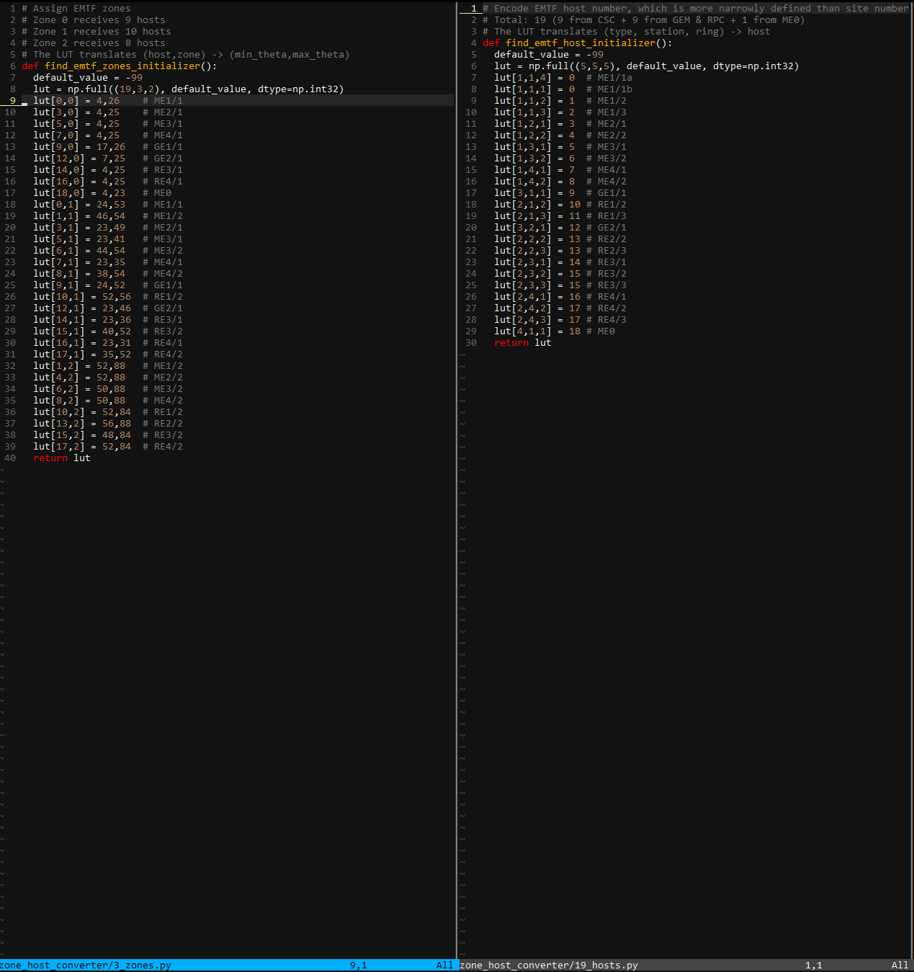

These files were taken from Jia Fu’s python code: <https://gist.github.com/jiafulow/9428651d83b26ec76d71405535cccdc8>

Output:

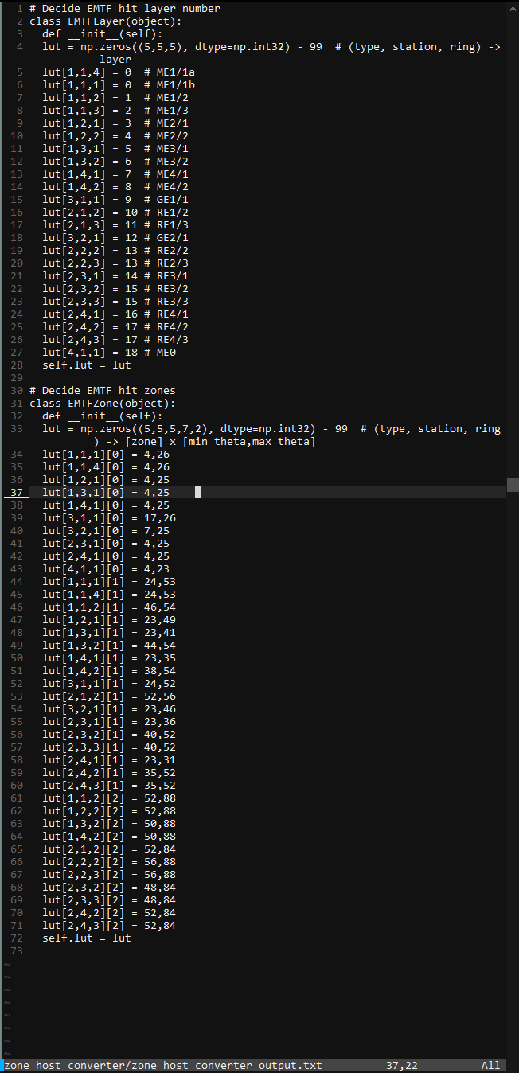

Knowledge of how this works is not crucial, so the comments I have on the source code should be enough.

### zapp

ZAPP will take these [type][station][ring][zone]->[min theta, max theta] arrays and turn them into [type][station][zone] arrays for the PCs. This version of ZAPP is much more slimmed down, as many of the optimizations I had were no longer needed.

README:

Purpose:

The original purpose was to condense Jia Fu's arrays into smaller arrays

organized to make PCS as generic as possible with regards to the zone

boundaries. I am currently using this to get bit sizes, zone boundary

array, and zone sizes for PCS with Jia Fu's new zones.

To use:

./zapp.out zone_host_converter/zone_host_converter_output.txt /dev/null

1 /*******************************************************************************

2 * Author: Rafael Hernandez

3 * Purpose: Zone Array Parser and Partitioner (ZAPP) is used for partially

4 * autonomous optimization of the zone boundary array using

5 * background knowledge about Zones that no compiler would have. I

6 * call it an ASPO, an Application-Specific Program Optimizer

7 * because of the use of background knowledge specific to a certain

8 * application

9 * For the 6/2021 onward version where we don't need a patternbank,

10 * call using:

11 * ./zapp.out zone_host_converter/zone_host_converter_output.txt /dev/null

12 * Assumptions: If boundaries' minimum is 1, then can safely subtract 1 from

13 * lower and upper bound. If not, then keeps values as is --

14 * may increase size if on boundary of 2 (15 vs 16).

15 * Python has EMTFLayer, one def: line, and then the

16 * initialization.

17 * No multiline code support for Python ('code; more_code') in this

18 * version of ZAPP

19 * My generator was used to get the pattern dumps, so the

20 * formatting is how I expect it to be

21 * PC11A and PC11B get station 0 and 1 respectively,

22 * and they have same th boundary requirements

23 ******************************************************************************/

# Appendix

## EMTFe

As context since a lot of the files come from EMTFe and EMTFe will help the reader understand EMTF, here are some Big Picture slides I made to explain EMTFe and the thought process behind the merger of EMTF and EMTF++. I tried embedding the pptx as an object, but the objects were removed when I made this into a pdf, so I am simply attaching the slides as images.

### Big Picture slides

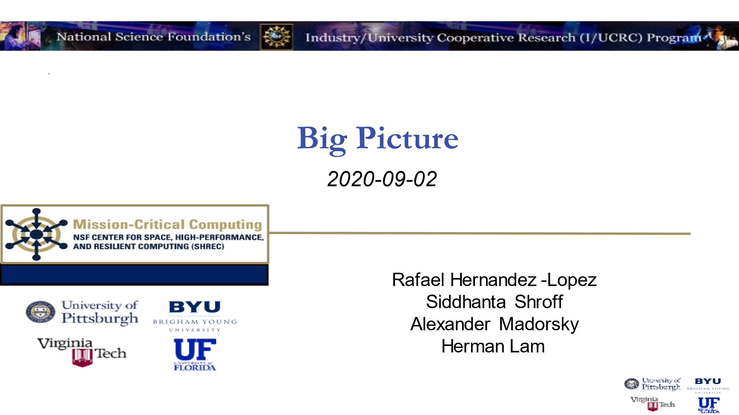

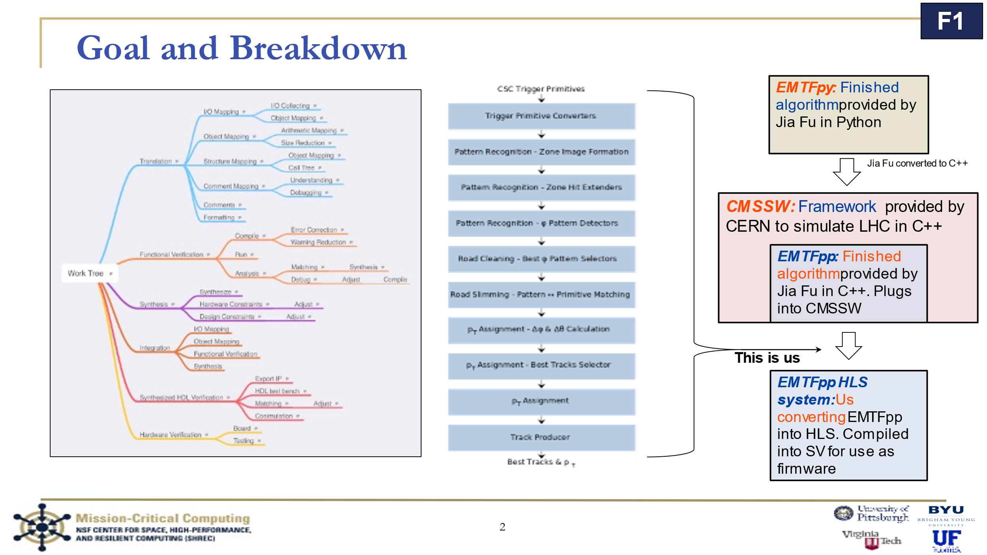

#### Introduction

This slide has my “work tree” that I made in 2019, the algorithm flow chart with the extra track producer box, and the structure of the work (EMTFpy to CMSSW into EMTFpp HLS). This EMTFpp is what I considered EMTFe, as we will see later in the slides, as it is a merger and not an exact translation.

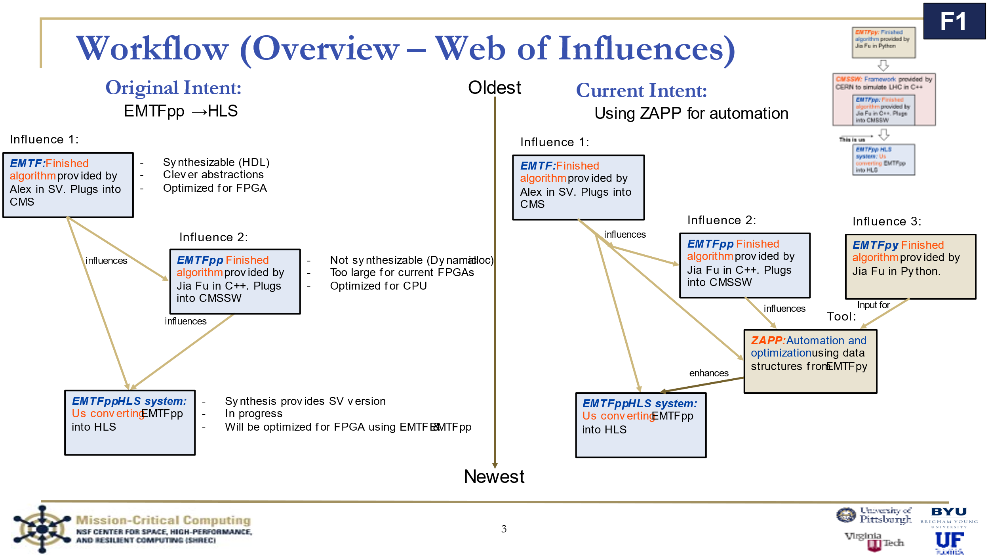

This slide shows the overall workflow and influences exacted on each part of the code. The original system was EMTF, which influences both EMTFpp HLS system (EMTFe) and EMTFpp. Both EMTF and EMTFpp influenced our work EMTFpp HLS system.

#### ZAPP

This slide also shows one of my original intentions for optimizing the primitive converters, ZAPP. ZAPP was in place mainly in the Pattern Recognition portion of Jia Fu’s previous iteration of EMTFpp, with some pieces in the Primitive Converters to help with genericness. It is still in PCs at the time of writing, but it was slightly adjusted for Jia Fu’s new data and the fact that the Pattern Recognition module is no longer implemented in EMTFe format and is instead in Jia Fu’s HLS code, myproject().

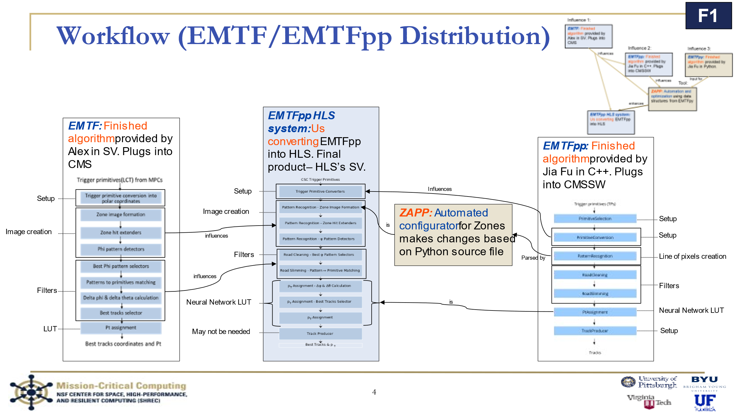

#### EMTF/EMTFpp distribution for EMTFe

This slide shows how ZAPP fit into EMTFe (center), and which parts of which code was merged.

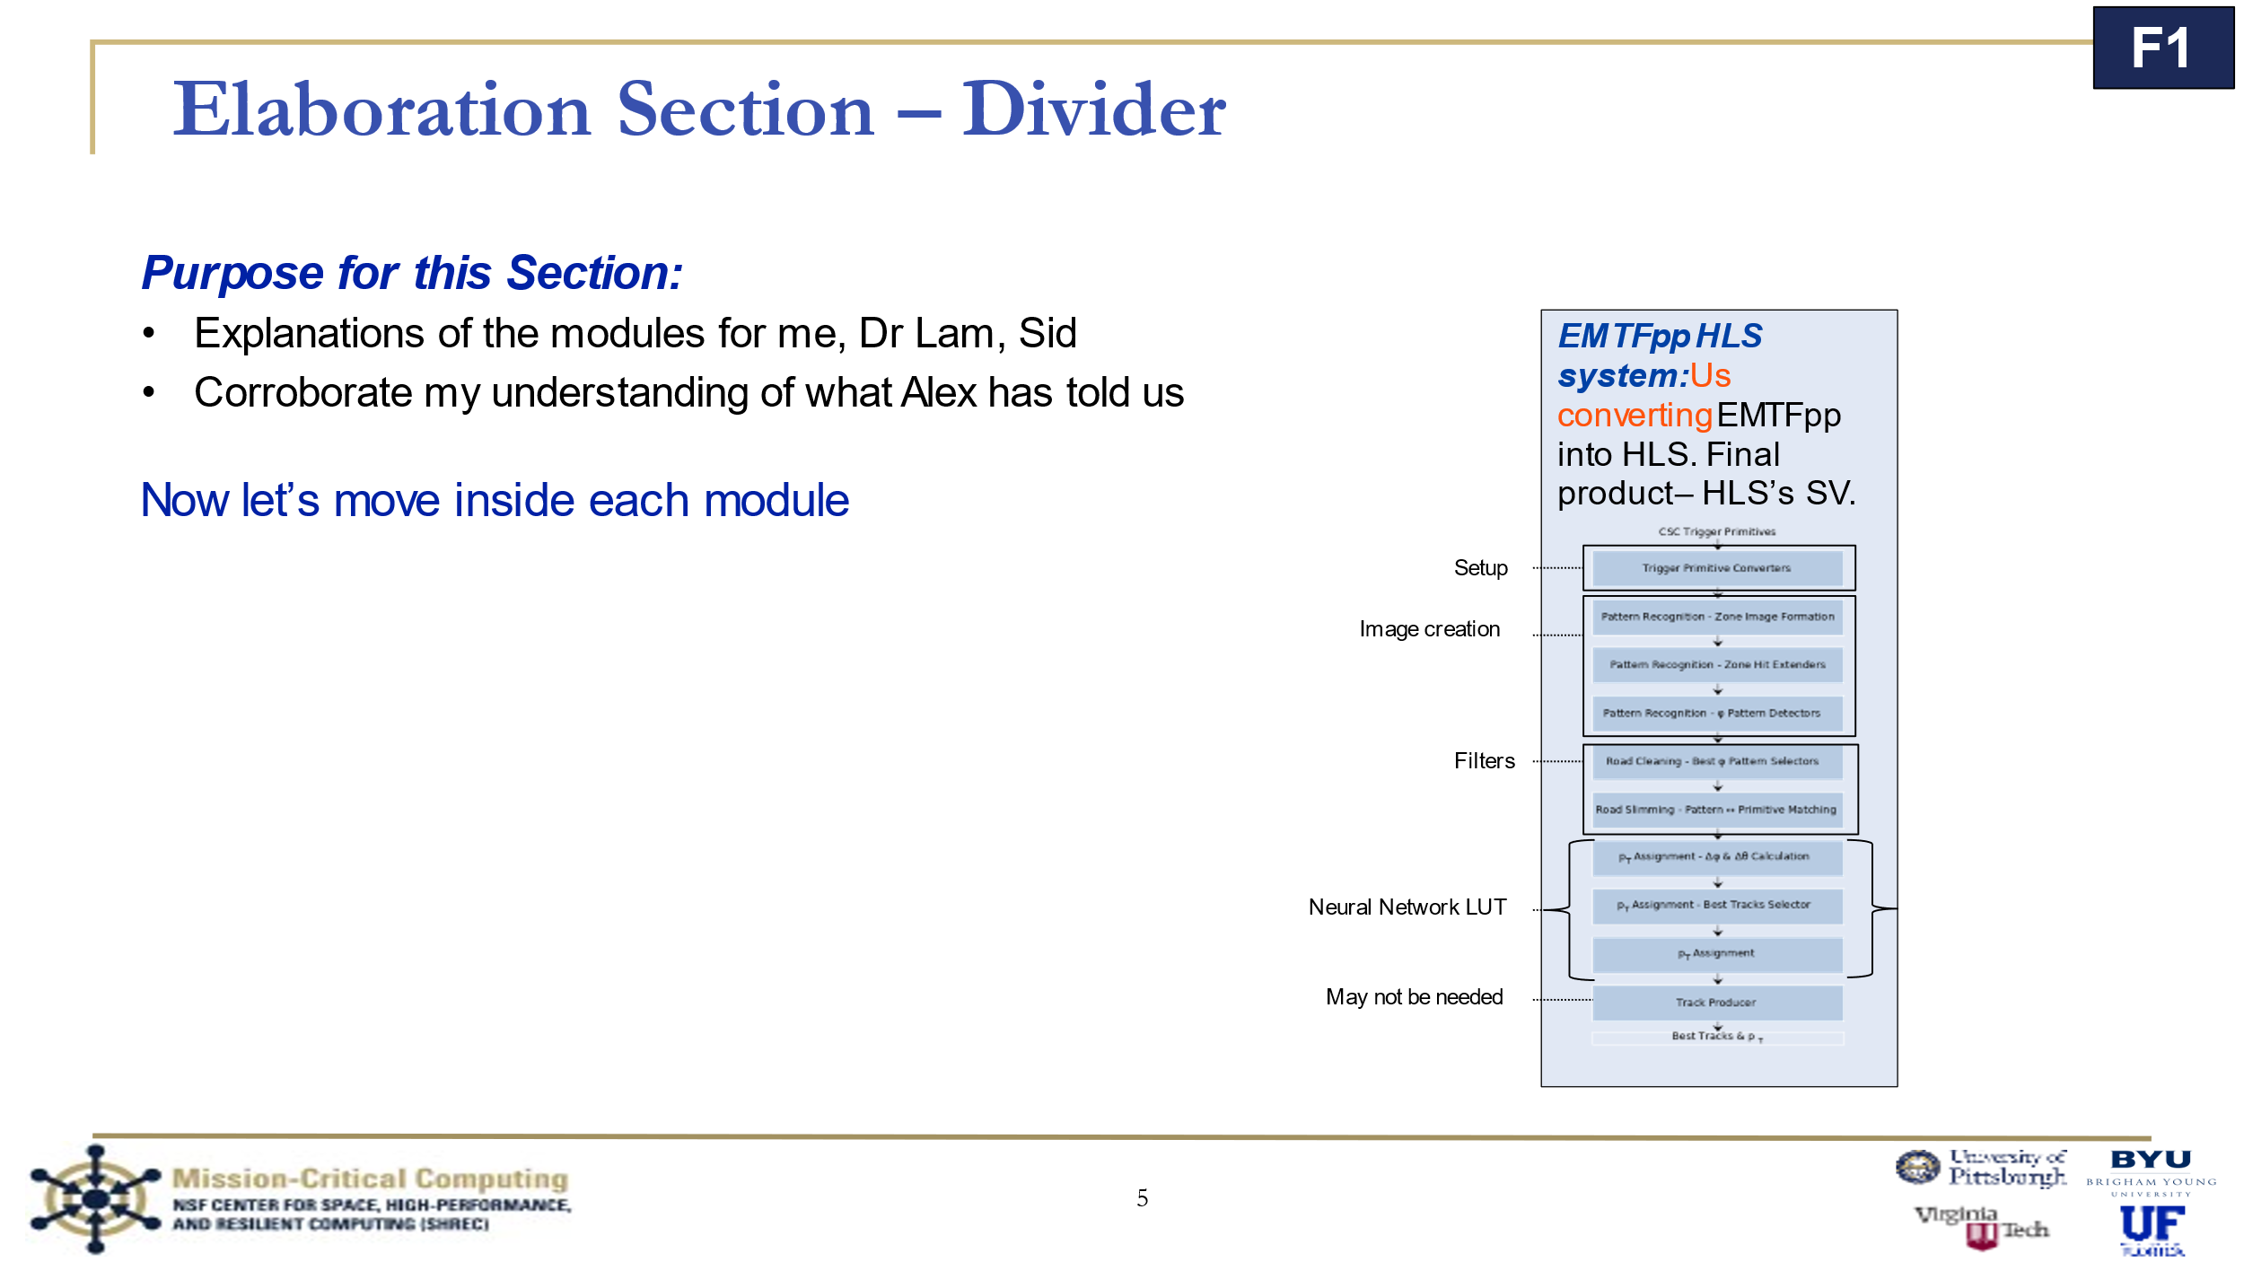

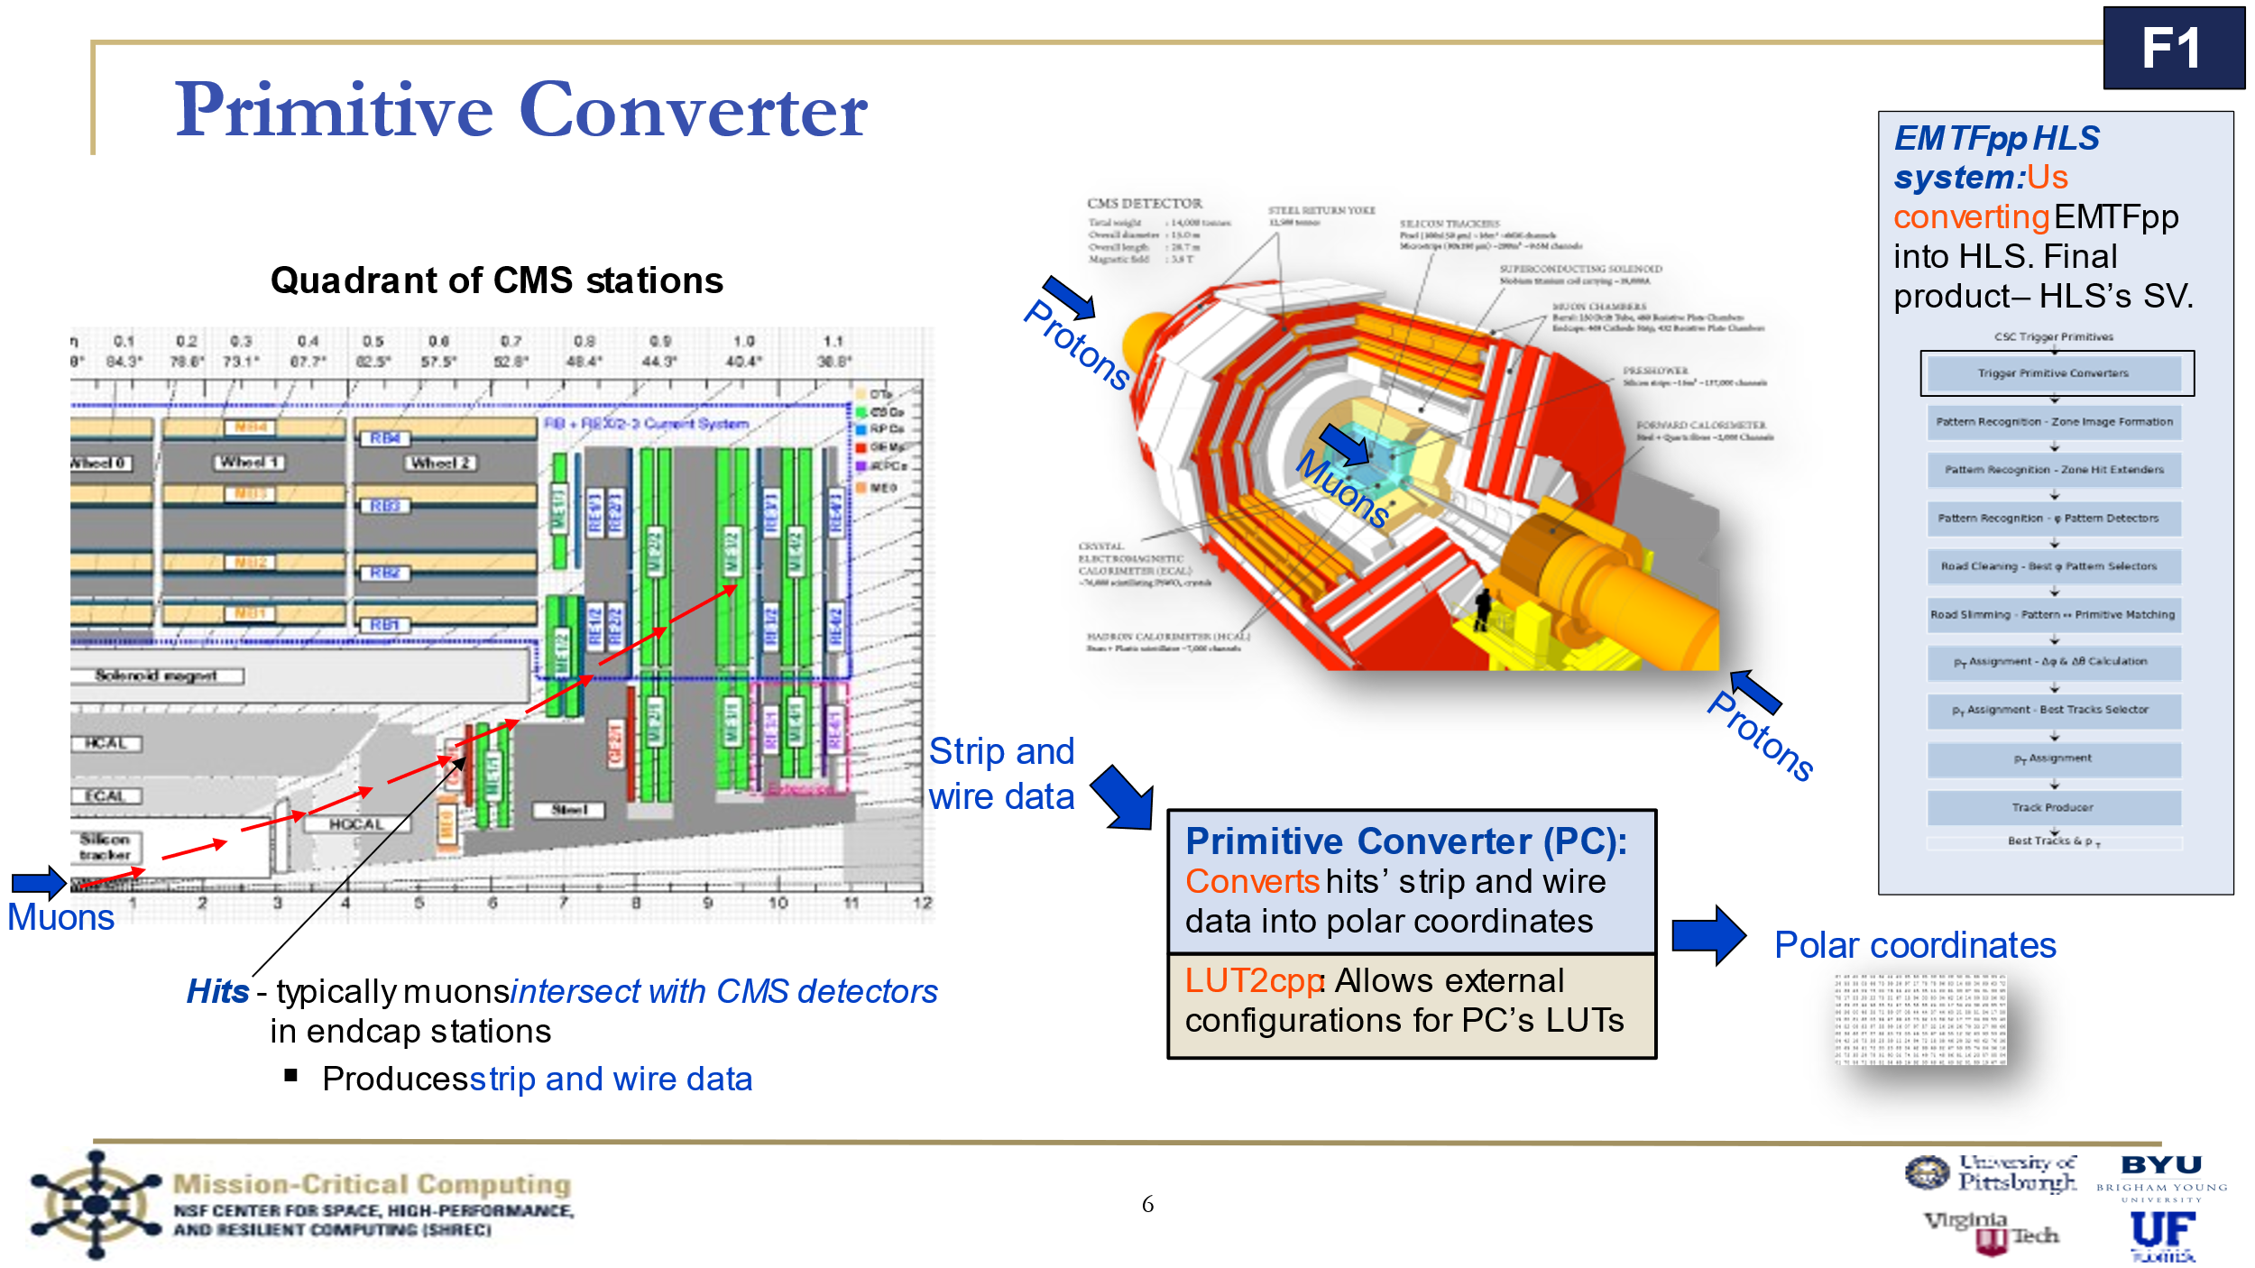

#### Primitive Converters (EMTFe)

This slide shows the PC module. They take in strip and wire data generated from a muon hit and converts it into polar coordinates. I worked on LUT2cpp which would convert Jia Fu’s LUTs to arrays but they in the current version of the code. If this is later seen to be needed, feel free to add it back in.

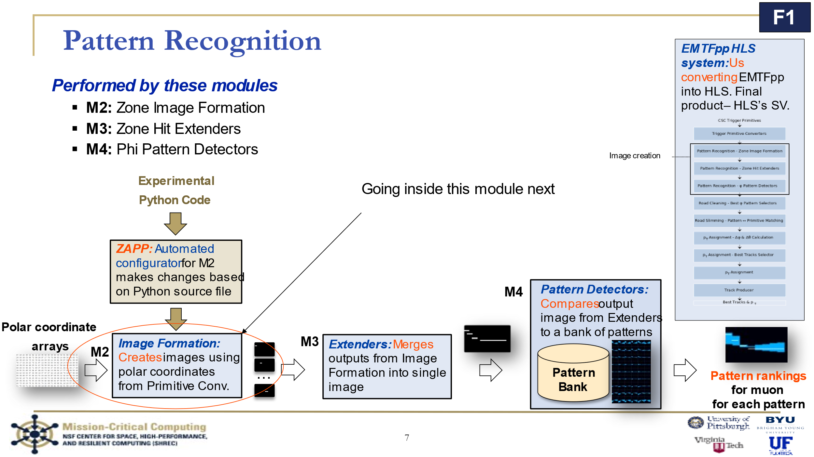

#### Pattern Recognition (EMTFe)

This set of the modules is replaced by Jia Fu’s myproject HLS code.

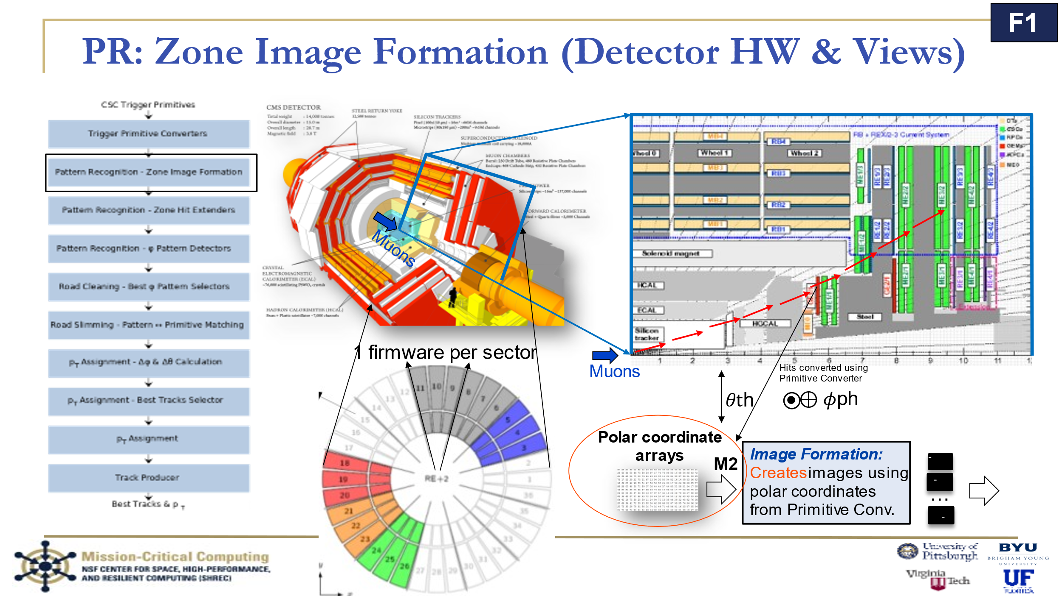

This slide shows how everything fits together. I think the image is from an RPC image I took from a CMS report, so it is mainly for illustration purposes.

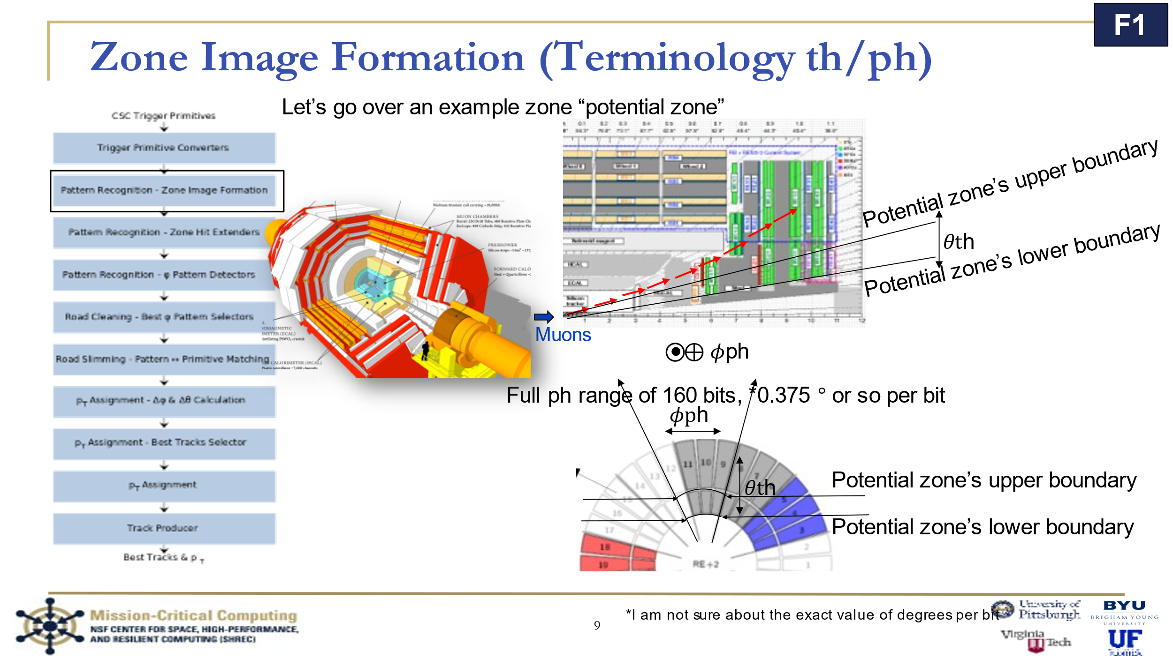

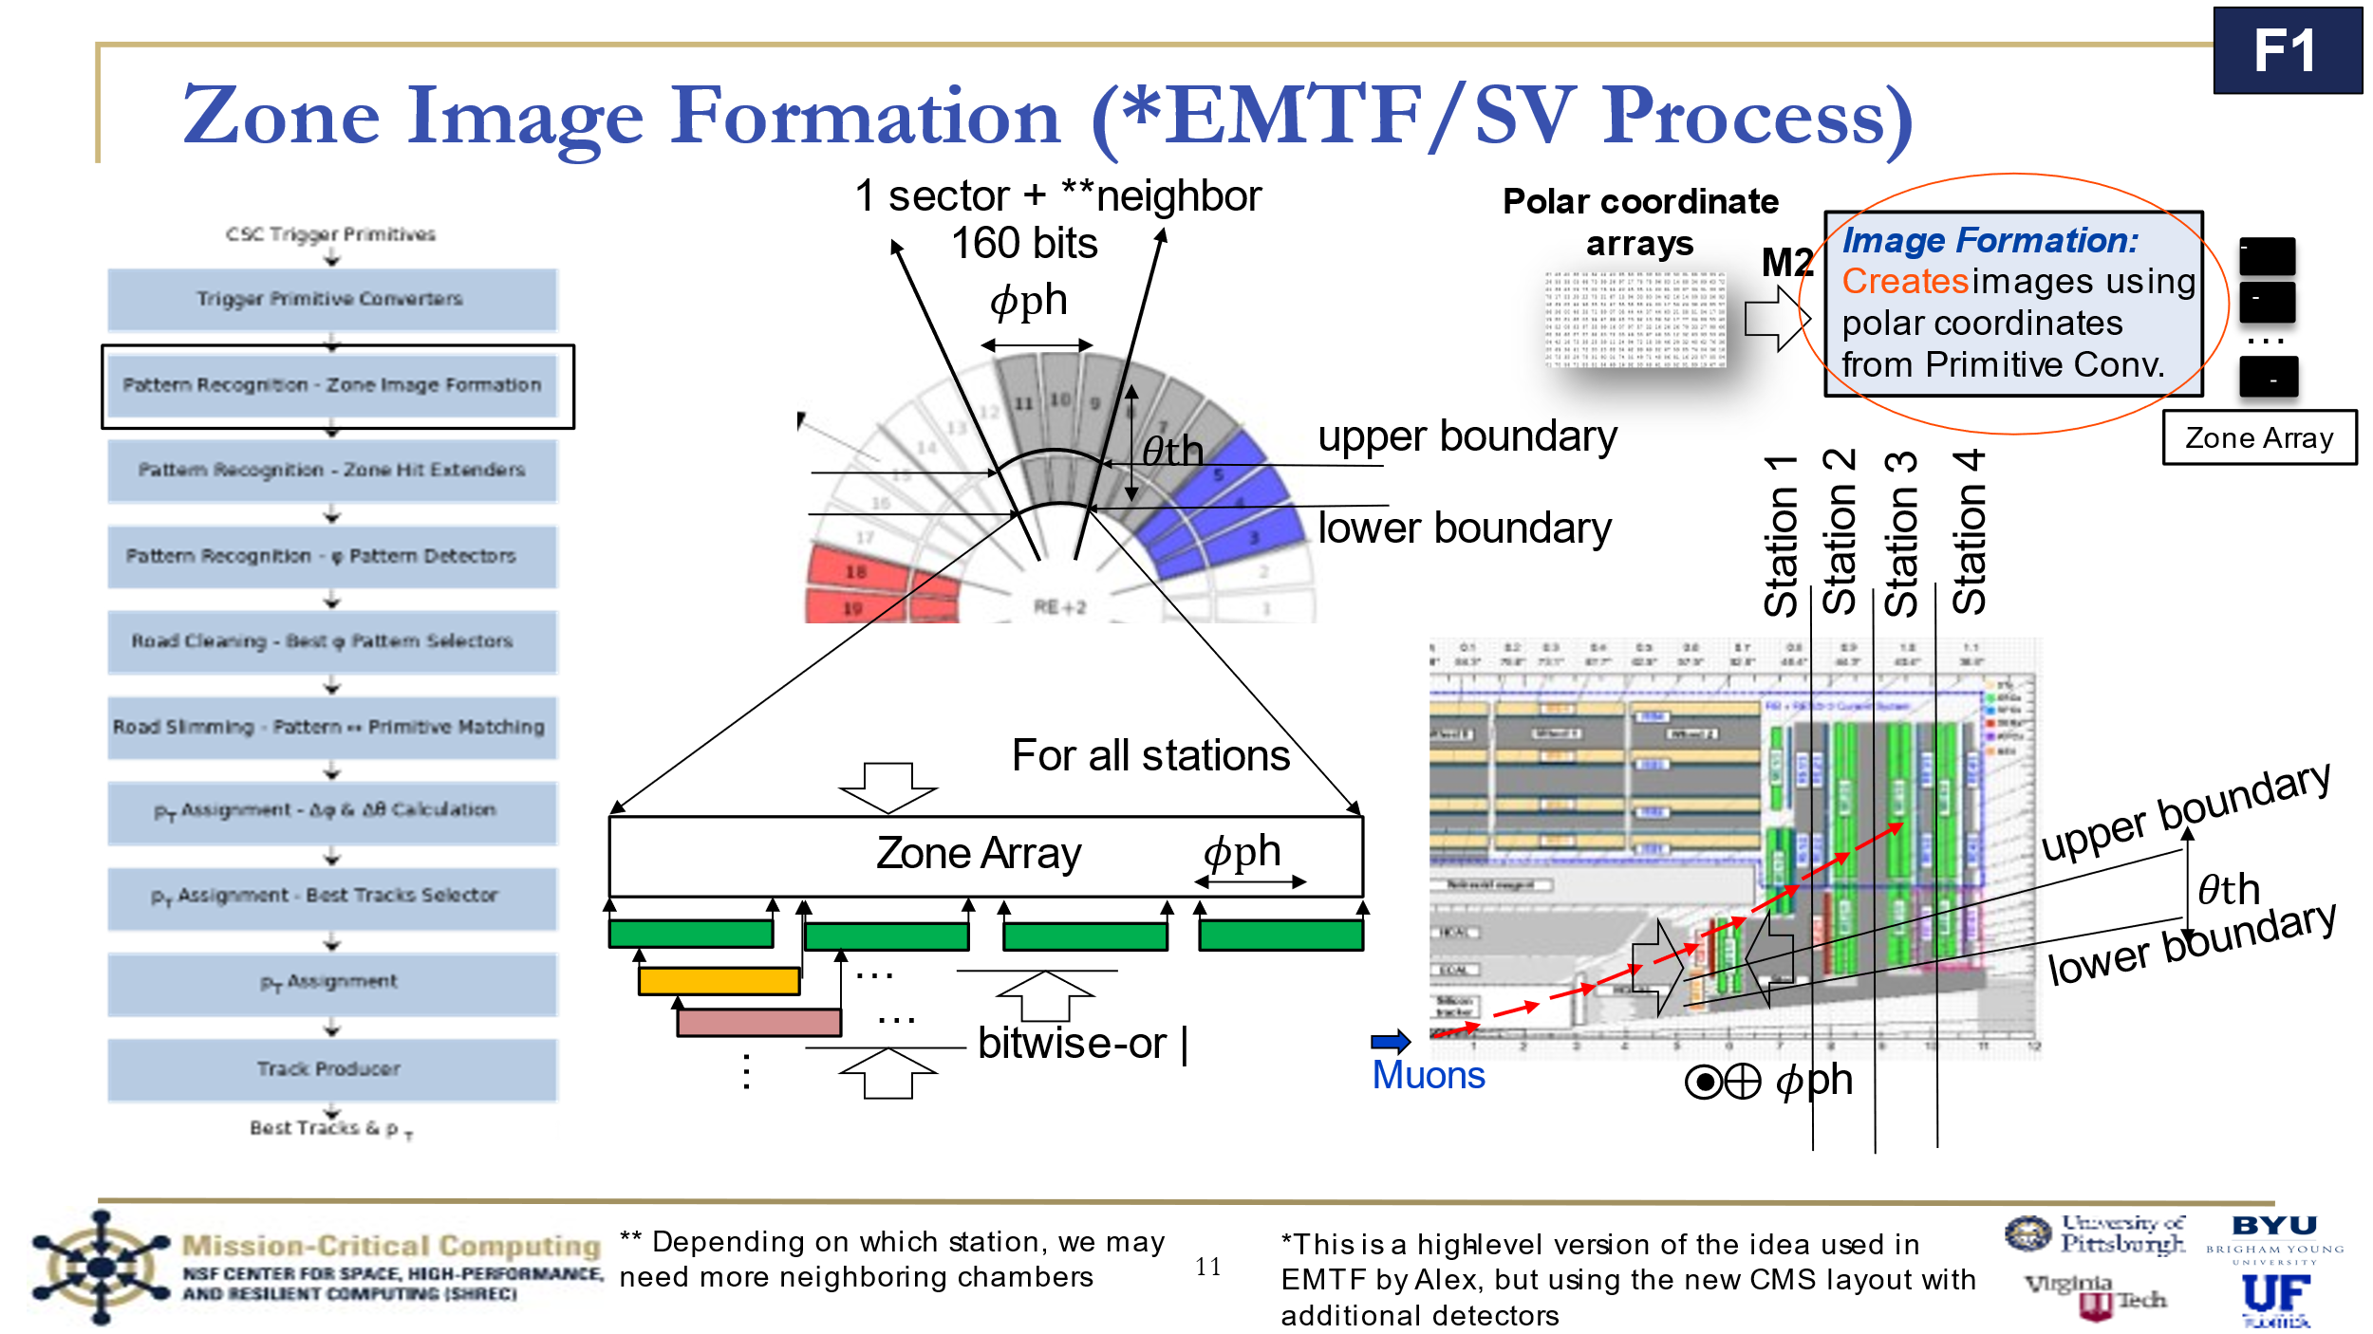

Slide 10 is this slide with some animations but the animations are a bit hard to look at in paper. The goal was to show how the different detectors were merged by ph_zone/ZoneImageFormation to form an image that would get passed onwards.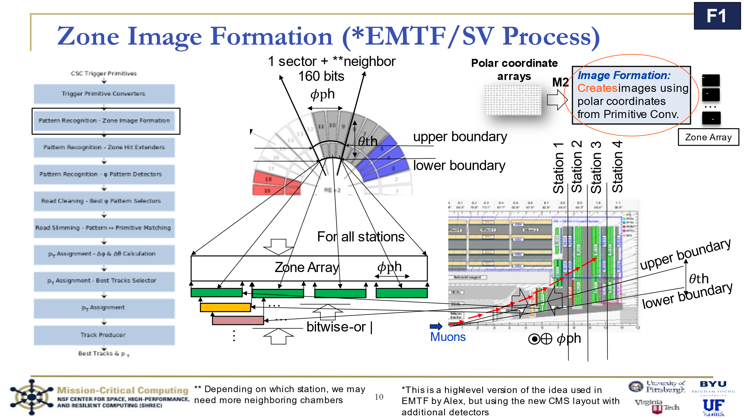

## Pragma experimentation

This was done by Sid.

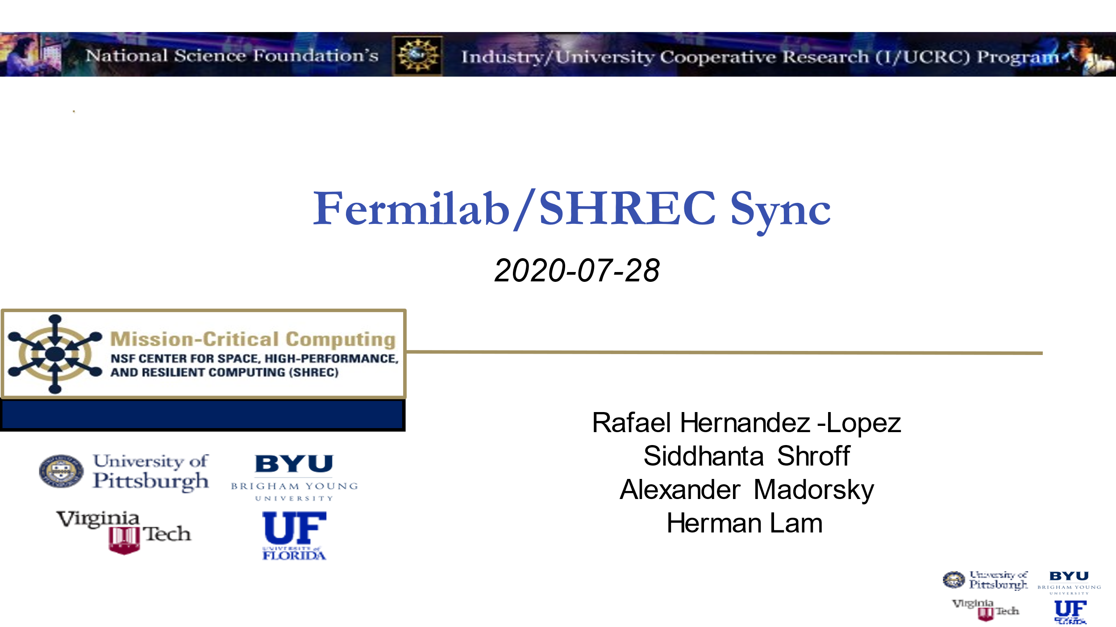

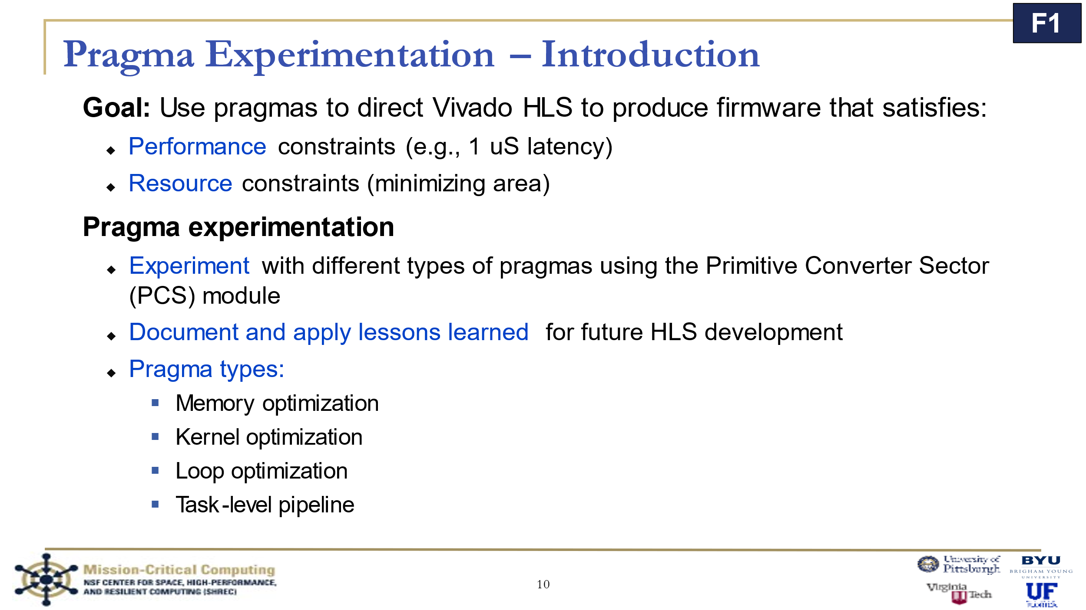

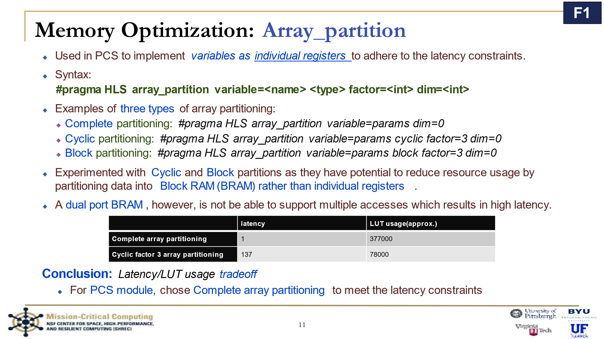

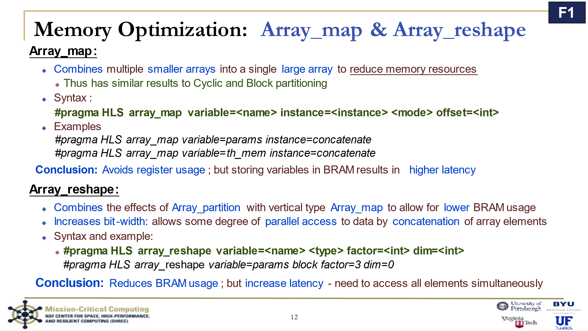

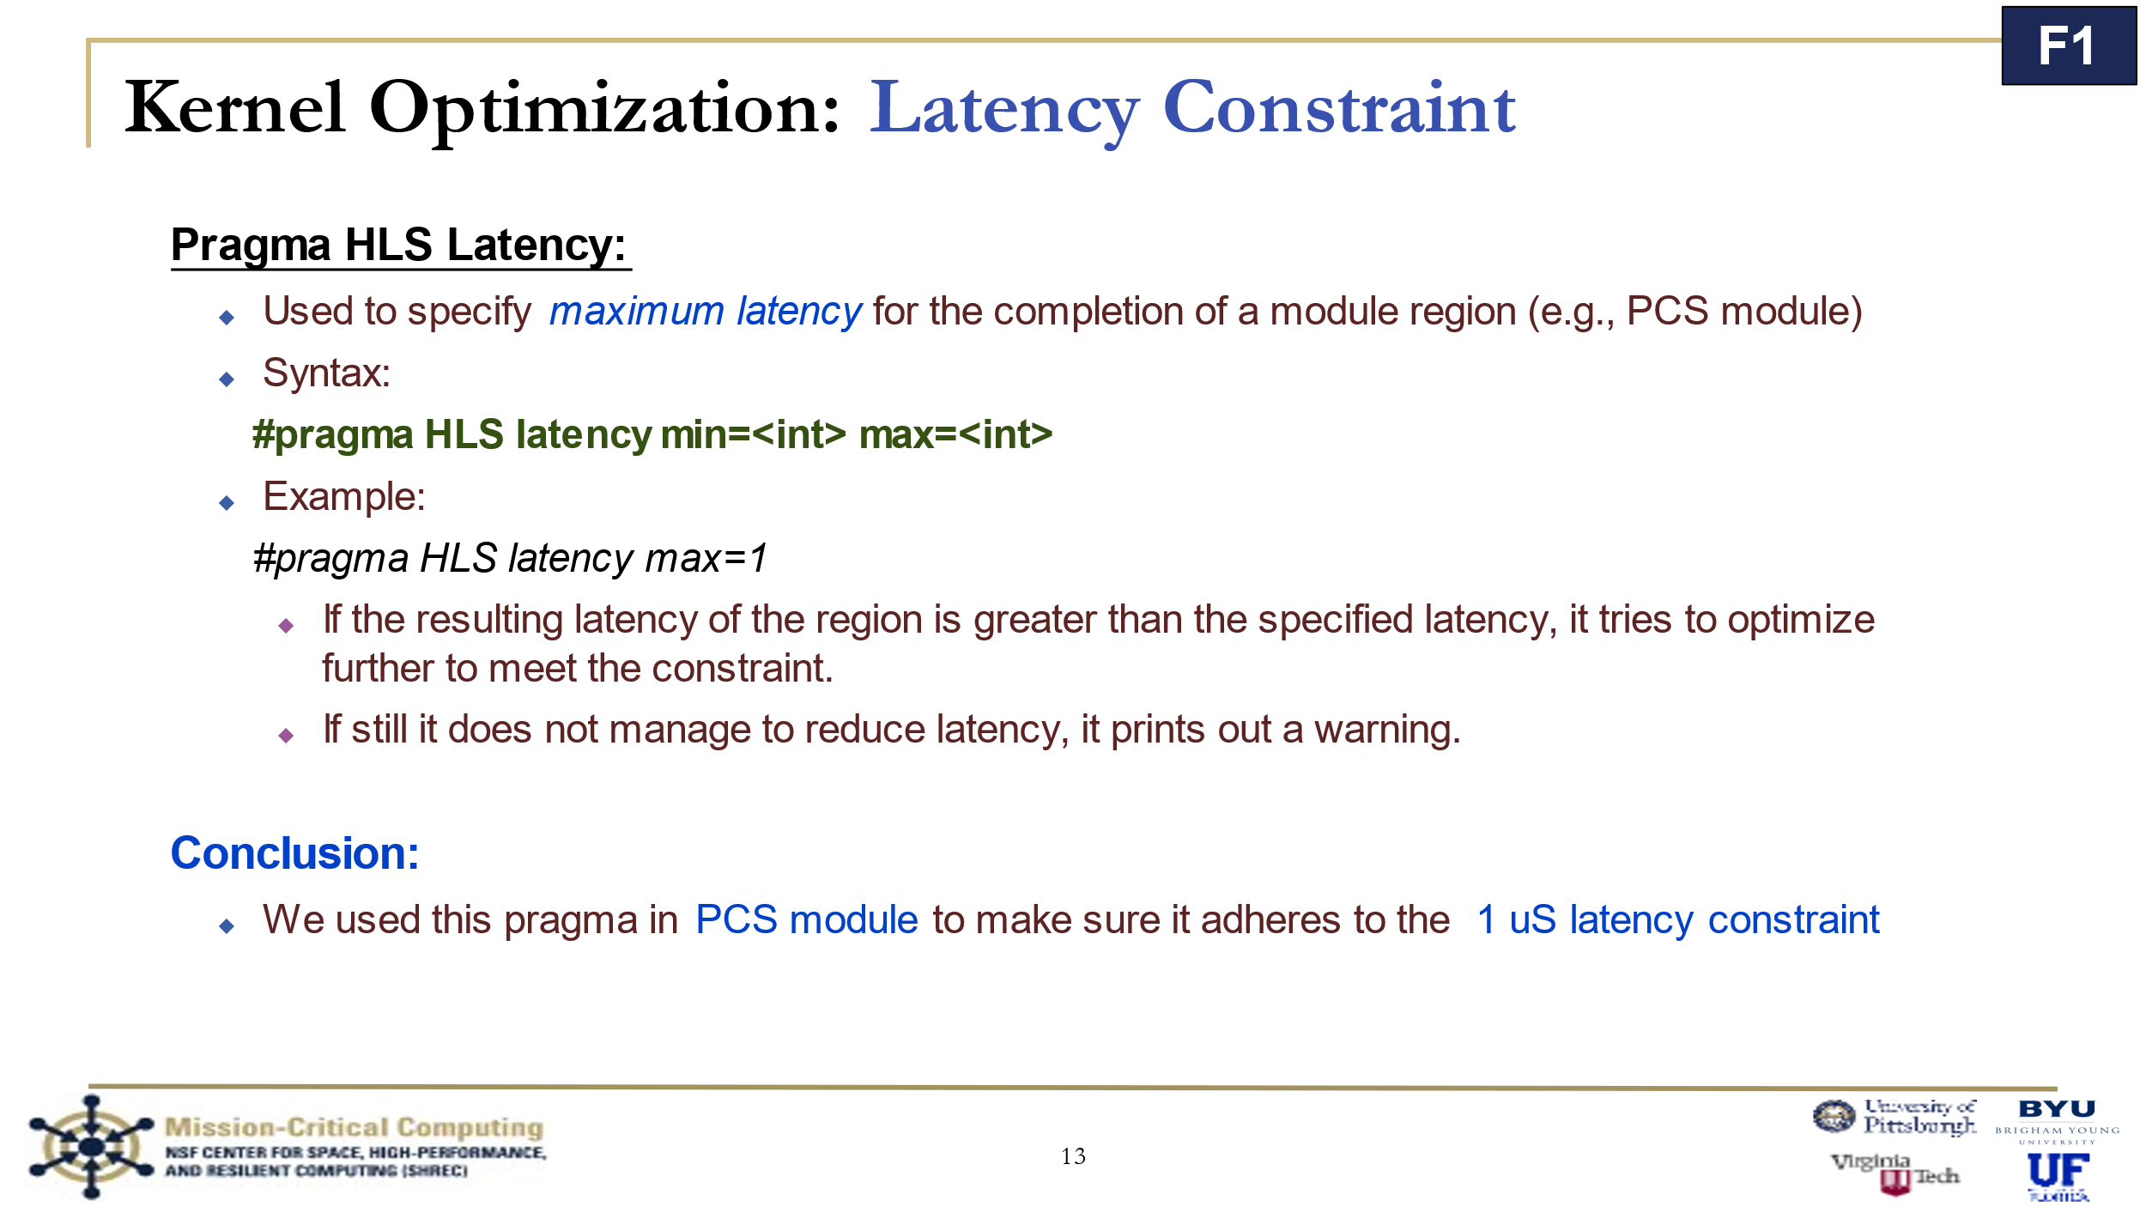

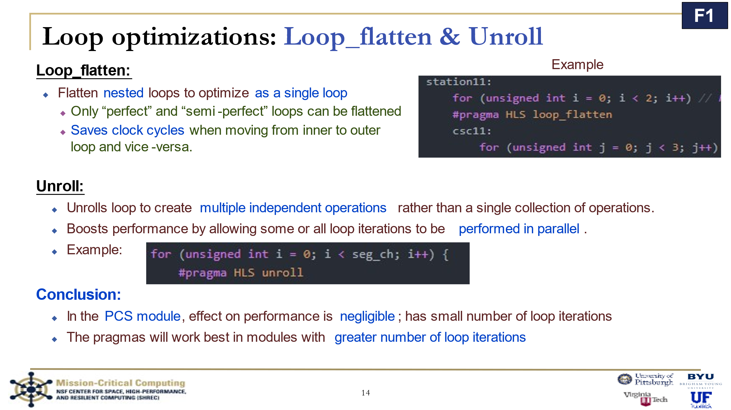

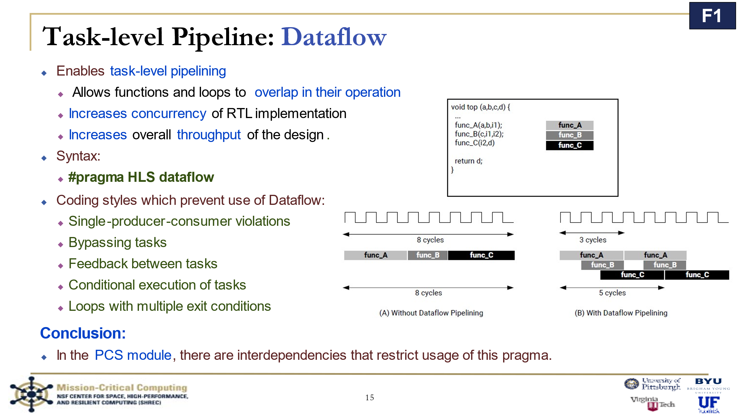

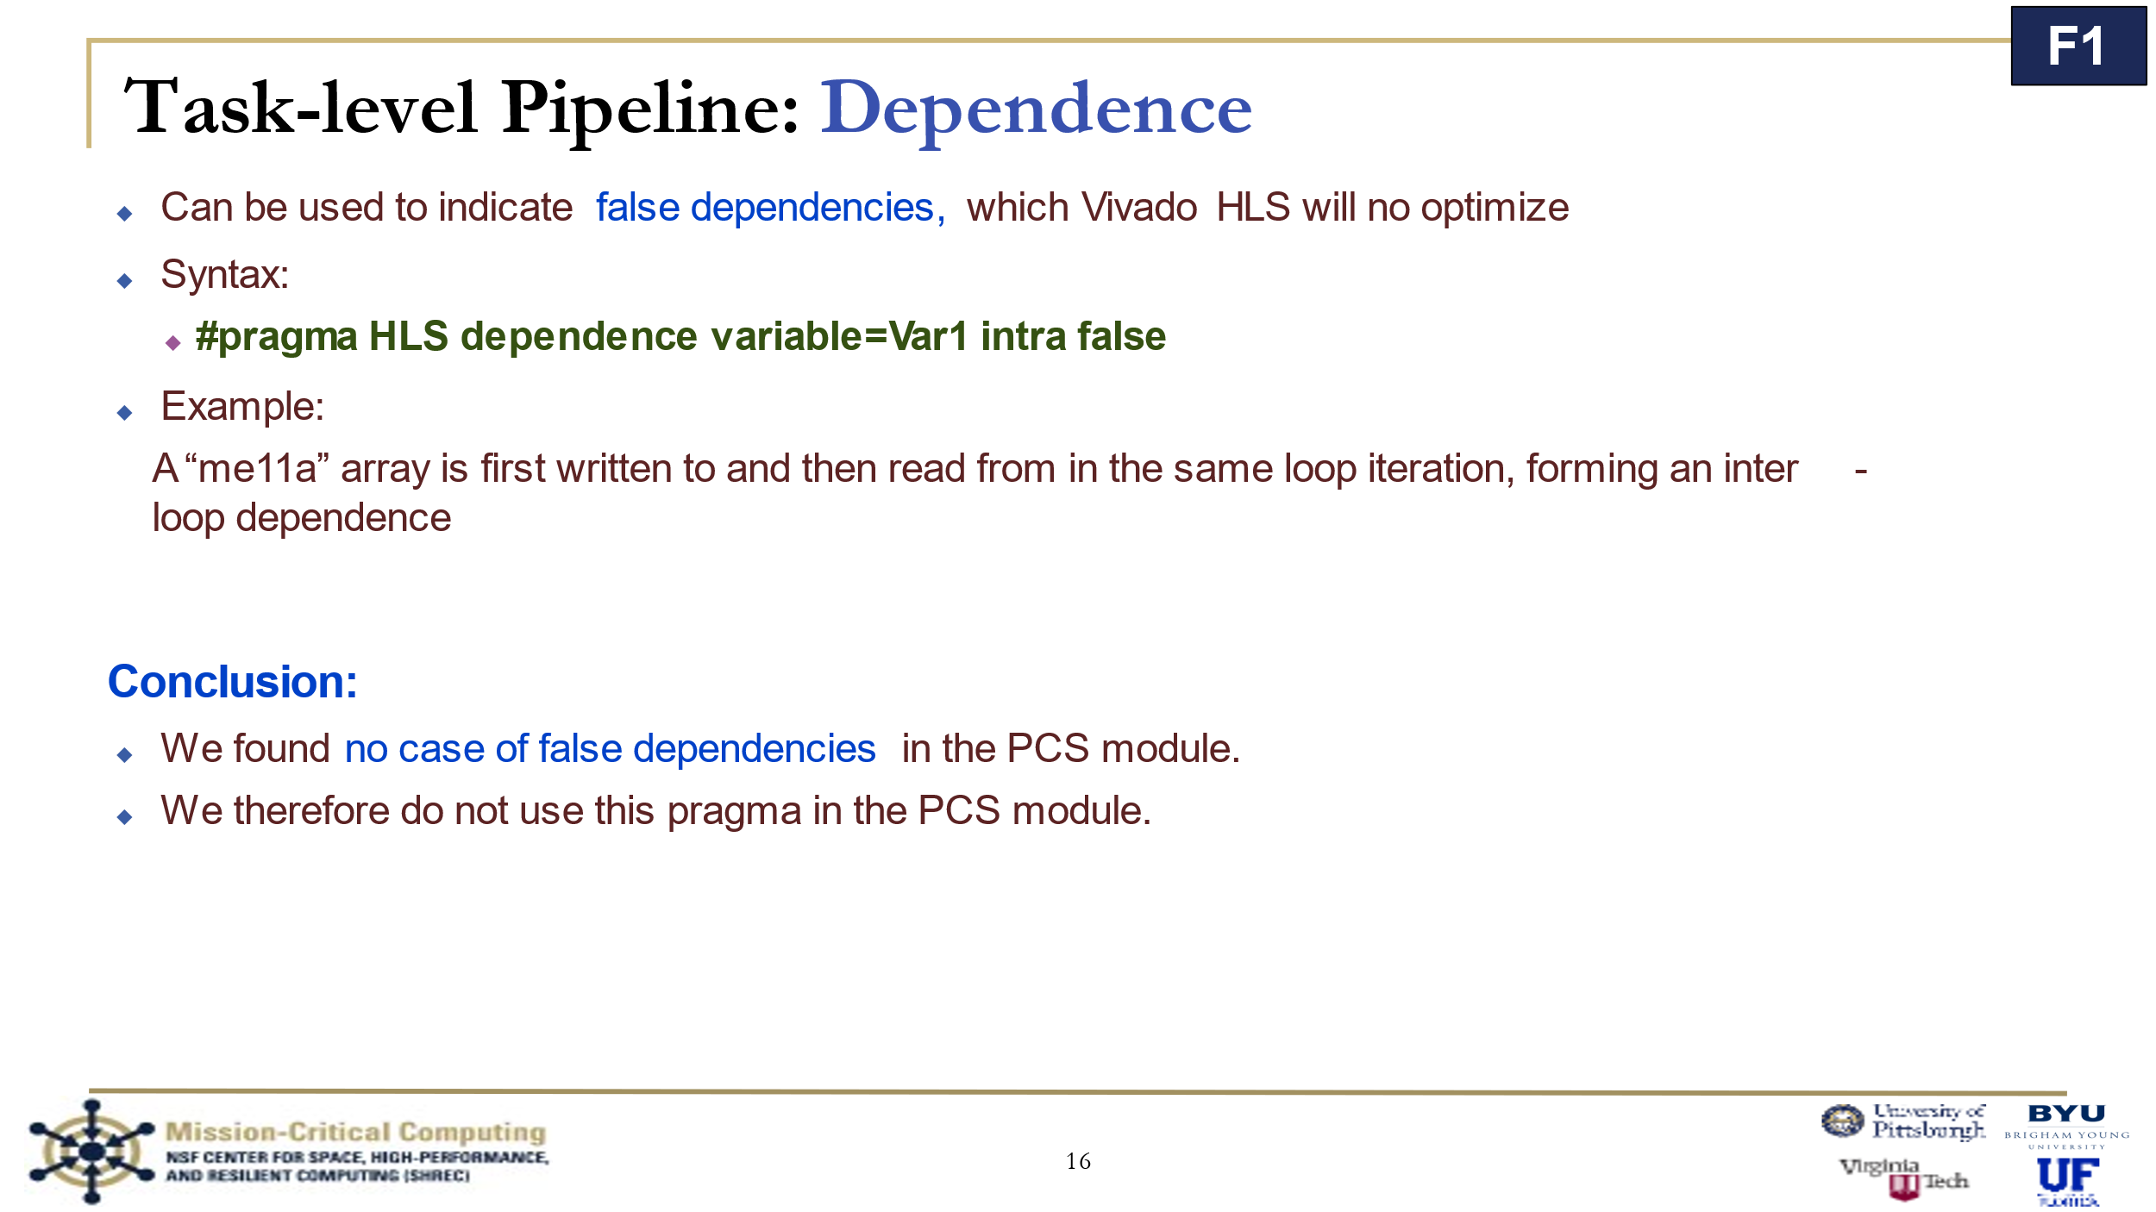

## myproject() on Vitis HLS

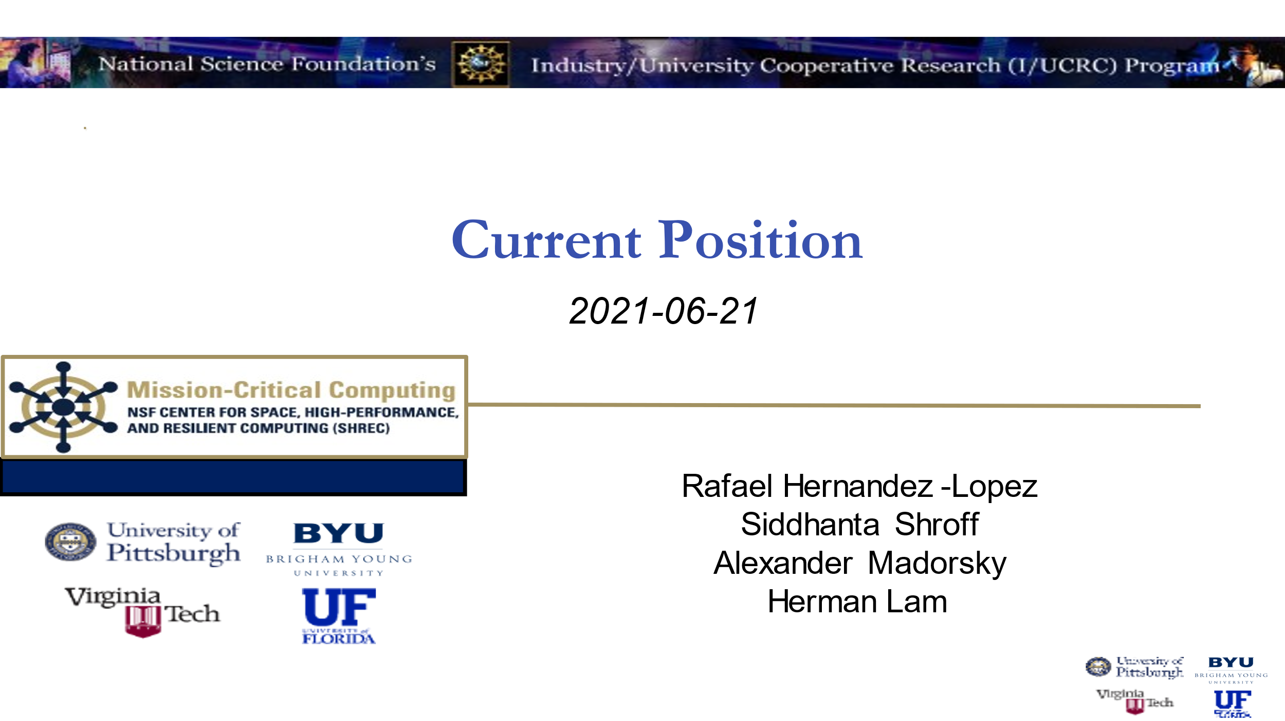

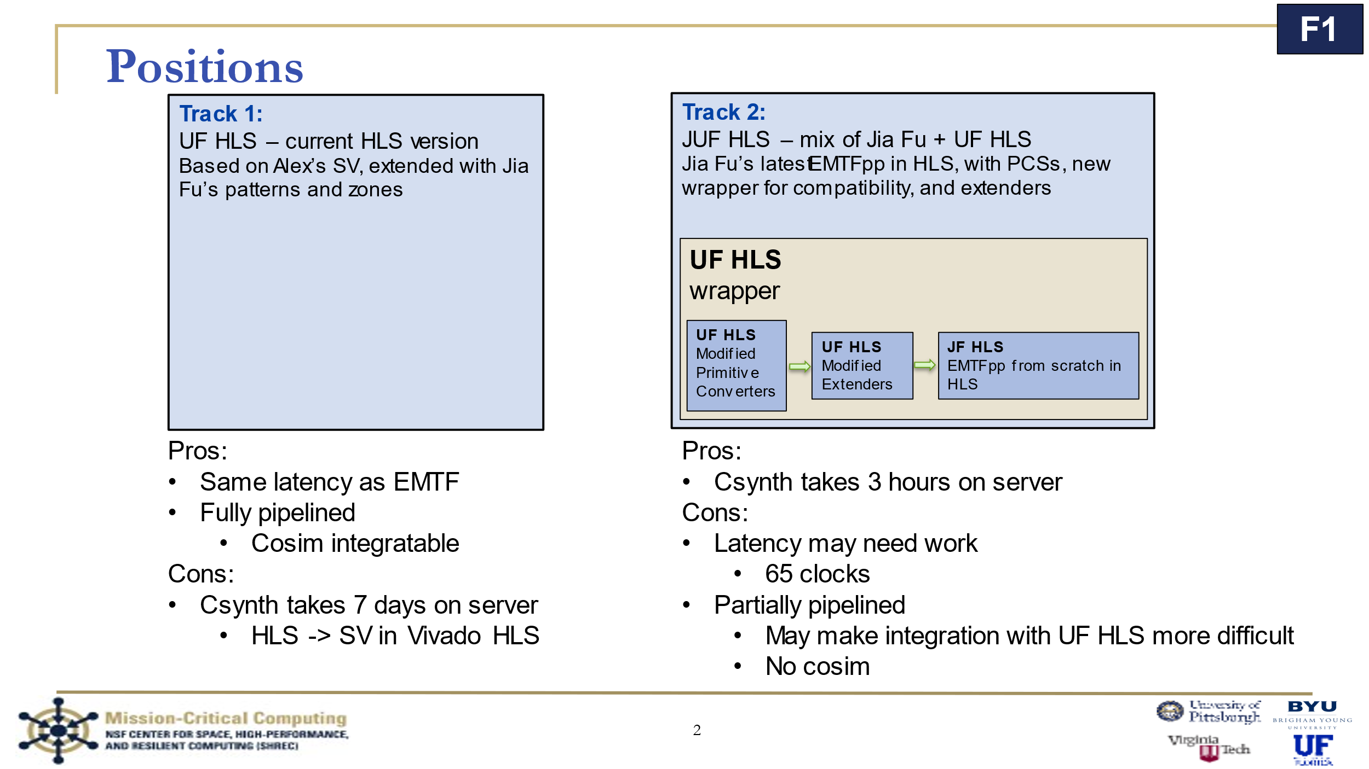

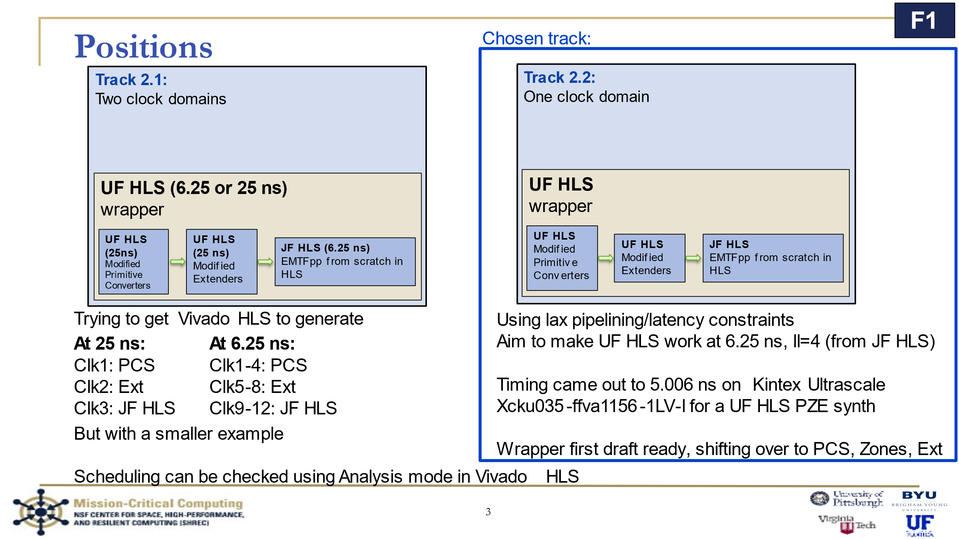

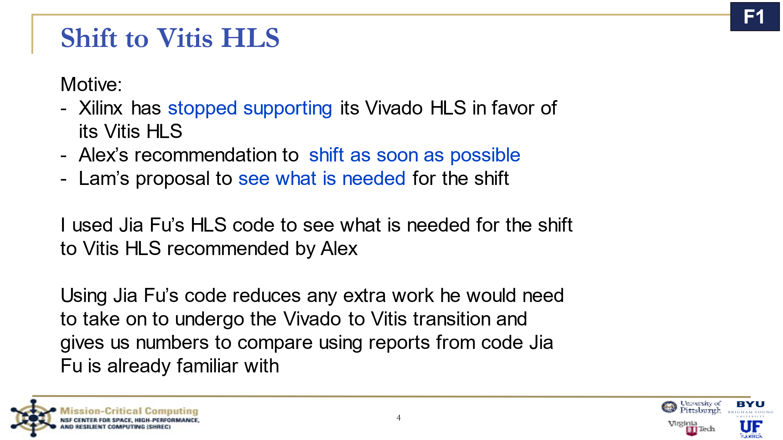

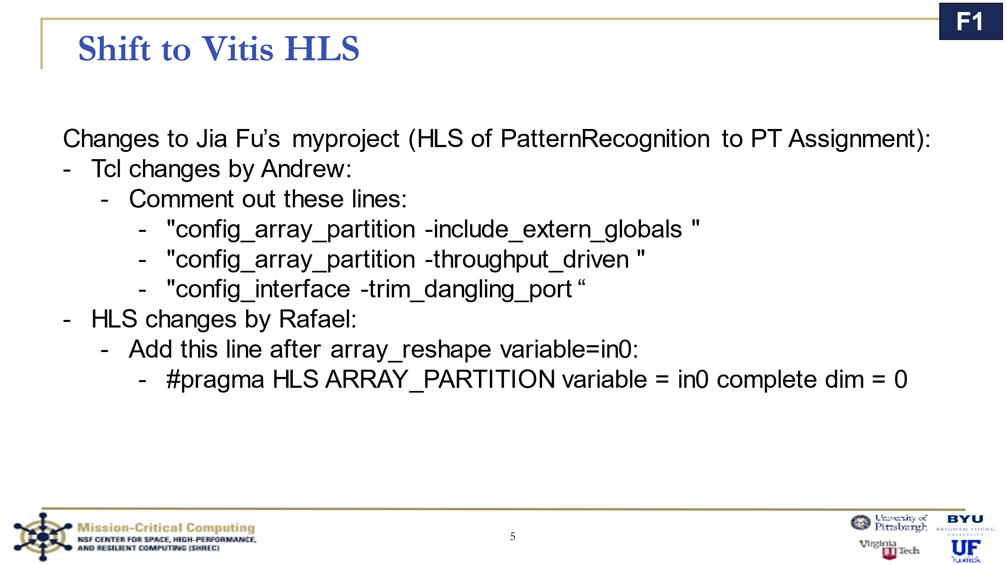

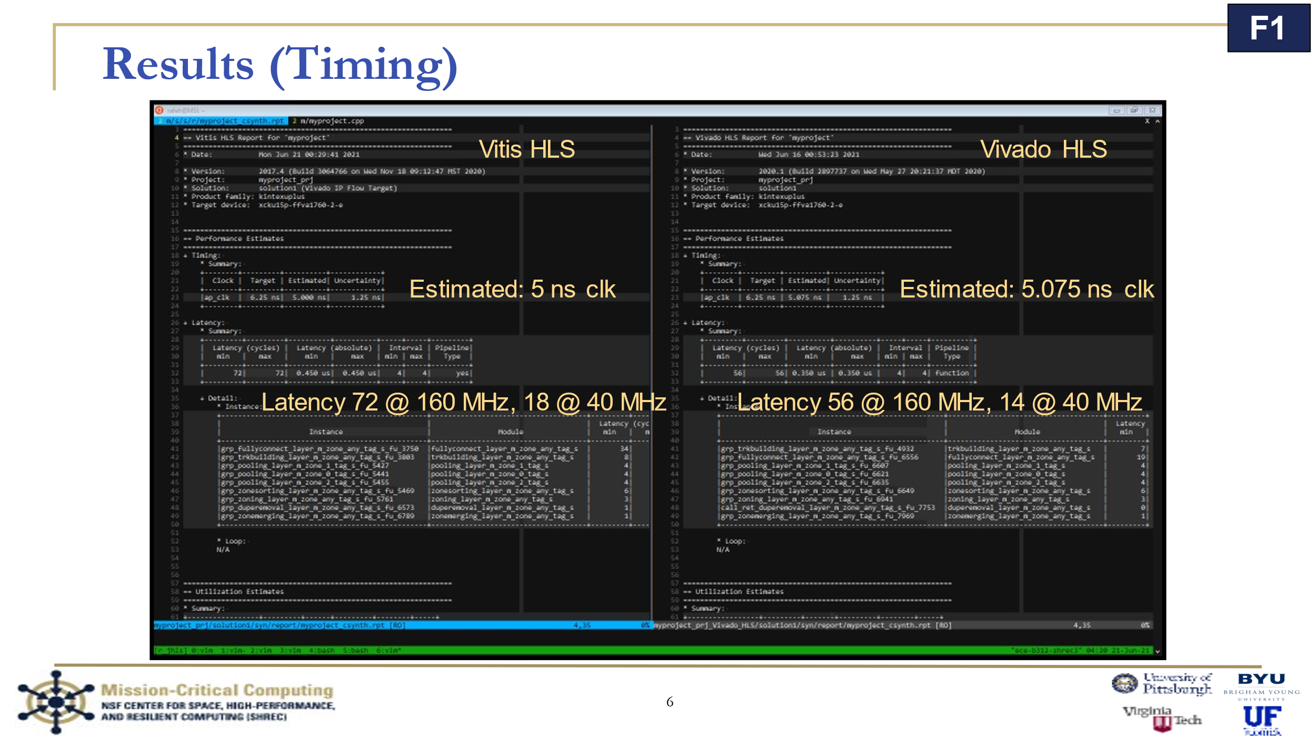

I later found out why II was 4; Jia Fu set his config files to make the II=4. II=1 is better for CoSim and can run on a slower clock. Comparing II=1 and II=4 resource usage was TODO.

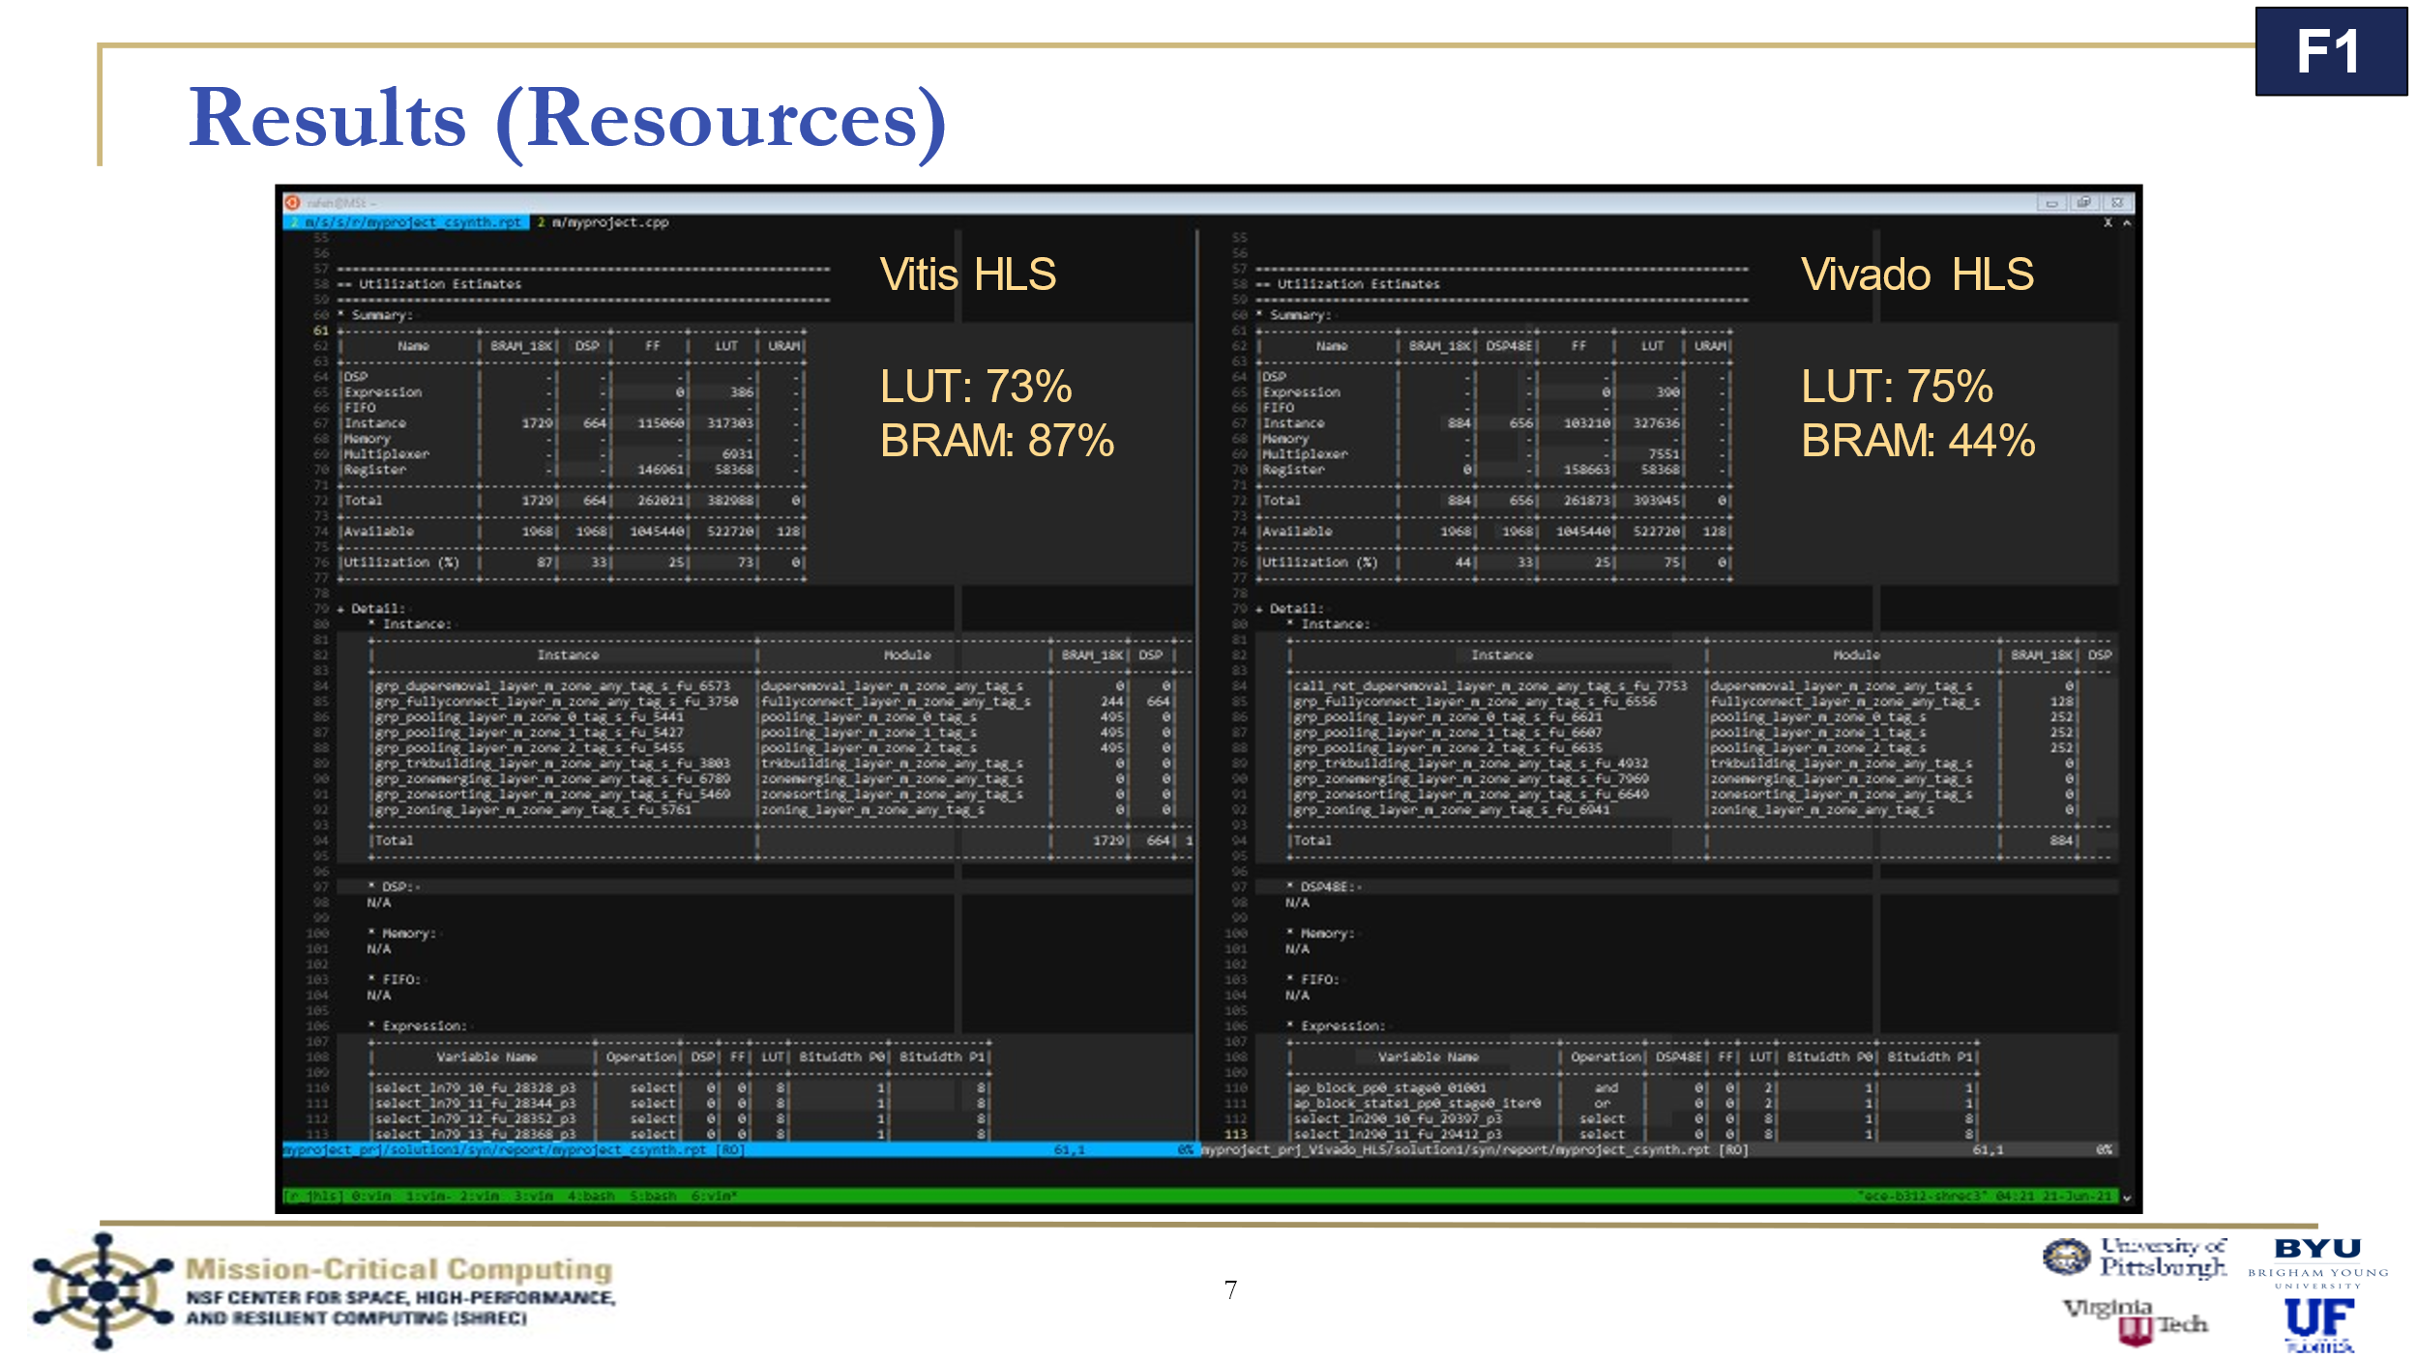

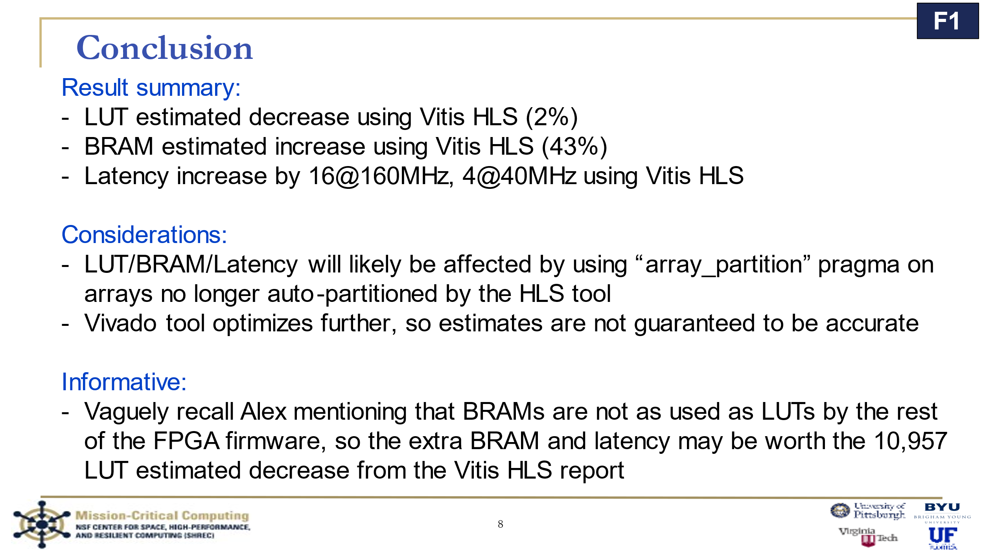

## r_in notes

These are my notes that helped me get the test bench memory controls set up:

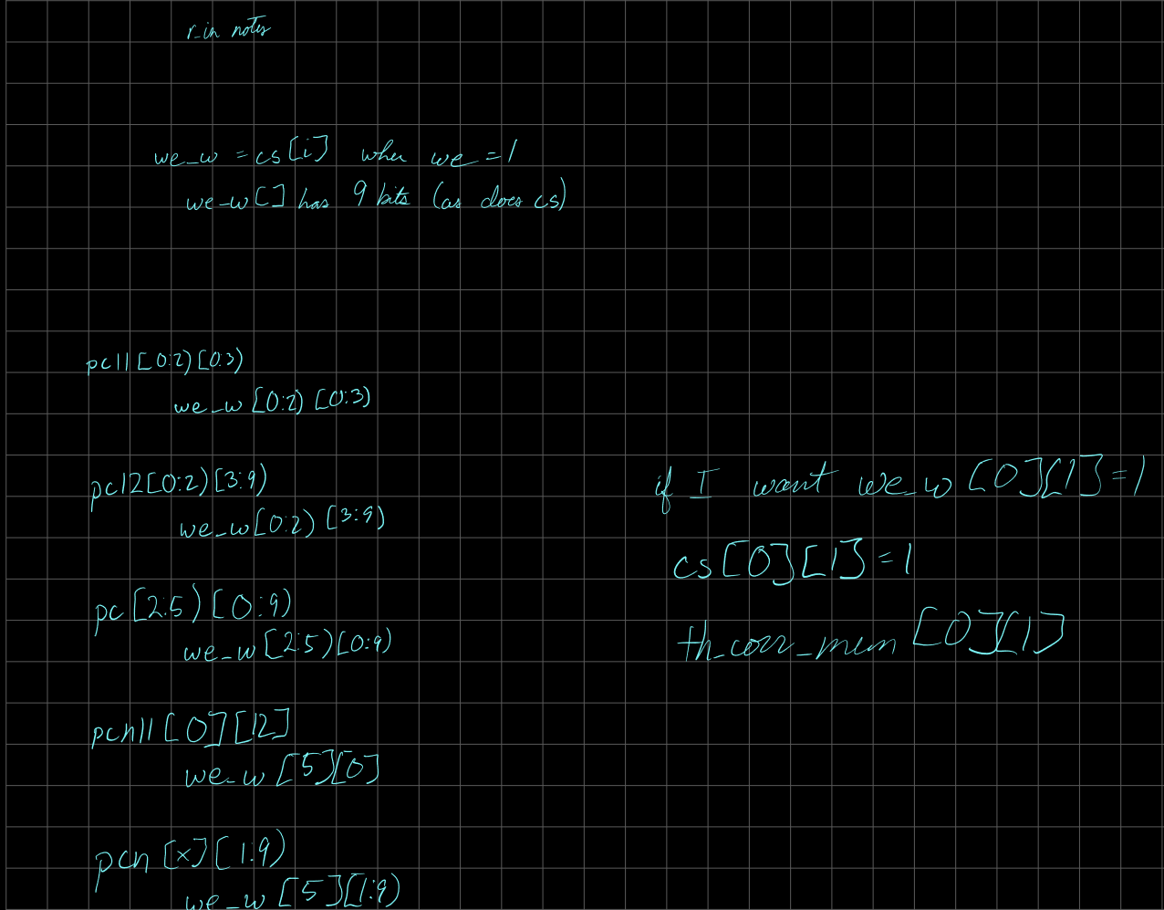

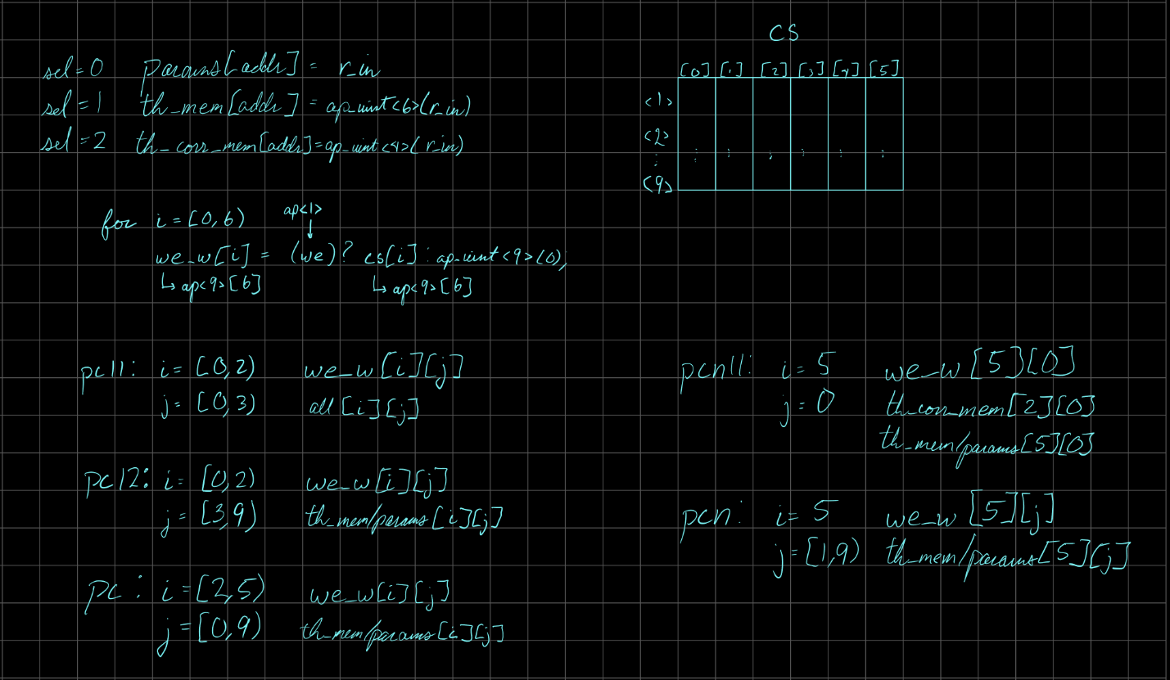

## RPC <> CSC notes

These are my notes that helped me get the RPC to CSC mapping ready for the test bench:

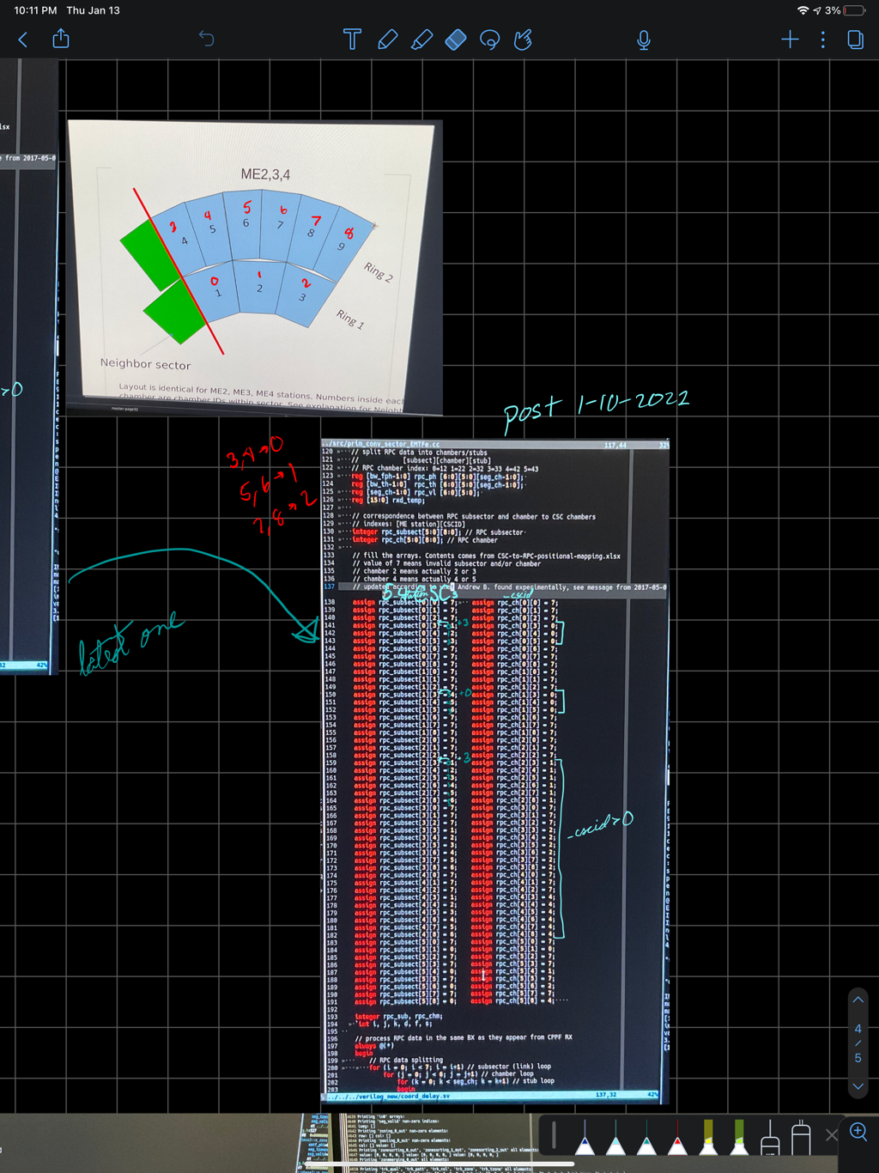

## Work Tree

The work tree was a visual diagram I made so I could more easily express the workflow I underwent, making it easier to explain to new people, and was requested by Dr Lam. It also comes with a markdown document.

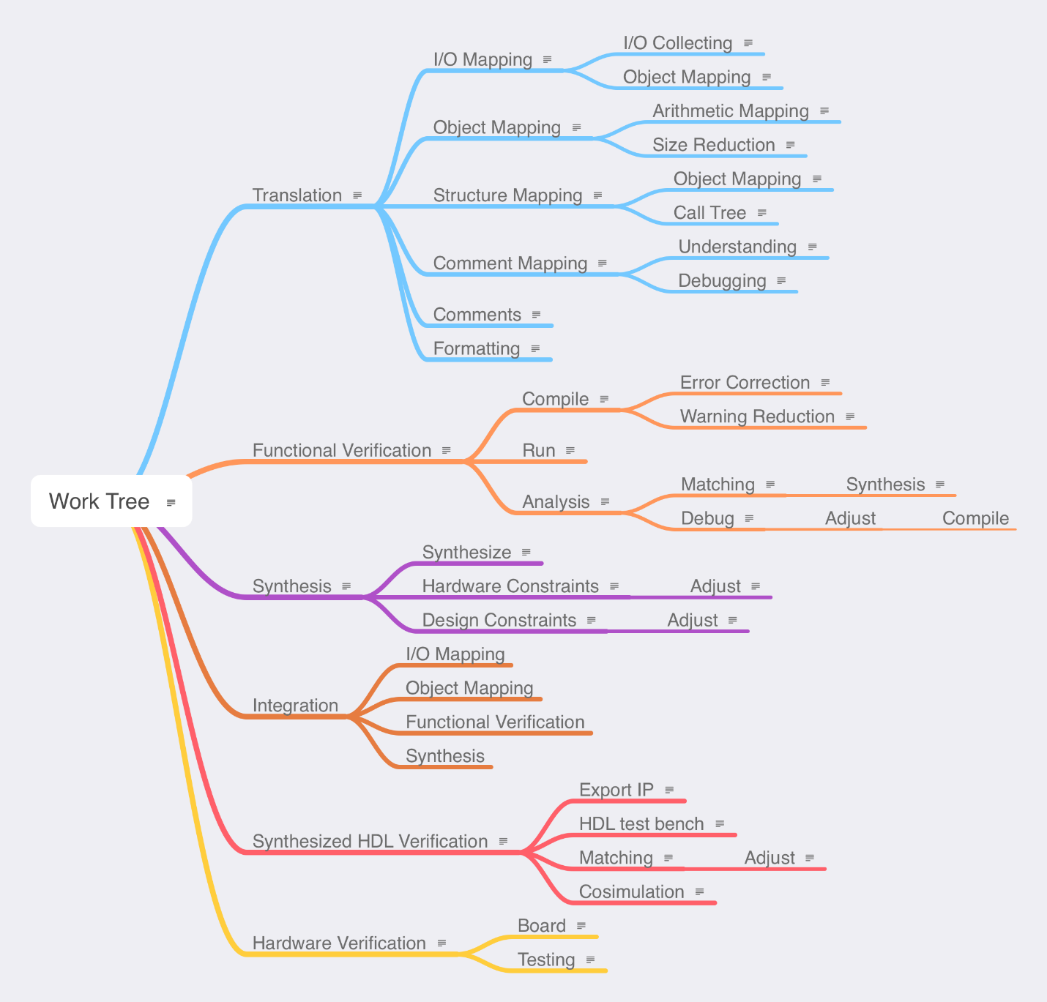

Figure 3: Work tree

The following is Work Tree.md:

# Wok Tree

Purpose: A resource for colleagues, senior officers, and anyone interested — an outline of my (Rafael Hernandez) procedure tree in converting any language (Original — SV/C++) to a new language (New — HLS) with some branches being applicable to any new language (like Translation) and others HLS-specific (like Synthesis). If all requirements in a step have been met, then it is “done”.

Name: It is called a Wok Tree instead of Work Tree because I am craving Chinese food.

Small print: I reserve the right to use this document for my own thesis/work/project and would like to be asked for permission and credited if anyone wants to use/modify/derive from my own work. Thank you for your compliance.

Questions/Concerns: Please refer any questions/concerns to my email (rhernandezlopez1 at ufl dot edu) and I will respond as soon as I see it!

Appreciation: I appreciate you for taking an interest in my work. It took a while to make this diagram/accompanying-text and the fact that you are reading this right now makes me very happy.

## Translation

Mostly unordered children.

### I/O Mapping

Map input and outputs from Original to New.

- I/O Collecting

Consider best way to compare variables, making the verification stage easier. Take time to extract inputs and outputs of Original for Functional Verification Analysis subbranch.

- Object Mapping

More information in the respective branch.

### Object Mapping

Adjust objects to New types where appropriate and trim used objects as much as necessary based on synthesis results or common sense.

- Arithmetic Mapping

Change code to match New object’s provided interface and optimizations wherever reasonable.

- Size Reduction

Ensure New size as small as reasonably possible.

### Structure Mapping

Adapt Original to a New structure if necessary.

- Object Mapping

New objects may provide a more compatible way of performing same task for the required platform.

- Call Tree

Running through the code from the top function down through every function call leads to both understanding and potential insight on code reduction. Manually creating a call tree for every function familiarizes the coder with the code structure — allowing better decisions for the mapping from Original to New.

### Comment Mapping

A very important and sometimes forgotten task. A stale comment (unupdated) can make debugging harder (code wrong or comment?) whereas a New comment may make debugging easier by allowing someone-else/future-self to see purpose and make changes/improvements as necessary.

- Understanding

A dive into comments and surrounding code can provide insight on the purpose, and insight might lead to a more compatible/smaller New code.

- Debugging

Debugging while writing saves time during the compile+simulation loop. Comment/code incompatibility may mean that something is wrong, letting the coder debug before a lengthy compile+simulation and making the code one step closer to a perfect translation.

### Comments

Obviously New meaningful comments should be made wherever and whenever reasonable, for both future-self and anyone who happens to read the code.

### Formatting

It is nice to write code for others — be that future-self, colleagues, senior officers, loved ones, or even rubber duckies. A compiler does not **need** any whitespace or reasonable code alignment, but scarce/excessive whitespace is a debugging/maintenance/reading nightmare that cost a lot of time (and possibly money) in the long run unless the code is never to be touched again. New formatting should match a reasonable guideline for easy reading and analysis, just as Original hopefully did.

## Functional Verification

Ordered children.

### Compile

The first step whenever new software is being tested. In order to run the software, some program should convert (compile) the code into a usable format.

- Error Correction

Sometimes two errors hide 30+ errors. These should be calmly and patiently eliminated no matter how annoying it may seem at the time that “it should work” but does not. A translation is very likely to have compiling errors — no one is perfect, nor are they expected to be.

- Warning Reduction

Warnings are also likely to appear, and some may even be able to be shrugged off. As many as possible should be eliminated, and all should be understood. If any warning is not removed, there should be a good reason for it — int in bool context, for example, is a common C occurrence that has many smart uses but may indicate a possible error [var1 = var2 instead of var1 == var2] so be sure to understand before ignoring the warning. A program should have zero reasonable warnings and zero errors.

### Run

The compiled code should be run/executed in some fashion that a usable result is generated.

### Analysis

The inverse I/O mapping should be applied to Run’s resulting data for matching with Original’s golden data.

- Matching

New’s output and Original’s output should have a unique and one-to-one correspondence. This is a requirement of having an inverse so if the mapping was made correctly, then the result of the matching should also be reliable.

With a reliable matching methodology, if New matches Original, then move on to Synthesis. If the match is not perfect, then continue on to debugging.

- Synthesis

Move to synthesis if matching.

- Debug

Alex Madorsky advised me to isolate the problematic event. Those events should be the ones in Matching that could not be mapped properly to Original’s data. Isolate them, walk through the code, and identify the problem. This may be immediately fixable or require more work. After every change, it is recommended to go back to Compile

- Adjust

- Compile

## Synthesis

Unordered children.

### Synthesize

Run the synthesis tool.

### Hardware Constraints

New must be able to fit on the required FPGA. LUTs, DSPs, FFs, etc. should not exceed the capacity of the FPGA chosen by senior officers. If any of these are exceeded, the logs are expected to be read and fully understood in order to adjust whatever is causing the large consumption of resources.

- Adjust

Return to functional verification’s Adjust subbranch or adjust a synthesizer directive (pragma HLS for Vivado HLS) and return to Synthesize.

### Design Constraints

New must meet or exceed expectations on pipelining (II = 1), latency, and clock period (25 ns total [clk+uncertainty]). If not met, the logs are expected to be read and fully understood in order to adjust whatever is causing the timing issue.

- Adjust

Return to functional verification’s Adjust subbranch or adjust a synthesizer directive (pragma HLS for Vivado HLS) and return to Synthesize.

## Synthesized HDL Verification

Ordered, besides Cosimulation.

### Export IP

Prepare HDL synthesized as IP block, and export to tool of choice (Vivado/ISE/Quartus or similar).

### HDL test bench

Test bench program should be similar to the one used on New but in HDL (likely Original’s if Original was an HDL) and should be run on New’s packaged IP block.

### Matching

New should match New’s output during Functional Verification. If match, go on to Hardware Verification, else adjust.

- Adjust

If not matching, return to Adjust subbranch in Functional Verification.

### Cosimulation

If the test-bench is set up to be compatible with some form of Cosimulation tool, then use that instead of HDL test bench and it should be able to do the Matching by nature. Note that the test bench must be set up. A simple Cosimulation process without any form of tests inside the test bench to return fail value (typically nonzero) will always say the hardware passed if it always returns the pass value (usually 0).

## Hardware Verification

Ordered.

### Board

New’s bitstream should be loaded onto the required board.

### Testing

The board should be supplied inputs and tested as if already loaded onto the application, with the output matching the expected result.

## EMTF SV function calls

Here is a slide I made April 2019 with the function calls done inside EMTF:

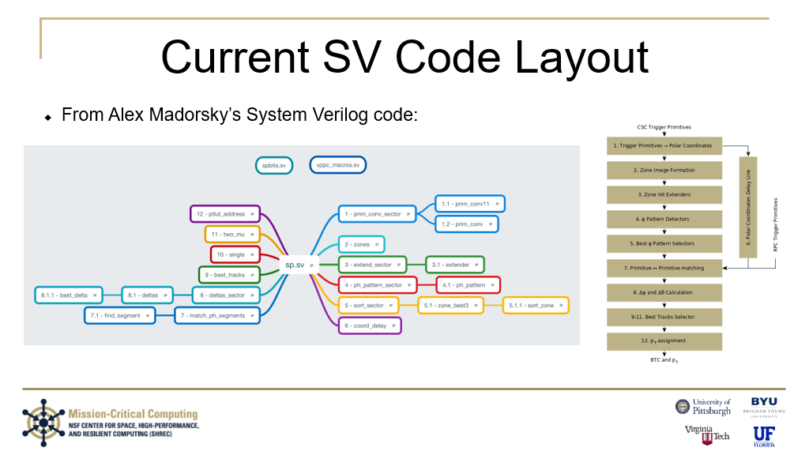

The flow chart was my best attempt back then at matching the algorithm’s stage with the functions, so it would be best to ask Alex about the call <> algorithm mapping rather than relying on this old slide.

## Alex’s CPPF-to-RPC-link-mapping.docx



## Alex’s cscid-to-ring-conversion.pdf

I fixed the ME1/2B 6th chamber from 5 to 6. HLS uses 0:8, not 1:9. Here is the document:

Relation between Chamber IDs (aka CSCIDs) and ring geometry

6

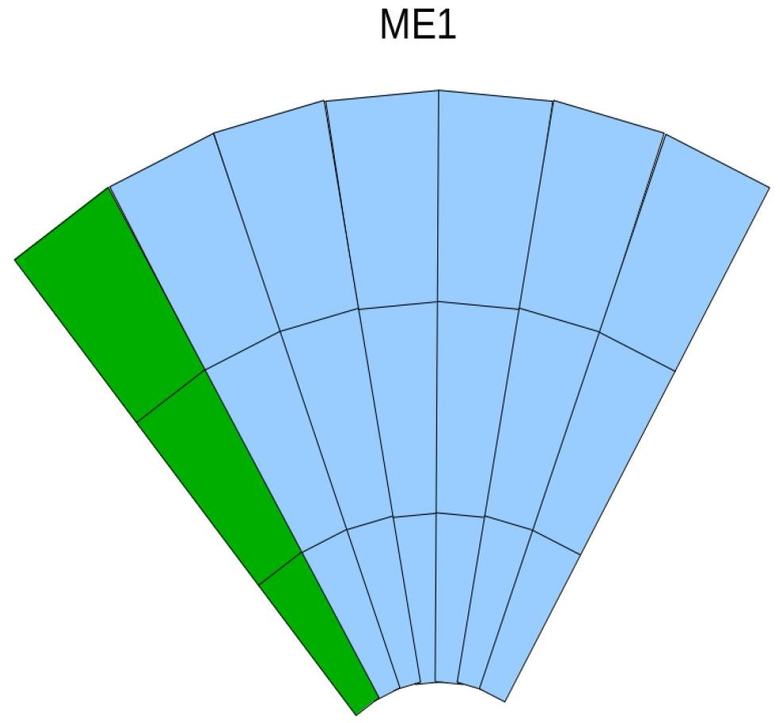

6



Neighbor sector



Subsector A Subsector B

ME1 station has two sub-sectors, A and B.

Numbers inside each chamber are chamber IDs within each subsector. See explanation for Neighbor sector chamber IDs below

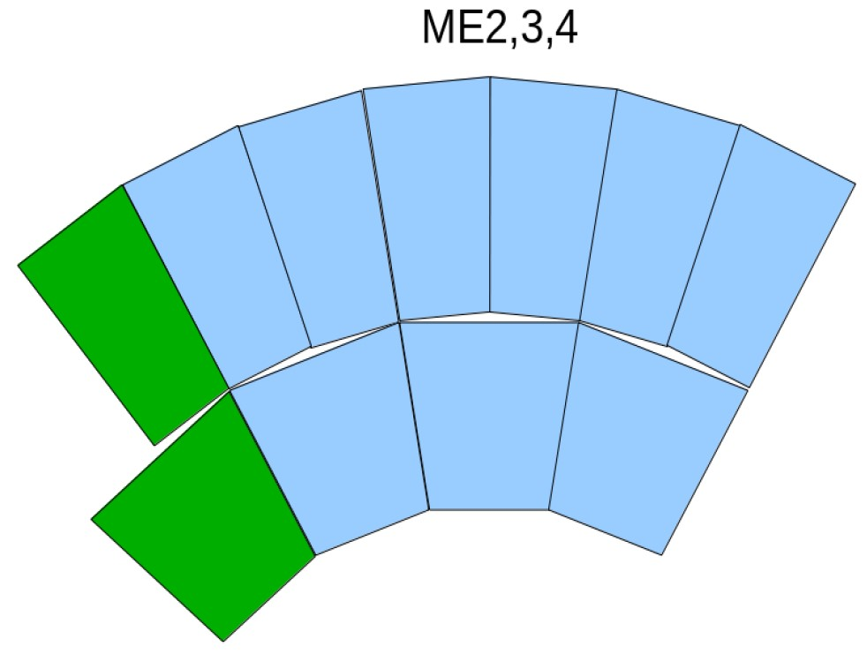

Neighbor sector



Layout is identical for ME2, ME3, ME4 stations. Numbers inside each chamber are chamber IDs within sector. See explanation for Neighbor sector chamber IDs below.

More details

In the EMTF Verilog code, trigger Primitives (aka LCTs) are passed as structures of type “csc_lct”. There is an array input of these structures declared in the top-level file “sp.sv”, like this:

csc_lct.in lct_i [5:0][8:0][seg_ch-1:0];

**First array index** is station number:

|  |  |  |
| --- | --- | --- |
| **lct_i [First Index]** | **Station** | **Subsector** |
| 0 | ME1 | A |
| 1 | ME1 | B |
| 2 | ME2 | N/A |
| 3 | ME3 | N/A |
| 4 | ME4 | N/A |
| 5 | Neighbor sector, all stations | N/A |

**Second array index** is chamber ID shown in the figures above, **minus 1**. This is true for lct_i[0..4]. Chamber IDs in neighbor sector lct_i[5] are explained below.

All LCTs from chambers in neighbor sector are passed in lct_i[5] subarray (first index = 5). The second index in such case is:

|  |  |  |
| --- | --- | --- |
| **lct_i[5] [Second index]** | **Station/subsector in neighbor sector** | **Chamber ID in neighbor sector** |
| 0 | 1B | 3 |
| 1 | 1B | 5 |
| 2 | 1B | 9 |
| 3 | 2 | 3 |
| 4 | 2 | 9 |
| 5 | 3 | 3 |
| 6 | 3 | 9 |
| 7 | 4 | 3 |
| 8 | 4 | 9 |

**Third array index** is the LCT number within one bunch-crossing (BX), coming from the same chamber. Parameter seg_ch is equal to 2, because one chamber is capable of sending maximum of 2 LCTs per BX.

## Terminology/Acronyms

Brackets []

Parentheses ()

Braces {}

ap_ – Arbitrary Precision signed

ap_u – Arbitrary Precision Unsigned

BRAM – Block Random Access Memory

CDL – Coordinate Delay Line

CERN – European Organization for Nuclear Research (Conseil Européen pour la Recherche Nucléaire)

CMS – Compact Muon Solenoid

CMSSW – Compact Muon Solenoid SoftWare

CoSim – Vivado HLS’s C++ vs generated RTL checker

CSim – Vivado HLS’s HLS simulation tool for C/C++ test benches

CSC – Cathode Strip Chamber

CSynth – Vivado HLS’s HLS to RTL generator

DRAM – Distributed Random Access Memory

EMTF – Endcap Muon Trigger Firmware (is my guess)

EMTFe – EMTF enhanced, intermediate UF version

EMTFpp/EMTF++ – Jia Fu version

EMTFpy – Jia Fu version in Python

FOP – Function-Oriented Programming

g++ -- GNU C++ compiler

HLS – High-Level Synthesis

PC/PCs – Primitive Converters

PCS – Primitive Converter Sector

ph/th – angles

phzvl – ph zone valid flags

LUT – Look-Up Table

_r | _a – Made by Rafael | Made by Andrew

_r_e – Made by Rafael for EMTFe

_r_ev – Made by Rafael for EMTFe, post-Vivado->Vitis transition (currently shifted to Vivado)

RPC – Resistive Plate Chamber

RTL – Register-Transfer Level, like what one specifies using Verilog and VHDL.

SHREC – center for Space, High-performance, and REsilient Computing

SP/sp – Sector Processor

Tcl – Tool Command Language

_tf – Test-Fixture

_tl – Top-Level

vl – valid

ZAPP – Zone Array Parser and Partitioner